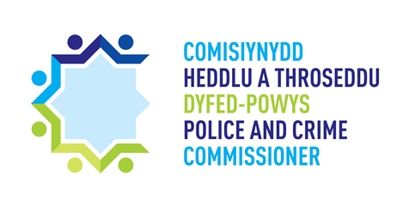
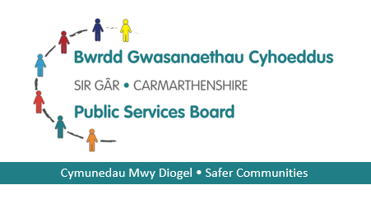

The Safer Streets Fund small grant scheme guidelines - Glanymor 4 & Tyisha 3

The Safer Streets Fund small grant scheme is a grant that has been made available via a successful bid from the Police and Crime Commissioner of Dyfed-Powys to the Home Office. Within the main bid is a small grants programme, which aims to reduce acquisitive crime and making residents feel safer across 2 specific wards in Llanelli. The Police and Crime Commissioner, working in partnership with The Carmarthenshire Safer Communities Partnership is offering the opportunity for charities, voluntary groups and community groups who are working on projects in the wards of Glanymor 4 and Tyisha 3 in Llanelli ONLY (see appendix A for map of eligible area). You can apply for the following amount:

- Up to £2000 – Charities, voluntary organisations and community groups are able to receive up to £2000 of funding to develop projects that have a direct impact on the communities of Glanymor 4 and Tyisha 3 and that their project is linked to the aims of the Safer Streets Fund small grant scheme.

Aims of the small grant scheme -
The aims of the small grant scheme are to:

• Reduce acquisitive crime in areas that receive funding – making resident’s safer and reducing demand on the police. Examples of acquisitive crime include house / shed burglary, theft, robbery, shoplifting, bike and vehicle theft, vehicle crime.
• Targeted projects that affect situational crime prevention in high crime areas. These measures involve environmental strategies to increase risk and reduce crime opportunities. Some examples of situational crime prevention in effect include installing surveillance equipment (for example video doorbells) in areas that experience a lot of vandalism. Another example includes installing security screens in banks to prevent robberies
• Grow local capability to undertake driven problem solving and capture evidence and practical learning about how best to implement situational crime interventions to prevent crime

Is the small grant scheme for you?

- Do you need funding of up to £2000 to help improve the communities of Glanymor 4 & Tyisha 3 only and the lives of people most in need?
- Are you a voluntary or community organisation, school, charity, or sports club situated within the wards of Glanymor 4 & Tyisha 3 or does your project directly benefit these areas?
- Is your project related to the aims highlighted in the guidelines and is your project focussing on reducing acquisitive crime in the wards of Glanymor 4 & Tyisha 3 only?
If you can answer yes to all these questions then the Safer Streets Fund small grant scheme may be right for you.

In your application you will need to tell us what the grant would be spent on and how this will achieve one or more of the aims of the scheme, and you can apply for up to £2000 to fund all or part of your project.

Here are some examples of what a grant can pay for:

- educational toys and games
- sports kit
- new sports equipment
- equipment hire
- publicity materials for use in your project
- sessional workers
- training
- transport costs
- venue hire
- volunteer expenses
- contribution towards running costs

But we won’t pay for:

- contingency costs
- endowments
- feasibility studies
- items that mainly benefit individuals
- purchase of alcohol
- parties, meals or entertainment, unless they are clearly linked to our aims and demonstrate a long-term benefit
- political or religious activities
- projects or activities that the state has a legal obligation to provide
- projects that you cannot maintain because of high ongoing costs or the need for specialist skills
- purchase of police equipment for statutory duties
- overtime or a contribution towards police or police staff salaries

Important Information

Once you have completed your application following the guidelines, please send your completed application form to the Safer Communities Partnership Manager Kate Harrop -KHHarrop@carmarthenshire.gov.uk

Timescales
Below are the timescales you will need to be aware of, to ensure that your bid is submitted in time and that you are able to spend your grant –
- Funding bid deadline – 31st January 2021
- Decision by Safer Communities Partnership and groups made aware of decision – Mid February 2021
- Funded project to be completed by – 31st March 2021

APPENDIX A
Map of Glanymor 4 and Tyisha 3 – eligible wards for the small grant scheme.
Please contact Jessica Williams on the below email address to clarify if your project falls within the eligible area – jessica.williams.opcc@dyfed-powys.pnn.police.uk

