Police and Crime
Commissioner for Dyfed-Powys

Scrutiny Panel
Dip Sampling Exercise
Complaint Case files - Handled Otherwise than by Investigation

Panel Members’ Findings & Feedback

May 2021

1.0 Background
In their fifth virtual scrutiny session on the 17th May 2021, Members reviewed the case files of 6 complaints which were handled otherwise than by investigation. As a result of not being quorate during the meeting, the Panel took the decision to conduct this scrutiny exercise remotely. Members were given 2 complaint cases to review each with feedback being emailed back to the OPCC by the 24th May 2021.
The Complaints and Misconduct Officer from the Professional Standards Department (PSD) attended part of the meeting in order to give an overview of this area of work and to highlight areas for the Panel to review. It was explained that from the 1st of February 2020 changes were made to the ways in which complaints are handled. Complaints are now recorded and separated into three categories as noted below:

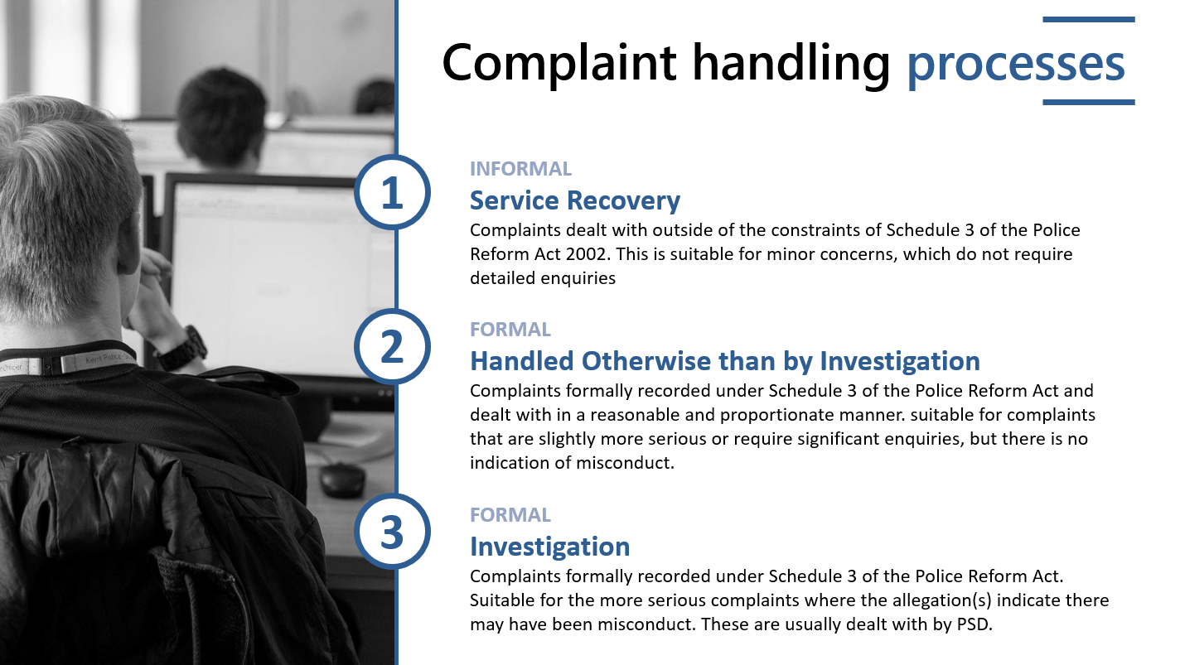
The Panel were asked to specifically review a selection of Handled Otherwise than by Investigation cases. Cases recorded under this category will be recorded and logged by PSD. The complaint handler will decide what action will be most useful in order to provide meaningful answers, remedy the dissatisfaction of the complainant and identify any learning. Reasonable and proportionate action should be taken to address the concerns and determine whether the service provided by police was acceptable. A record of all actions taken by the Force and the quality of service decision should be documented on a template and PSD, who should then send a formal notification of the outcome to the complainant, which will provide them with their right to request a review of the handling.
Potential actions could include:
- Learning;
- Reflective Practice;
- An Apology;
- Policy Review;
- An explanation; or
- No further action.

2.0 Findings

Case 1
- It was felt that the correspondence within this case was of a high standard. The letter from the Deputy Chief Constable and Head of PSD was exemplary, both in terms of language and content.
- It was noted that the case took a very long time to process, however, it was acknowledged that part of the delay was waiting on the Court handling the Fixed Penalty Notice.
- It was felt that the apology from the officer was somewhat perfunctory and could have been put across in more personalised manner.
- The case was handled in a fair and open manner, with a thorough process being undertaken despite very little evidence being available.
- Positively, advice was sent as how the complainant could take the complaint forward if they did not agree with the outcome. The complainant had asked for an apology and learning by the officer, this was agreed to and issued, evidencing their wishes were taken into consideration.
- The complainant was kept informed throughout the process, with plenty of updates on the progression of the complaint review process. This included information about the delays due to court proceedings.

Case 2

- It was felt that the initial contact email to the complainant was clear and concise.
- It was felt that the final email to the complainant could have signposted the complainant to support services – either to the Police and Crime Commissioner’s Office, the Independent Office for Police Conduct (IOPC) or their local Citizens Advice Bureau.
- This complaint was handled in a fair and open manner, with the outcome decision supported by relevant force policy and legislation.

Case 3
- Members noted that the complaint had been recorded in line with policy.
- The complainant had received an acknowledgement by email and a copy of the outcome of their complaint in writing, as well as being updated throughout the process.
- Members queried whether a referral to support services were made in relation to concerns raised regarding mental health issues and the safety of children. It was unclear from the records as to whether the Multi Agency Referal Form had been submitted.

Case 4
- Members noted that the complaint had been recorded in line with policy and was handled in a fair and open manner.
- Very good communication with the complainant was noted, with an acknowledgement of their initial complaint by email and a copy of the outcome of their complaint in writing as well as a phone call on completion of the process.

Case 5
- This case took approximately 10 months to come to a conclusion. There appeared to be a few incidents where the case was re-allocated to different individuals.
- The Investigating Officer in dealing with this complaint was unable to speak to the police officer who had dealt with the investigation originally as the officer had left the department. In view of this they could only review the process as documented, concluding that all procedures had been followed and the complainant updated appropriately. No further action was therefore to be taken. However the Investigating Officer also noted that there was organisational learning to be had, as there was no rationale recorded by the Force as to why an investigation had not taken place where a crime was alleged.
- It was noted that there was no timescale in which complaint investigations should be completed. A letter was sent initially to complainant regarding the impact of Covid-19 restrictions on staffing, however, there were no timescales given in order to manage the complainant’s expectations as to what would be a reasonable timeframe to expect to receive an update.

Case 6
- This complaint was made and withdrawn on the same day, despite an Investigating Officer being appointed promptly. The finalisation letter from Professional Standards was sent some three months later, however it was clear and detailed.
- This matter was in the process of being dealt with quickly and the officer’s initial response to the complaint indicated they were open to feedback and any learning.
- Indications were that the case was dealt with in a fair and open manner, however the complainant withdrew before a full review had been completed.

3.0 Summary:

- The Panel wished to highlight that all complaint cases were handled in a fair and open manner.
- All complainants were given information on what to do if they were unhappy with the outcome of their complaint.
- All complainants received an acknowledgement email and an outcome letter in relation to their complaint. Correspondence with complainants was of a high standard.
- Members queried whether there should be a timescale in which complaint investigations should be completed in order to manage the expectations of complainants.

4.0 Observations

Observations | Force Response
Members queried whether there should be a timescale in which complaint investigations should be completed in order to manage the expectations of complainants. | This is a valid observation it would seem prudent to have timescales in place to provide complainants with an indication of how long it will take to address their complaint.  The difficulty is that the type of complaint we receive can vary widely in severity and complexity, from standard service delivery issues to serious abuses of position or authority. Some complaints comprise only one allegation and some multiple. In the past we have received complaints where there have been up to 50 allegations made.  It then becomes problematic placing one fixed timescale on the resolution of complaints. Every complaint is unique and the handling is dependent on the circumstances of that individual complaint.  This is reflected in the Complaints Legislation and IOPC Statutory Guidance, where timescales are stipulated for certain significant events in the process, but not for the handling of a complaint.  We are however required to keep the complainant updated every 4 weeks and we try where possible to use this update to provide the complainant with an indication of how long we think it will take to complete the handling of their complaint.

