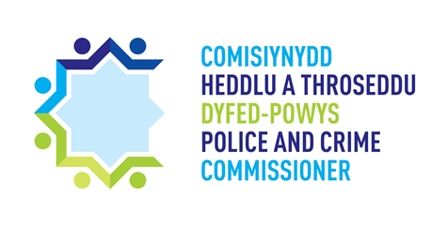

**DYFED-POWYS**

**POLICE AND CRIME COMMISSIONER**

**INDEPENDENT CUSTODY VISITING SCHEME**

**ANNUAL REPORT**

**APRIL 2020 – MARCH 2021**

Contents

1. Foreword from the Dyfed-Powys Police and Crime Commissioner 3

2. Introduction 4

3. Independent Custody Visitors 4

4. ICV Rotas 5

5. Visiting Data 6

I. Number of visits and ICV Calls 6

II. Number of detainees 6

III. Timings of visits 7

6. Issues Raised 8

7. Panel Meetings 9

8. Training and Events 10

9. Independent Custody Observers Pilot and Custody Record Reviewing 10

10. Quality Assurance Framework 11

11. Covid-19 11

12. Interested in becoming an ICV? 12

Appendix A: 13

Appendix B 14

# Foreword from the Dyfed-Powys Police and Crime Commissioner

Independent Custody Visiting was borne out of Lord Scarman’s report on the Brixton riots in 1981 which recommended that a system of independent, unannounced inspection of procedures and detention in police stations by local community members be introduced. This was formalised in 2002 by the Police Reform Act which places a statutory duty on all Police and Crime Commissioners to implement an Independent Custody Visiting Scheme.

An Independent Custody Visiting Scheme was established in Dyfed-Powys in 2001. Since its roll out, thousands of visits have been made to custody suites across the Dyfed-Powys area, ensuring detainees are treated with respect and dignity irrespective of the reason for their detention.

Custody Visiting has introduced transparency of police custody processes. Independent Custody Visitors (ICVs) have a crucial role in ensuring the Human Rights of detainees are upheld and that the Police and Criminal Evidence Act 1984 is complied with.

It has been a challenging year for my ICVs, with physical visits having to be put on pause for a period of time due to the Covid-19 pandemic and the introduction of ICV telephone calls into our custody suites. I would like to take this opportunity to thank all my ICVs for their continued support and enthusiasm during this difficult time and for their flexibility and willingness to trial new ideas to ensure the scheme has kept functioning. I would like to offer my personal thanks to them all.

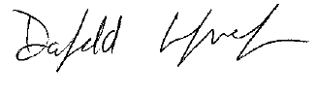

Dyfed-Powys Police and Crime Commissioner

# Introduction

Independent Custody Visitors (ICVs) are volunteers from our local community who visit police custody suites in pairs, unannounced, to check on the welfare of detainees and to ensure that their rights are upheld. ICVs also undertake checks on the custody environment to ensure it is safe and of a good standard. If any concerns are identified, these are raised by ICVs initially with the Custody Police Sergeant and also via the Police and Crime Commissioner’s office for discussion with Police Inspectors. Updates are then provided to the Office of the Police and Crime Commissioner (OPCC) for consideration. Any overarching themes are fed into Policing Board for consideration for further action to be taken if appropriate. The ICVs’ role offers protection to detainees and transparency of detention processes.

# Independent Custody Visitors

At the end of March 2021 there were 23 Independent Custody Visitors (ICVs) on the Scheme, spread across the 4 ICV Panel areas; Carmarthenshire, Ceredigion, Pembrokeshire, and Powys.

Figure 1: Number of ICVs in each Panel Area

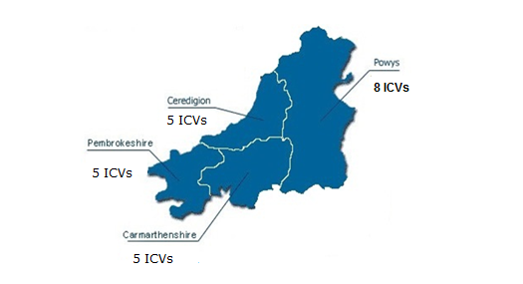

We had five ICVs resign from the Scheme between 1 April 2020 and 31 March 2021 and three new ICVs joined the ICV rotas within this period.

Every effort is made for the Scheme to represent the demography of Dyfed-Powys, but critically, volunteers who show a genuine commitment and interest in the Scheme are appointed to the Team. However within our last recruitment drive, every effort was made to recruit individuals from a diverse range of ages, making a slight improvement on last year’s overview.

Figure 2: Gender and Age of ICVs

|  |  |
| --- | --- |
| Age: | Percentage |
| 18-24 | 17% |
| 25-34 | 0% |
| 35-44 | 0% |
| 45-54 | 5% |
| 55-64 | 26% |
| 65-74 | 35% |
| 75+ | 17% |

# ICV Rotas

Ammanford, Aberystwyth, Haverfordwest, Brecon and Newtown are the main Custody Suites in the Dyfed-Powys area. Ammanford, Aberystwyth and Haverfordwest are visited once a week with Brecon and Newtown being visited on a fortnightly basis. This is due to their varying size and use. There are two other Custody Suites in Dyfed-Powys; Cardigan and Llanelli. They are used as overspill suites and ICVs do not routinely visit these Custody Suites. However, should these overspill suites be used, the OPCC will be notified and can arrange an ICV visit if necessary.

|  |  |
| --- | --- |
| **Custody Suite** | **Cell Capacity and detention rooms (used for the detention of children)** |
| Ammanford | 6 cells  2 detention rooms |
| Haverfordwest | 17 cells  2 Detention rooms |
| Aberystwyth | 7 cells  1 Detention room and 1 dry room |
| Brecon | 8 cells  1 Detention rooms |
| Newtown | 9 cells  1 Detention room |
| Llanelli  (Only used as an overspill) | 8 cells  2 detention rooms |
| Cardigan  (Only used as an overspill) | 6 cells |

ICVs are provided with a rota assigning a pair of ICVs to a week / fortnight. They then arrange the day and time of the visit within the specified week / fortnight.

Within their six-monthly ICV Panel meetings, ICVs are provided with data on their recent visits as well as the profile of custody throughput. They are asked to consider this data when arranging visits to ensure visits are conducted at varied days and times throughout the week.

ICVs usually have the option of visiting a custody suite in a different Panel area. This ensures good practice is shared across the areas, however these no cross visits were able to be facilitated due to the Covid-19 pandemic. These will be offered again when appropriate.

# Visiting Data

## Number of Visits and ICV Calls

During 2020/2021, a total of 91 ICV calls and 14 physical visits were conducted by my ICVs to custody suites across the Force area; during which time there were 201 detainees in custody. Of these, 31 detainees consented to be visited or spoken to and 5 detainees were observed. ICV calls brought a challenge in that It was found that the number of detainees happy to accept a phone call from our ICVs were much lower than those willing to agree to an ICV visit in person.

## Number of Detainees

During 1st April 2020 to 31st March 2021, a total of 5,955 detainees were held in the custody suites across Dyfed-Powys. Of these, 305 were in custody at the time of the ICVs’ visits. 48% of those detainees present were visited by ICVs (146).

|  |  |
| --- | --- |
| **Custody Suite** | **April 2020 –March 2021 throughput** |
| Ammanford | 2,281 |
| Llanelli (Only used as an overspill) | 22 |
| Haverfordwest | 1,749 |
| Aberystwyth | 771 |
| Cardigan (Only used as an overspill) | 15 |
| Brecon | 774 |
| Newtown | 763 |

## Timings of visits

Figure 5: The number of calls and visits during 1st April 2020 to 31st March 2021

Figure 6: The number of visits during 1st April 2020 to 31st March 2021

During the pandemic and through the introduction of ICV calls we have seen an increase in the amount of ICV contact on the weekends. Visit days continue to be well spread out and unpredictable.

ICVs carry out visits most commonly in the morning which is the busiest time in custody, therefore maximising the chance of seeing as many detainees as possible. Not many visits are carried out after 21:00 as detainees tend to be sleeping and therefore ICVs are likely to have a lower number of detainees to speak to during later hours. ICVs do however try to carry out visits during a variety of times including weekends as well as week days so as to ensure a level of unpredictability in terms of the days and times they visit.

# Issues Raised

During their visits ICVs check on the welfare of the detainees as well as the conditions in which they are held. ICVs are mindful of the rights afforded to detainees whilst held in Custody as per Code C of the Police and Criminal Evidence (PACE) Act 1984. A summary of these can be found in Appendix B.

ICVs are expected to discuss any minor welfare or environmental issues with the Custody Sergeant or accompanying officer at the time of the visit.

Any issues which cannot be resolved during a visit, or which ICVs feel need to be dealt with at a higher level are reported to the Scheme Administrator within the OPCC.

These are then recorded and followed up with Dyfed-Powys Police’s (DPP) Custody Chief Inspector or the relevant Inspectors. They then consider the issues, provide the scheme administrator with an update / report, and take any necessary actions.

Positive comments and observations are also noted on the forms and reported back to senior custody staff.

The Scheme Administrator notifies ICVs of the outcome of their report, and further discussions around the issue are held at the next ICV Panel Meeting.

Should any issues need to be considered at a higher level, I personally take the matter to a Policing Board to discuss with the Chief Constable.

Below is a list of concerns raised by ICVs Between 1st April 2020 and 31st March 2021 with a response as to the progress made against each concern.

|  |  |
| --- | --- |
| **Concern identified** | **Progress made** |
| ICV call: Kitchen light required attention in Ammanford. | Resolved: Issue reported to the Estates Team and problem has been fixed. |
| ICV call: Issue with not all Custody Staff being trained in the Custody Early Warning System (CEWS) trained. | Resolved: Initial delay in training due to Covid-19, all staff now trained. |
| ICV call: Hoovering of cell vents. There needs to be regular hoovering of the air vent grills by cleaners to ensure they are dust free to allow efficient air flow in cells and other areas of custody. | Resolved: The hoovering of cell vents is now a regular part of the cleaning regime. |
| ICV call: There is a need for improvements to be made to the custody desk in Aberystwyth. | Resolved: Work has been carried out by Estates and improvements have been made to the front desk in Aberystwyth including a health and safety screen. |
| ICV call: Panic strip not working in Haverfordwest suite in corridor. | Resolved: Panic strip was immediately fixed. |
| ICV call and visit: No Bible available in Ammanford. | Resolved: This was an ongoing issue. However, this has now been resolved and a new Bible is now in custody. |
| ICV call: Drainage issues in Ammanford. | Resolved: Specialists called out and the issue was resolved. |
| ICV call: Painting needed within the cells in Brecon. | Ongoing: This issue has been reported to Estates and has been incorporated into their work plans. |
| ICV call: Temperamental outside buzzer at Newtown custody suite | Resolved: New part ordered and installed. |
| ICV call and visit: Heating issues in some of the cells in Newtown. | Resolved: This issue was reported and necessary work has been completed. |
| ICV calls: Cracks on custody walls in Newtown. | Ongoing: The estates team have been made aware of this concern and it is being monitored. |
| ICV call: Issues with downloading CCTV footage. | Ongoing: This issue is being monitored closely. |
| ICV visit: All Visitors should have their temperature checked on arrival in the suite. | Resolved: Reminder of Covid-19 guidance circulated to all custody staff. |

Over the last year many positive comments have been noted. ICVs regularly note within their findings that custody is clean and tidy with everything in good order. On a few occasions ICVs commented that the Covid-19 safety guidelines have been embedded very well and that custody is working well under challenging circumstances.

# Panel Meetings

ICV Panel Meetings are held twice a year in each area, where ICVs have the opportunity to discuss any issues that have been raised with the Custody Inspector. They must satisfy themselves that the explanations given are adequate, and that the result ensures no adverse impact on a detainee’s welfare, human rights or health and safety. It is also an opportunity to reflect on the last 6 months; how the Scheme is running and if any improvements could be made. Due to the Covid-19 pandemic all ICV Panel meetings were conducted virtually via Skype for Business.

# Training and Events

* An Annual training day was held virtually via Skype for Business on the 3rd of December 2021. Inputs included information on the Diversionary Scheme, an input on changes to PACE in relation to females in custody, an input on Covid-19 procedures within the suites and an update on CEWS training.
* During National Volunteers week the 1st-7th of June, I held virtual calls with all the ICVs in order to thank everyone individually for their contributions.

# Independent Custody Observers Pilot and Custody Record Reviewing

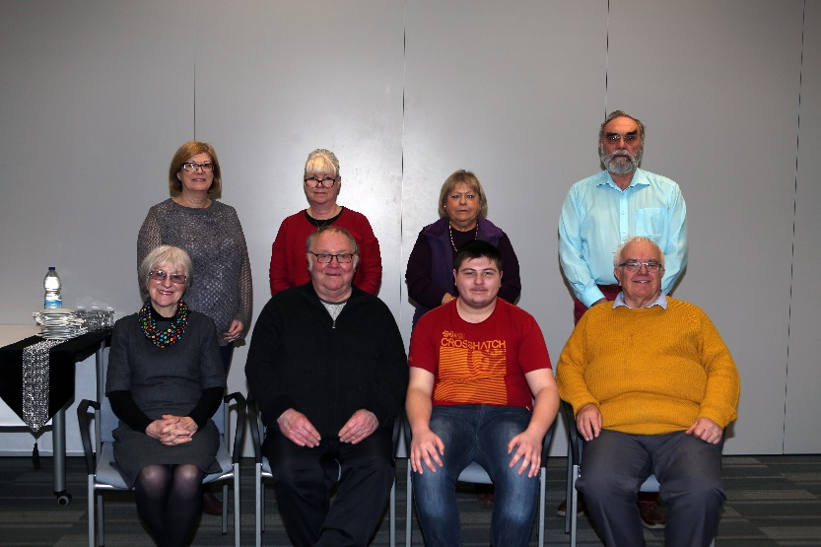Back in September 2019 my Independent Custody Visiting Scheme became one of five Force areas, the only in Wales, to take part in the National ‘Independent Custody Observers Pilot’. The 6-month Pilot, run by the Independent Custody Visiting Association (ICVA), aims to further protect the welfare of those identified as vulnerable within police custody, including young people. The Pilot gave my ICVs the opportunity to routinely review a selection of custody records of vulnerable detainees, giving them an opportunity to consider a detainee’s entire journey through custody. The second phase of the Pilot - trialled in the Pembrokeshire area - launched on 24 January 2020, and brought some changes to the ICV visits. With consent from the detainees, ICVs are able to observe some of the custody procedures which they previously did not review, such as the booking in and release procedures. These additional checks open up more of the custody process to my ICVs, giving them a better insight into the totality of care extended to vulnerable detainees across Dyfed-Powys custody suites.

The independent evaluation of the Pilot was finalised in July 2020 with the recommendation being that these additional checks during ICV visits and the regular Custody Record Reviews become a regular part of the ICV role. These changes are currently with the Home Office for consideration.

Unfortunately, due to Covid-19 our ICVs were unable to meet and review custody records, however, throughout the Pandemic my office has been undertaking independent dip-sampling of custody records on a monthly basis to ensure that checks on the welfare of detainees continue, and that all rights and entitlements continue to be granted during this unprecedented time.

## Overview of key findings

205 Records were reviewed in total from April 2020 to March 2021.

## Areas of Good Practice

* It was found that all detainees were explained their rights and entitlements (in the presence of Appropriate Adult (AA) if required).
* Positively all children in custody were provided with an AA.
* The figures of females being assigned a female officer and being offered menstrual products has increased significantly.

## Areas of improvement identified

* Alternative accommodation for children in custody continues to be an issue. This is being discussed at an all Wales level and I intend on meeting with local Heads of Children’s Services in May 2021 to discuss a way forward.
* Hygiene provisions and Covid-19 safety measures were not regularly being recorded in custody logs.

The aim is that ICVs will return to Custody Record Reviewing once Covid-19 guidelines allow.

# Quality Assurance Framework

The Independent Custody Visiting Association (ICVA) Quality Assurance Awards were presented at a ceremony at the House of Lords on the 15th of May 2019. There were four graded levels of award, and the Dyfed-Powys Scheme was delighted to have received the Gold standard; meaning the Scheme provides an excellent standard of custody visiting and volunteer management. This award lasts for 2 years, and it is my intention for my Scheme to be reassessed by ICVA during the coming year.

# Covid-19

As a result of the rapid developments of the Coronavirus pandemic towards the latter part of the last financial year, Dyfed-Powys Police made the decision to postpone all non-essential visits to Police sites in order to safeguard the resilience of policing in Dyfed-Powys. As a result of this, our Visitor demographics, and in response to a number of our Independent Custody Visitors (ICVs) asking to withdraw themselves from ICV visits until the current situation with Coronavirus eases, I agreed to suspend all ICV visits on the 18th of March 2020 until further notice.

In the absence of ICV visits, members of my office undertook a number of steps to ensure that my statutory oversight of the police custody environment was maintained whilst visiting was put on hold. This involved undertaking independent dip-sampling of custody records on a fortnightly basis to ensure that checks on the welfare of detainees continued, and that all rights and entitlements continue to be granted during this unprecedented time.

In addition, the Scheme Administrator remotely attended weekly custody contingency planning meetings on their response to Covid-19, as well as co-ordinating a response to a weekly questionnaire from the Independent Custody Visiting Association regarding detainees’ access to healthcare and Appropriate Adults.

I also continued to keep a close eye on Dyfed-Powys Police’s performance data, including the volume of crime, calls for service and the number of detainees going through custody on a weekly basis. This allowed me to understand the current pressures on the Force as well as ensuring my office’s oversight was proportionate and supportive.

On the 10th August 2020 ICV calls were introduced, allowing ICVs to phone custody and to speak with detainees, check on their wellbeing and ensure that their rights are being upheld.

On the 18th September 2020, a decision was made to introduce a phased return to physical ICV visits, with a mixed rota of calls and physical visits. This decision was continuously reviewed throughout the year with the Scheme moving from a mixed rota to calls only, depending on local Covid-19 levels and lockdown restrictions in each area.

This approach will be reviewed with the aim of returning to physical visits when safe to do so.

# Interested in becoming an ICV?

If you are interested in volunteering for the Police and Crime Commissioner and becoming an ICV within the Dyfed-Powys area, or would like some further information, please visit:

<http://www.dyfedpowys-pcc.org.uk/en/the-office/volunteer-schemes/independent-custody-visitors/>

Or contact Caryl Bond on 01267 226440

Or Email: [caryl.bond.opcc@dyfed-powys.pnn.police.uk](mailto:caryl.bond.opcc@dyfed-powys.pnn.police.uk)

# Appendix A:

|  |
| --- |
| **A detainee’s rights under Code C of PACE are summarised below. This is the information provided to detainees at the police station. Full details are available in the Police Code of Practice C.** |
| **1**. Tell the police if you want a solicitor to help you while you are at the police station. This is free. |
| **2**. Tell the police if you want someone to be told where you are. This is free. |
| **3**. Tell the police if you want to look at their rules – they are called the Codes of Practice. |
| **4**. Tell the police if you need medical help. Tell the police if you feel ill or have been injured. Medical help is free. |
| **5**. If you are asked questions about a suspected offence, you do not have to say anything. However, it may harm your defence if you do not mention when questioned something which you later rely on in court. Anything you do say may be given in evidence. |
| **6**. The police must tell you about the offence they think you have committed and why you have been arrested and are being detained. |
| **7**. The police must let you or your solicitor see records and documentation about why you have been arrested and are being detained and about your time at the police station. |
| **8**. If you need an interpreter, the police must get you one. You can also have certain documents translated. This is free. |
| **9**. Tell the police if you are not British and you want to contact your embassy or consulate or want them to be told you are detained. This is free. |
| **10**. The police must tell you how long they can detain you for. |
| **11**. If you are charged and your case goes to court, you or your solicitor will have a right to see the prosecution evidence before the court hearing. |

# Appendix B

|  |
| --- |
| **The environmental checks that ICVs undertake whilst visiting Custody:** |
| - Check that the cells are clean (both occupied and empty cells where possible). |
| - Check that the kitchen and food preparation area is clean and tidy. |
| - Check that all other areas within Custody are clean and tidy. |
| - Check that the heating, lighting and ventilation is adequate. |
| - Check that the medical room is locked if no healthcare professional is present. |
| - Check that a first aid kit is readily available. |
| - Check that there are sufficient stocks of bedding, anti-rip suits & spare clothing. |
| - Check that there are sufficient stocks of food. |
| - Check that the Custody Suite is clear of any apparent health and safety hazards. |
| - Check that the cell buzzer and CCTV systems are in working order. |
| - Check that religious materials are readily available to detainees. |
| - Check that there are no ligature points posing a risk to detainees. |

|  |
| --- |
| **The welfare checks that ICVs undertake whilst visiting Custody:** |
| - Are they being treated reasonably? |
| - Have they been made aware of their legal and visitor rights? |
| - Do they understand their rights as they have been explained to them? |
| - Has someone been informed of their detention (if they have requested this)? |
| - Have they seen a solicitor (if they have requested this)? |
| - Have they been offered/ provided with food/drink? |
| - Have they requested / received medical attention if needed? |
| - Have they been given access to toilet/ hygiene/ washing facilities? |
| - Has additional bedding/ replacement clothing/ blanket been provided, if required? |
| - Have suitable rest periods and/or exercise been made available, if appropriate? |