

**Police and Crime**

**Commissioner for Dyfed-Powys**

**2023/24 – 2027/28 Medium Term Financial Plan**

**Including**

1. **Precept Proposal**
2. **Reserves Strategy**
3. **Capital Strategy**

**January 2023**



**Contents**

1. Police and Crime Commissioner’s Summary & Precept Proposal
2. Organisational, Operational and Workforce Context
3. Funding Context and Police Precept
4. Council Tax Base
5. Economic Landscape
6. Dyfed Powys Police – Financial Context
7. 2023/24 Police Funding Settlement & National Context
8. Council Tax Capping/Referendum – Wales versus England
9. Budget Requirement 2023/24, Force Review & Savings Plan
10. Medium Term Budget and Outlook
11. Future Funding Settlement and Formula Funding
12. Future Savings Plans/Force Review and Assumptions
13. Capital Investment Plans
14. Impact on Reserves
15. Medium Term Financial Plan Summary
16. Section 25 & Budgetary Risk
17. Public Consultation & Opinion
18. Conclusion

**Appendices**

1. Budget 2023/24 – 2027/28
2. Section 25 Chief Finance Officers Report
3. Risk Assessment of Material Budgets
4. Reserves Strategy
5. Reserves 2022/23 – 2027/28
6. Capital Strategy
7. Capital Programme 2022/23 – 2031/32
8. **Police and Crime Commissioner’s Summary and Precept Proposal** 
   1. I take great pride in having been elected as your Police and Crime Commissioner for a second term, and will continue to develop a close working relationship with all communities of the vast geographical area that is served by the Dyfed-Powys Police Force. Working in partnership across the four Unitary Authority areas of Carmarthenshire, Ceredigion, Pembrokeshire and Powys has and will remain a priority for me. I remain committed to giving the public a strong voice in shaping both its policing service and the wider criminal justice system.
   2. The Dyfed-Powys Police Service (Dyfed-Powys) is an integral part of our communities, and this unique relationship is of paramount importance. The public must remain central to everything we do and every decision we make. Providing an evidence base for our actions and investments is important and by harnessing the use of technology and data to shape our services, I am certain that further improvements can be made in ensuring the security and safety of our area.
   3. I have set the strategic direction and laid out priorities within my published Police and Crime Plan which will evolve and adapt to the challenges over the coming years, in order to ensure that policing and criminal justice services remain relevant and cognisant of the context in which they operate. I am confident that a partnership approach will lead to an improved service for our communities.
   4. Dr Richard Lewis took up post as Chief Constable in December 2021 we continue to work together constructively to deliver positive outcomes for the communities of Dyfed-Powys. It has been pleasing to see notable successes in relation to positive His Majesty’s Inspectorate of Constabulary and Fire & Rescue Services (HMICFRS) feedback in relation to the Neighbourhood Policing structural changes, as well as changes linked to end-to-end crime processes and marked improvements in crime data integrity.

* 1. Having restructured my team, it has been yet another busy year focusing on the priorities of my new Police and Crime Plan, discharging the array responsibilities including increased scrutiny and engagement activities. Commissioned Services continue to report challenging levels of demand and it is pleasing that my office have been able to secure additional funding from the Ministry of Justice to continue to support services at a higher level.
  2. One of my key responsibilities as your Police and Crime Commissioner (Commissioner) is to set the precept each year. This precept is the amount of taxation that is raised through local council taxpayers to support policing services. In doing so, I consider several different factors including the Chief Constable’s future resourcing requirement, the level of reserves, feedback from residents of the Dyfed-Powys area and plans for investment in infrastructure.
  3. The statutory arrangements established under the Police Reform and Social Responsibility Act state that:
     + I must notify the Police and Crime Panel (P&CP) of my proposed precept by the 1st February.
     + The P&CP must review the proposed precept by the 8th February.
     + If the P&CP vetoes the proposed precept, I must notify the P&CP of my revised precept by the 15th February.
     + The P&CP must review the revised precept by the 22nd February.
     + I must set a precept by 1st March.
  4. The Chief Constable continues to report financial performance monthly through Policing Board and quarterly through Police Accountability Board. Financial management and medium-term financial planning are overseen by the Finance & Strategy Board. My Chief Finance Officer (CFO) continues to work closely and constructively with the Director of Finance (DOF) and Corporate Finance team.
  5. Detailed discussions have been ongoing throughout 2022/23 in relation to in-year financial management and the Medium Term Financial Plan (MTFP).  These have taken place within the formal governance structure, as well as a series of precept and MTFP meetings between myself, the Chief Constable, Director of Finance (DOF) and my Chief Finance Officer (CFO). The meetings took place during 2022 on 29th September, 15th November, 24th November (pre-finance seminar), 13th December and 20th December (post settlement, which was received on 14th December).
  6. The Chief Constable and I held a virtual Finance Seminar on the 30th November 2021 for members of the Police & Crime Panel (P&CP), Joint Audit Committee (JAC) and Audit Wales. The purpose of the event was an opportunity for the Force to present a summary of the operational environment that they work within and the impact that this has on their demand levels and subsequent resource requirements for 2023/24 and beyond.
  7. The seminar also covered the steps taken so far in preparing the 2023/24 budget and the draft position, including budget assumptions, pressures, funding context, savings, efficiency measures and the significant investment requirements which are needed to underpin the delivery of policing services. Our Treasury Management advisors also presented on a range of wider economic and local financial considerations. This seminar allowed a valuable opportunity to present on both the operational and financial challenges and context, which impact on my plans for the precept for 2023/24.
  8. A meeting was then held with the P&CPs Precept Sub-Group on the 7th December to discuss their reflections and considerations arising from the Finance Seminar, with a further meeting on the 11th January 2023.
  9. Dyfed Powys Police Service have faced significant financial challenges since 2010 due to significant reductions in funding from central government, the legacy of implications arising from previous decision making, along with significant cost pressures and continual changes in the demand for policing services against a very challenging financial and economic landscape.

* 1. As we know, the last few years have been unprecedented for a variety of reasons, but 2022/23 has unfortunately continued in this vain with a weakening economy, higher interest rates and soaring inflation. The impacts of the cost-of-living crisis are far reaching and are also set against the backdrop of the War in Ukraine, post-Brexit, the Covid-19 Pandemic and political turmoil, which have all contributed to a volatile economic landscape.  The impact of these is having a significant implication for all public services and undoubtedly will have impacts on future government funding.
  2. Having recognised the extent of the future financial challenges, the Chief Constable issued a Force Bulletin on the 30th June 2022. The bulletin formally announced the initiation of a Force Review Team to assess all areas of activity seeking efficiencies, savings and transformational opportunities. The Chief Constable also held a Senior Leaders Day on 18th October 2022 to focus on the extent of the financial challenges ahead and harness ideas which could be progressed by the Force Review Team.
  3. Importantly, the Chief Constable also took a range of early steps to proactively contain expenditure within 2022/23, which could then mitigate financial burdens as well as assisting in meeting one-off cost pressures.  I also took measures to contain expenditure within my own office, which will allow some flexibility in dealing with the financial challenges.
  4. The Force have now identified a large and ambitious savings and cost reduction plan for 2023/24 and beyond.  It is, however, important to note that this is far greater than those achieved in any previous period, including operation Sage, Public First and Spending Wisely. The achievement of this will carry some inherent risks which will require careful management and oversight.
  5. The 2023/24 provisional settlement was announced by the Crime and Policing Minister on 14th December 2022, with funding to Police and Crime Commissioners increasing by up to an additional £523m, including the assumption regarding local flexibility to increase council tax precept:
  + £349m would come from council tax precept, increase of £15 per Band D property
  + £100m as set out in the Spending Review 2021
  + £140m additional funding to support the costs of the 2022/23 pay award, but allocated through ring-fenced specific grant for the Police Uplift Programme
  + £70m reduction due to the reversal of the employer National Insurance (NI) increase in relation to the Health & Social Care Levy
  + £4.4m increase in adjustments to the council tax grants and precept grants
  1. Despite the headline figures announced by the Minister, it was immediately evident that this would not cater for the significant pay and price inflation, the unforeseen burdens and deal with the service demands.
  2. The 2023/24 settlement for Dyfed-Powys is £1.203m/1.9% higher than 2022/23 and includes the following:
* Core grant increase of £0.211m/0.3%
* The continuation of the specific grant of £1.302m, which was introduced in 2019/20 to partly mitigate pressures arising from changes to the employer’s contribution rate for Police Officer pensions
* Specific grant of £1.948m, being £0.992m/103.7% higher than 2022/23 to support the officers under the Police Uplift Programme. Albeit that the revised terms and conditions are awaited, the Minister set out expectations that overall police officer numbers will be maintained at the agreed allocations and that these additional officers are utilised to reduce crime and honour this Government’s commitment to keep the public safe
  1. Dyfed Powys Police are on track to have their allocation of the Police Uplift Programme, 137 (40, 40 & 57) officers recruited by 31st March 2023. Whilst this commitment has been welcomed, concerns remain that organisational choices are being unduly hindered by the dichotomy and conflict arising from meeting the government requirements and expectations whilst dealing with the extent of financial challenges faced and utilising resources in the most efficient and effective manner.
  2. This issue is further compounded by the doubling of the specific ringfenced grant for the Police Uplift Programme within the 2023/24 settlement, especially as this additional funding was to help support the costs of the 2022/23 police officer pay award. The nuancing of these complex issues continues to be raised at a national level.
  3. The police grant settlement announced precept flexibility for Police and Crime Commissioners in England of £15 per band D property, without triggering the need for a local referendum. It is however important to recognise that the arrangements between England and Wales differ and are outlined further in section 8.
  4. The removal of capital grant in 2022/23 means that the costs of supporting vital capital infrastructure investment in Estates, Fleet, and Information Technology (both local and national projects) must be met locally. The MTFP includes a significant trajectory of increases in revenue contributions to capital over the next 10 years, along with assumptions in relation to prudential borrowing and the consequential revenue costs of financing. Ultimately, both put considerable additional pressure on the revenue budget.
  5. Disappointingly, this is another one-year settlement. This lack of clarity makes informed decision making and medium term forecasting almost impossible. There are also some key financial uncertainties relating to; police officer pension revaluation work that remains ongoing; the ongoing formula funding review work; and also lack of certainty of other specific grants which underpin an array of policing functions. The scale of future public spending consolidation from 2024/25 onwards is also unclear.
  6. After extensive scrutiny by the Police & Crime Panel (P&CP), I was unanimously supported in setting a council tax precept for 2022/23 in Dyfed-Powys of £290.16 for an average band D property, with this once again being the lowest in Wales. Police funding is complex with an array of factors, differentials between England and Wales, impact of historic decisions and respective financial positions, which make meaningful comparisons difficult, but section 3 provides some contextual information.
  7. In providing their unanimous support for 2022/23, the Police & Crime Panel (P&CP) also set out the following:
     + *“The Panel expects you to re-evaluate the capital programme for future years and give serious consideration to the cancellation or deferment of some elements of it in recognition, that going forward, the capital programme has to be funded from revenue due to the demise of Home Office capital funding.*
     + *That the panel further recognises that the new Chief Constable has not had the opportunity to put his entire influence into these proposals, and the panel wishes to encourage you to work with him to seek a solution that places a lesser burden on rate payers whilst maintaining a quality service in future years.”*
  8. In discharging these expectations, I have ensured a range of measures:
* I have worked closely with the CC during the year and am confident that he has now had an opportunity to ensure that the Force budget requirement is in-line, not only with the Police and Crime Plan, but also his own priorities for the Force.
* I am also confident that the CC has demonstrated a proactive and genuine commitment to addressing the scale of the financial challenges, by instigating a Force Review at an early stage in 2022. The in-year austerity measures, and ambitious scale of the savings plan for 2023/24 and beyond are testament to the desire to lessen the burden on the taxpayer. The CC has consistently continued to emphasise and reinforce the need for financial restraint and savings.
* I have taken steps within my own office to contain expenditure within 2022/23 and to critically re-evaluate budget requirements for 2023/24 to assist in mitigating financial pressures.
* Extensive review work and due diligence has been undertaken by the Strategic Estates Group, Strategic Information Technology Group and Strategic Fleet Group, to critically assess their in-year budgets and future investment requirements, seeking to prioritise and defer projects without hindering operational delivery and causing undue financial and operational risk.
* I have chaired the Joint Firearms Unit (JFU) Range Platinum Board, which has undertaken extensive due diligence on its operational requirement and the financial requirement over the last six months, with both my CFO and the Force being integral and active members to wider project governance structure.
* At every stage within the series of Precept and MTFP meetings, and indeed through my scrutiny and review of the in-year financial position, I critically question and constructively challenge aspects of the revenue budget requirement, organisational delivery structure and specifically the capital programme, to assure myself of the requirements, progress and ultimate delivery.
* At my request, the Force have undertaken a critical review of their Estates requirement, in conjunction with their operational and strategic delivery plans. It is pleasing that this has now come to fruition, and this will allow me to make informed decisions in relation to both estate rationalisation and investment requirements.
  1. To inform my considerations for 2023/24 and in order to fulfil my responsibilities as Commissioner, I consulted with the public to obtain their views on the level of Police Precept increase and priorities within my Police and Crime Plan. It was pleasing to see the significant increase in responses to this year’s consultation, as a direct result of extensive promotion through a variety of mediums. Of the 1,194 respondents, 67.2% are happy to pay between 5% and 12.5% towards local policing, with 47.7% of those happy to pay between 7.5% and 12.5%. I have considered the responses carefully in my deliberations for 2023/24, and especially in light of the current cost of living crisis. The results of this consultation are outlined in section 22 of this report.
  2. At this point in the financial year, there have been several operational and organisational pressures including high operational demand over the summer months, providing mutual aid support for national events, consequential pressures arising from held vacancies, as well as significant additional costs arising from extraordinary pay and inflationary increases. Whilst there are still several assumptions as we head into the final few months, both the Chief Constable and I are confident that the year-end position will be positive, as a direct consequence of the proactive steps taken to deal with the financial challenges. This will hopefully allow me to create some reserves to mitigate some one-off pressures during the next financial year.
  3. I will keep my Reserves Strategy and positions under review, and have sought to re-prioritise and utilise as appropriate, whilst maintaining a focus on prudent financial management and endeavouring to provide future financial resilience.
  4. I am painfully aware of the pressures that the cost-of-living crisis is putting on our communities.  Sadly, these challenges have hit us hard and despite careful financial planning, there will be increasingly difficult decisions to make over the next few years. There is a fine balance between ensuring an efficient and effective Policing Service and ensuring the safety of the public, whilst also ensuring value for money for the taxpayers and sound financial management. I am confident in the robustness of this MTFP, which is set out with some clarity, but this does not underestimate or mitigate the financial challenges and uncertainties which are outside of our control.
  5. **I therefore submit my precept proposal for scrutiny by the Dyfed-Powys Police and Crime Panel, which will raise the average band D property precept by £1.87 per month or £22.49 per annum to £312.65, a 7.75% increase. This increase will raise a total precept of £72.518m. This will provide a total funding of £133.414m, representing a £5.970m/4.68% increase for 2023/24.**
  6. The financial landscape continues to be both unpredictable and challenging. This level of funding will enable the Force to focus on the delivery of my new Police and Crime Plan for 2021-2025 along with the Chief Constable’s priorities - continuing to safeguard the communities of Dyfed-Powys. However, even this level necessitates an ambitious savings plan, including some service reductions which will be managed on a risk-based approach.
  7. This report aims to provide Dyfed-Powys Police and Crime Panel Members with the information necessary to scrutinise my precept proposal and provide information in relation to the operational and financial context, which underpin the resourcing requirements and assumptions for 2023/24 and beyond.

## Organisational, Operational and Workforce Context

## Spanning 4,188 square miles, Dyfed-Powys is the largest geographical force area in England and Wales. With 13,842 miles of roads, 2 large ports, 350 miles of coastline and vast areas of countryside, the geography presents us with significant demand and resourcing challenges.

## The resident population of 518,062 is spread across extensive rural areas, holiday and market towns and more heavily populated areas. The draw of tourism presents unique demands with large numbers of tourists visiting key towns. This presents its own implications for crime, anti-social behaviour and roads policing.

## Dyfed-Powys works in partnership with four local authorities and has coterminous local basic command units. Beyond the four counties, Dyfed-Powys also collaborate on an All-Wales basis regarding policing responsibilities.

## Service demands continue to grow and become increasingly complex. The Force has experienced year-on-year increases in recorded crime, with incidents involving mental ill-health and more complex inquiries into child sexual exploitation and cybercrime. Changes to the way that crimes are recorded nationally have impacted on published crime levels and account for some of the increase. Work continues to improve crime data integrity and the Force’s focus on vulnerability over the last year has realised a positive increase in the reporting and recording of crimes.

## The service continues to evolve quickly to enable its response to new risks, threats, and changes in technology, many of which have required new ways of working.

## The neighbourhood-policing model is at the heart of service delivery and is underpinned by Response, Crime Investigation and Safeguarding functions. The Commissioner published his new Police and Crime Plan in late 2021, with the following priorities underpinning all aspects of operational and organisational delivery:

* Victims are supported.
* Harm is prevented.
* Our justice system is more effective.
  1. To meet the priorities of the Commissioner’s new Police and Crime Plan, the Chief Constable, after consultation with all senior managers, set out several complementary priorities. The Force continues to develop its detailed delivery plans.

**Picture 1**

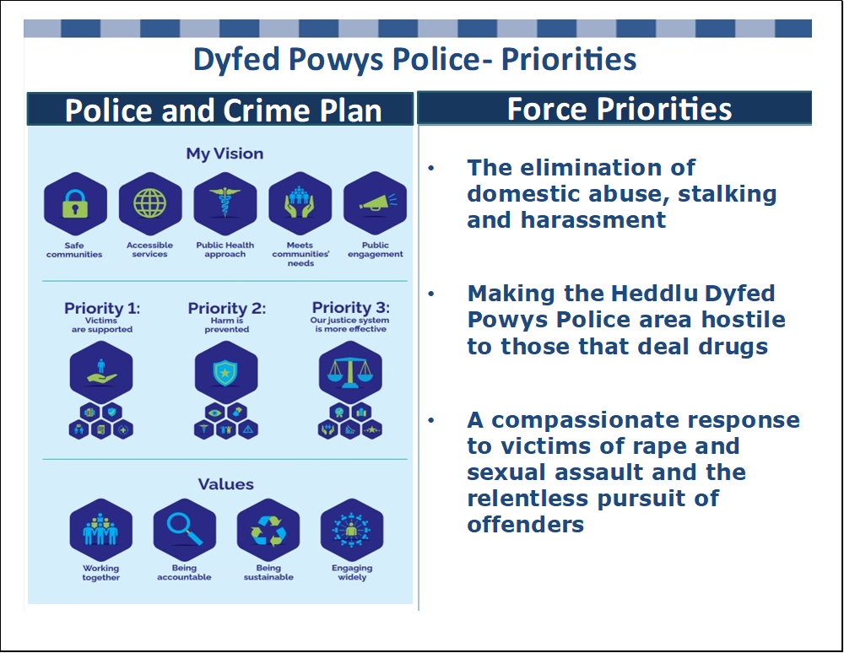

* 1. The Force’s organisational focus shifted during 2020-2023 from the Pandemic – which is now being managed as business as usual, towards the cost-of-living crisis affecting the public, the workforce and the costs of providing policing services.
  2. There has been a renewed Home Office focus and scrutiny of police performance, which is set to continue linked to the Beating Crime Plan, with significant work being undertaken on operational productivity and outcomes by the National Police Chief’s Council (NPCC). At a national level, the legitimacy of the Police Service is under scrutiny in relation to race and inclusion as well as violence against women and girls. It was important to consider the Policing role in the context of the ‘service of last resource’ in relation to the partnership landscape, particularly at a time of severe financial stress.
  3. Demand on the Force in terms of crime volumes had almost doubled since 2017, linked to new crime types such as stalking and harassment and changes in recording practices as depicted in the Table below. This is having an impact on both officer/staff workloads and wellbeing as they deal with higher levels of complexity, vulnerability and risk.

**Table 1 – Recorded Crime**

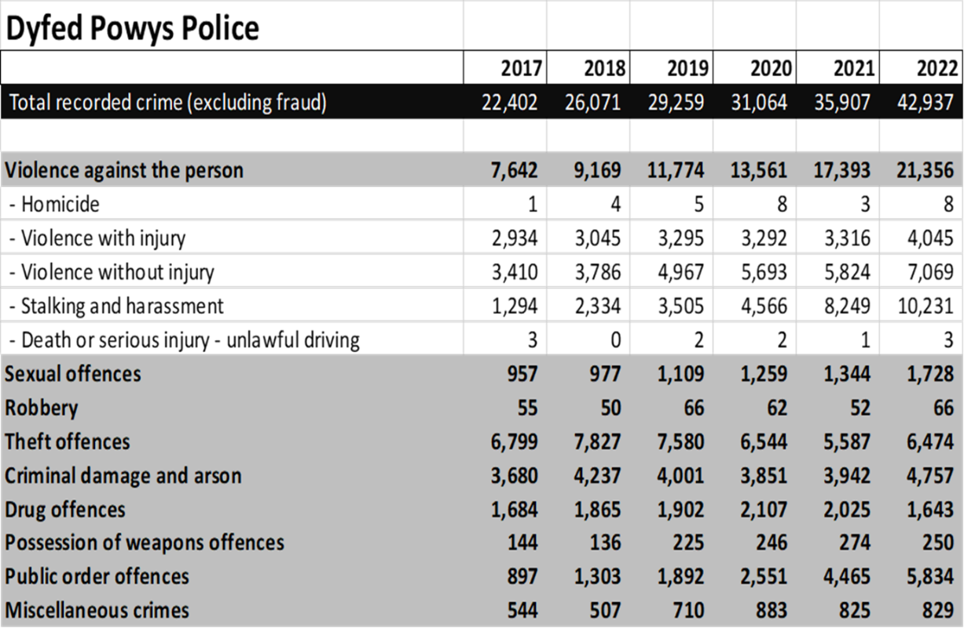

* 1. There have been notable successes in relation to positive His Majesty’s Inspectorate of Constabulary and Fire & Rescue Services (HMICFRS) feedback in relation to the Neighbourhood Policing structural changes, as well as changes linked to end-to-end crime processes. Significant efforts had been dedicated to meeting the funded uplift target of 137 police officers in Dyfed-Powys, as well as 15 additional Police Community Support Officers (PCSOs) funded by Welsh Government. The Force has also regained its Investors in People accreditation.
  2. The Force already has important and ambitious plans in place to invest in people, new technology and infrastructure. These include new custody facilities in Carmarthenshire and South Powys, a new Records Management System, Control Room telephony Infrastructure, Office 365, Crime Data Integrity, dealing with vulnerability, firearms training, performance scrutiny and social media capabilities. These investments are vital for the Force to be able to maintain a fit for purpose working environment and technology platform for the future.
  3. The Force has finalised its Force Management Statement for 2022 which identified key demand challenges across analytical capacity, future demand pressures linked to the cost-of-living crisis, infrastructure, non-reported demand, and training requirements which were being taken forward.

**Picture 2 – Force Management Statement**

|  |  |
| --- | --- |
| **Theme** | **Description** |
| Analytical Capacity | There are many areas of the business that don't currently have analytical capacity to carry out some of their demand management or reporting work on an internal and national level. The increase in data and digital data has meant that even some areas of the business that have not previously needed analytical capabilities now require them. |
| Cost of living /  Economic  Conditions | The force is currently being impacted by various cost of living / economic conditions. Current increase in the cost of living coupled with the significant number of very young officers on early pay points could cause issues in respect staff facing financial difficulties.  Demand within HDPP has increased due to the increasing number of asylum seekers placed within the area.  There is also currently a risk to the Estate and its efficiency in use and direct link to increasing Gas, Electricity and fuel prices. |
| Demand / Capacity | There are demand and capacity issues across the force whereby future demand is expected to outstrip current capacity. Work will need to be undertaken to determine if any streamlining of processes can assist in any situation where additional resources may not be possible. This is also true in some areas of current demand levels and the available capacity to deal with that demand. |
| Non-Human Assets | There is a lack of resilience in some of the equipment across the force which needs addressing. There are concerns in relation to the implementation of NicheRMS and the subsequent demand associated with this change. Other systems are outdated or are not fit for purpose. There are telephony issues where the supplier of our Emergency Telephony and Contact Management Solution are not able to deliver a working solution to the problems. Ageing estate and a lack of capacity for the efficient working of certain departments or storage facilities is also a concern. These areas are already being addressed. |
| Hidden Demand | The work undertaken by the Crime and Incident Hub remains unseen and unrecognised across local policing areas. This is a high risk to the force as it influences decision making regarding resourcing and policy. The impact of the Force Review is yet to be seen, this may have impact on demand and resources.  There may also be a risk that hidden harm is present in some of our communities but is not being reported to us. |
| Training | There is a lack of PIP2 accredited detective constables within force. Also, within force, we have six RPU officers who are not yet Tactical Pursuits and Containment (TPAC) trained. The delivery of NICHE is placing huge demand on Tutors, Assessors, Trainers (TATs) and reducing opportunity for Training Day delivery of other subjects. |

* 1. Despite an improving picture in terms of HMICFRS assessment, there is still a requirement for much key work to be delivered, to improve further.

**Picture 3 – HMICFRS Assessment**

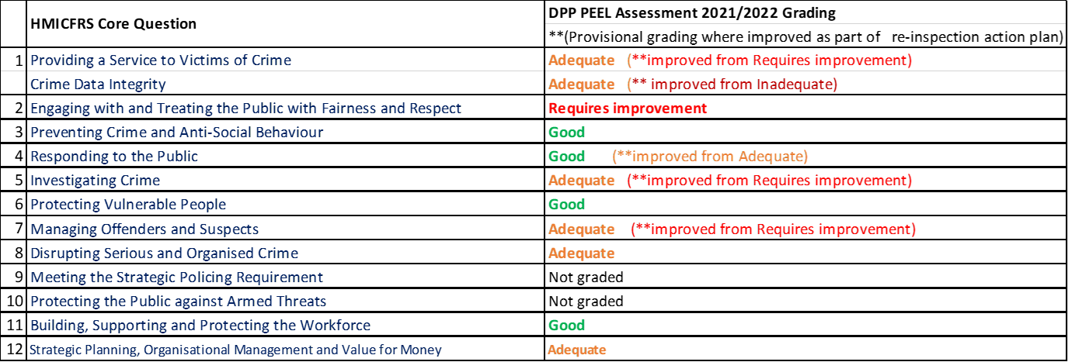

* 1. Both the Commissioner and Chief Constable recognise the severe impact that the cost-of-living crisis is having on the public, staff and budgets set against the challenging operational environment for staff and officers. The Force has a clear plan, priorities and outcomes to deliver, supported by clear governance arrangements and a delivery plan. The Force is continuing to improve and is working hard and making headway against the HMICFRS Assessment scores and against increasing demand levels.
  2. Given the cost-of-living crisis and its impact on baseline budgets, significant and difficult decisions have been taken to keep non-essential police staff vacancies unfilled. This creates increased workload and pressure on staff at a time of increasing demand. A Force Review Team has been working since June 2022, with a view to identifying cost and service reductions totalling £10m over 3 years – with around £5.9m of these scheduled to be delivered in 2023/24. Savings of this magnitude are far higher than those delivered previously and will be very challenging and risky to deliver in the current climate. There was a limit to the cost reductions that the Force can make safely, with an important balance needing to be struck between financial and operational risks.

**Picture 4 – Cost Reduction Plan**

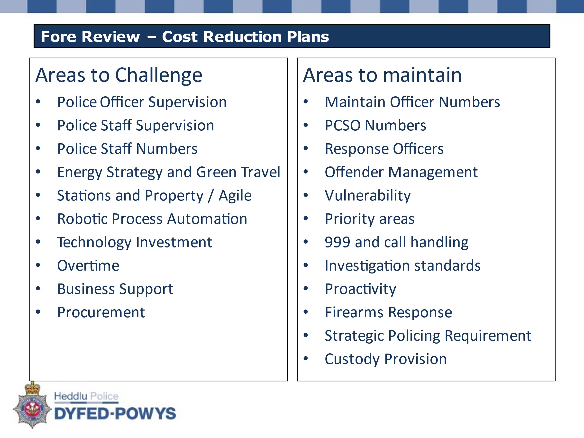

1. **Dyfed Powys Police – Funding Context and Police Precept**
   1. The financial challenges have been well documented, and the following graph sets out the context of grant funding since the Comprehensive Spending Review 2010 (CSR2010):

**Graph 1: Central Grant Reductions 2010/11 to 2026/27**

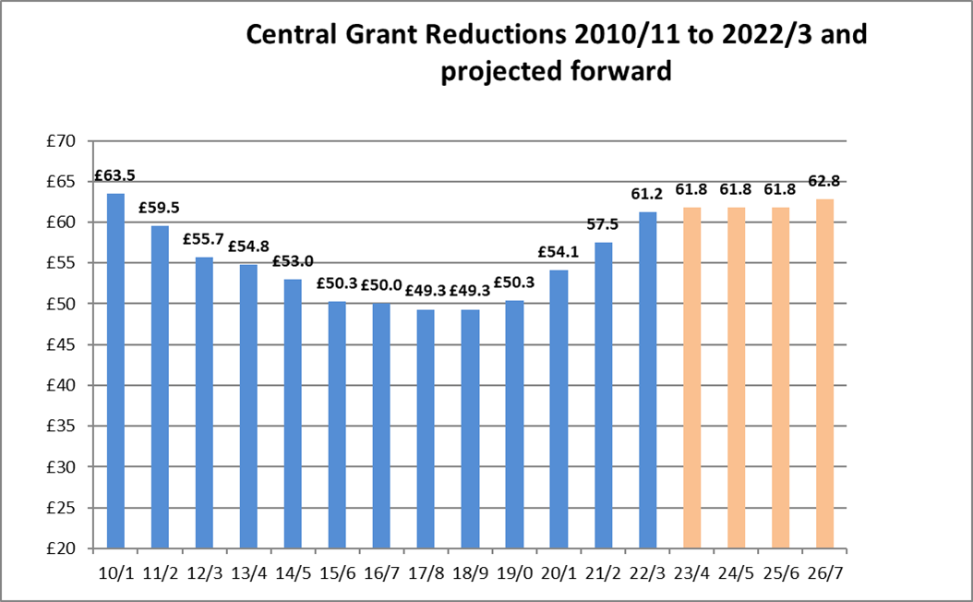

**£13m or 21%**

* 1. The real termreduction presented even greater challenges with inflationary increases needing to be offset by comprehensive efficiency/savings plans and reductions set against the landscape of changing and increased complexity of demand for policing services. It is also important to note that increases in police funding over more recent years have been to support the Police Uplift Programme which has come with very clear expectations, targets, and requirements for Police Officer recruitment.
  2. The following graph shows how the proportion of income that Dyfed-Powys Police receives from central sources compared with local sources, has changed over time:

**Graph 2: Proportion of Council Tax Precept to Central Government Funding %**

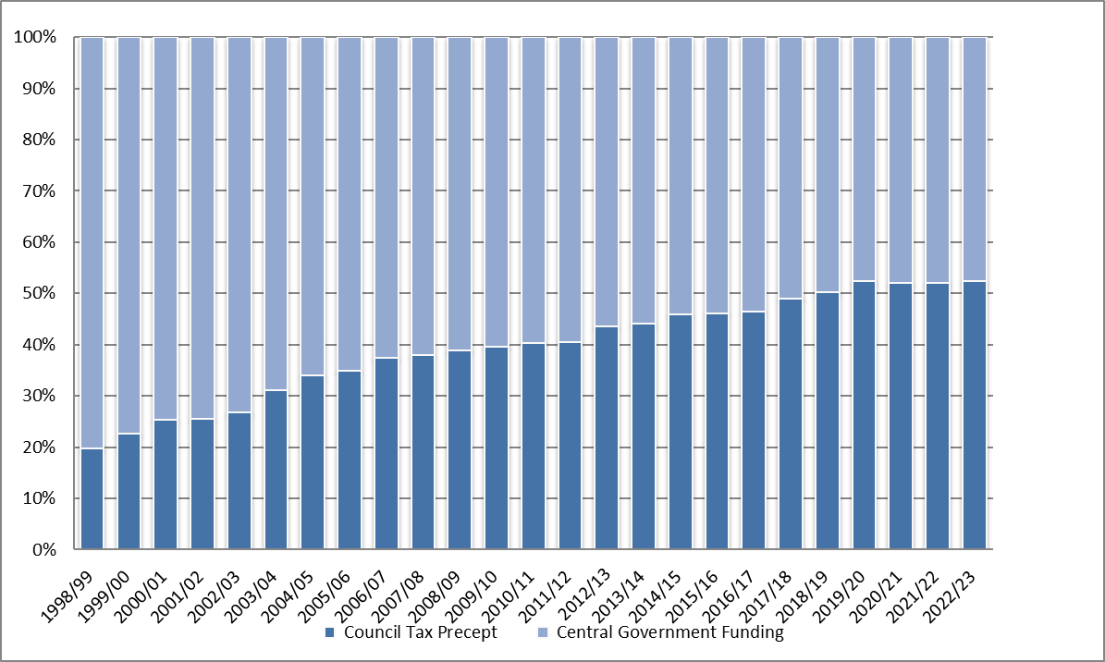

* 1. Historically, central government funding provided the vast majority of Dyfed-Powys Police’s funding, but the proportion received from core grants has decreased significantly over time. The percentage of funding being met through local taxation has risen significantly over time. The proportional split or ‘gearing’ trajectory is likely to continue to increase, as more funding is required to be met from the local taxpayer. It is also important to note again that core grant increases in recent years have been to support the Police Uplift Programme and have not met the array of other inflationary and cost burdens.
  2. The proportion of funding raised through council tax differs significantly between forces nationally. Northumbria’s Council Tax makes up 19% of their total funding, followed by West Midlands at 20.7% and Merseyside at 23%. Conversely, Surrey has 56% of their funding coming from Council tax, followed by Dyfed-Powys at 52% and North Wales at 51%. On average, 35% of budgets are made up from Council tax. English forces also benefit from Council Tax Freeze/Support Grants which clearly impact on historic precept levels, which generally mean that their precepts are lower.
  3. The following graph shows the amount of funding that Dyfed-Powys Police has received from both local and central sources over time:

**Graph 3: Council Tax Precept to Central Grant Funding £**

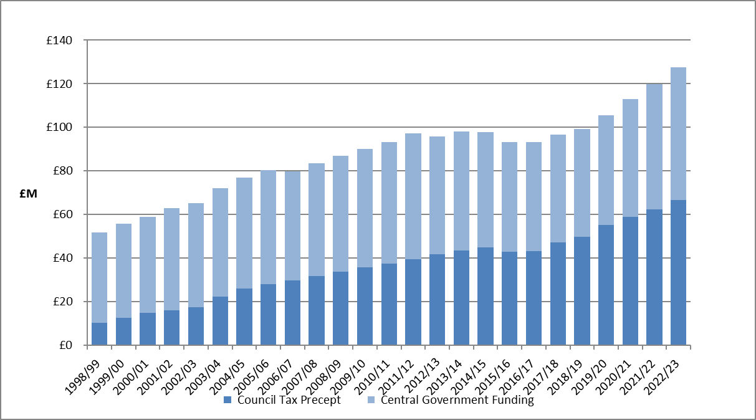

* 1. The following table shows that the core grant funding per head of population for Dyfed-Powys continues to be the lowest in Wales. If Dyfed-Powys was funded at the average level for Wales, this would equate to an additional £10.4m of core grant funding:

**Table 2: Core Grant Funding per head of population**



* 1. Residents in Dyfed-Powys have seen the twelfth lowest increase in Band D Police Precept since 2012/13 and the table below highlights the comparative position with most similar forces, and the other Welsh forces. It should be noted that English Forces also receive Council Tax Freeze/Support Grant which are not included in the below:

**Graph 4: National % Band D Precept Increase**

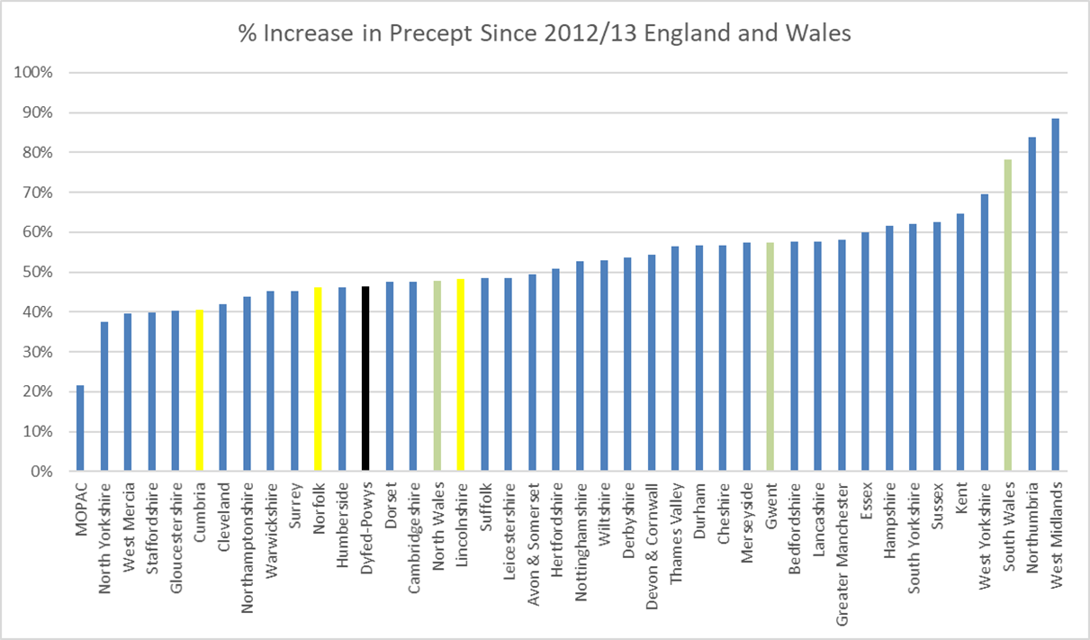

*Green – Welsh forces (MOPAC – Mayors Office of Policing & Crime - London)

* 1. Residents in Dyfed-Powys continue to have the lowest Police Precept in Wales. If Dyfed-Powys’ precept level was set at the average for Wales, this would equate to an additional £3.1m of funding.

**Table 3: Precept Levels Wales**



* 1. The year-on-year percentage change in precept levels for forces in Wales is shown in the following graph.

**Graph 5: Year on Year % changes in Precept across Wales**

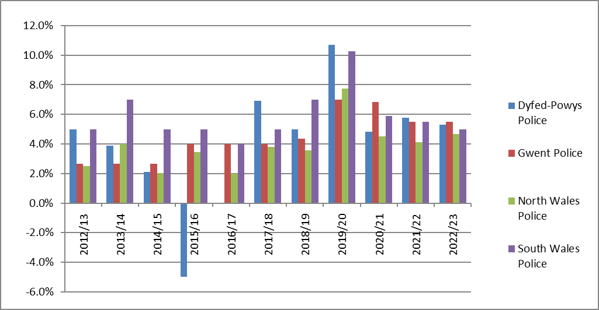

3.10 The following graph shows the change in precept levels for the forces in Wales since 2012/13. The previous decision by the first Police and Crime Commissioner to reduce the precept by 5% in 2015/16 and then not increase in 2016/17, has had a dramatic impact on the comparative trajectory as shown below and the legacy of these decisions continue to impact:

**Graph 6: Increases in Precept levels across** **Wales**

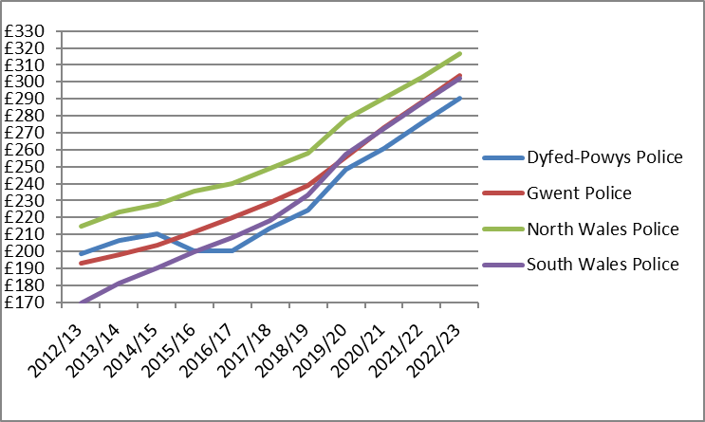

1. **Council Tax Base**
   1. The Police Precept which is raised through local Council Taxpayers is allocated to the billing councils, based on the relevant tax bases notified by them. The tax base is calculated from the number of properties in each area allocated to each property band with factors for single occupancy, empty homes, second home premiums and assumptions on collection rates within the context of economic and development factors. The tax base is expressed as a “Band D” equivalent as follows:

**Table 4: Tax Base Levels**



* 1. The Police Precept is added to the figures for the Unitary Authorities and forms part of the overall Council Tax demand bills.
  2. Under the regulations, the billing authority must determine a schedule of instalments for payments to precepting authorities. The agreement is that the Unitary Authorities will pay the Force in 12 instalments on or before the last working day of each month.
  3. It should also be noted that when announcing the police settlement, the Government makes assumptions regarding the tax base changes, using information provided by the Office of Budget Responsibility. For Wales a 0.5% increase was assumed, however the actual increase for Dyfed-Powys is slightly higher at 0.8%. For comparative context the assumed increase for England is 1.1%.

1. **Economic Context** 
   1. The Bank of England has forecast a "very challenging" two-year recession. A recession has been widely expected in the UK due to the prices of goods such as food, fuel, and energy soaring, which is down to several factors, including the war in Ukraine, with the Consumer Price Index (CPI) reaching 11.1% in October 2022.
   2. Chancellor Jeremy Hunt said he would try to make any recession *"shallower and quicker"* than predicted, but he has warned of *"eye-watering"* decisions needed on public spending and taxation to *"restore confidence and economic stability."* Mr Hunt said he was *"under no illusion that there is a tough road ahead"* with the worst cost-of-living crisis since the 1950s.
   3. The Chancellor announced the Autumn Statement on 17November 2022, which was accompanied by the Office of Budget Responsibility’s (OBR) Economic and Fiscal Outlook. The following graph is an extract from this report:

**Graph 7 – OBR Consumer Price Index (CPI)**

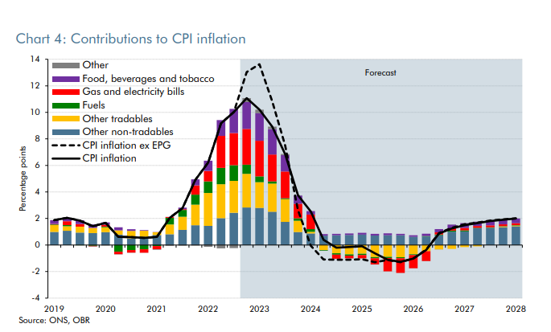

**\*** EPG – Energy Price Guarantee; ONS – Office of National Statistics

* 1. The National Police Chiefs Council (NPCC) released figures from a survey in October, which found that energy inflation was adding £100m a year to force deficits. The survey also found that there were additional cost pressures of £127m for service development and other contractual inflation. This led to a request for an additional funding to protect the service from inflationary pressures, but also raised the significant risk of future pay awards being higher than expected.
  2. There has been pressure across the public sector due to larger pay rises than expected during 2022/23. The Police sector were expecting a pay award of between 2% and 3%. However, in July the government announced that police officers will get a pay award of £1,900 at all pay points, worth around 5% when all ranks and pay scales are considered. After the announcement, Priti Patel, the then Home Secretary announced additional funding to help cover the increased pressure on budgets of £70m in 2022/23, £140m in 2023/24 and £140m in 2024/25. This did, however, assume that next year’s pay award would drop back down to previous assumption of what is believed to have been 2%.
  3. Worryingly however, the Minister of State for Crime & Policing stated in a letter sent to The Association of Police and Crime Commissioners (APCC) and NPCC that, *“PCCs should consider the pressures on their budgets, including the potential for a 2023-24 pay award above 2% next year, for which they should budget appropriately.”*

1. **Dyfed Powys Police - Financial Context**
   1. The Force faces a range of financial risks and opportunities over the short and medium term, that this budget proposal is looking to address as summarised in the chart below:

**Picture 5 – Financial Risk and Opportunity Balance Sheet**



* 1. The most immediate financial risk being faced is linked to pay award and inflationary pressures, which are significantly above budgeted levels in the current financial year. The OBRs forecasts shown in Graph 7, have been used as the main basis of inflationary decisions/assumptions and have been incorporated into this budget proposal.
  2. Given the highly volatile economic position, making assumptions on future pay, interest rate and non-pay inflationary increases are very challenging. In general, there is a significant gap between the inflation assumption included when setting the 2022/23 budget (generally at 3.25%) and the reality (currently at 10.1%) which needs to be considered. In addition, there will be a need to incorporate a pay award and inflationary assumptions for the 2023/24 financial year.
  3. Inflationary pressures of this magnitude have not been experienced for many decades. These affect all aspects of policing cost including pay, non-pay and capital programme works, which have all needed to be reviewed and updated, with the costs of utilities and fuel being of particular concern.
  4. The Force has already brought in a range of measures aimed at mitigating the impact of inflation challenges in the current year and indeed is aiming to deliver a planned underspend of £894k against its 2022/23 budget, to offset one-off budget pressures in 2023/24. This is being achieved by:
     + A reduction in transferees that were planned in Autumn 2022
     + Earmarking additional income received from mutual aid
     + Reducing training spending
     + Police staff vacancy management (80-100 Full-time equivalent [FTE])
     + Delays in implementing technology projects – Record Management System and Contact Management Solution
     + Additional scrutiny and authorisation of non-pay spending
     + Additional scrutiny and authorisation of overtime
     + Offsetting budget overspends and pressures from the increased pay awards, overtime, and bank holiday spending as well as insurance, fuel and general inflation and exchange rate fluctuations
     + Additional Home Office Grant of £495k to offset the pay award
  5. Other financial risks highlighted in the chart above include concerns around future grant funding linked to Police Community Support Officers (£3.4m) and the School Liaison Programme (£0.3m) as well as other specific grants and contributions totalling over £8m, which are funding an array of core policing activities including the Safety Camera Partnership, Ports policing and Victim Services.
  6. The Force is also experiencing crime volume increases, alongside associated increases in digital forensic and accreditation requirements across many of its functions, which is manifesting in additional overtime and staffing requirements to address.
  7. There is concern that the 2023/24 settlement announcement covered only a single year, with no information being made available on the potential impact of police pension revaluations likely to be implemented in 2024/25, formula funding impacts, nor the likely scale of the Public Sector financial consolidation mentioned in the Autumn Statement from 2024/25 onwards.
  8. The Force also faces financial penalties should it not maintain police officer and PCSO numbers, which restricts its ability to make savings through workforce modernisation or police officer reductions. Indeed, the bulk of future savings will have to be delivered from police staff and non-pay headings, partly by reverse modernisation.
  9. The Force is projected to employ 2,188 police officers, staff and PCSOs by the end of March 2023 – which is a likely peak given the scale of financial challenges it will face from 2023/24 onwards, as depicted in the chart below. The recruitment profile also means that around 19% of our projected 1,313 police officers will be in training.

**Picture 6– Workforce Summary**

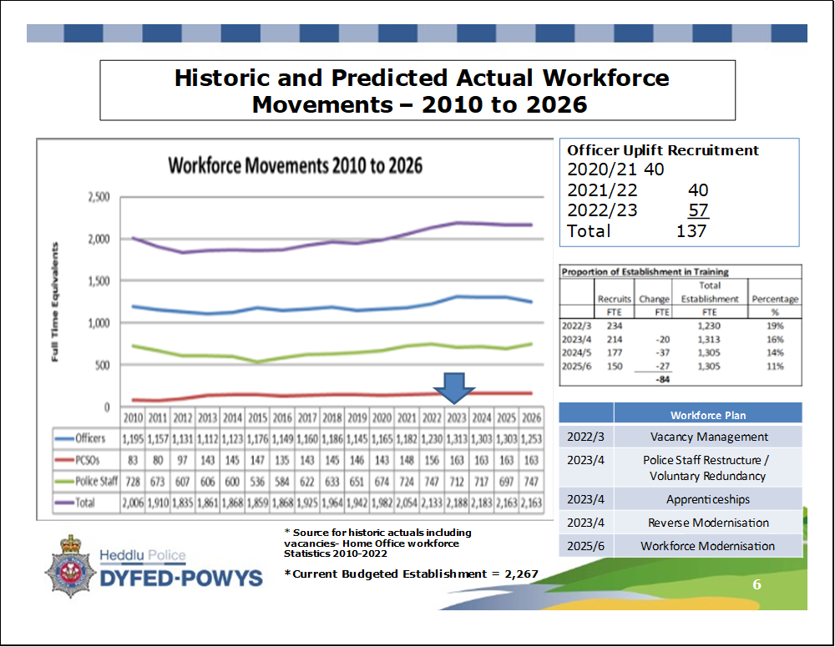

1. **2023/24 Police Funding Settlement and National Context**
   1. The 2023/24 Provisional Settlement was announced on 14th December 2022 in a written statement by the Crime and Policing Minister, Chris Philip. Full details of the Settlement can be found on the Home Office gov.uk pages. The Welsh Government also published information for the Welsh forces on their website.
   2. The Minister outlined expectations for policing to approach the 2023/24 financial year with a focus on the Government’s key priorities:

* Ensuring overall police officer numbers are maintained at the agreed Police Uplift baseline, plus force level allocations of the 20,000 additional officers.
* Deploying these additional officers to reduce crime and honour this Government’s commitment to keep the public safe.
* Delivering improvements in productivity and driving forward efficiencies, maximising the value of the Government’s investment.
  1. Assuming every force takes the full £15 precept, the total amount of extra funding available for forces is £523.4m. This is made up as follows:
  + £349m would come from council tax precept increase of £15
  + £100m as set out in the Spending Review 2021
  + £140m additional funding through ring-fenced grant for the Police Uplift Programme to support the costs of the 2022/23 police officer pay award
  + £70m reduction due to the reversal of the employer NI increase in relation to the Health & Social Care Levy.
  + £4.4m increase in adjustments to the council tax grants and precept grants.
  1. In 2023/24 the top slices total £1,114m, a £259.7m reduction over last year (£1,373.7m). The biggest changes to funding were an £83.2m decrease in Capital Reallocations and an £80m reduction in Police Technology Programmes. A number of top slices were also dropped, regrouped or had come to an end, including the Police Uplift Programme, Police Now, National Operational Policing Units, Police & Criminal Justice Service performance, Crime Reduction Programmes, Rape Review and Counter Terrorism.

**Table 5 Police Top Slice/ Reallocations**



* 1. Pensions Grant allocations remain unchanged from the figures given for the settlement in 2019/20.
  2. Council Tax Legacy Grants relating to Council Tax Freeze grants from 2011/12, 2013/14, 2014/15 and 2015/16 as well as Local Council Tax Support for funding, for English Force areas, remain separately identifiable in 2023/24.
  3. Capital Funding has been moved under the umbrella of reallocations and adjustments. Total Police Capital Funding is now worth £104.9m, down from £188.1m last year, a reduction of £83.2m. Capital funding grant allocations to Force areas no longer exists.

**Table 6 – National Police Capital Grant Allocations**



* 1. The Minister announced a total of £1,002.2m for Counter Terrorism (CT) policing in 2023/24. PCCs will be notified separately of force-level funding allocations for CT policing, which will not be made public for security reasons.
  2. The settlement also maintains an allocation of £2.4m to help to address the Welsh apprenticeship levy contribution, Dyfed-Powys will receive £0.3641m as a specific grant in 2023/24. Dialogue is still ongoing to seek to address the disparity between England and Wales, with the Home Office indicating that this may not be the final resolution to this issue.
  3. For Dyfed-Powys Police, the 2023/24 settlement is outlined in the table below:

**Table 7: Total Funding for 2023/24**



*RSG – Revenue Support Grant; NNDR – National Non-Domestic Rates

* 1. The settlement also sets out a number of expectations, to ensure that they make the best of public money. The Home Office (HO) expect to see at least £100 million of cashable savings as part of Spending Review 2021 (SR21). This should be achieved through the following:
  2. Working with BlueLight Commercial to maximise financial and commercial benefits related to procurement, through use of the organisation’s commercial expertise, leveraging the purchasing power available across the sector, and developing the capacity to implement a full commercial life-cycle approach to procurement.
  3. Corporate Functions, where the Home Office (HO) and BlueLight Commercial are conducting ongoing work with the sector to understand the opportunities around the management of corporate functions, for example, implementation of shared service models.
  4. The HO have commissioned the National Police Chief’s Council (NPCC) to conduct a review of operational productivity in Policing. It is expected that that the review will deliver clear, practical and deliverable recommendations to improve the productivity of policing.

1. **Wales Council Tax Capping/Referendum – Wales versus England**
   1. As outlined above the 2023/24 Provisional Settlement and headline figures assumed council tax precept flexibility of £15, without the need to call for a local referendum.
   2. Under devolution, the arrangements for Wales are that the power to determine capping levels on the council tax are administered by the Welsh Government.
   3. There are two forms of capping − designation and nomination. Welsh Government may designate or nominate an Authority for capping its precept, if in their opinion its budget requirement is excessive.

* Designation requires an Authority to reduce its budget requirement and re−bill the Council Taxpayers (through the Unitary Authorities).
* Nomination effectively puts an Authority on notice that Government will stipulate a budget limit for the following year. Welsh Government is responsible for determining the criteria (the principles) for capping for all Local Authorities and Police Forces in Wales. The principles must include a comparison between the calculated budget requirement with that calculated for a previous financial year. Ministers are free to include in the principles any other matters they consider relevant.
  1. Both the Commissioner and Chief Constable have maintained effective communications with both Minsters and Welsh Government through the Policing Partnership Board for Wales. The continued strengthening of the relationship of the Police Liaison Unit (PLU) has provided a valuable and additional opportunity to highlight the financial pressures and operational demands that are being faced by Dyfed-Powys Police and the wider police service in Wales.
  2. It is for locally accountable Commissioners to consult and take decisions on local precept, explaining to their electorate how additional investment will help deliver a better police service.
  3. The Government has announced flexibilities over the amount of precept that can be added to a bill without triggering a referendum (for England only) in recent years. 2018/19 saw the first significant increase with a £12 flexibility, this was followed by a £24 flexibility in 2019/20, a £10 flexibility for 2020/21 and £15 for 2021/22. The SR21 initially confirmed that for every year of the three-year Spending Review, PCCs would be given a £10 flexibility, however, due to the inflationary pressures facing forces, a £15 precept flexibility would be given for this year only.
  4. Assuming all forces take £15, the additional flexibility is worth around an extra £100m when compared to forces just taking £10. Assuming each PCC increases their precept by £15, combined with tax base growth assumptions of 1.106% for England and 0.5% for Wales, there will be an additional £349m of resources for policing from council tax alone.
  5. Due to historic differences in council tax, the proportion that £15 represents can vary significantly between force areas. The £15 increase means that Northumbria’s percentage increase is 9.75%, followed by the West Midlands at 8% and Essex at 6.86%. Conversely, £15 represents a 5.17% increase for Dyfed-Powys, 4.97% for South Wales, 4.94% for Gwent and 4.73% for North Wales. The impact of Council Tax Freeze/Support Grants in England clearly has impacted on historic precept levels, which generally mean that their precepts are lower.
  6. These inherent differences in both historic core grants and local precept decisions, mean that it is very difficult to draw meaningful comparisons between force areas.

1. **Budget Requirement for 2023/24 Force Review and Savings Plans**
   1. Work has continued in earnest during 2022 to further develop the budget setting process. This approach has seen Corporate Finance staff continuing to work closely with service managers and budget holders, to fully review baseline budgets and critically assess demand and cost pressures, whilst also seeking to identify efficiencies and savings linked to the Force Review.
   2. The relationship between in-year financial monitoring and budget setting has been strengthened. The aim of the process is to channel resources towards the delivery of key priorities whilst ensuring a clear link between the budget, MTFP and underpinning workforce and capital investment plans and requirements.

**Picture 7 – Financial Monitoring Setting (FMS) and MTFP Linkage**

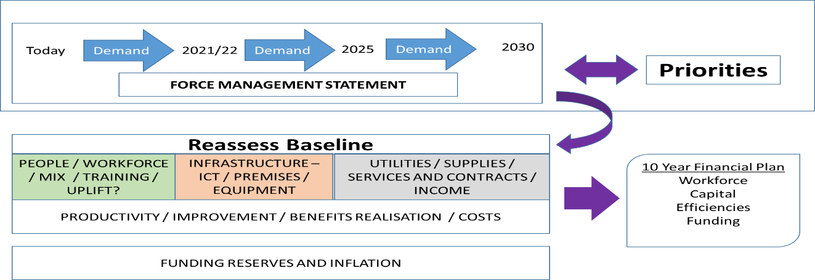

* 1. The Strategic Finance and MTFP Board within the formal governance structure has continued to oversee the development of this approach, with financial planning being a key focus for the Strategic Estates Group/Operational Estates Group, Information Technology (IT) Strategy Group and Fleet Strategy Group.
  2. The use of both The Chartered Institute of Public Finance and Accountancy (CIPFA) and HMICFRS Value for Money profile benchmarking data continues to develop, as this is seen as vital in helping to assess demand and value for money considerations. The following table provides some high-level benchmarking and comparator data for 2022/23. The data shows the significant impact that the Force’s geography has on spending, for example, custody, firearms, and traffic in comparison to others.

**Table 8- Police Objective Analysis Benchmarking Data**

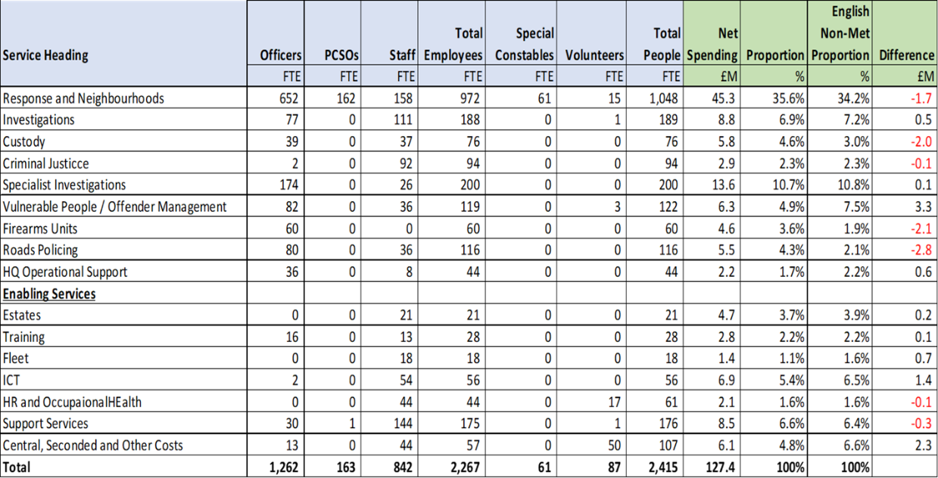

* 1. The starting point for the construction of the budget for 2023/24 has been to correct the pay and non-pay inflation assumptions that were made during the budget process for 2022/23. There is a need to update the baseline budgets, for the full-year unforeseen impact of the additional pay awards agreed during 2022 and inflationary pressures being experienced. The net effect of these increases is around £5.331m as shown below:

**Table 9 – Inflation Adjustments**

|  |  |  |  |  |
| --- | --- | --- | --- | --- |
| **Budget Heading** | **Budgeted %** | **Actual %** | **Difference %** | **Difference £m** |
| Police Officer Pay (£1,900 From Sept.) | 3.5 | 4.8 | +1.3 | +0.584 |
| Police Staff Pay (£1,900 From Sept.) | 3.5 | 6.8 | +3.3 | +0.783 |
| Police Officer Pensions | 2.5 | 3.1 | +0.6 | +0.011 |
| Electricity | 14.9 | 56.0 | +41.1 | +0.257 |
| Gas | 16.0 | 66.0 | +50.0 | +0.108 |
| Vehicle Fuel | 3.25 | 25.0 | +21.75 | +0.145 |
| Forensic Services | 3.25 | 20.0 | +16.75 | +0.096 |
| Insurance | 3.25 | 20.0 | +16.75 | +0.030 |
| General Inflation | 3.25 | 8.0 | +4.75 | +0.547 |
| **Total Inflation Correction** |  |  |  | **+2.561m** |
| Full Year Impact of Pay Awards |  |  |  | **+2.770m** |
| **Total Impact of 22/23 Inflation** |  |  |  | **5.331m** |

* 1. This unforeseen additional cost pressure of over £2.561m to correct pay and price inflation assumptions is a significant and unusual factor in the 2023/24 budget, caused by the War in Ukraine and other world events. The Office for Budget Responsibility (OBR) report warns that inflation will average 9.1% over the 2022 calendar year and 7.4% in 2023.
  2. As well as the inflation correction, the Force has numerous additional ‘standstill’ budget pressures that it must incorporate into its baseline budget. The Force needs to take account of the full-year impact of the 57 additional uplift police officers recruited in the 2022/23 financial year, on a part year basis. This adds a further £1.556m to baseline costs. Police officers and staff are also entitled to annual increments, which will add a further £0.644m in 2023/24 net of slippage that arises from people leaving the organisation. In addition, an error was made in the council tax base information for 2022/23 budget that resulted in a shortfall of £0.075m against the base budget that has been funded on a one-year basis from reserves, that will need to be corrected.
  3. There are also specific cost pressures related to the additional bank holiday (£0.120m), summer demand (£0.145m), firearms licensing income (£0.150m), forensics (£0.030m) and a reduction in school liaison grant support (£0.030m) which also needs to be incorporated into the standstill budget position.
  4. Assumptions on inflation and pay awards for the next financial year are extremely challenging to set. Electricity and Natural Gas purchases, which are bought in advance via the Crown Commercial Services framework, are reasonably certain and will see inflationary increases of 283% and 146% respectively from April next year. The pay award assumed for police officers and staff had been set at 3% initially. Non-Pay inflation was budgeted at 5.75% based upon initial assumptions. These have been reduced at risk to 2.75% and 5.25% respectively, predominantly to reduce the impact on the council taxpayer.
  5. Specific inflationary factors have been included for rates (+9%), fuel (+7.3%), rents (15%) and pensions (10.1%). No inflation has been included against specific grants. Inflation linked to the exchange rate fluctuations have also affected a small number of specific Information, Communication and Technology (ICT) and forensic headings that have added a further £0.139m to baseline standstill costs.

**Table 10 2023/24 Standstill Requirement**

|  |  |  |
| --- | --- | --- |
|  | **Budget Requirement £m** | **% NRE** |
| **Opening Budget 2022/23** | **127.445** |  |
| Inflation/Pay Correction for 22/23 baseline budget | 2.561 | 2.0% |
| Full Year Effect of Last Year Pay Award | 2.770 | 2.2% |
| Full Year Impact of Police Officer Uplift (57) | 1.556 | 1.2% |
| Officer and Staff Increments | 0.644 | 0.5% |
| Council Tax Base Adjustment | 0.075 | 0.1% |
| Bank Holiday/Summer Demand/Firearms Income etc. | 0.475 | 0.4% |
| General Specific Inflation 2023/24 (general/Gas/Electricity) | 3.245 | 2.5% |
| Part Year impact of Pay Awards (at 2.75% September 2023) | 1.818 | 1.4% |
| Specific Inflation – exchange rates/other factors | 0.108 | 0.1% |
| **Total Standstill Budget Increases** | **+13.252** | **10.4%** |
| Reduction in National Insurance – Social Care Levy | -1.073 | -0.8% |
| Reduction in Local Government Pension Contributions | -0.290 | -0.2% |
| Uplift Grant Increase | -0.992 | -0.8% |
| **Standstill Budget Position** | **+10.898** | **8.6%** |
| **Carry Forward Standstill Budget Position** | **£138.343** | **+8.6%** |

*NRE – Net Revenue Expenditure

* 1. The standstill position is mitigated to some extent by the reduction in National Insurance contributions of 1.25% (£-1.073m) and a reduction in the Local Government Pension Scheme Contribution of 1% (£-0.290m) following the latest valuation. The settlement also confirmed an increase of £-0.992m (to £1.947m) in the specific grant linked to maintaining police officer uplift numbers.
  2. In total, the cost pressures and fortuitous savings highlighted above mean an increase in standstill budget of 8.6% or £10.898m. Without further mitigation, this would have resulted in a council tax precept increase of £43.59 or 15.0% for the 2023/24 financial year.
  3. The Force have further committed to largely unavoidable cost pressures that will add to the budget requirement for 2023/24. These are listed in the Table below. The most significant of these relate to the new Carmarthenshire Custody facility, which will be opening early in the new financial year. There are service pressures and improvements that the Force is committed to make across property, performance, Digital Crime infrastructure, collaboration, and collaboration/accreditation that the Force needs to include in its budget requirement. These are linked to its strategic priorities.

**Table 11 Unavoidable Cost Pressures**

|  |  |  |
| --- | --- | --- |
|  | **Budget Requirement £m** | **% NRE** |
| **Budget 2023/24 carried forward** | **138.343** | **8.6%** |
| Estates and Capital Costs of new Carmarthenshire Custody | 1.103 | 0.9% |
| Property Storage and Performance System Investment | 0.220 | 0.2% |
| Crime Investigation and Demand Pressures (Staffing) | 0.609 | 0.4% |
| Collaboration – Forensics Accreditation and Programme | 0.146 | 0.1% |
| Digital Computer Crime System Charges | 0.123 | 0.1% |
| **Total Budget Increases** | **+2.201** | **1.7%** |
| **Carry Forward Budget Position** | **£140.544m** | **10.3%** |

* 1. Both the Commissioner and Chief Constable recognise that precept increases of this magnitude are unrealistic given the economic climate and the cost-of-living pressures being faced by the public and have been working since June 2022 on trying to mitigate the potential pressures. As outlined previously, the Force Review aims to save £10m over 3 years, with £5.9 million of this being targeted for delivery for the 2023/24 financial year. The Commissioner has also reduced or deferred some ICT spending which has enabled a reduction in Direct Revenue Financing contributions.
  2. In addition, as alluded to above, the Force is aiming to achieve a planned underspend of £0.894m in the current year which can be used to mitigate one off pressures and transient costs increases and energy price inflation. A summary of the impact of these measures is included below:

**Table 12 – 2023/24 Budget Requirement**

|  |  |  |
| --- | --- | --- |
|  | **Budget Requirement £m** | **% NRE** |
| **Carry Forward Budget Position** | **£140.544m** | **10.3%** |
| **UTILISATION OF RESERVES (£1.009M)** |  |  |
| 4 Bank Holiday costs from Reserves (11 days in 2023/24 to 7 days in 2024/25) | -0.290 | -0.2% |
| Energy Costs – Assumed Transitory from reserves | -0.424 | -0.3% |
| Chief Constables Reserve Utilisation – Summer Demand | -0.145 | -0.2% |
| Additional Contributions – Driver Retraining | -0.150 | -0.2% |
| **FORCE REVIEW COST/SERVICE REDUCTIONS (£6.206M)** |  |  |
| Reduction in Direct Revenue Financing | -0.057 | -0.0% |
| Commissioner’s Office and Commissioning | -0.162 | -0.1% |
| Force Review – Savings and Service Reductions | -5.902 | -4.6% |
| Force Review – Estimated Cost of Change | 1.482 | +1.2% |
| Force Review – Reserves to meet One-Off Costs | -1.482 | -1.2% |
| **Total Savings and Reserves Utilisation** | **-7.130** | **-5.6%** |
| **Total Net Budget Increases** | **+5.969** | **4.7%** |
| **Final Budget Requirement** | **£133.414m** | **+4.7%** |

* 1. The reduction in the budget requirement from £140.5m to the final budget requirement of £133.4m represents a net reduction of £7.1m from the utilisation of reserves and the Force Review. There are significant financial and operational risks inherent in terms of:
     + Reduction in services and police staff positions
     + Inflation risks in terms of pay and inflation assumptions and changes
     + Delivery risks in terms of the £5.9m Force Review Programme
     + Risks to the in-year spending position due to unforeseen pressures
     + Future risks in terms of further increases in borrowing costs or capital scheme costs, as well as inflation and pay awards
  2. The overall result of the settlement, budget required, savings plan and proposed precept has resulted in the following balanced budget being prepared. A fuller breakdown for 2023/24 to 2027/28 is provided in Appendix A.

**Table 13: Summary Budget Requirement and Funding 2023/24**



1. **Medium Term Budget & Outlook**
   1. Assumptions for the 2023/24 budget setting process have been challenging to make and attempting to project further forward for the future is even more challenging, given the array of financial and economic uncertainties.
   2. The one-year settlement for 2023/24 and absence of information for future settlement is concerning and makes decision making and medium-term forecasting almost impossible. As previously referenced, there are also some key financial uncertainties relating to police officer pension revaluation work that remains ongoing, as well as formula funding work and future impacts on specific grants which underpin an array of policing functions. The scale of future public spending consolidation from 2024/25 onwards is also unclear.
   3. Assumptions linked to our own cost base for capital and revenue are no easier to make given the scale of financial volatility being experienced globally. These include assumptions around future costs pressures linked to energy, fuel, pay awards and general inflation.
   4. The discipline of maintaining a Medium-Term Financial Plan (MTFP) that is based on a set of reasonable assumptions is, however, vital given the scale of financial challenges and financial risks inherent in setting a balanced budget and precept level for the 2023/24 financial year. Maintaining financial resilience over the medium-term is an important consideration – not just for next year, but into the future.
   5. It is expected that pay and price inflation will continue to exert pressure on the costs of providing policing services over the planning period of the MTFP and the following assumptions have been made in relation to these.
   6. Specific inflation is included for 2023/24 for gas, electricity and fuel etc. however a general rate of increase has been applied from 2024/25 onwards at this stage. The assumption on pay and price inflation are linked to the latest Office of Budget Responsibility (OBR) report, that predicted that high inflation was set to continue well into the 2023 calendar year and would reduce dramatically from 2024/25, before returning gradually to the Bank of England target rate from 2026/27 onwards.
   7. Risks have been assumed in the 2023/24 budget position, particularly relating to pay and non-pay inflation, with a pay award of 2.75% being budgeted for at a time when inflation will be expected to be running at around 7%. This follows Home Office guidance that the pay assumption should be higher than 2%. Assuming a generally higher pay and price increase level for 2024/25 than suggested by the current OBR forecast would be prudent for the current MTFP.

**Table 14 – MTFP Inflation Assumptions**

|  |  |  |  |  |  |
| --- | --- | --- | --- | --- | --- |
| **Budget Assumption %** | **23/24** | **24/25** | **25/26** | **26/27** | **27/28** |
| Police Officers | 2.75% | 1.75% | 1.5% | 1.5% | 1.5% |
| Police Staff | 2.75% | 1.75% | 1.5% | 1.5% | 1.5% |
| General Inflation | 5.25% | 0.50% | 1.0% | 2.0% | 2.0% |
| Pensions Increase | 10.1% | 0.50% | 1.0% | 2.0% | 2.0% |
| Electricity | 99.2% | 0.50% | 2.5% | 2.3% | 2.0% |
| Natural Gas | 217.0% | 0.50% | 2.5% | 2.3% | 2.0% |
| Rates | 9.0% | 0.50% | 1.0% | 2.0% | 2.0% |
| Rents | 15.0% | 0.50% | 1.0% | 2.0% | 2.0% |
| Fuel | 7.3% | 0.50% | 1.0% | 2.0% | 2.0% |

1. **Funding Settlement Assumptions and Formula Funding**
   1. The Medium-Term Financial Plan (MTFP) reflects flat cash settlements for 2024/25 and 2025/26 reflecting an array of potential risks. These include formula funding and public sector, the spending consolidation that was announced in the Autumn Statements.
   2. On formula funding, there is no basis on which to make an informed assumption at this stage. Using a figure for example, from the aborted exercise in 2016, would be unreliable. With changing crime types, our share of national crime now exceeds our formula share of 0.71% which was not the case in 2016. This was evident to our case which was presented to Members of Parliament (MPs) in July 2022. In addition, the Home Office has consulted recently on the additional costs of rurality and seasonality, which impact this Force substantially.

**Picture 8 Formula Funding – Key Facts 2016 v 2021**

**2021 2016**

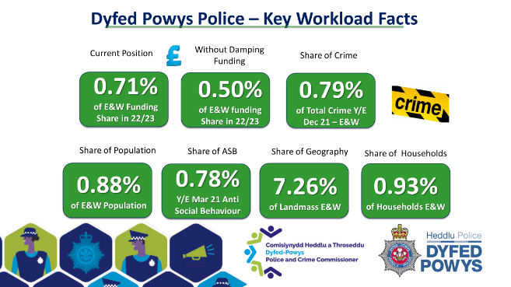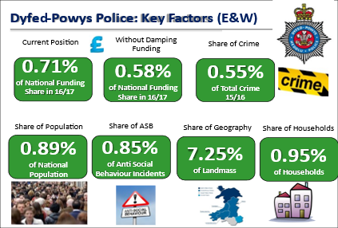

* 1. Despite the Home Office ambition to implement changes to the formula in the lifetime of this parliament, implementing formula funding changes in times of falling overall budgets will be extremely challenging. Exact timing (with an election in 2024) is still unclear and the Home Office is silent on any floors and ceilings or other protections that would apply. The interaction between uplift grant (£1.9m) and officer numbers etc. will be interesting in this context.
  2. It is believed that consultation on the approach and principles will be undertaken early in 2023. Given the scale of impact that the review of funding formula could have, both the Commissioner and Chief Constable have agreed to record this eventuality on the Strategic Risk Register. There is no doubt that any significant reductions in central grant funding would have serious implications on police services and the communities of Dyfed-Powys. A specific Gold Group would be established to develop sustainable plans for operational and organisational models to meet the potential scenarios.
  3. A similar medium-term concern is the Revaluation of Police Officer Pensions that is currently ongoing. This has the potential to significantly increase the 31% pension contribution that the Force currently pays into the pension fund (by as much as 20%). The percentage increase will depend upon the outcome of the Governments Actuary Department consultation on the appropriate discounting rate, which is unresolved at present.
  4. The revaluation will be affected by two factors. Firstly, the impact of the McCloud Sergeant remedy which extended protection for all officers from the impact of the career average salary scheme to all officers for a period of 10 years from 2012. This applies across most public sector pension schemes including fire, teachers, Local Government Pension Scheme (LGPS) and Health Service. Secondly, by the impact of general life expectancy, officer recruitment and general inflationary and pay award pressures that may be more scheme specific.
  5. Previous changes to pension contributions affecting the police pension schemes have been funded by Government. For this MTFP, it is assumed that an increase in contributions of £10.1m in 2024/25 is fully funded by Government in the form of an additional grant. This clearly is a risk, and the situation will be closely monitored over the coming months.
  6. For MTFP purposes, a flat cash for the settlement is assumed over the following 2 years - 24/25 and 25/26 with the additional cost of the pension revaluation being fully funded by Government. A forward precept assumption of 5% has also been incorporated at this stage. This may appear overly optimistic, however at this stage, there is limited information available on which to make a more informed impact assessment.

1. **Future Savings Plans/Force Review Assumptions**
   1. In addition to these increases in base costs, a cost and service reduction plan has been developed by the Force Review Team that aims to deliver savings amounting to £11.2m over the next five years. This is indicative at present, but a high-level summary of current plans is below:

**Table 15 – Savings Plan/ Force Review**

|  |  |  |  |  |  |  |
| --- | --- | --- | --- | --- | --- | --- |
| **Savings Plan/ Force Review** | **23/24** | **24/25** | **25/26** | **26/27** | **27/28** | **Total** |
| Non-Pay Reductions | -593 | -50 | -50 | -50 | -50 | **-793** |
| Direct Revenue Financing (DRF) to Capital Reduction | -600 | 0 | 0 | 0 | 0 | **-600** |
| Income Generation (Net) | -185 | 0 | 0 | 0 | 0 | **-185** |
| Police Staff Reductions | -3,000 | -741 | 0 | 0 | 0 | **-3,740** |
| Police Officer Savings | -429 | -166 | -195 | -195 | 0 | **-985** |
| Procurement Savings | -500 | -150 | -150 | -50 | -50 | **-900** |
| Premises Related | -430 | -300 | -200 | -200 | 0 | **-1,130** |
| Technology Related | -140 | -220 | -300 | -300 | -100 | **-1,060** |
| Fleet Related | -25 | -50 | -50 | 0 | 0 | **-125** |
| Workforce Modernisation | 0 | 0 | -875 | -875 | 0 | **-1,750** |
| Total | **-5,902** | **-1,677** | **-1,820** | **-1,670** | **-200** | **-11,269** |

* 1. As previously outlined, achievement of the savings plan carries inherent risk and this will require close management and oversight.
  2. The exact breakdown of this plan will need further work and consultation at this stage. There is a keen desire to protect police staff jobs where possible and minimise functions where police officers will be undertaking work that would more appropriately and economically delivered by police staff, although this does form part of the current plans costed above.

1. **Capital Investment Plans**
   1. Assets are vital to the delivery of efficient services and should be well managed and maintained. Strategies for Estates Management, Information, Communication and Technology (ICT) and Vehicle replacements underpin the Capital Strategy, in providing the details for the longevity and the optimum replacement cycles for these items.
   2. The Capital Programme and financing which covers the revised position for 2022/23 through to 2027/28 is summarised below:

**Table 16- Capital Programme 2022/23 – 2027/28**



* 1. Work has continued through the Strategic Finance and Medium-Term Financial Planning Group to consider and prioritise financial and investment requirements over a longer time frame. Whilst it contains several assumptions and uncertainties, the Capital Programme in Appendix G shows an extended projection covering a 10-year period. This programme will be revisited as clarity arises and annually, as part of the formal budget and precept setting.
  2. The draft capital programme requires total funding of £100.1m for 2022/23 to 2027/28 with £22.6m now being planned to be spent in 2022/23. For the current capital programme to be fully financed over the next five years, capital reserves will be depleted by the end of 2024/25.
  3. It is foreseen that external borrowing of £66.1m will be needed to fund the programme and the full debt charges associated with this have been built into future revenue budgets in this medium-term financial plan. Most of this borrowing will be linked to new assets and fund the building of a new station and custody facility for Carmarthenshire; provide a solution to the ageing police facility in Brecon, along with the new training facility for the Joint Firearms Unit. The cost of these three capital projects is currently expected to be in the region of £52.3m.
  4. Borrowing will also be required to support the extensive investment requirements in maintaining the estate and critical Information, Communication and Technology (ICT) infrastructure to support the effective delivery of policing services, as well as for cost saving sustainability schemes.

1. **Impact on Reserves**
   1. In accordance with the Home Office Financial Management Code of Practice (FMCoP), the Commissioner considers the role of reserves when compiling the MTFP and annual budget. The Commissioner, supported by his Chief Finance Officer (CFO), holds the responsibility for ensuring the adequacy of reserves each year so that unexpected demand-led pressures on the budget can be met, without adverse impact on the achievement of the key priorities.
   2. The FMCoP requires the Commissioner to establish a strategy on reserves in consultation with the Chief Constable. This Strategy is shown in Appendix D and details the approach for 2023/24 and beyond.
   3. In considering resilience and sustainability factors, the Commissioner keeps earmarked reserves under review, not only formally when completing the Statement of Accounts, but also during the year when considering in financial management reports and preparing the MTFP. These assessments and in-year financial position have allowed for some planned mitigation of one-off pressures and cost burdens to be met by reserves.
   4. As part of the proactive steps taken during the year by both the Commissioner and Chief Constable, it is anticipated that the in-year financial position should allow for some mitigation of one-off pressures in the next financial year, as well as the creation of a reserve to mitigate against additional inflationary pressures.
   5. A detailed financial model has been built that incorporates the various forward projections and assumptions with prudent financial management and financial resilience in mind. The following table provides a summary position with further detail provided in Appendix E.

**Table 18 – Reserves Projections 2022/23 to 2027/28**



* 1. The general reserve is maintained at £4.032m over the course of the MTFP period, which sees overall reserves available for utilisation by the Commissioner fall from £19.502m in March 2022 to £5.772m by 2028. In terms of financial resilience, the existence of reserves built up in recent years has been fundamental in the Commissioner being able to fund cost pressures and make savings that are needed to balance budgets in 2023/24.

1. **Medium-Term Financial Plan Summary** 
   1. Based on the assumptions detailed above, a summarised revenue budget position covering the period April 2022 to March 2028 is shown in Appendix A, with a variation statement showing the main additions and deletions from the budget for each year detailed below:

**Table 19 – MTFP 2023/24 to 2027/28**

* 1. Although a balanced budget is presented for future years, it is important to recognise that a significant efficiency plan is reflected and note the risks regarding uncertainties around inflation, pension increases and the formula funding review.
  2. It is also worth highlighting the potential conflict and dichotomy that may arise from future requirements in meeting the Government’s future expectations that Police Officer numbers will be maintained, as this may inhibit optimal organisational resource planning.
  3. It must be noted that the current financial position has dented financial resilience and the Force has a significant cost and service reduction plan to implement. There are significant potential financial challenges that lay ahead, and the budget and Medium-Term Financial Plan presented seeks to strike a balance between the immediate pressures being felt by the public and the Force, set against a very uncertain and unpredictable future.

1. **Section 25 and Budgetary Risk**
   1. Section 25 of the Local Government Act 2003 requires that the Chief Finance Officer (CFO) report to the Commissioner, at the time the budget is being set, on the risks and uncertainties that might require more to be spent on the service than planned, and the adequacy of financial reserves. This report is shown in Appendix B.
   2. Allowance is made for these risks by:

* making prudent allowance in the estimates; and in addition
* ensuring that there are adequate reserves to draw on if the service estimates turn out to be insufficient.
  1. It is important that budgetary risk has been minimised when the budget is set. The level of budgetary risk must be formally considered by the Commissioner informed by the advice and judgement of their CFO.
  2. Appendix C also outlines a risk impact assessment across various budget headings and based on the percentage of the net revenue budget and the known factors, which could influence levels of actual expenditure or income.

1. **Public Consultation and Opinion**
   1. On the 1st December 2022, the Commissioner launched a public consultation on the police precept for 2023/24.  It was important to the Commissioner that he sought the views of the public and the Dyfed-Powys Police workforce.  He urged all to voice their opinion on this critical issue, to ensure that as a Police Force, Dyfed-Powys Police can continue to safeguard its communities with the highest standard of service available.
   2. To assist the public in providing their views, a survey was created and promoted widely. A total of 1,418 people responded to the consultation.  Of the 1,418, a total of 1,290 respondents noted that they were a resident or business tax-payer in Dyfed-Powys. Of these 1,290 respondents, a total of 1,194 answered the following question on the precept level:

*How much more would you be prepared to pay each month through the police precept to support the delivery of your local policing service? (Please note that percentages are by reference to a Band D council tax property.)*

**Table 20 Public Consultation Responses**

|  |  |  |
| --- | --- | --- |
| Option | Number | Percentage |
| **5%** (£14.51 per year/£1.21 per month). This would leave Dyfed-Powys Police with a funding shortfall of £3.3m but assumes a savings/efficiency plan of £5.9m. | 234 | 19.6% |
| **7.5%** (£21.76 per year/£1.81 per month). This would leave Dyfed-Powys Police with a funding shortfall of £1.6m but assumes a savings/efficiency plan of £5.9m. | 146 | 12.2% |
| **9.9%** (£28.60 per year/£2.38 per month). This would leave Dyfed-Powys Police with no shortfall in funding but assumes a savings/efficiency plan of £5.9m. | 185 | 15.5% |
| **12.5%** (£36.27 per year/£3.02 per month) This would leave Dyfed-Powys Police with no shortfall in funding but would also reduce the savings/efficiency plan by £1.8m to £4.1m. | 238 | 19.9% |
| None of the above | 391 | 32.8% |

* 1. It was pleasing to see the significant increase in responses to this year’s consultation and important to highlight that 47.7% of responses supported between 7.5% and 12.5% increase in Band D precept.

1. **Conclusion**
   1. As outlined in the Commissioner’s summary, given the historic funding decisions and scale of the financial challenges and operational risks that both Dyfed-Powys Police and the wider police service face, it is vital to secure a Police Precept which will safeguard policing and support the continued delivery of the priorities set out in the Police and Crime Plan in both a sustainable, but prudent manner.
   2. The above report sets out the array of internal and external factors and considerations, which have informed the development of the MTFP.
   3. The Commissioner submits a precept proposal for 2023/24 and assumptions that underpin the MTFP to 2026/27, which will seek to raise the average band D property precept by £1.87 per month or £22.49 per annum to **£312.65, a 7.75%** increase. This increase will raise a total precept of £72.518m. This will provide a total of core central and local funding of £133.414m representing a 4.68% increase on funding levels in 2022/23.
   4. The impact of this Police Precept on each property banding are shown below:

**Table 21 - Council Tax Bandings**



18.5 After taking account of the comprehensive and ambitious savings plan, this level of funding will seek to allow the Force to continue to deliver their operational and strategic plans continuing to positively impact the standards of service that the public can expect, but the financial landscape remains both uncertain and challenging which is an inherent risk. This will continue to be an area of focus for strategic planning.



1. Section 25 of the Local Government Act 2003 requires that the Chief Finance Officer (CFO) report to the Commissioner, at the time the budget is being set on the following matters:

* the robustness of the estimates made for the purposes of calculations;
* and the adequacy of the proposed financial reserves.

1. Both the Commissioner and Police & Crime Panel (P&CP) are required to have regard to this report when considering and making decisions in connection with the budget.
2. As we know, the last few years have been unprecedented for a variety of reasons, but 2022/23 has unfortunately continued in this vain with a weakening economy, higher interest rates and soaring inflation. The impacts of the cost-of-living crisis are far reaching and are also set against the backdrop of Brexit and the Covid-19 Pandemic. The impact of these will undoubtedly have significant implications for public services and future government funding.
3. Detailed discussions have been ongoing throughout 2022/23 in relation to in-year financial management and the MTFP. These have taken place within both an informal setting between myself and the Director of Finance (DoF), within a formal Force and Office of the Police and Crime Commissioner (OPCC) governance structure, as well as the series of Budget and MTFP meetings between the Commissioner, Chief Constable, DoF and myself.
4. Having recognised the extent of the future financial challenges, the Chief Constable issued a Force Bulletin on the 30th June 2022 which formally announced the initiation of a Force Review Team. Importantly, the Chief Constable also took a range of early steps to proactively contain expenditure within 2022/23, which could then mitigate financial burdens as well as assisting in meeting one-off cost pressures.
5. In recognising the financial challenges, the Force have identified a large and ambitious savings plan for 2023/24 and beyond. It is important to note that this is far greater than those achieved in any previous period, including operation Sage, Public First and Spending Wisely. The savings plan is underpinned by detailed assumptions which have been transparently set out, but as work and consultations progress, a number of these will take time to crystalise to gain absolute financial clarity. The consequential impacts, implications and inherent operational and organisational risks will require close oversight. It is recognised that efficiencies are proving harder to achieve and the constraints of the Uplift Programme are likely to inhibit the optimal resource mix for the Force.
6. The proposed budgets that have been presented during the year are based on a comprehensive line-by-line assessment of inflation assumptions. To inform the assumptions both the DoF and I have taken cognisance of a wide range of financial and economic data, including the very comprehensive report issued by the Office of Budget Responsibility (OBR) as well as continuing to engage closely with professional networks.
7. The Chief Constable has transparently set out his Budget Requirement at each stage and has documented the changes as they have materialised or crystalised during this period. It must be recognised that a considerable number of assumptions and estimates are used to construct the budget requirement. This is not and cannot be an exact science, and variations will be inevitable.
8. Although the MTFP has sought to make proper provision for realistic pay and price increases, and achievable levels of income, it must be recognised that there is climate of risk due to complexity of issues that are currently at play.
9. Whilst additional grant has been allocated on a recurring basis to assist in meeting the £1,900 pay award which was awarded during 2022/23, the settlement does not take into account any exceptional inflationary pressures that are being incurred. The Home Secretary and Minister’s letter of 14th December 2022 also states that *“PCCs should consider the pressures on their budgets, including the potential for a 2023-24 pay award above 2% next year, for which they should budget appropriately.”* The Home Office do not formally share the basis of their assumptions, although have indicated previously that they have used 2%. Clearly with such a large proportion of the expenditure budget circa75% being spent on pay, any variance between assumed and actual pay awards can have huge ramifications. For scale and sensitivity purposes, a 1% variation would have a part year effect of £630k (award from September).
10. Our planning assumptions began with a pay award of 3% from September 2023 and 5.75% for general inflation for 2023/24. However, given the wider financial challenge and in order to mitigate the impact on local taxpayers, we have taken a risk-based approach with an assumption of 2.75% which equates to a £115k reduction in the budget requirement for 23/24, along with a reduced assumption on general inflation of 5.25% which would see a budget reduction of £158k. Clearly these assumptions carry inherent risk, which we will seek to partially mitigate by establishing an earmarked reserve through the in-year position or through reclassification. Any differentials between assumptions and actual pay award would also need to be considered in the longer term.
11. There are still a number of wider risks over the MTFP with uncertainties around the impacts of pension remedy, formula funding review, potential pressures and reductions in specific grants, and one year funding settlements with no certainty over the future. We also do not have certainty over a number of more local issues.
12. Reserve levels are considered in the context of risk, which comply with The Chartered Institute of Public Finance and Accountancy (CIPFA) guidelines, which state that “*in order to assess the adequacy of unallocated general reserves….take account of the strategic, operational and financial risks facing the authority*.”
13. The adequacy of general reserves needs to be closely monitored to ensure that it is maintained at a sustainable level. The assumed profile of funding and cost of services within the MTFP sees a reduction of General Reserves falling from 3.16% of Net Revenue Expenditure at the end of 2022/23, to 2.5% by the end of 2027/28. This reduction is due to the increases in the net revenue budget rather than the utilisation with general reserves remaining at £4.032M. These levels assume that there are no calls on general reserves to meet unforeseen financial burdens. It is vital and prudent that this balance is maintained to allow for unforeseen burdens and operational requirements. It is also important to note that even in a scenario where there may be eligibility for a Special Grant, costs up to the equivalent of 1% of net revenue budget (£1.331M for 2023/24) would ordinarily need to be met locally.
14. Ongoing review and consideration are given to earmarked reserves to assist in meeting particular initiatives or to mitigate against specific risks. In preparing the MTFP, consideration has been given to the anticipated in-year financial monitoring and a number of movements have been proposed to the Commissioner to assist in mitigating one-off pressures, but this will not be finalised until the year end.
15. Despite the assumed increases in council tax precept, there will be a need for continued savings/efficiency requirements over the term of the MTFP and the uncertainties around future core and specific grant funding, complexities in relation to pensions costs set against the wider economic landscape, mean that the financial environment is likely to remain challenging for the foreseeable future.
16. I am content that the MTFP has fully considered and documented the array of known issues and assumptions which impact over the period of the planning period to produce a balanced budget for 2023/24. I can confirm that the revenue and capital estimates contained in this MTFP are considered robust and that the level of reserves is considered adequate. Dyfed-Powys will however continue to face financial challenges and there is a need for continued focus to ensure financial resilience and sustainability to protect the communities of Dyfed-Powys.

**Beverley Peatling**

**Chief Finance Officer (CFO) to the Police and Crime Commissioner for Dyfed-Powys**

| **Budget area** | **% of net costs** | **Risk level** | **Identified Risk** | **Mitigating factor** |
| --- | --- | --- | --- | --- |
| Police Officer Salary Costs and Pensions | 62.8% | High | The impact of the 2022/23 pay award has seen significant financial implications and despite additional grant funding being received in the 2023/24 settlement (via ring-fenced specific grant for Police Uplift), there are concerns and risks associated with future pay awards. In a letter from the Home Secretary dated 14th December 2022, Commissioners were advised to plan for future pay awards in excess of 2%. The uncertainty and pressures within the wider economic landscape could result in additional unavoidable pay pressures which would need to be funded and therefore could impact on service delivery. Assumptions have been made in relation to future pay awards, but until finalised they remain uncertain and therefore a risk.  Increased financial impact as a consequence of an earlier timing of the pay award.  Overtime incurred on major incidents/operations/investigations is not controlled and monitored and therefore exceeds the budget.  The number of officers in post increases above the approved funded establishment.  The full ongoing costs of Operation Uplift will not be fully funded by the Government Grant.  This budget is very sensitive to changes in police officer numbers and the complexities in managing retirements, ill-health retirements, retention, recruitment of new recruits, as well as meeting requirements attached to the Police Uplift programme.  Government expectations and conditions of the grant to support Operation Uplift will contradict and hinder the force in its transformation and ability to meet future efficiency and saving requirements.  Additional specific grant funding was received to assist in mitigating the impact of the 2018 pensions valuation direction, but there is no certainty of the continuation of this grant.  Future changes in pension’s valuations remain a risk.  In addition to this, there are considerable uncertainties in relation to the financial implications of the Supreme Court’s judgement in relation to the McCloud/ Sergeant case, which found unlawful age discrimination. The government accepted that this judgement applied to all the main public sector pension schemes, including Police. The full extent of the financial implications is still not known, but there are indications that this could see employer’s contribution rates increasing to up to circa 40% with no guarantee of additional grant funding. | The assumptions around pay awards are based upon an array of financial and economic information which is reviewed on an ongoing basis.  There is tight financial control and management of overtime, both by budget holders and the Force Resource Group, with continued strengthening of financial reporting and management information. Budget holders are well aware of the financial challenges and their responsibilities for prudent financial management, with a strong ethos and awareness of the need for financial control.  A Chief Constable Contingency Fund was established to ease the peaks and troughs of major and critical incidents.  Finance representation on all gold groups and other operational investigation groups occurs as a matter of course. This enables overtime and other costs to be closely monitored at each meeting, with timely reporting facilitating decision making.  The establishment is monitored through formal governance and in detail by the Force Resource Group.  People Services as a recruitment plan for the year ahead based on the projected number of police officer retirements, leavers, transferees, and additional officers as part of the Police Uplift Programme. The required intake of probationers is planned and allocated accordingly, with a strengthening of arrangements to ensure that the Home Office targets are met, with additional reporting to the Home Office throughout the year.  Representations to the Home Office through respective groups in relation to the wider implications and perhaps unintended consequences of Operation Uplift, despite the headline announcements within the three-year funding settlement.  The pay budgets are continually monitored as part of the budgetary control process, with formal reporting throughout the governance structure. Financial performance is discussed regularly by the Commissioner and Chief Constable at Policing Board, Policing Accountability Board and within dedicated Finance Seminars with both the Police & Crime Panel (P&CP), Joint Audit Committee and Audit Wales. Financial matters are also covered in the Finance and Strategy Board, Strategic Finance and Procurement Group and MTFP Group.  Representations continue in relation to the complex pension’s issues with a dedicated team within The National Police Chiefs Council (NPCC). Historically major changes which have significant financial implications have been funded through the Home Office and then factored into subsequent actuarial reviews. |
| Police Staff Salary Costs (including Police Community Support Officers [PCSO’s]) | 28.9% | High | The impact of the 2022/23 pay award has seen significant financial implications and despite additional grant funding being received in the 2023/24 settlement (via ring-fenced specific grant for Police Uplift), there are concerns and risks associated with future pay awards. In a letter from the Home Secretary dated 14th December 2022, Commissioners were advised to plan for future pay awards in excess of 2%. The uncertainty and pressures within the wider economic landscape could result in additional unavoidable pay pressures which would need to be funded and therefore could impact on service delivery. Assumptions have been made in relation to future pay awards but until finalised they remain uncertain and therefore a risk.  The number of staff in post increases above the approved funded establishment.  Projects requiring staff involvement outside of normal working hours are accurately costed for, additional costs such as overtime etc.  Organisational and operational risk associated with the extent of Police Staff related savings as part of the Force Review and 2023/24 Savings Plan.  Funding for PCSOs is reduced or ceased, which is an increased risk given the wider economic and financial pressures. | The assumptions around pay awards are based upon an array of financial and economic information which is reviewed on an ongoing basis.  The establishment is monitored through formal governance and in detail by the Resource Management Board. A Gateway process has been established to monitor and control all changes to establishment and indeed all posts are reviewed and considered fully before being advertised.  The pay budgets are continually monitored as part of the budgetary control process, with formal reporting throughout the governance structure. Financial performance is discussed regularly by the Commissioner and Chief Constable at Policing Board, Police Accountability Board and within dedicated Finance Seminars with both the Police & Crime Panel (P&CP), Joint Audit Committee and Audit Wales. Financial matters are also covered in the Finance and Strategy Board.  Representations to Welsh Government will continue to seek certainty over future funding to support PCSOs. |
| Indirect Staff Costs | 2.7% | Medium | These might increase above budget.  Insurance costs significantly increase due to pressures within the Bluelight arena.  Costs of training/Policing Education Qualifications Framework (PEQF) increase and uncertainties continue in relation to longer term funding arrangements of the Apprenticeship levy. | Training budgets have been set to reflect operationally critical requirements. Budgets are monitored on a monthly basis and a Training Prioritisation Group considers training priorities before training is delivered.  The Commissioner and Chief Constable continue to discuss and monitor training requirements at Policing Board.  Although funding continues to be received, discussions will continue with the Home Office in relation to a final solution for funding to support PEQF.  Insurance pressures have been recognised within the budget and a reserve has been created to mitigate against insurance related exposure. |
| Premises Costs | 5.0% | Red | Despite a programme of work to address the condition of the estate and maintenance backlogs, increased revenue costs may be required to ensure that the estate is maintained as a safe working environment for staff and officers.  Increasing electricity and gas costs as a result of significant pressures and market conditions and more extreme weather conditions. | The estates requirements of the capital programme are considered as part of Medium-Term Financial Strategy and annual budget setting process and have been subject to specific review by the Finance and Strategy Board.  There has been a strengthening of governance arrangements around Estates during late 2021. The Strategic Estates Group brings together key staff from the Commissioner’s office and the Force to meet monthly to discuss estates matters including finances. Considerable work has been undertaken by this group to develop a risk-based prioritisation methodology for maintenance works. Matters are escalated to the Finance and Strategy Board, which is chaired by the Deputy Chief Constable.  National negotiation of energy contracts through Bluelight Commercial.  Review of energy utilisation to seek efficiencies and ‘invest to save’ opportunities.  Submission of grant application in relation to funding for sustainability initiatives.  The Sustainability Group will consider further opportunities and oversee the Sustainability and Transformation Reserve. |
| Transport Costs | 1.9% | Medium | Although there are planned changes to the fleet size, the costs of fuel are prone to significant market fluctuation which could increase in running costs.  Market conditions continue to be challenging as a consequence of world events and economic landscape. | The fleet requirements of capital programme are considered as part of the Medium-Term Financial Strategy and annual budget setting process and has been subject to specific review by the Finance and Strategy Board.  The Strategic Vehicle Group meets to discuss the vehicle fleet – the group is chaired by the Director of Finance (DoF) with matters being escalated to the Finance and Strategy Board.  Fuel prices are monitored and their impact regularly assessed through the robust budget monitoring procedures that are in place.  Telematics data is allowing the Force to monitor vehicle usage and optimise the size of the fleet.  The capital programme includes provision for the continued adoption of electric vehicles, which will reap efficiencies and savings.  Market conditions continue to be monitored at a local, regional and national level. |
| Supplies and Services and Commissioning | 11.9% | High | Nonpurchase orders could result in overspends against the budget.  Market conditions continue to be challenging as a consequence of world events and economic landscape. | Purchase orders are processed with a built-in budget check for high value items.  The Procurement Department ensure that the procurement of goods and services are made in accordance with Financial Regulations and Procedures.  Robust budget monitoring procedures are in place and adhered to.  The establishment of BlueLight Commercial continues to facilitate and reap some national, regional and local savings. The Force is fully engaged in the work. |
| Agency & Contracted Services and Commissioning | 3.0% | Medium | Additional and increasing costs arising from the collaboration arrangements – specifically the Regional Organised Crime Unit (ROCU), Joint Firearms Unit (JFU) and its training facility.  Continued pressures and impacts of inflationary increases within Commissioned Services could impact on service delivery. | Work has been ongoing to strengthen the governance and financial management arrangements surrounding collaboration with improved reporting now in place.  The Commissioner’s commissioned services are authorised by the Director of Commissioning and are overseen by the Commissioning Advisory Board. |
| Capital Financing | 2.7% | High | The scale of the capital investment requirements is significant and increases in interest rates would increase borrowing costs.  Fluctuations and increases in interest rates cause additional financial pressures.  Continued delays and increased costs for national Information Technology (IT) programmes.  Increased costs for capital projects. | External advice from Treasury Management Consultants.  The Capital Strategy, Investment Strategy and Medium-Term Financial Plan are aligned.  Capital investment requirements will continue to be reviewed.  Regular monitoring of all capital projects both local and national.  Robust assessment and prioritisation of capital investment requirements through appropriate governance. |
| Specific Grant | -10.6% | Medium | Critical services that are supported by grants cannot be sustained.  Additional financial burdens incurred as a result of lost/ reduced grant funding.  Grants should be utilised in accordance with the terms and conditions of grant.  Grant providers may cease payments of grant with minimal notice. | Local, regional and national representations continue to be made in relation to the range of specific grants that underpin core policing emphasising the need for longer term certainty.  The assumptions in relation to all specific grants are considered on an annual basis and routinely as part of financial monitoring.  Posts funded by grants should be recruited on a temporary basis for the duration of the grant, wherever possible, with all changes to these posts being scrutinised by the Establishment Control Group and authorised by the Director of Finance (DoF) and Head of People Services.  All terms of grant are authorised by the CFO.  Comprehensive exit plans continue to be developed for each specific activity supported by external grants.  Commissioned services supported by specific grants are authorised by the Commissioner, Director of Commissioning after consultation with the CFO. |
| Other Income | -6.2% | Medium | Income targets are under achieved as a result of lower than forecasted activity levels. | The Strategic Finance and Procurement Group consider opportunities for the maximisation of income generation, with budget holders being actively encouraged to develop opportunities.  Income is reviewed and monitored as part of financial management and budgetary control arrangements. |
| Use of Reserves | -2.0% | High | Unexpected demand led pressures on budgets cannot be met without an adverse impact.  Inflationary pressures higher than those assumed.  Reduced financial resilience as reserves reduce. | Annual review and consideration of the Reserves Strategy which outlines the approach and arrangements.  Operational reserve to mitigate peaks in critical and major incidents.  Creation of Inflation Mitigation Reserve if in-year position allows.  Insurance reserve created to mitigate against increases in self-insured levels of exposure.  Other specific reserves considered as appropriate to mitigate against one-off pressures.  Formal governance arrangements continue to review medium-term requirements, reserves and funding matters.  Regular monitoring of the financial position occurs through the formal governance structure. |
| Capital | N/A | High | The size, high cost and complexity of capital projects increases the risk of exceeding budgets, time overruns and not achieving the objectives of the original business case.  Considerable strains in market conditions as a consequence of world events and economic landscape.  Continued delays and increased costs for national Information Technology (IT) programmes. | The capital programme is approved and monitored through formal governance arrangements.  There has been considerable focus through the Finance and Strategy Board, MTFP Group and within the Strategic Estates, Information and Communication Technology (ICT) and Fleet Groups to critically review infrastructure requirements over a 10-year period.  There has been ongoing strengthening in relation to project proposals and business cases and this work will continue in earnest, to ensure that all investments are fully considered and options appraised, with business benefits being clearly identified.  Regular monitoring of all capital projects both local and national. |

**RESERVES STRATEGY**

**RESERVES, BALANCES AND PROVISIONS**

**1 Introduction**

* 1. The requirement for financial reserves is acknowledged in statute. Sections 32 and 43 of the Local Government Finance Act 1992 which require local authorities in England and Wales to have regard to the level of reserves needed for meeting estimated future expenditure when calculating their budget requirement.
  2. The Financial Management Code of Practice states that the Police and Crime Commissioner (Commissioner) should establish a strategy on reserves (including how they might be used by the Chief Constable) and provisions in consultation with the Chief Constable. This should have due regard to the need to ensure the ongoing funding of policing activities and the requirement to meet exceptional or extraordinary policing operations.
  3. Reserves are an essential part of financial management. They help the Commissioner and Chief Constable cope with unpredictable financial pressures and plan for future spending commitments.
  4. All reserves will be held by the Commissioner and managed to balance funding and spending priorities and to manage risks. This forms an integral part of the medium-term financial planning process.

1. **Definitions**
   1. Reserves and balances are different from provisions from an accounting perspective. In the case of useable reserves (as opposed to unusable reserves) and provisions, both amounts represented on the balance sheet should be matched by physical cash balances, unless internal borrowing has taken place.
   2. **Usable Reserves** – are balances which are generally held for three specific purposes and are categorised as general reserves or earmarked reserves:

* A working balance to help smooth the impact of uneven cash flows – general reserves;
* A contingency to deal with unexpected events – general reserves;
* A means of building up funds to meet known or predicted requirements – earmarked reserves.
  1. **Earmarked Reserves** – these are balances that are being held by the Commissioner for specific initiatives and purposes.
  2. **Ring-fenced Reserves -** these are balances that are being held by the Commissioner on behalf of third parties and cannot therefore be utilised without specific direction.
  3. **Unusable Reserves** - do not have equivalent cash balances and are held for accounting purposes.
  4. **Provisions** – are required for any liabilities of uncertain timing or amount that have been incurred.

1. **Governance Arrangements**
   1. Minimum governance requirements in respect of reserves and balances are:

* The Commissioner has a sound based strategy on the level and nature of reserves and balances it needs which will be considered by the Joint Audit Committee;
* The required levels of reserves and balances should be reflected in the annual budget and Medium-Term Financial Plan (MTFP);
* The Commissioner monitors and maintains the level of reserves and balances within the range determined by its agreed policy, advised by the CFO who will ensure that there are clear protocols for their establishment and use;
* The Commissioner retains adequate reserves so that unexpected demand-led pressures on budgets can be met without adverse impact on the achievement of the key priorities;
* The Commissioner’s strategy for reserves and balances is based on a thorough understanding of needs and risks and is properly and clearly reported at the same time the budget and precept are set. The level of balances is kept under review and managed to ensure that financial standing is sound and supports the Commissioner in the achievement of their long term objectives;
* Where target levels for reserves and balances are exceeded, the opportunity costs of maintaining these levels have been established, compared to the benefit accrued.
  1. Locally agreed Financial Regulations and the Scheme of Consent should:
* Contain full details of how the Reserves and Balances strategy will operate locally;
* Ensure that the annual budget includes a realistic amount of operational contingency that is available to the Chief Constable for operational priorities, without the need for additional approval; and
* Make provision, where appropriate, for budgets to be carried forward from one financial year to the next.

**Statutory Responsibilities**

* 1. The *“CIPFA Statement on the Role of the Chief Finance Officer of the Police and Crime Commissioner and the Chief Finance Officer of the Chief Constable”* sets out the five principles that define the core activities and behaviours that belong to the role of the CFO and the organisational arrangements needed to support them.
  2. For each principle the Statement sets out the governance arrangements required within an organisation to ensure that CFOs are able to operate effectively and perform their core duties.
  3. Governance arrangements required in respect of reserves and balances and which are the responsibility of the CFO are:
* Ensuring that advice is provided on the levels of reserves and balances in-line with good practice guidance;
* To report at the time, the budget is considered and the precept set, on the robustness of the budget estimates and the adequacy of financial reserves, as required by Section 25 of the Local Government Act 2003, and in line with CIPFA guidance.
  1. Both should be undertaken in consultation with the Director of Finance (CFO Chief Constable).
  2. There are also a range of safeguards in place that militate against the Commissioner over-committing financially. These include:
* The balanced budget requirement;
* Chief finance officers’ Local Government Finance Act 1988 Section 114 powers, which require the Chief Finance Officer to report if there is, or is likely to be, unlawful expenditure or an unbalanced budget; and
* The external auditor’s responsibility to review and report on financial standing includes a review of the level of reserves, taking into account their knowledge of the organisation’s performance over a period of time. However, it is not the responsibility of auditors to prescribe the optimum or minimum level of reserves for individual organisations.

**5. Home Office Guidance on Police Reserves**

5.1 On 31st March 2018 the Minister for Policing and the Fire Service published new guidance on the information that each Police and Crime Commissioner (PCC) must publish in terms of police reserves.

5.2 One of the key requirements is that the information on each reserve should make clear how much of the funding falls into each of the following three categories:

• Funding for planned expenditure on projects and programmes over the period of the current medium-term financial plan.

• Funding for specific projects and programmes beyond the current planning period.

• As a general contingency to meet other expenditure needs, held in accordance with sound principles of good financial management.

5.3 The Minister also outlined that future grant funding levels would take into account the transparent publication of this information across the service.

1. **Assessing the Appropriate Level of Reserves**
   1. The Commissioner is responsible for ensuring that the level of reserves is appropriate for local circumstances and is accountable to taxpayers for the decisions made. The CFO (Commissioner) has a duty to provide the Commissioner with the advice they need to make good decisions.
   2. Reserves are maintained as a matter of prudence. They enable the organisation to provide for cash flow fluctuations and unexpected costly events and thereby help protect it from overspending the annual budget, should such events occur. Reserves for specific purposes may also be maintained where it is likely that a spending requirement will occur in the future.
   3. The public’s acceptance of the precept is partly reliant on the understanding that the precept is spent on policing and that only a reasonable and prudent amount of any over-funding is being stored away as a general reserve. Conversely, when unforeseen expenditure arises, it is likely that the public would expect that the organisation would have sufficient resources to cover the expense without recourse to overspend.
   4. In order to assess the adequacy of reserves, the CFO (Commissioner) should include an up-to-date assessment of the strategic, operational and financial risks.
   5. Setting the level of reserves is one of several related decisions that must be taken when preparing the MTFP and the budget for a particular financial year.
   6. Assessing the required level of reserves should involve carrying out an analysis of the Balance Sheet on an annual basis and projecting forward the key items of the Balance Sheet. This projection incorporates forecasting levels of reserves and balances over a three-year time horizon to cover the MTFP and capital programme.
   7. In assessing the level of reserves, due consideration is also taken of the Government support arrangements:

* Welsh Government Emergency Financial Assistance Scheme to help Forces faced with financial burden as a result of providing relief and carrying out immediate work in response to large scale emergencies. The scheme is subject to a threshold which is set at 0.2% of the revenue budget.
* Home Office Special Grant to meet additional costs that would be incurred from policing unexpected and exceptional events within their areas. If approved forces are expected to meet the additional costs of the event up to 1% of the revenue budget.
  1. An effective reserves and balances strategy should consider the organisations approach to treasury management, capital expenditure plans and the need for external borrowing, against the use of balances and reserves.
  2. CIPFA guidance suggests that in addition to cash flow requirements, the following factors should be considered:

|  |  |
| --- | --- |
| **Budget Assumptions** | **Financial Standing and Management** |
| The treatment of inflation and interest rates | The overall financial standing of the organisations (level of borrowing, debt outstanding, council tax collection rates etc.) |
| Estimates of the level and timing of capital receipts | The organisations track record in budget and financial management, including the robustness of the medium-term plans |
| The treatment of demand led pressures | The organisations capacity to manage in-year budget pressures |
| The treatment of planned efficiency savings/productivity gains | The strength of the financial information and reporting arrangements |
| The financial risks inherent in any significant new funding partnerships, major outsourcing arrangements or major capital developments | The organisation’s virement and end of year procedures in relation to budget under/overspends at organisational and departmental level |
| The availability of other funds to deal with major contingencies and the adequacy of provisions | The adequacy of the organisation’s insurance arrangements to cover major unforeseen risks |

* 1. The Commissioner must have due regard to the need to ensure the ongoing funding of policing activities (including the requirement to meet exceptional or extraordinary operations). The annual budget should include a realistic amount of operational contingency to be available to the Chief Constable to meet operational priorities, without the need for additional approval.
  2. The Chief Constable will ensure that the annual revenue budget is sufficient to finance foreseeable operational needs, by presenting a business case as part of the MTFP and annual budget setting process to the CFO (Commissioner) and Commissioner, for one-off expenditure items to be funded from earmarked reserves.
  3. The business case should include consideration of the level of reserves required for major incident investigations and other operational requirements, the amount of reserves required and timescales for their use.
  4. Approval of business cases for the use of reserves will be subject to the authorisation limits set out in Financial Regulations, to assist with day-to-day operational decision making.

1. **General Reserves**
   1. The Chartered Institute of Public Finance and Accountancy (CIPFA) *“Guidance Note on Local Authority Reserves and Balances”* states that a General Reserve is required to act as *“a working balance to help cushion the impact of uneven cash flows and avoid unnecessary temporary borrowing – this forms part of general reserves.”* A General Reserve is also required to act as *“a contingency to cushion the impact of unexpected events or emergencies – this also forms part of general reserves.”*
   2. Whilst CIPFA does not stipulate a minimum or optimal level of general reserve, its general guidance is to establish a reserve representing *“resources set aside for purposes such as general contingencies and cash flow management.”*
   3. Setting the level of earmarked and general reserves is just one of several related decisions in the formulation of the MTFP and the budget for a particular year. Account should be taken of the key financial assumptions underpinning the budget, alongside a consideration of the organisation’s financial management arrangements.

**8. Earmarked Reserves including Ring-fenced Reserves**

* 1. The current accounting Code requires the purpose, usage and basis of transactions of earmarked reserves to be clearly identified. A review of the purpose and level of reserves will be carried out annually during the budget setting process and details of the use of reserves included in the relevant note to the Statement of Accounts.
  2. Earmarked reserves are categorised as either “usable” reserves or “unusable” reserves. Usable reserves can be applied to fund expenditure, unusable reserves are not resources backed and therefore do not have equivalent cash balances.
  3. It is the Commissioner’s policy to use reserves to fund non-recurring purchases to reduce the impact on the council tax precept. This includes using capital reserves to reduce the Capital Financing Requirement (CFR), if appropriate, which in turn will reduce the Minimum Revenue Provision charged to the revenue account annually.
  4. The target level of earmarked reserves will therefore fluctuate annually, but will always be justifiable and monitored to ensure levels of earmarked reserves are not too high or too low. Should the Commissioner deem that the level of usable reserves that he holds is above and beyond the levels reasonably required and specifically earmarked for future projects, the Commissioner may return reserves to the public. This is to be achieved by first utilising reserves to fund one-off investments.
  5. Useable reserves will be classified in-line with the new Home Office classifications as outlined above.
  6. There are also a number of unusable reserves currently held which include:
* **Revaluation Reserve** - The Revaluation Reserve contains the gains arising from increases in the value of Property, Plant and Equipment and Intangible Assets. The balance is reduced when assets with accumulated gains are revalued downwards or impaired, consumed through depreciation, or disposed of and the gains are realised;
* **Capital Adjustment Account -** The Capital Adjustment Account absorbs the timing differences arising from the different arrangements for accounting for the consumption of non-current assets and for financing the acquisition, construction or enhancement of those assets under statutory provisions;
* **Accumulated Absences Account -** The Accumulated Absences Account absorbs the differences that would otherwise arise on the General Fund Balance from accruing for compensated absences earned but not taken in the year, e.g. annual leave entitlement carried forward at 31st March. Statutory arrangements require that the impact on the General Fund Balance is neutralised by transfers to or from the Account;
* **Pensions Reserve -** The Pensions Reserve absorbs the timing differences arising from the different arrangements for accounting for post-employment benefits and for funding benefits in accordance with statutory provisions.

1. **Reporting Framework**
   1. The Commissioner has a fiduciary duty to local taxpayers and must be satisfied that the decisions taken on balances and reserves represent proper stewardship of public funds.
   2. The level and utilisation of reserves will be informed by the advice and judgement of the CFO (Commissioner). To enable the Commissioner to reach their decision, the CFO (Commissioner) will report the factors that influenced their judgement and ensure that the advice given is recorded formally within the MTFP. As a minimum, this report will include a statement:

* detailing the level of general reserve and any movements on the fund;
* on the adequacy of the earmarked reserves, relative to spending and an estimate of provisions in respect of the forthcoming financial year and the MTFP;
* how reserves have changed over time;
* on the annual review of earmarked reserves including estimates of the year-end balances. The statement will list the various reserves, their purpose, when they will be utilised and appropriate level; and
* an assessment of the risk of major incidents (operational and non-operational) occurring, which is reflected in the budget and MTFP.
  1. This report will be provided annually, based on estimates, to the Commissioner prior to approval of the council tax precept, with the reserves position also being considered annually as part of the Commissioners approval of the Statement of Accounts.
  2. As outlined above, the Home Office issued specific guidance on Police Finance Reserves in January 2018 which seeks enhanced transparency across the service to demonstrate clear utilisation plans. The reporting framework detailed above addresses these requirements.

1. **The “Opportunity Cost” of Holding Reserves**
   1. The external auditor encourages a statement within the Reserve Policy on the opportunity cost of holding reserves. “Opportunity Cost” is an economic theory term, which means if you spend something on one thing you cannot spend it on something else.
   2. Applied to reserves, this means that if reserves are held which are too high, then an organisation is foregoing the opportunity to lower the Council Tax. This theory does not however lend itself well in practice where levels of council tax increase can be capped.
   3. During the budget setting process, the Commissioner considers using reserves for one-off investments. This is considered a more sustainable use of ‘excess’ reserves and reduces the impact on the council tax precept. As reserves reduce, the opportunity to do this reduces.
   4. It is essential that the Commissioner’s decisions on reserves are communicated clearly to local taxpayers to promote accountability.
2. **Provisions**
   1. Provisions are required for any liabilities of uncertain timing or amount that have been incurred. Provisions are required to be recognised when:

* the local authority has a present obligation (legal or constructive) as a result of a past event;
* it is probable that a transfer of economic benefits will be required to settle the obligation; and
* a reliable estimate can be made of the amount of the obligation.
  1. A transfer of economic benefits or ‘other event’ is regarded as probable if the event is more likely than not to occur. If these conditions are not met, no provision should be recognised.
  2. The requirement for provisions will be regularly assessed.







**Capital Programme & Strategy**

1. **Introduction**
   1. The Chartered Institute of Public Finance and Accountancy (CIPFA) Prudential Code 2021 requires local authorities to produce a capital strategy to demonstrate that capital expenditure and investment decisions are taken in-line with desired outcomes and take account of stewardship, value for money, prudence, sustainability and affordability.
   2. This Capital Strategy sets out the principles that underpin the production of the Police and Crime Commissioner’s (Commissioner) forward capital programme. It provides a high-level overview of how capital expenditure, capital financing and treasury management activity contribute to the delivery of desired outcomes. It also provides an overview of the governance arrangements for approval and monitoring of capital expenditure, outlines how associated risk is managed and considers the implications for future financial sustainability.
   3. The priorities for policing in the local area are detailed in the Police and Crime Plan (PCP). This document is compiled by the Commissioner in consultation with the Chief Constable. The priorities take account of the views of local people and partners, as well as the Commissioner’s priorities as the elected representative. The Commissioner published his new PCP in December 2021, the following priorities will underpin and be central to all aspects of operational and organisational delivery:

* Victims are supported.
* Harm is prevented.
* Our justice system is more effective.
  1. The Commissioner and Chief Constable also take account of Strategic Policing Requirements issued by the Home Secretary. The Chief Constable is responsible for supporting the Commissioner in the delivery of the priorities set out in the PCP and has developed a Police and Crime Delivery Plan to support the PCP. His operational delivery, performance monitoring frameworks and financing decisions focus on these priorities. Five key delivery principles will support the PCP:
* Delivering value for money
* Public engagement
* Working together
* Supporting victims
* Strong leadership
  1. The Capital Strategy is a tool to support planning and corporate working across the two Corporations Sole helping to ensure that assets are used and managed well. The Capital Strategy shows how we prioritise, monitor, deliver and evaluate our capital programme using the basic principles of the project methodology.

1.6 The Dyfed-Powys area is geographically the largest police area in England and Wales covering over half the landmass of Wales. It is particularly affected by the challenges associated with policing a largely rural area which includes two significant Ports, the major installations at Milford Haven and a vibrant tourist industry. Capital Assets, whether Police Stations, Police Houses, Radio Masts, Vehicles or Information Technology and other operational equipment play a vital role in the delivery of policing services across the area and in terms of delivering PCP priorities.

**2 Key Partnerships**

2.1 In delivering each element of the strategy, the Commissioner plans to take due account of the continuing collaboration agenda and will take every opportunity to engage with neighbouring Forces and other constituent Authorities in developing strategies to counter common problems. This Capital Strategy takes account of the continuing need to invest in these key priority areas working with partners in the future.

1. **Financial Sustainability**
   1. For many years Dyfed-Powys Police has benefitted from significant levels of capital reserves which have been supplemented by the sale of operational buildings or police houses.
   2. These reserves have historically underpinned capital investment, but recent years the position moves away from the use of reserves into a position of funding through either direct revenue financing or borrowing. This therefore adds pressures to the revenue budget and consequentially to the council tax precept. It must also be noted that is in a continued period of revenue pressures, increased demand and funding uncertainty.
   3. The strategic approach is therefore to invest in core infrastructure now, that will not only offer overall service improvements to the public, but also maximise revenue savings into the future, through more efficient and mobile use of police personnel, enabled by improved Information and Communication Technology systems and other core infrastructure, for example, connected vehicle fleet and building assets.
   4. Capital investment will also be influenced by and take account of national visions for policing, the strategic policing requirement and both regional and local priorities.
   5. All project proposals and business cases for capital investments will focus very clearly on business benefit realisation both from a financial perspective and also from a non-financial perspective, which will provide a sound basis to inform critical decision making.
2. **Environmental Sustainability & Decarbonisation**
   1. In 2019, the Welsh Government declared a Climate Emergency for Wales, to help trigger more action to address the climate change challenge. The Welsh Government reinforced the ambition for the Public Sector in Wales to be carbon neutral by 2030 and published the report ‘Prosperity for All: A Low Carbon Wales (2019), setting out 100 policies and proposals to decarbonise Wales. This Strategy provides Welsh Police Forces with a framework for prioritisation and support a clear plan of action that can be delivered locally and/or in collaboration by and beyond 2030 and seeks to introduce a series of planned interventions and improvement measures.
   2. As part of an all-Wales approach, Dyfed-Powys are firmly committed to playing their part and have developed a Strategy setting out the ambition for decarbonisation and committed to a long term, future sustainable police service. Achieving net zero carbon will require a thorough transformation of the systems that make up the backbone of our operations, including transport, energy use, procurement of goods and services and the built environment.

* 1. Dyfed-Powys is very conscious of its obligations in relation to environmental sustainability and these considerations will form an intrinsic part of all capital investment proposals.

1. **Capital Programme**
   1. Assets are vital to the delivery of efficient services and should be well managed and maintained. Strategies for Estates Management, Information and Communication Technology (ICT) and Vehicle replacements underpin the Capital Strategy, in providing the details for the longevity and the optimum replacement cycles for these items.
   2. The Capital Programme and financing which covers the revised position for 2022/23 through to 2027/28 is summarised below:

**Table 1- Capital Programme 2022/23 – 2027/28**



* 1. Work has continued through the MTFP Group and Finance and Strategy Board to consider financial and investment requirements over a longer time frame. Whilst it contains a number of assumptions and uncertainties, this Capital Strategy includes a capital programme, shown at Appendix G, which has been extended to cover a 10-year period. This programme will be revisited as clarity arises and annually, as part of the formal budget and precept setting.

1. **Estates**
   1. The Commissioner has an Estates Strategy which provides clear guidance and direction around the future strategic and operational Estates requirements for the Dyfed-Powys Force and provides clarity for budget allocation and future investment requirements.
   2. The aim of this strategy is to:

• Create an efficient, fit for purpose and sustainable estate that delivers value for money and facilitates flexible working in-line with the Police and Crime Plan

• Deliver an estate which provides an appropriate level of security for officers and staff and information

• Provide a visible and accessible service which enables multi-agency working and promotes visible policing

* 1. The main focus will be:

• Investment in the portfolio, as required, to maintain full operational effectiveness.

• Sale of vacant and redundant properties.

• Construction of the new Carmarthenshire Custody and Station facility in Dafen Llanelli.

• Consolidation and collaboration with Local Service Board members and partners.

• Delivering the new Brecon facility to provide collaborative Policing and Custody facility in South Powys.

• Agreement on the future of buildings that might require major investment/replacement, in order to continue servicing the needs of the community.

* 1. Governance arrangements around Estates have been reviewed and have continued to strengthen during 2022/23. This has ensured that all stakeholders are better represented and the inherent linkage between operational requirements and estate provision are better aligned to support policing services.
  2. All intended investment and decisions will be assessed to consider the following criteria:

• Location: Operationally Fit for Purpose

• Public Facing Status - Customer Facing

• Overall Condition of Property and Financial Burden

* 1. The Strategic Estates Group continue to use the Project Risk Based Assessment Criteria to assist with the prioritisation of capital investment aligned with financial affordability criteria:

• Risk to operational effectiveness (to include smarter working)

• Risk to not meeting a legislative or statutory requirement including International Standards Organisation (ISO) accreditation

• Risk to building fabric/system, which increases cost with long term implications

• Risk to Force & Commissioner Reputation (including partnership arrangements)

• Risk to Health & Safety

• Risk to the Security of the Site

* 1. Critical to the provision of policing within Dyfed-Powys has been the requirement for improved custody and station facilities in Carmarthenshire. This project has been ongoing for a number of years and has faced a number of challenges along the way. The project seeks to deliver an 18-cell complex, with ancillary office accommodation and Police station facilities on the outskirts of Llanelli. The Construction phase of the project commenced in October 2021 where ground clearance and stabilisation works commenced, the last year has seen significant development with the main structure and external infrastructure, aligned with internal partitions and 1st fix infrastructure already in place. The project is expected to cost in the region of £18.6M and remains on financial plan within the approved budget value. It is programmed to be completed mid-May 2023, with occupation soon after. The Project continues to have formal governance arrangements in place under the Director of Finance’s direction.
  2. Significant refurbishment works and investment has taken place over recent years to address a considerable programme of condition survey works across the estate, however the extent and inherent deterioration of the estate means that continued investment is required across all four counties.
  3. The previous condition survey has helped inform the Estates Strategy in determining which properties to retain and where future moves and accommodation changes need to be planned to meet operational requirement. The future property strategy aligned with force crime demand analysis data is a priority for the organisation. This work will provide clarity on the optimum operational location of policing hubs, and will provide direction for future collaboration opportunities, reducing revenue costs where it is deemed that other estate solutions are viable, and complement future policing in a more effective way than the current estate. The Pembrokeshire Estate Strategy is a key area of focus which will be reviewed in greater detail in the coming year, this will determine possible future capital and revenue implications, aligned with the current condition of the estate.
  4. Aligned with operational policing needs by site, the Force have agreed the geographic policing requirements across each territory. This process involved structured crime pattern data, response timescales, cost of running the estate, and condition of the estate. These requirements will be reviewed by the Estates function and Governance, and the future of each asset aligned with collaboration activities will be determined and validated for future investment need.
  5. Due to the deteriorating condition of the existing facility in Brecon, provision of £7.8m has been included for a potential new build. A full intrusive condition survey confirmed that it was cost effective to build new versus refurbishment of the current building, alternative options have been investigated and we are currently progressing a collaborative facility with partners for the possible occupation of an existing office building where a new custody and Vehicle maintenance facility will be built. The operational requirements have been critically reviewed and have assessed that a considerably smaller footprint is required within Brecon. Whilst this may cause delays in its planning, given the scale of investment, ensuring full due diligence of all options, and progressing with the most cost effective and future proofed solution remains paramount to all involved. The timing of the scheme delivery is currently being validated, but currently anticipated to be across the 2023/24 and 2024/25 financial years.
  6. The requirement for a firearms training facility to support the southern Welsh Forces collaborative Joint Firearms Unit was identified during 2018/19. The existing range has been deemed not fit for purpose and a new facility is required to meet the very extensive training needs and legal requirements for firearms officers. Considerable discussion has taken place between Commissioners and Forces, with a full business case being produced to consider a range of options and potential locations for a new facility. Extensive due diligence has been undertaken and negotiations on land purchase have been finalised. Total costs of circa £56M have been identified with £15.1M being Dyfed-Powys Police’s share of costs profiled over the next three financial years. The effects of the Covid-19 pandemic on the scheme in terms of material pricing, along with land acquisition delays, have meant that progress has been impacted. Significant cost increases have arisen on the scheme attributed to the above caused by the rise in inflation, ground remediation works and ecological constraints relating to the site.
  7. In addition to these major developments, there will be a continued risk assessed programme for planned and reactive maintenance. Prioritisation of works is reviewed based on risk factors aligned to condition of fabric and to the occupant, legislative requirements and business continuity considerations, which inform the decision-making process and timescales. Condition surveys have previously been carried out across the whole estate determining the level of investment required at each location by each sub fabric element. Custody upgrades are carried out in a phased approach based on risk and corrective actions as identified during HMICFRS audits and national custody design guide standards.
  8. It is also worthy of note that ISO accreditation of Scientific Support facilities has attracted capital investment, this is to ensure that fit for purpose and compliant facilities result to maintain operational policing and compliance standards.
  9. The capital budget supplements a centralised revenue budget for planned and cyclical major buildings works, which are programmed based on risk and future strategies for each building. Revenue resources are also held and managed locally for smaller scale repairs, upkeep, and maintenance initiatives/programmes. Investment has been prioritised within the capital programme to achieve efficiencies and reap reductions in revenue expenditure within the estate where possible.
  10. Significant financial pressures on utilities and rates have affected in-year and future budget management and setting, this continues to be focussed upon with income generation opportunities and further saving initiatives being investigated to mitigate as much cost to the organisation as possible.
  11. The organisation continues to embed agile and efficient ways of working. This approach will have further longer-term implications for both the estate and for Information Technology (IT), which may require some upfront investment to facilitate longer term efficiencies. Assessments of these where required have been included with the capital programme.
  12. A Sustainability Group was established during 2019, their terms of reference seeking to explore and maximise sustainability opportunities. This work has continued in 2021/22, with an all-Wales strategy and resource pool being used to provide a national unified approach and direction, aligned with BlueLight Commercial initiatives and direction. The forward capital programme includes provision for a number of initiatives, which as well as considering environmental and sustainable considerations, will also seek to achieve financial and sustainability efficiencies. To-date, the Decarbonisation Plan for the Headquarters site continues to be mobilised with LED Lights, enhanced insulation, heating/environmental controls, and presence detection having been installed. This was grant funded to the value of £879k and delivered in 2021/22. Savings forecasted of £90k per annum are being realised in energy saving.
  13. Further structured investment to save Capital allocation for reducing the environmental impact of the Estate continues, aligned with the HQ decarbonisation plan on other large consumer sites and allocation for comparable schemes are planned in the MTFP for each site respectively. These will be assessed on the return on the investment and ability to reduce the force carbon footprint, aligned with the wider decarbonisation to be net zero by 2050 target set. Grant funding will be sought where possible to deliver such schemes.
  14. The Facilities Management Contract commenced in spring of 2019 on a 3year +1+1 term. A mid contract review was undertaken in 2021, confirming that the arrangements mobilised delivered statutory compliance, but fell short on key aspects of customer service. The future of service provision was further examined in 2022/23, aligned with the option to extend the contract a further year, this review concluded that the contract would cease mid-2023 and the provision of services would be direct, with smaller specialist suppliers for future provision. The demobilisation and mobilisation phase are currently being progressed by the Estates Facilities Management team to ensure continuity of service and the process is being used to validate future service level agreements in tandem.

1. **Fleet**
   1. The Force has a good understanding of the demand for fleet through telematics. Arrangements are in place to ensure that the Fleet make-up continues to match demand and the evolving operational requirement through the Fleet User Group and the Strategic Fleet Management Group.
   2. A significant reduction in mileage across the marked and unmarked fleet was experienced in 2020/21 as the Force dealt with the pandemic. Whilst the 2023/24 mileage volumes are expected to show an increase from 2020/21, a 10% reduction in mileage is anticipated from the normal baselines as a result of a number of initiatives.
   3. The Force has already utilised telematics data to reduce the fleet from 415 vehicles in 2017/18 to 404 in 2021/22 and anticipated 385 vehicles by 2024 as a result of the changes including the End-to-End project and smarter working. The 10-year capital programme fully reflects the replacement requirements, based upon value for money considerations around replacements versus servicing costs.
   4. Dyfed-Powys is aware of its obligations in terms of sustainability and has started to invest in electric vehicles and charging infrastructure. Further work is being undertaken collaboratively with BlueLight services and other public sector partners to scope and plan the requirements, particularly in relation to carbon neutrality and phasing out of diesel vehicles. The four Welsh Forces have written the “All-Wales police Sustainability and Decarbonisation Strategy” which sets the objectives for the vehicle and fleet arenas of all Welsh Forces. There is a timeline against the Policy and in 2023, 20% of non-operational vehicles are to be electric, 2024/25 50% of vehicles procured to be at least plug-in hybrid electric or fully electric for appropriate locations. 2026 onwards, all non-operational vehicles to be ultra low emission (hybrid and/or electric).
   5. The Force continues to exploit collaboration through a shared fleet management system across southern Wales, as well as meeting servicing requirements of partner agencies
2. **Information Technology**
   1. The current Force Information and Communication Technology (ICT) Strategy ends in 2024. This strategy has served the force well and has provided clear direction in terms of the Force’s ambitious digital transformation aims and the essential ICT infrastructure upgrades required to deliver a robust, resilient and performant platform, with increased capacity to support the Force’s needs over the period. The strategy continues to set out the objectives and projects for the coming year. In 2023, the Force ICT strategy will need to be reviewed and a new updated version produced in readiness for 2024, building on the successes achieved in the previous strategy, and clearly setting out the digital aspirations and supporting infrastructure required for the next four years. It will also need to reflect the changes brought in by the new Chief Constable and incorporate the aims of the National Police DDAT (Digital, Data and Technology) Strategy.
   2. The Force also has an accompanying Digital Transformation Strategy which spans 2021–2026, focussing on exploiting the potential benefits that are possible through the utilisation of emerging digital technology. This has been the focus of much attention due to the Force Review, where automation in its various guises is seen as a realistic and proven approach to deliver savings and increase resource capacity. So far, robotic processing automation (RPA) has been successfully used to automate processes in the vulnerability hub, in particular domestic cases - another 22 processes have been identified from across the force and these will be considered for automation during 2023. Similarly, the area of ‘Power Applications’ and ‘Power Automate’ will be further exploited during 2023, looking to develop our own apps in a managed and controlled way, but also looking at what other forces have done and re-using these for our purposes where it delivers benefits for the business.
   3. We are joining the West Coast Collaboration Niche RMS instance in May, they are also using RPA to assist with the automation of a number of Niche processes, we will be contributing financially to the collaboration for us to onboard and benefit from this RPA work, this includes the ongoing cost of digital workers, the support required to maintain them moving forward and also supporting the development of future automated processes.
   4. The security of the supply of Information and Communication Technology (ICT) assets has been affected by Brexit, Covid-19 and the war in Ukraine, this has led to delays in getting some equipment (e.g. failure to produce sufficient chips and essential gases and materials are in short supply, which are essential to the manufacturing process of Information Technology (IT) equipment). The situation with infrastructure equipment is proving difficult to get - still long lead times on delivery and as such is having a knock-on effect on the delivery of some of our digital projects. Everything is being done to expedite the matter with suppliers looking at alternate products which are available in the channel, however it is very much problematic. Cost of ICT equipment is also spiralling with some suppliers increasing from between 10 and 20%, which will impact on what can be purchased from within budget.
   5. The forward capital strategy takes account of a number of local strategic IT projects and also a number of re-procurement projects involving technologies and IT solutions that have reached the end of contract or end-of-life of essential equipment. The key IT capital projects which are planned for the 2023/24 period are:
      1. The implementation of the Niche RMS is planned to go-live in May of 2023 and significant progress has been made in many areas such as:

* The to-be processes are complete and the necessary changes have gone to Niche for them to provide up to three upgrades prior to going live, the second upgrade will be available in early 2023 for testing. Only minor changes will be allowed for the final upgrade and if absolutely necessary to go-live.
* Significant progress has been made in terms of data quality/de-duplication activities, with only a small number of left to be dealt with.
* BRC (Back Record Conversion) work is largely complete, with formal iterative testing and continuous refinement taking place. They are meticulously reviewing the data loaded into Niche, ensuring that everything is as expected and that all Niche business rules are complied with.
* The Force has agreed the detailed project plan for go-live with the West Coast region, with Dyfed-Powys Police being given the go-live slot of May 2023. Detailed planning with key stakeholders is taking place in force, so that all are fully sighted on what will happen at the point of transition and which systems will be available to them post go-live.
* Formal training of staff has commenced and will run through leading up to go-live.
* Consultation is taking place with key external stakeholders such as the Crown Prosecution Service (CPS), Courts, Police National Database (PND) etc. to ensure that all of these areas are covered, interfaces testing and that everything works.
  + 1. The new Contact Management System project has moved to the implementation stage, there are three elements to the new system, emergency telephony, Integrated Communication Control System (ICCS) and CRM (Customer Relationship Management). The intention is to deliver the solution in stages with the emergency telephony and ICCS being made available and due to go live in Mid-2023, this is dependent on the circuits being in place and we are awaiting finalisation dates. The CRM part is planned for quarter 1 of 2024. The new CMS will integrate with both Niche and Sopra Steria Storm system.
    2. Work has been carried out as part of the Commissioner’s reinvestment in CCTV provision across the Force with phases one to three complete. There are two towns remaining, namely Narberth and Aberaeron, with work planned to be completed by April 2023, with handover to force communications centre as part of business as usual.
    3. The Smarter working project is being delivered in phases, with roles being defined as either fixed or agile, leading to the decision as to the right Information Technology (IT) equipment for each role. The project will define agile working areas across the force and determine the correct equipment needed. This will include identifying all roles that require laptops as agile workers, and improvements in technology/infrastructure to accommodate the increase. The capital program includes a provision for laptop and desktop computer replacements.
    4. The force has procured a Digital forensics technical solution which will be implemented in 2023 and will deliver an extensible and sustainable digital media storage solution for the Digital Crime Unit, meeting both current and future needs - in a compliant way and also ensuring storage growth being catered for by the contracted supplier.
    5. The Force has made a 10-year commitment to standardise the Digital Evidence Management System platform for the storage of all digital evidence material with the plan to integrate with Niche to provide a seamless experience for the officer. This will see capital spend in terms of hardware required for digital interview, in car video and Body Worn Video (BWV).
    6. In 2023, we will be negotiating a new MFD (Multi-Factor Devices) contract, in-line with the savings needed by the force. Due to Covid-19 and the lack of use of the current devices, it should be possible to extend the life of these devices and, as such, much of the current kit won’t need replacing. High usage devices will need replacing, such as the MFDs in the Custody Suites.
    7. A reserve of additional laptops/desktops have been purchased to ensure the supply chain threat can be mitigated as much as is reasonable to do so. Hopefully, we have sufficient for the remainder of 2022/23 and will look to minimise any spend in 2023/24, the aim will be to use the assets for longer and reduce the spend in this area as much as possible.
    8. The current backup solution is reaching end of life, consideration is being given to the replacement backup solution this financial year as costs will inevitably go up 20% next year. The latest modern advanced backup solutions are being considered, these provide ways of protecting the data from ransomware attacks and re-introduce tape backups as part of the solution creating an air gap.
  1. The forward capital strategy takes account of national programmes of work that are being taken forward by The National Police Chiefs Council (NPCC) and the Home Office. There are numerous schemes being taken forward nationally including the following:
     + 1. National Law Enforcement Database (NLED) programme has adopted a new approach to deliver the replacement for PNC. They are taking a product centric approach which is proving to be very successful and is well liked by the forces, who are able to influence change in the product. They are currently progressing the following areas and as an early adopter force, we should see the delivery of the following during 2023/24:
* Property Service
* Roadside Driver Check
* Vehicle Check
* Wanted on Court Warrant – which is the first product under development within the “Person” domain.
  + - 1. NIAM – National Identity Access Management is largely implemented in force and is due to go live in early 2023. This will allow the force to consume new national services, such as NLED. Digital Public Contact – Single Online Home has a detailed future capability roadmap that is planned over the next few years, which will require continued support from the organisation to ensure our public facing website develops in-line with the national programme and has the latest advancements.
      2. A National Automatic Number Plate Recognition Service, there is a lot of change happening at national level and this is being monitored closely.
      3. The National Enabling Programme has now come to a close and the– work is progressing under three strands:
* The force has rolled out the Microsoft365 (M365). We are currently in the process of rolling out the full functionality of MS Teams and Teams Voice. This includes simple compliant methods for requesting a guest and a team, also progressing good information management governance around file management and retention ensuring it is properly aligned with national policies. The project team are developing a roadmap for the introduction of further M365 applications.
* IAM – Identity and Access Management is now embedded with work ongoing with South Wales Police (SWP) and Gwent Police to assist with collaboration across the region. The Connect project has been set-up which sets out the clear scope and aspirations for this project and is being driven forward by Assistant Chief Constable (ACC) for Collaboration.
* NMC – National Monitoring Centre has been in place for some time and is functioning well, alerting of any issues which are then addressed by us in force.
  + - 1. Emergency Services Network (ESN) Mobile Communications Programme is going through another programme reset with re-lotting taking place for certain key services. The delivery date for ESN is slipping ever further to the right, with no realistic foreseeable delivery dates. This has led to the need to consider at a national level Airwave sustainability, how best to keep the Airwave network fit for purpose until 2026 and beyond (2030 being muted). This means we will continue to need Airwave radios and Mobile Data Terminals (MDTs) for the foreseeable future.
      2. Current MDTs are nearing end of life, their fixed batteries are degrading and not lasting a full shift. The force is investing in new MDTs which have  replaceable batteries and are cheaper.
      3. In respect of Airwave handsets, the Force continue to buy stock of both vehicle and pocket sets to add to our pool of devices to protect us against the programme slippage for ESN.

1. **Capital Requirements and Resources**
   1. There has been a significant reduction in core capital funding allocated by the Home Office over recent years with only £85k being received for 2021/22. The funding settlement for 2023/24 announced that all capital funding directly to Commissioners will cease and be redirected to national projects. This erosion has caused additional burden on revenue budgets with capital funding needing to be met from reducing capital reserves, increased direct revenue contributions from revenue and prudential borrowing, which brings long term additional burdens on the revenue budget to fund both interest and minimum revenue provisions.
   3. In addition to the array of investment requirements for critical local and regional infrastructure, there are also financial burdens arising from a number of mandatory national Information Technology projects, which in the main, are outside of the control of Dyfed-Powys. These projects continue to cause concern both in terms of delays and cost increases, with much dialogue continuing between the APCC, the NPCC and the Home Office. HMICFRS State of Policing report for 2021 also made specific critical comment.
   4. As part of his integrated service and financial planning arrangements, the Commissioner estimates the level of capital resources available for subsequent years in order to draw up a forward capital programme.
   5. The Commissioner and Chief Constable have prioritised investment in the capital programme towards strategic priorities, unavoidable spending and towards areas that reduce future revenue expenditure and a revised capital programme for 2022/23 to 2027/28 totalling £100.151M.
   6. In order to meet future capital investment requirements and mitigate the cessation of capital grant funding, the medium-term financial plan and capital programme include an increasing trajectory of revenue contributions to capital with external prudential borrowing to support investment in critical infrastructure.
   7. The profiled level of capital investment and external resources are used to assess the need for both short and long-term borrowing. The strategy also feeds into the considerations that the Commissioner makes annually in setting prudent sustainable and affordable borrowing levels and indicators.
   8. Local Authorities, including the Police, can set their own borrowing levels based on their capital need and their ability to pay for the borrowing. The levels will be set by using the indicators and factors set out in the Prudential Code. Borrowing costs are not supported by the Government, so Dyfed-Powys Police needs to ensure it can fund the repayment costs. The authority’s Minimum Revenue Provision (MRP) Policy sets out a prudent approach to the amount set aside for the repayment of debt. These are set out separately under the Treasury Management Strategy, which is considered and approved by the Joint Audit Committee. The Code is explicit that the authority must not borrow to invest primarily for financial return.
   9. In addition to their own capital programme, the Commissioner and Chief Constable work with other partners to secure additional capital and revenue resources to further partnership, transformational and sustainability objectives wherever and whenever possible. These are dealt with through complementary processes.
2. **Governance Arrangements**
   1. As outlined the capital programme has been prioritised by the Commissioner and Chief Constable, who appraise requirements against strategic priorities. The processes recognise the varying scale and complexity of capital projects and incorporate a proportionate approach to capital project appraisal, monitoring and evaluation.
   2. The Commissioner manages his capital strategy operationally through the Policing Board, which oversees the major change projects for both capital and revenue. In addition, the Finance and Strategy Board will support delivery and monitor specific programme risks. Detailed implementation work is assigned to key individuals and overseen by the Strategic Estates, Strategic Information and Communication Technology (ICT) and Strategic Vehicle User Groups or at specific Project Boards, including the Capital Build Group, which are established to oversee and govern major capital schemes.
   3. Major projects are managed in accordance with project management best practice in terms of compliance with PRINCE 2 project methodology. Links have been established between benefits management on key projects, efficiency planning and costing information.
   4. A project proposal form has been developed to capture project considerations, risks, costings, timescales and business benefits in a consistent manner across the organisation. All project proposals will be considered by the Recovery, Change & Transformation Group.
   5. The Capital project proposals are considered and prioritised with reference to a business case and are considered against the following factors:

* Strategic importance - how the bid supports the Commissioner’s priorities and wider national and regional priorities;
* The outcomes that will be achieved and the specific benefits and impacts;
* Financial Sustainability – whether costs are realistic and the level of future revenue implications;
* Environmental Sustainability;
* What options have been considered;
* What other funding sources may be available;
* The degree to which the proposals support partnership working.
  1. Particular consideration is given to ongoing revenue costs stemming from capital projects within the appraisal process. All potential capital bids identify ongoing revenue costs and consider how these can be met. Revenue costs stemming from capital schemes including any prudential borrowing requirements, are built into the medium-term financial plan.
  2. Prioritisation is then made, based on four categories, which are listed below in order of priority:
* Unavoidable (statutory, contractual or tortuous liability);
* Corporate Priority (relating directly to the Corporate Aims and priorities for improvement);
* Service Priority (meeting stated service priorities);
* Other (payback, invest to save, leverage of external funding etc.).
  1. Lower priority projects which cannot be delivered within available resources can only be considered and undertaken if additional resources or an under-spend on the approved capital programme is identified during the year.
  2. Progress against capital schemes is reported as part of financial reporting to the Finance and Strategy Board, Policing Board, Force Executive Board and quarterly to the Policing Accountability Board. Specific projects and reports are also considered by the respective governance groups, which sit below these Boards i.e. Strategic Estates Group, Capital Build Group, Strategic IT Group and Strategic Fleet User Group, with risks and highlight reporting escalated through the governance structure as appropriate.
  3. Following approval of the capital programme, a project manager and a user representative is identified for each capital project. The project manager is responsible for managing the project implementation and delivering its objectives. For all projects within the capital programme, an officer is identified as project sponsor.
  4. The user representative is responsible for representing users and customers and for defining the quality requirements. Both roles reflect the underlying principles of the PRINCE 2 project management methodology. The project manager produces a project plan for approval. Progress against the project plan is reported to the Programme Management Board and Project Sponsor.
  5. Once projects have been completed, the project manager completes a post implementation review for the major capital projects. This includes identifying at what stage the post project review will be carried out. The post implementation report is reviewed by the Change and Transformation Group and escalated to the Policing Board if required.
  6. To evaluate the actual success and outcomes of capital projects, a post project review is also carried out. The depth of this review is proportionate to the scale of the project and the benefits set out in the initial Project Initiation Documentation.
  7. This review is in effect, a check of performance against the original proposal. It focuses on the outcomes achieved, the extent to which the benefits claimed are being realised, the actual costs, both revenue and capital, and the impact of other funding and partnership working. Dyfed-Powys can then use this information to learn lessons and make any improvements identified during project implementation.
  8. The ongoing success of projects is monitored through a number of mechanisms such as officer feedback, public consultation and customer feedback.

1. **The Disposal of Assets**
   1. The Commissioner and Chief Constable recognise the need to dispose of surplus or unsuitable assets to help achieve its corporate aims and deliver its capital programme and the detailed process for disposal of assets is included in the Corporate Governance Framework. A number of properties have already been disposed of and plans to market further properties will be done in conjunction with delivering the Estates Strategy in-line with the Commissioners wider responsibilities.
2. **Conclusion**

8.1 This Capital Strategy considers all aspects of capital management, sets out the methods for assessing capital projects and assets and outlines the revised capital programme for the period 2022/23 to 2027/28, with wider outlook to 2031/32. The strategy should be read in conjunction with the detailed Estates, Information and Communication Technology (ICT) and Fleet Strategies, Sustainability & Decarbonisation Strategy and the Treasury Management Strategy which covers the requirements of CIPFAs Prudential Code.

