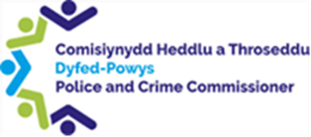

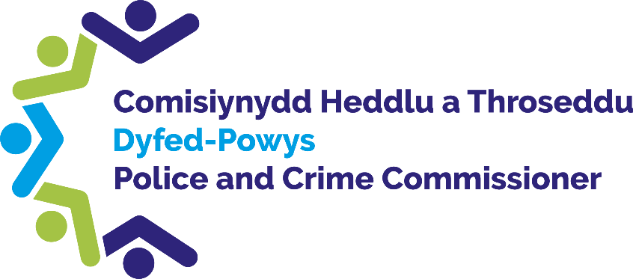

Police and Crime
Commissioner for Dyfed-Powys

Scrutiny Panel
Dip Sampling Exercise
Force Communication Centre Call handling

Panel Members’ Findings & Feedback

January 2023

Contents
Contents 1
1.0 Overview 2
2.0 Background, Purpose and Methodology 2
3.0 Force Communication Call reviews 3
4.0 Calls 4
5.0 Observations 7

1.0 Overview
At the meeting of the Commissioner’s Quality Assurance Panel held on the 26th January 2023, a random selection of seven 999 Force Communication Call recordings were considered by the Members. Members listened to the audio recording and reviewed the corresponding STORM (Force Command and Control system) record.
The meeting was held in person at Dyfed-Powys Police headquarters and remotely via Microsoft Teams. All fourteen Panel members were in attendance.
In the morning the Panel received an input from a trainer within the Force Communication Centre (FCC). The presentation gave an overview of the department and explained the changes made since the Panel last reviewed calls. A tour of the FCC was also given to all new members of the Panel.

Background, Purpose and Methodology
The Quality Assurance handbook, available on the PCC’s website, states the background and purpose of the Panel along with how the dip sampling is carried out and what the Panel is asked to consider.

Force Communication Call Handling
The Quality Assurance Panel members were asked to review the sample of calls considering the below criteria:
- The call opening
- Establishing the caller needs
  - Logical progression of questions to quickly determine the purpose of the call
  - The call handler explains to the caller what course of action they are taking
  - Caller’s needs are immediately identified
- Investigation & data entry
  - Clear, logical questioning ensures that the information is quickly & logically recorded
  - Caller’s details are recorded accurately (Date of Birth, full address and telephone numbers)
  - Call handler confirms information and all key points as necessary
  - If relevant information is offered it is recorded on STORM
  - No call-back would be needed as all relevant information captured
- Victim / vulnerability established & recorded
  - Thorough questioning quickly establishes that caller is a victim, be it of crime or otherwise
  - Thorough logical & sensitive questioning establishes if caller is vulnerable
- Rapport / professional manner
  - Call handler from the start of the call shows the caller politeness and empathy
  - Starts to build rapport from the outset
  - It is clear that the caller is comfortable speaking to the call handler
- Positive service offered
  - Call handler signposts caller to information / services, transfers the call to the CIH or tasks an officer to attend
- Threat, Harm, Risk, Investigation, Vulnerability, Engagement and Safeguarding (THRIVES)
  - information is recorded in relation to a THRIVES assessment
  - Call handler identifies if the caller is vulnerable/upset and grades the response required accordingly
- Recap
  - Call handler recaps pertinent points either throughout the call or as a summary at the end of the call
- Closure advice / management of expectations
  - Call handler gives relevant advice to caller
  - Caller is fully aware of what will happen next for them
  - STORM reference is provided (caller is clear what the STORM reference is) and text to any mobile provided by the caller
  - It is clear that caller is reassured / happy with service provided

Review of Calls
Call 1
- Members acknowledged that the caller on this call was distressed, however, Members felt that the call handler on this call could have taken better control of the call by explaining things clearer. It was felt that the call handler appeared to sound nervous. The caller’s name was not asked until a considerable amount of time into the call.
- It was noted that no safeguarding advice was given to the caller.
- It was felt that the call could have ended better, no reference number or explanation of the next steps were given to the caller.
- Members noted that there is also a missing postcode and house number on the STORM record for the call.

Call 2
- Members highlighted that the call handler was calm and very thorough. The call handler had good questioning and built a good rapport.
- It was felt that there were a couple of long pauses whilst the call handler recorded some information, these gaps could have been briefly explained to the caller.
- Members felt that appropriate safeguarding advice was given, the additional question of asking if there was anyone else in the property would have been beneficial, but the call handler did try and assess the vulnerability of the caller. The caller also reported that something unknown had been pushed through his door by his neighbour. Members felt that in order to safeguard the caller further, that this could have been checked whilst the caller was on the phone.
- It was noted positively that the call handler checked twice that the caller was happy for an officer to visit their address.
- A STORM reference number was given to the caller at the end of the call.

Call 3
- The call handler waited on the line until the police had arrived with the caller.
- The Panel queried whether call handlers are able to give a time estimate for the arrival of the police, it was felt that providing this caller with an estimate would have helped calm and reassure them.
- It was felt that at the beginning of the call the Caller was extremely distressed, and it was felt that more reassurance could have been given right at the very beginning. However, as the call developed the call handler did try to reassure and calm the caller. The call handler did try to safeguard the caller as the call went on.
- It was acknowledged that the line was poor at the beginning of the call, however, members noted that a few details were missed by the call handler at the beginning of the call which did mean that the caller had to repeat details a few times, this did frustrate the caller.
- It was noted that the caller did mention that they were autistic, members queried whether call handlers have specific training on how to adapt to a caller’s needs.
- During the call the caller did mention that this could cause her to have suicidal thoughts. Members acknowledged that disclosures like that must be extremely difficult for call handlers and queried whether there is specific training given to advise call handlers on the best way to respond.
Call 4
- Members noted that the call handler didn’t ask for the caller’s name, which may have been useful before the line got disconnected.
- Members felt that the call handler did otherwise ask appropriate questions and did try to establish the callers needs.

Call 5
- The Panel felt that the call handler built an excellent rapport and had a calm tone.
- Members noted that what was going to happen next was explained very well to the caller.
- No STORM reference number was given to the caller.

Call 6
- It was felt that the call handler built a good rapport and communicated well with the caller.
- The call handler gave an estimate on how long until the Police’s arrival and provided good reassurance.

Call 7
- It was noted that the caller asked appropriate questions and built a good rapport.
- It was noted that the caller was asked to call back if they had any further information, however, no STORM reference number was given to them.

General Comments
- A discussion took place in relation to the increase in the digital contact within the FCC. It was noted that it would be beneficial for the Panel to do a specific review of the FCC digital contact in the future.
- The Panel wished to pass on their thanks to the call handlers within the FCC and acknowledged the difficult job that they do.

Observations
Panel Members made the following observations:
Observations | Force Response
Members queried whether any guidance is given in relation to call handlers sharing their own names with callers. | This is advised in initial training, though as the 101 greeting includes the name automatically and the emergency greeting does not, this is a habit that can be neglected. To be fed back to the teams.
Members queried whether call handlers have specific training on how to adapt to a caller’s needs, such as Autism awareness training etc. | All staff have had Autism Awareness training in initial training and have had updated training last year to capture existing staff. Updates come in regularly and are shared with all officers and staff.
Members queried whether there is specific training given to advise call handlers on the best way to respond to disclosures of suicidal thoughts or self-harm whist on a call. | All staff last year received ‘Suicide Negotiator’ training from our Police Negotiator teams, which includes a national negotiator trainer. We intend for this training to be delivered annually going forward.
Members noted that the time lapses and holds were not always explained to the callers, i.e. when typing details onto the systems. A number of pauses and silences during the calls that could be worrying for any caller. (See previous recommendation from March 2022). | This will be shared with teams again. They are advised to explain any silent periods. I don’t think they realise at the time how long those time periods are because they are doing something during that time. We can re-iterate this to the teams.
It was noted that the STORM reference number was not provided to the caller in the majority of calls. | This ought to be done. Many do so via text message which is stamped on the report. This is looked at daily in audit processes.
It was queried whether the question: “Are you ok/in danger? Should be a standard question for 999 calls to try and gain control of the call from the beginning. – Ambulance control used as an example at the outset of 999 calls “Is the patient breathing?” (See previous recommendation from March 2022). | Ambulance calls are all heavily scripted due to the medical risks presented. Most of ours are not as there are too many variables for what the caller may be reporting, however call takers are advised to ask ‘what is happening’ when they answer the call as ‘police emergency’. This can be shared with teams again.
Members felt that it would be beneficial for the What3words app and the BSL live line to be promoted to the public. (See previous recommendation from March 2022). | I 100% agree. Attempts have been made to ‘launch’ BSL999 and SignLive UK (the non-emergency app) with a media campaign, however Corporate Comms had limited capacity to do so at the time. The department will be very happy to revisit this along with W3W.

Previous observations made by the Panel
Date | Observations | Force Response
March 2022 | The Panel wished to highlight call 3 as good practice and felt this call could be used for future training purposes. | I will ensure that the contact handler is praised and I shall request that I use her call in training as an example of what we aim for on every call.
March 2022 | Panel Members observed 2 successful transfers to the CIH, providing the public with a good level of service. There was one unsuccessful transfer observed. | I am pleased that we were able to offer that service. Hopefully the CIH will continue to evolve and help make DPP as accessible and victim-focused as possible.
March 2022 | Within some of the call samples the Panel Members disagreed with the THRIVES assessment, specifically relating to the caller’s vulnerability. | Vulnerability is a major priority for the force. The THRIVES scripting has been completely changed recently as we were noticing similar issues. The Vulnerability question now asks if anyone is affected by the call is vulnerable and the contact handler has to note down what additional support the caller needs from the force.
March 2022 | Members noted that the time lapses and holds were not always explained to the callers. | I will feed this back to the teams as we do advise to keep the caller in the loop about what is happening when we go quiet / put someone on hold.
March 2022 | Members noted that the initial tone of answering the calls was important. The need for the call handler to make the caller feel important and build a rapport from the beginning was essential to make a good first impression. It was felt that this could have been improved in calls 1 and 5. | Agreed that first impressions are very important. I will feed this back to the teams to help highlight the importance of this.
March 2022 | Panel Members asked whether these calls would have been reviewed by a Supervisor and asked for a Supervisor to review call 1 to establish whether feedback to the Call Handler was required. | These specific calls were not reviewed by a supervisor. Our supervisors review 2 random calls per person, per month to provide feedback. I will pass on to his supervisor to review to ensure that any patterns can be addressed.
March 2022 | Members felt that it would be beneficial for the Force to promote other emergency numbers and the silent emergency call 55 to the public to raise awareness.  It would also be useful for the What3words app to be promoted in terms of it can assist the work of the FCC in helping to identify the location of calls and vulnerable callers. | The availability of these services is well publicised in the media, but Corporate Communications may be able to share something about them to the force’s social media pages.
March 2022 | The Panel recognised that staff may be under additional pressures during Public holidays and busy times and recognised that staff may be impacted by demand outstripping the resources available. Members wondered if this would impact on how often staff are able to have breaks. | Supervisors are (rightly) quite strict about ensuring that staff go for all of their scheduled breaks (they get 3 per shift).  We try to schedule a break every 2 to 2 ½ hours, but when it’s busy this timescale can stretch out longer, and they sometimes have to wait longer than we’d like to go on their breaks.  Of course, staff can go to the toilet in addition to these scheduled breaks whenever they need. Supervisors can also give extra welfare breaks if someone has taken a distressing call and needs support.

