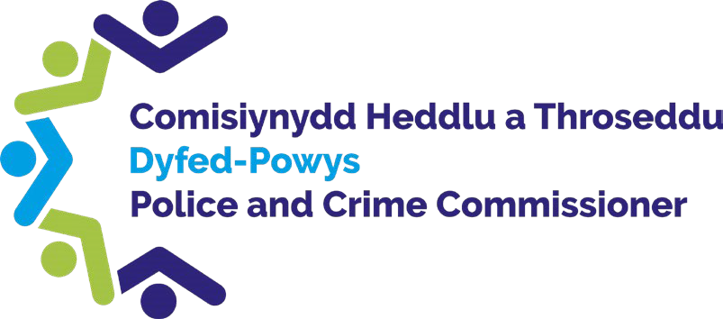
Comisiynydd Heddlu a Throseddu Dyfed-Powys, Blwch Post 99, Llangynnwr, Caerfyrddin, SA31 2PF
Dyfed-Powys Police and Crime Commissioner, PO Box 99, Llangunnor, Carmarthen, SA31 2PF

E-bost: Email: opcc@dyfed-powys.police.uk

Dear Colleague

Policing Accountability Board Meeting

I am writing to invite you to the next meeting of the Policing Accountability Board that is to be held on Thursday the 26th October at 10:00am at Medrus Conference Centre, Penbryn, Aberystywth University, Aberystwyth SY23 3BY

As you are aware, meetings of the Policing Accountability Board are one of the most important strategic meetings that take place within the governance structure of the Police, and are held every quarter. They are public meetings where members of the public can attend in order to watch Chief Constable Dr. Richard Lewis being held to account on policing matters by myself, and to ask any questions or raise local issues with us. For further information about Policing Accountability Board meetings please visit our website Policing Accountability Board (dyfedpowys-pcc.org.uk)

We are keen to see as many representatives as possible from the wider community in Brecon and beyond, and to this end, I would like to invite you to attend the meeting on 26th October.

I kindly ask that you send an email to OPCC@dyfed-powys.police.uk by Thursday 19th October at the latest if you intend to attend. If you wish to ask a question or raise any concerns during the meeting, I kindly ask you to email my Office in advance of the meeting so that we can ensure that we are able to provide a complete response to you at the meeting.
Thank you in advance for your time, and I look forward to hearing from you. Kind regards

Dafydd Llywelyn

Dyfed Powys Police and Crime Commissioner
web www.dyfedpowys-pcc.org.uk twitter DPOPCC facebook dyfedpowyspoliceandcrimecommissioner gwefan
www.dyfed-powys.pcc.police.uk trydar DPOPCC facebook dyfedpowyspoliceandcrimecommissioner

