Mae’r dogfen hon ar gael yn Cymraeg

This Document is available in Welsh**.**



**Police and Crime**

**Commissioner for Dyfed-Powys**

**2024/25 – 2028/29 Medium Term Financial Plan**

**Including**

1. **Precept Proposal**
2. **Reserves Strategy**
3. **Capital Strategy**

**January 2024**



**Contents**

1. Police and Crime Commissioner’s Summary and Precept Proposal
2. Organisational and Operational Context
3. Dyfed-Powys Police - Funding Context and Police Precept
4. Council Tax Base
5. Economic Landscape
6. 2024/25 Police Funding Settlement and National Context
7. Council Tax Capping/Referendum – Wales versus England
8. Dyfed-Powys Police – 2023/24 Financial Context
9. Workforce Plan
10. Budget Process and Budget Requirement 2024/25
11. Medium Term Budget and Outlook
12. Future Savings/ Cost Reduction Plan and Force Review
13. Capital Investment Plan
14. Impact on Reserves
15. Medium Term Financial Summary
16. Section 25 and Budgetary Risk
17. Public Consultation and Opinion
18. Conclusion

**Appendices**

1. Budget 2024/25 – 2028/29
2. Section 25 Chief Finance Officers Report
3. Risk Assessment of Material Budgets
4. Reserves Strategy
5. Reserves 2023/24 – 2029/30
6. Capital Strategy
7. Capital Programme 2023/24 – 2032/33
8. **Police and Crime Commissioner’s Summary and Precept Proposal** 
   1. I take great pride in having been elected as your Police and Crime Commissioner (PCC) and have worked extensively to develop a close working relationship with all communities of the vast geographical area that is served by the Dyfed-Powys Police Force. Working in partnership across the four Unitary Authority areas of Carmarthenshire, Ceredigion, Pembrokeshire and Powys has and remains a priority for me and I am confident that maintaining this partnership approach will lead to improved services for our communities.
   2. I remain committed to giving the public a strong voice in shaping both its policing service and the wider criminal justice system locally, regionally and at a national level.
   3. The fourth term Police and Crime Commissioner elections are scheduled for 2nd May 2024.
   4. The Dyfed-Powys Police Service (Dyfed-Powys) is an integral part of our communities, and this unique relationship is of paramount importance. The public must remain central to everything we do and every decision we make. Providing an evidence base for our actions and investments is important and by harnessing the use of technology and data to shape our services, I am certain that further improvements can be made in ensuring the security and safety of our area.
   5. I have set the strategic direction and laid out my priorities within the published Police and Crime Plan 2021-2025. These continue to underpin all aspects of operational and service delivery and are further supported and enhanced by the Chief Constable’s priorities for the Force.
   6. Dr Richard Lewis took up post as Chief Constable (CC) in December 2021 and we have continued to work together constructively to deliver positive outcomes for the communities of Dyfed-Powys.
   7. HMICFRS issued their latest Police effectiveness, efficiency and legitimacy (PEEL) assessment in November 2023. Although many positive aspects were recognised in the report, there are areas of operational delivery where improvements are required. I am however reassured that significant steps have and continue to be taken towards redressing this since the inspection fieldwork period. My precept proposal will allow the Chief Constable to make some prioritised investment to bolster critical service delivery.

* 1. My team has had yet another busy year focusing on the priorities of my new Police and Crime Plan, discharging the array of responsibilities including increased scrutiny and engagement activities. Commissioned Services continue to report challenging levels of demand and it is pleasing that my office have been able to secure additional funding from the Ministry of Justice to continue to support services at a higher level.
  2. One of my key responsibilities as your Police and Crime Commissioner (Commissioner) is to set the precept each year. This precept is the amount of taxation that is raised through local council taxpayers to support policing services. In doing so, I consider several different factors including the Chief Constable’s future resourcing requirement, the level of reserves, feedback from residents of the Dyfed-Powys area and plans for investment in infrastructure.
  3. The statutory arrangements established under the Police Reform and Social Responsibility Act state that:
     + I must notify the Police and Crime Panel (P&CP) of my proposed precept by the 1st February.
     + The P&CP must review the proposed precept by the 8th February.
     + If the P&CP vetoes the proposed precept, I must notify the P&CP of my revised precept by the 15th February.
     + The P&CP must review the revised precept by the 22nd February.
     + I must set a precept by 1st March.
  4. The Chief Constable continues to report financial performance monthly through Policing Board and quarterly through Police Accountability Board. Financial management and medium-term financial planning are overseen by the Finance and Strategy Board. My Chief Finance Officer (CFO) continues to work closely and constructively with the Director of Finance (DoF) and Corporate Finance team.
  5. Detailed discussions have been ongoing throughout 2023/24 in relation to in-year financial management and the Medium-Term Financial Plan (MTFP). These have taken place within the formal governance structure, as well as a series of precept and MTFP meetings between myself, the Chief Constable, Director of Finance (DoF) and my Chief Finance Officer (CFO). The meetings took place during 2023 on 26th September, 26th October, 17th November (pre-finance seminar), 14th December and 20th December (post settlement, which was received on 14th December).
  6. The Chief Constable and I held a virtual Finance Seminar on the 28th November 2023 for members of the Police & Crime Panel (P&CP), Joint Audit Committee (JAC) and Audit Wales. The purpose of the event was an opportunity for the Force to present a summary of the operational environment that they work within and the impact that this has on their demand levels and subsequent resource requirements for 2024/25 and beyond.
  7. The seminar also covered the steps taken so far in preparing the 2024/25 budget and the draft indicative position, including budget assumptions, pressures, funding context, savings, efficiency measures and the significant investment requirements which are needed to underpin the delivery of policing services. Our treasury management advisors also presented on a range of wider economic and local financial considerations. This seminar allowed a valuable opportunity to present on both the operational and financial challenges and context, which impact on my plans for the precept for 2024/25.
  8. A meeting was also held with the P&CPs Precept Sub-Group on the 26th September to provide an update on the achievement and impact of efficiency/ cost reductions agreed as part of the 2023/24 budget. A further meeting was held on the 13th December to discuss the sub-groups reflections and considerations arising from the Finance Seminar, with a subsequent meeting on the 11th January 2024 ahead of the P&CP meeting to consider the Precept proposal on the 26th January 2024.
  9. The Dyfed-Powys Police Service has faced significant financial challenges since 2010 due to significant reductions in central government funding, the legacy of implications arising from previous decision-making, along with significant cost pressures and continual changes in the demand for policing services, against a very challenging financial and economic landscape.

* 1. As we know, the last few years have been unprecedented for a variety of reasons, with 2023/24 continuing in this vein with continued high interest rates, reducing (but stubbornly high) inflation, significant operational demands and organisational change arising from global, national, and local issues.
  2. The impacts of the cost-of-living crisis are far reaching and are also set against the backdrop of the wars in Ukraine and Gaza, recent shipping attacks in the Red Sea, the aftermath of Brexit, the covid-19 pandemic and continued political instability, which have all contributed to a volatile economic landscape. These have significant implications for all public services, with government spending at a national level still being in significant deficit despite historically high levels of personal taxation.
  3. In light of this and having recognised the extent of future financial challenges, the Chief Constable initiated a Force Review in mid-2022 to critically assess opportunities for cost reductions. The Force identified a large and ambitious savings of £10m over three years, with £6.292m of this being delivered in 2023/24 through a range of initiatives and organisational change. Whilst it is pleasing to see that this will be realised there have been some organisational impacts including backlogs affecting some areas of work and on officer and staff wellbeing more generally.
  4. The Force Review will now enter its second phase. This will focus on the operational policing structure and processes, productivity and efficiency improvements and a number of other projects aimed at improving productivity that are vital to delivering a further £2.2m in savings in 2024/5.
  5. The 2024/25 provisional settlement was announced by the Crime and Policing Minister on 14th December 2023, with funding to Police and Crime Commissioners increasing by up to an additional £922m, including the assumption regarding local flexibility to increase council tax precept:
  + £298m would come from council tax precept (an increase of £13 per Band D property).
  + £184m additional funding to support the costs of the 7% pay award in 2023/24
  + £286m to cover the additional costs arising from the revaluation of police officer pensions but allocated through ring-fenced police pensions grant.
  + £83m through additional Police Uplift Programme ringfenced grant
  + £67m to support additional officer recruitment.

* 1. Despite the headline figures announced by the Minister, it was immediately evident that this would not cater for the wider pay and price inflation, the unforeseen burdens and deal with the service demands that have been recognised nationally. Budget surveys have identified inflationary increases of £639m and coupled with growth and services pressures totalled nearly £1bn nationally.
  2. The 2024/25 settlement for Dyfed-Powys is £7.948m or 12.4% higher than the original 2023/24 settlement as shown in the table below.

**Table 1 : Grant Settlement 2024/25**

|  |  |  |  |  |  |  |
| --- | --- | --- | --- | --- | --- | --- |
| **Funding Element** | Original 23/4 (£m) | Extra 23/4 (£m) | Revised 23/4 (£m) | Provisional Settlement 24/5(£m) | Increase since Original 23/4  (£m) | % Increase from Original 2023/4 |
| Core Grants | 60.896 | +2.337 | 63.233 | 64.538 | +3.642 | 6.0 |
| Operational Uplift | 1.948 |  | 1.948 | 3.010 | +1.062 | 54.5 |
| Pensions Grant | 1.303 |  | 1.303 | 4.067 | +2.764 | 212.1 |
| **Settlement** | **64.147** | **+2.337** | **66.484** | **72.095** | **+7.468** | **11.6** |
| Additional Uplift Grant (+10) | 0.000 |  | 0.000 | 0.480 | +0.480 |  |
| **Overall** | **64.178** | **+2.337** | **66.484** | **72.575** | **+7.948** | **12.4** |

* 1. The increase in un-hypothecated grants is £3.642m or 6% more than the original 2023/4 budget, with the additional funding elements needing to be matched against additional spending for pensions and Police Officer Uplift costs. In terms of additional funding available to support 2024/5 budget increases, the following can be noted.
* The core / un-hypothecated grant increase that is available to meet additional 2024/5 budget pressures is £1.305m or +2.1%.
* The Uplift Programme Grant Specific grant is £1.062m/54.5% higher than 2023/24 to support the officers under the Police Uplift Programme. This funding was in line with the £150m promised nationally as part of the spending review, albeit it was anticipated as core funding and not additional specific grant. The revised terms and conditions are awaited, but there is a suggestion that these will include increased penalties and thresholds if expectations are not met in maintaining officer numbers at agreed levels.
* The Pension Grant increase of £2.764m fully funds the additional costs arising from the 4.4% increase in the employer’s contribution rate for Police Officer pensions as well as some additional administration costs linked to McCloud remedy on a one-off basis.
* Additional recruitment grant of £0.480m to assist in meeting national uplift targets linked to an additional 10 officers to a headcount of 1,314.
  1. Dyfed-Powys Police are on track to have their allocation of the Police Uplift Programme; 141 (42, 42 and 57) officers at the target levels at the reporting dates of 30th September and 31st March 2024. Funding for another 14 officers was confirmed for 2023/4. The additional officers for 2023/24 and 2024/25 are to assist in meeting national targets and do not form part of the ongoing baseline.
  2. Whilst this increase has been welcomed, concerns remain that organisational workforce mix choices are being unduly hindered by the dichotomy and conflict arising from meeting the UK Governments requirements and expectations, whilst dealing with the extent of financial challenges faced and utilising resources in the most efficient manner, especially in light of the increasing element of ringfenced funding. The nuancing of these complex issues continues to be raised at a national level.
  3. The police grant settlement announced precept flexibility for Police and Crime Commissioners in England of £13 per band D property, without triggering the need for a local referendum. This does not apply in Wales and section 7 provides further information.
  4. Police funding arrangements are complex, and it is also important to recognise that there are array of differences and disparities between both England and Wales and indeed between individual forces which mean that core settlements, grants and precept decisions can impact very differently.
  5. The removal of capital grant in 2022/23 means that the costs of supporting vital capital infrastructure investment in Estates, Fleet, and Information Technology (both local and national projects) must be met locally. The need for continued investment is significant as this is fundamental to delivery of policing services and as an enabler for improved productivity and efficiency, as well as making progress against national carbon reduction targets. The MTFP includes a significant trajectory of increases in revenue contributions to capital over the next 10 years, along with assumptions in relation to prudential borrowing and the consequential revenue costs of financing. Ultimately, both put considerable additional pressure on the revenue budget.
  6. Disappointingly, this is a one-year settlement. This lack of clarity makes informed decision making, medium-term forecasting and strategic planning almost impossible. There are also some key financial uncertainties relating to the ongoing formula funding review work; and also lack of certainty over other specific grants which underpin a considerable array of policing functions. The scale of future public spending consolidation is also unclear.
  7. In November 2023 and as a consequence of severe financial challenges, Welsh Government disappointingly announced that their manifesto pledge to fund 600 PCSOs across Wales, was no longer possible. All forces were requested to immediately pause recruitment. A series of meetings were held to discuss implications and planning scenarios. Dyfed-Powys’ share of 600 equated to 89 which represented an original 74 plus an additional 15, with internal match funding of an additional 74 totalling 163. Clearly this raised a number of operational and financial concerns and risks with PCSOs being an integral and important part of neighbourhood policing and much valued resource by communities and this is very much a critical factor which I plan to address as part of the 2024/25 MTFP as outlined in section 10.
  8. Without any prior discussion, Welsh Government also notified in mid-December 2023, that the totality of funding for the All-Wales Schools programme (£0.3m) would be withdrawn from 1st April 2024. The posts that are underpinned by this funding are police officers and therefore reductions cannot be made without impacting on the requirements to maintain officer numbers as part of the Police Uplift Programme. Work will be ongoing to review the future operating model and associated implications.
  9. There have been several operational and organisational pressures that have impacted in the current financial year including Operation Cambrian, which saw high levels of local protests in relation to the Home Office’s plan to utilise the Stradey Park Hotel to house asylum seekers.
  10. Despite not meeting the thresholds for Special Grant, I have written to the Home Secretary raising concerns and requesting consideration of the £1.2m cost (£0.4m additional direct costs along with £0.8m of officer duty time).
  11. Organisational pressures were also accompanied by high demand over the summer months and a requirement to provide mutual aid support of numerous national events. These were coupled with high levels of officer leavers in late summer, staff vacancies, recruitment difficulties and Information and Communications Technology (ICT) system change with the Force Review organisational structure changes also contributing.
  12. There have been areas of positive financial variance that have arisen during the year with additional and fortuitous grants being received for custody provision for the Prison Service and unexpected Home Office funding to support for additional recruitment and ICT programmes. Vacancies and higher than anticipated officer resignations have resulted in positive financial impacts. Additional savings and income from Estates have been delivered as part of the Force Review, and higher than anticipated investment income receipts have arisen through higher interest rates and early receipt of grants.
  13. Whilst there are still several uncertainties remaining in relation to the overall budget position for the remainder of the year, both the Chief Constable and I are confident that the year-end position will be positive, which will allow me to reduce capital financing burdens as well as creating a reserve to mitigate some one-off pressures.
  14. Whilst maintaining a focus on prudent financial management, resilience and sustainability, I keep my Reserves Strategy and positions under active review and have sought to re-prioritise as appropriate.
  15. After extensive scrutiny by the Police & Crime Panel (P&CP), I was unanimously supported in setting a council tax precept for 2023/24 in Dyfed-Powys of £312.65 for an average band D property, once again being the lowest in Wales.
  16. As part of their scrutiny and assurance considerations underpinning their considerations of the 2024/25 precept, the Police & Crime Panel (P&CP) also undertook review of the following areas:
* Estates – review of the Joint Firearms Range, factors considered in making decisions on the estate, savings through rationalisation, process for new build/ renovation specifications.
* Commissioning – review of commissioned services and the process for new commissioning, performance and value for money evaluation, impact on Police and Crime Plan priorities.
* Efficiency Savings – review of progress on 2023/24 efficiency savings, impacts on service delivery and on Police and Crime Plan priorities.
  1. At every stage within the series of Precept and MTFP meetings, and indeed through my scrutiny and review of the in-year financial position, I critically question and constructively challenge aspects of the revenue budget requirement and organisational delivery structure to assure myself of the requirements, progress and ultimate delivery. I also undertook a series of challenge and scrutiny sessions specifically reviewing the Estates, ICT and Fleet Strategies and future capital programme.
  2. To inform my considerations for 2024/25 and to fulfil my responsibilities as Commissioner, I consulted with the public to obtain their views on the level of Police Precept increase. Whilst it was disappointing to see a decrease in responses to this year’s consultation, it was notable that 67.3% of responses supporting either an enhanced or increased level of funding.
  3. Respondents were also given the opportunity to provide comments, which have been analysed with some broad themes that include significant levels of support for the police, highlighting the importance of police visibility, expressing concerns regarding crime levels, government policy, some critical commentary on service delivery, and concerns around the impact of the cost-of-living crisis. I have considered the responses carefully in my deliberations for 2024/25, and particularly so in light of the current cost-of-living crisis. The results of this consultation are outlined in section 17 of this report. My team will be undertaking further work in relation to the array of comments and, where appropriate, these will form part of my ongoing discussions with the Chief Constable.
  4. I am painfully aware of the pressures that the cost-of-living crisis continue to put on our communities. There is a fine balance between ensuring an efficient and effective, visible and accessible Policing Service, addressing operational services demands to ensure the safety of the public, whilst also ensuring value for money for the taxpayers and sound financial management. Having udertaken a comprehensive process, I am confident in the robustness of this MTFP, but this does not underestimate the difficult decisions or indeed mitigate the financial challenges and uncertainties which are outside of our control.
  5. **I therefore submit my precept proposal for scrutiny by the Dyfed-Powys Police and Crime Panel, which will raise the average band D property precept by £1.62 per month or £19.38 per annum to £332.03, a 6.2% increase. This increase will raise a total precept of £79.364m. This will provide a total funding of £143.902m, representing a £8.150m/6.0% increase on the revised funding for 2023/24.**
  6. The operational and financial landscape continues to be both unpredictable and challenging. This level of funding will enable the Force to focus on the delivery of my Police and Crime Plan for 2021-2025, until a new plan is developed by the next Police and Crime Commissioner, which along with the Chief Constable’s priorities will continue to safeguard the communities of Dyfed-Powys.
  7. I will also be outlining new objectives for the Chief Constable to focus on improved performance and outcomes.
  8. This report aims to provide Dyfed-Powys Police and Crime Panel Members with the information necessary to scrutinise my precept proposal and provide information in relation to the operational and financial context, which underpin the resourcing requirements and assumptions for 2024/25 and beyond.

## Organisational and Operational Context

## Spanning 4,188 square miles, Dyfed-Powys is the largest geographical force area in England and Wales. With 13,842 miles of roads, two large ports, 350 miles of coastline and vast areas of countryside, the geography presents us with significant demand and resourcing challenges.

## The resident population of 518,062 is spread across extensive rural areas, holiday and market towns and more heavily populated areas. The draw of tourism presents unique demands with large numbers of tourists visiting key towns. This presents its own implications for crime, anti-social behaviour and roads policing.

## Dyfed-Powys works in partnership with four local authorities and has coterminous local basic command units. Beyond the four counties, Dyfed-Powys also collaborate on an All-Wales basis regarding policing responsibilities.

## Service demands continue to grow and become increasingly complex. The Force continues to experience year-on-year increases in recorded crime, with incidents involving mental ill-health and more complex inquiries into child sexual exploitation and cybercrime. Changes to the way that crimes are recorded nationally have impacted on published crime levels and account for some of the increase. Work continues to improve crime data integrity and the Force’s focus on vulnerability over the last year has realised a positive increase in the reporting and recording of crimes.

## The service continues to evolve quickly to enable its response to new risks, threats, and changes in technology, many of which have required new ways of working.

## The neighbourhood-policing model is at the heart of service delivery and is underpinned by Response, Crime Investigation and Safeguarding functions. The Commissioner published his new Police and Crime Plan in late 2021, with the following priorities underpinning all aspects of operational and organisational delivery:

* Victims are supported.
* Harm is prevented.
* Our justice system is more effective.
  1. To meet the priorities of the Commissioner’s new Police and Crime Plan, the Chief Constable, after consultation with all senior managers, set out several complementary priorities. The Force continues to develop its detailed delivery plans.

**Picture 1**

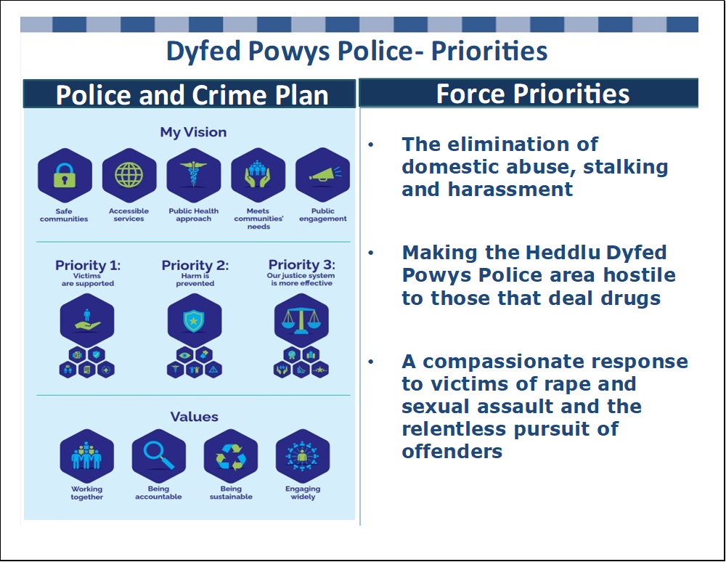

* 1. There has been a continued focus and scrutiny of police performance by the Home Office, linked to the Beating Crime Plan, with significant work being undertaken on operational productivity and outcomes by the National Police Chief’s Council (NPCC). At a national level, the legitimacy of the Police Service is under scrutiny with a focus on ‘Restoring Public Trust’ examining police standards and culture. Race, inclusion as well as violence against women and girls also remain areas of focus.
  2. Demand on the Force in terms of crime volumes had almost doubled since 2017, linked to new crime types such as stalking and harassment and changes in recording practices as depicted in the Table below. This is having an impact on both officer/staff workloads and wellbeing as they deal with higher levels of complexity, vulnerability and risk.

**Table 2 – Recorded Crime**

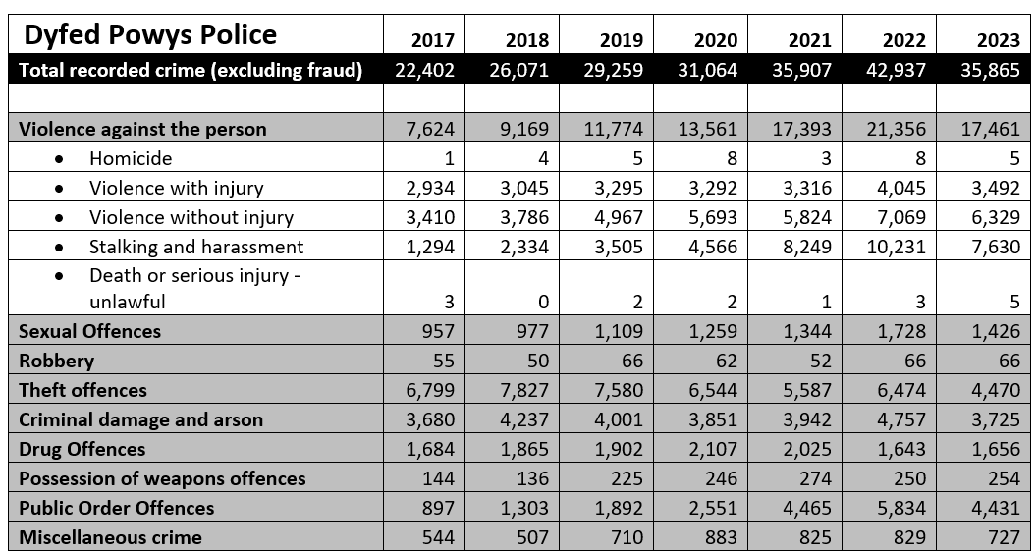

*2023 part year figures to 27th November 2023

* 1. It was important to consider the Policing role in the context of the ‘service of last resource’ in relation to the partnership landscape, particularly at a time of severe financial stress. In this vain, considerable work has been undertaken at a national level in relation to Right Care Right Person (RCRP). RCRP involves the police working with partner agencies to identify the most appropriate agency to give vulnerable people the care and support they need. While some mental health incidents do require police attendance, there are a significant number that involve no safety risk or crime. The new approach will mean that police can focus on attending health incidents where there is a significant safety risk or crime being committed and refer others to the appropriate partner agency. Estimates show that implementing the principles of RCRP could save around one million police officer hours each year across England and Wales.
  2. The Force is currently reviewing and aligning its strategic planning cycle, recognising the importance and complexities of the many interacting organisational facets. The below diagram endeavours to represent this:

**Picture 2**

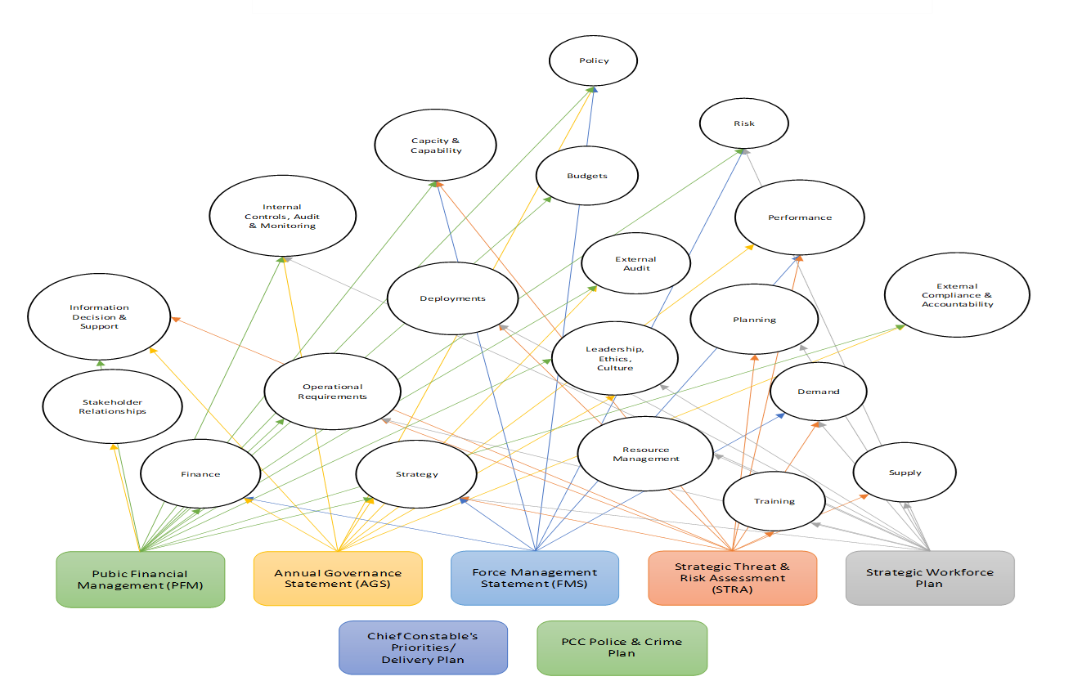

* 1. As a consequence of this ongoing work, the next Force Management Statement will not be submitted until May 2024. HMICFRS will use this to inform their inspections of forces’ efficiency, effectiveness and legitimacy, inform their thematic inspections and to supplement their monitoring of forces’ performance.
  2. HMICFRS issued their latest Police effectiveness, efficiency and legitimacy (PEEL) assessment in November 2023. Although a number of positive aspects were recognised, there are a number of areas where improvements are required. Work is already underway to address these, with associated planned investment to bolster service delivery.

**Table 3 – HMICFRS Assessment 2023**

|  |  |
| --- | --- |
| **HMIC Core Question** | **Grading** |
| Police powers and treating the public fairly and respectively | Adequate |
| Preventing and deterring crime and antisocial behaviour, and reducing vulnerability | Adequate |
| Responding to the public | Adequate |
| Investigating crime | Adequate |
| Protecting vulnerable people | Requires improvement |
| Managing offenders and suspects | Adequate |
| Building, supporting and protecting the workforce | Requires improvement |
| Leader and force management | Adequate |

* 1. In relation to aspects of financial management it was pleasing to see that HMICFRS identified that “the force effectively uses data to understand its finances: Dyfed-Powys Police uses data effectively to manage and understand its finances. This makes sure the force understands the actual cost of its resources and the level of finance that is available. It has a disciplined approach to using finances effectively and supporting the wider management teams in making savings.”
  2. They also found that “the force’s financial plans, including its investment programme, are affordable and will help the force continue to meet future demands. The force shows effective financial management. It makes the best use of the finance it has available, and its financial plans are both ambitious and sustainable.”
  3. Having recognised the challenging financial landscape, the Chief Constable initiated a Force Review during 2022. The first phase of the Force Review required the identification and realisation of cost and service reductions totalling £10m over three years – with around £6.2m of these scheduled to be delivered in 2023/24. Savings of this magnitude were far higher than those delivered previously and would be both challenging and risky to deliver in the current operational and financial climate. Striking a careful balance between financial and operational risks would be paramount in decision making.
  4. The Force Review undertook an extensive range of activities during 2023/24 to deliver the required savings:
* Spending freezes through enhanced overtime and purchase order controls;
* Not filling vacant positions temporarily to provide redeployment opportunities;
* Short-term non-pay and capital spending reductions identified through Chief Officer team workshops;
* Identifying and delivering procurement and central budget non-pay savings;
* Review of force structure and detailed police staff establishment;
* Detailed staff consultation process to understand efficiencies possible;
* Compulsory, voluntary, early retirement and redeployment processes;
* Planned use of reserves to cover one-off costs (e.g. early retirement) and part-year cost reductions during the year;
* Service changes – e.g. station front counter opening hours;
* Automation of processes – Robotic Processing Automation (RPA) and Microsoft365.
  1. Despite successful delivery of the required cost reductions, these have not been without some detrimental impacts including:
  + Police Staff and Officers’ Wellbeing affected - having to deliver more with less, recognising the cost-of-living pressures that individuals are facing;
  + Backlogs in Business Support Departments - ANPR Auditing / Firearms Licensing / Disclosure and FOI / Criminal Justice / Corporate Comms / Legal and Digital Forensics - Investigation timeliness;
  + Loss of Skills / Experience in a number of departments -Business Support Unit/ Fleet / Criminal Justice;
  + Recruitment difficulties – attraction in a challenging employment market;
  + Officers in non-front-line roles - Coroners Officer Support / Detention and escort duties / Investigation roles;
  + Public Impacts - Station Rationalisation / Investigation Timeliness / Victim Updates / PEEL Areas for Improvement / Disclosure / Vetting / CCTV.
  1. The need for continued cost reductions and efficiencies is recognised across the organisation and the Force Review will enter a second phase for 2024/25 focussing on:
* Operational Policing structure review – resources in right place/effective rotas;
* Review operational processes - realise benefits of Niche investment;
* Further workforce changes – assessing timescales for workforce modernisation or reverse modernisation whilst achieving officer uplift maintenance targets;
* Prioritisation (or delay) of new capital and revenue change projects unless considered high risk or delivering sustainable savings;
* Further review of assets including premises/ICT and Fleet;
* Sustainability and income generation opportunities;
* Continuous improvement programme to free up capacity, enhance productivity and efficiency.

1. **Dyfed-Powys Police – Funding Context and Police Precept**
   1. The financial challenges have been well documented, and the following graph sets out the context of grant funding since the Comprehensive Spending Review 2010 (CSR2010):

**Graph 1: Central Grant Reductions 2010/11 to 2026/27**

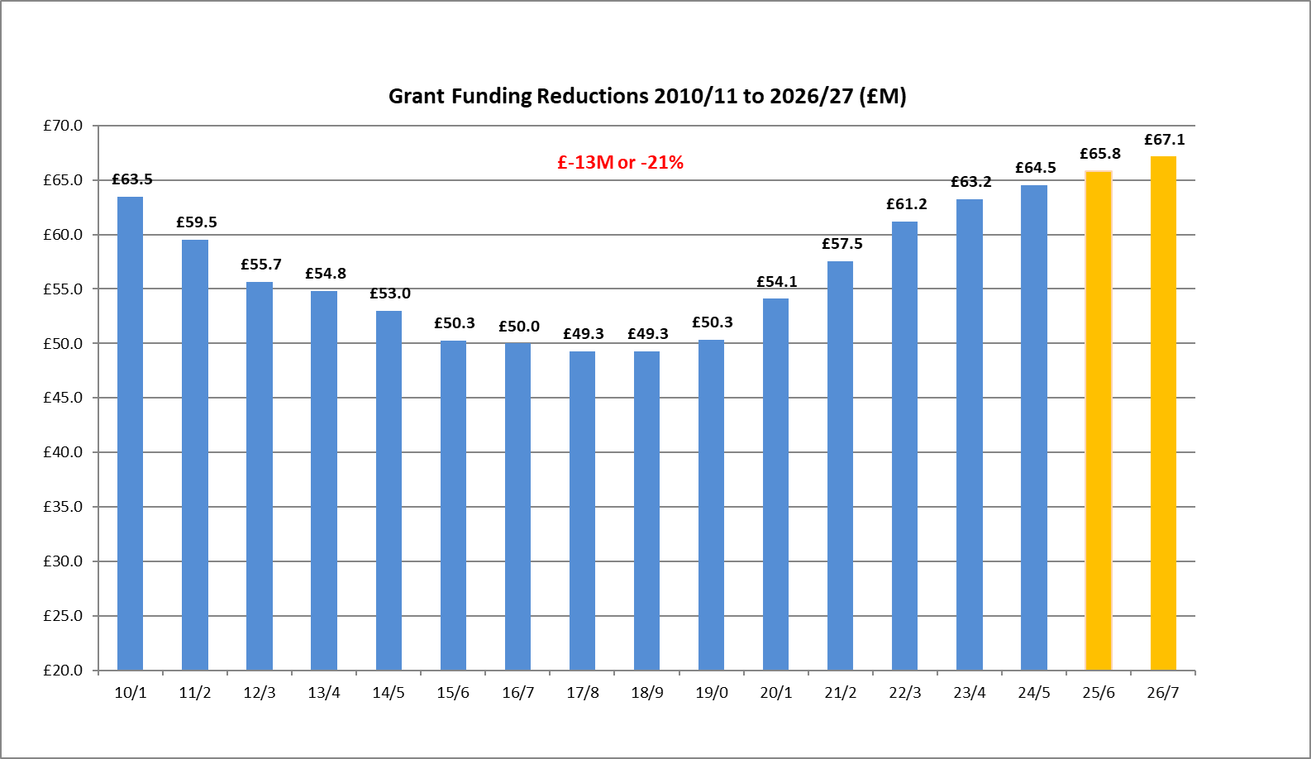

**£14m or 22%**

* 1. The real termreduction presented even greater challenges with inflationary increases needing to be offset by comprehensive efficiency/savings plans and reductions set against the landscape of changing and increased complexity of demand for policing services. It is also important to note that increases in police funding over more recent years have been to support the Police Uplift Programme which has come with very clear expectations, targets, and requirements for Police Officer recruitment.
  2. The following graph shows how the proportion of income that Dyfed-Powys Police receives from central sources compared with local sources, has changed over time:

**Graph 2: Proportion of Council Tax Precept to Central Government Funding %**

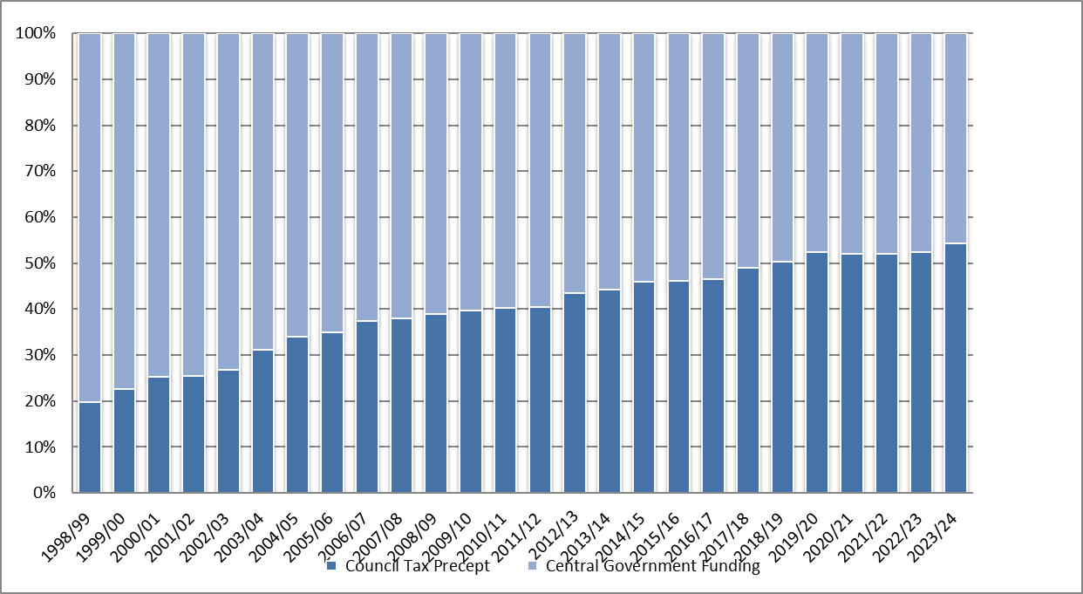

* 1. Historically, central government funding provided the vast majority of Dyfed-Powys Police’s funding, but the proportion received from core grants has decreased significantly over time. The percentage of funding being met through local taxation has risen significantly over time. The proportional split or ‘gearing’ trajectory is likely to continue to increase, as more funding is required to be met from the local taxpayer. It is also important to note again that core grant increases in recent years have been to support the Police Uplift Programme, Pensions increases and have not met the array of other inflationary and cost burdens.
  2. The proportion of funding raised through council tax differs significantly between forces nationally. For 2023/24, Northumbria’s council tax precept made up 20% of their total funding, followed by West Midlands at 21.4% and Merseyside at 24.4%. Conversely, Surrey has 56.8% of their funding from council tax precept, followed by Dyfed-Powys at 54.4% and North Wales at 53.1%. Nationally, 36.1% of policing budgets are funded by local council tax precept. English forces also benefit from Council Tax Freeze/Support Grants which clearly impact on historic precept levels, which generally mean that their precepts are lower.
  3. The following graph shows the amount of funding that Dyfed-Powys Police has received from both local and central sources over time:

**Graph 3: Council Tax Precept to Central Grant Funding £**

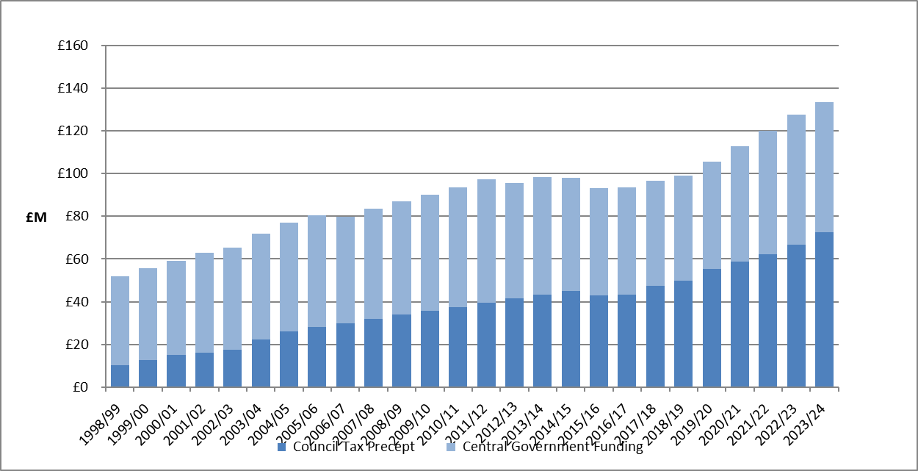

* 1. The following table shows that the core grant funding per head of population for the Dyfed-Powys area continues to be the lowest in Wales. If Dyfed-Powys was funded at the average level for Wales, this would equate to an additional £10.4m of core grant funding:

**Table 4: Core Grant Funding per head of population**

|  |  |  |
| --- | --- | --- |
| **Grant Funding per head of population (£)** | **2022/23** | **2023/24** |
| Dyfed-Powys Police | 116.59 | 116.99 |
| Gwent Police | 147.68 | 148.19 |
| North Wales Police | 126.01 | 126.45 |
| South Wales Police | 144.59 | 145.09 |
| **Wales** | **136.43** | **136.91** |

* 1. Residents in the Dyfed-Powys area have seen the eighteenth lowest increase in Band D Police Precept since 2012/13 and the table below highlights the comparative position with most similar forces, and the other Welsh forces. It should be noted that English Forces also receive £507m in Council Tax Freeze/Support Grant which are not included in the below:

**Graph 4: National % Band D Precept Increase**

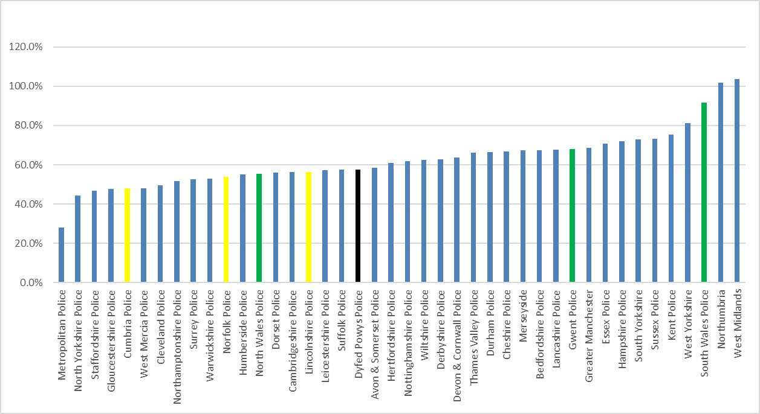

*Green – Welsh forces; *Yellow – Most Similar Forces

* 1. Residents in the Dyfed-Powys area continue to have the lowest Police Precept in Wales. If Dyfed-Powys’ precept level was set at the average for Wales, this would equate to an additional £2.8m of funding.

**Table 5: Precept Levels Wales**

|  |  |  |  |
| --- | --- | --- | --- |
| **Council Tax at Band D (£)** | **2022/23** | **2023/24** | **%** |
| Dyfed-Powys Police | 290.16 | 312.65 | 7.75% |
| Gwent Police | 303.80 | 324.52 | 6.82% |
| North Wales Police | 316.80 | 333.09 | 5.14% |
| South Wales Police | 302.11 | 324.47 | 7.40% |
| **Wales** | **303.69** | **324.36** | **6.81%** |

* 1. The year-on-year percentage change in precept levels for forces in Wales is shown in the following graph.

**Graph 5: Year on Year % changes in Precept across Wales**

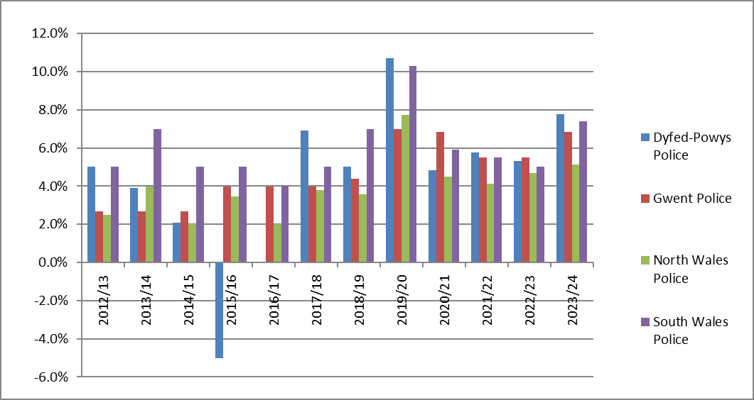

3.10 The following graph shows the change in precept levels for the forces in Wales since 2012/13. The previous decision by the first Police and Crime Commissioner to reduce the precept by 5% in 2015/16 and then not increase in 2016/17, has had a dramatic impact on the comparative trajectory as shown below and the legacy of these decisions continue to impact:

**Graph 6: Increases in Precept levels across** **Wales**

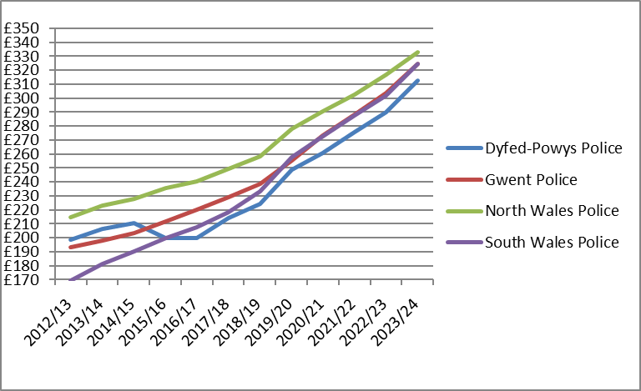

1. **Council Tax Base**
   1. The Police Precept, which is raised through local Council Taxpayers, is allocated to the billing councils, based on the relevant tax bases notified by them. The tax base is calculated from the number of properties in each area allocated to each property band with factors for single occupancy, empty homes, second home premiums and assumptions on collection rates within the context of economic and development factors. The tax base is expressed as a “Band D” equivalent as follows:

**Table 6: Tax Base Levels**



* 1. The Police Precept is added to the figures for the Unitary Authorities and forms part of the overall Council Tax demand bills.
  2. Under the regulations, the billing authority must determine a schedule of instalments for payments to precepting authorities. The agreement is that the Unitary Authorities will pay the Force in 12 instalments on or before the last working day of each month.
  3. It should also be noted that when announcing the police settlement, the UK Government makes assumptions regarding the tax base changes, using information provided by the Office of Budget Responsibility. For Wales, a 0.5% increase was assumed with 0.7% for England.
  4. The actual increase for Dyfed-Powys for 2024/25 is significantly higher at 3.1% with three constituent authorities making decisions to increase their premiums for second homes and empty properties. This increases the taxbase by 7,079.36 which at 23/24 precept level generates an additional £2.213m.
  5. It should be noted that changes in the profile of second homes and empty properties may detrimentally impact in the future.

1. **Economic Landscape**
   1. In January 2023, the Prime Minister set out three economic priorities: to halve inflation, grow the economy and reduce debt.
   2. Consumer Prices Index (CPI) inflation has now more than halved from a peak of over 11% last autumn to 3.9% in November 2023. The economy has recovered from the pandemic more quickly than first thought, grown more than expected this year, and is forecast to grow in every year of the forecast period. Underlying debt is forecast to fall as a proportion of GDP from 2027-28 and the UK Government has greater headroom against its fiscal rules than at Spring Budget 2023.
   3. The Chancellor announced the Autumn Statement in November 2023, stating that the UK Government must continue to bear down on inflation, and the Office for Budget Responsibility (OBR) forecasts that government policies in the Autumn Statement continuing to reduce inflation next year. With inflation falling and the economy and public finances stabilised after a series of unprecedented shocks, it is hoped that the UK Government can now take the long-term decisions necessary to strengthen the economy.
   4. The UK Government remain focussed in improving public sector productivity with specific reference in the Autumn Statement:
   * “While day-to-day spending will continue to grow above inflation in future years, public spending faces many pressures. The UK Government will get the most out of every pound spent by boosting public sector productivity and by focusing spending on the UK Government’s priorities. The recently published independent Policing Productivity Review has made a series of recommendations to improve police productivity. These proposals range from building on recently introduced measures that cut unnecessary bureaucracy to driving greater productivity through the adoption of new and improved technology. If all of these were implemented, they could save up to 38 million hours of police officer time per year, the equivalent of an additional 20,000 police officers.”
   1. The Autumn Statement was accompanied by the Office of Budget Responsibility’s (OBR) Economic and Fiscal Outlook. The following graph is an extract from this report:

**Graph 7 – OBR Consumer Price Index (CPI)**

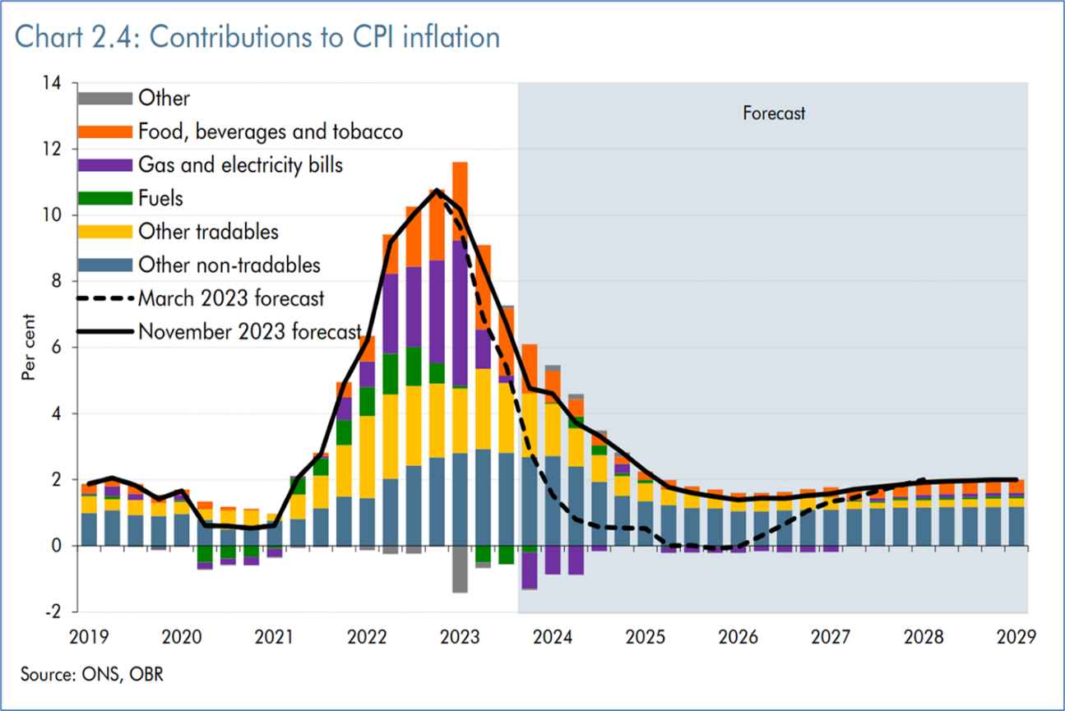

ONS – Office of National Statistics

* 1. There has been pressure across the public sector due to larger pay rises. The Police sector were generally expecting a pay award of between 2% and 3% during 2023/24. However, in July the UK Government announced that they had accepted the Police Remuneration Review Body (PRRB) recommendations in full:

• Awarding a consolidated increase of 7% to all ranks up to and including assistant chief constables and commanders;

• Removal of point 0 of the constables’ pay scale; and

• An increase to pay point 3 of the chief superintendents’ pay.

* 1. Recognising the financial impacts of this, the Minister of State for Crime and Policing announced additional in year funding during 2023/24 of £2.338m for Dyfed-Powys.

1. **2024/25 Police Funding Settlement and National Context**
   1. The 2024/25 Provisional Settlement was announced on 14th December 2023 in a written statement by the Crime, Policing and Fire Minister, Chris Philip. Full details of the Settlement can be found on the Home Office website. The Welsh Government also published information for the Welsh forces on their website.
   2. The Minister said “Today, the Government has set out the provisional police funding settlement…for the forthcoming financial year. For 2024-25 overall funding … will rise by up to £842.9m compared to the restated 2023-24…This funding settlement demonstrates that the Government remains committed to giving policing the resources they need to keep the public safe…The Home Office was only able to deliver this substantial funding increase by reprioritising funding from other programmes.”
   3. The Minister outlined expectations for policing to approach the 2024/25 financial year with a focus on the UK Government’s key priorities:

* “In return for this significant investment, it is imperative that policing continues to deliver on driving forward improvements to productivity and identifying efficiencies where possible. The Government will continue to work with the sector to unlock the full range of opportunities and benefits of productivity and innovation to enable officers to have the tools to deliver on their core mission of keeping the public safe.
* “We, therefore, expect policing to approach the 2024-25 financial year with a focus on this Government’s key priorities:

• Maintaining 20,000 additional officers (148,433 officers in total nationally) through to March 2025.

• Continuing to deliver on the opportunities presented by new technology and innovation to deliver improvements in productivity and drive forward efficiencies, therefore maximising officer time and service to the public.

• Improving the visibility of police officers and focusing on providing a targeted approach to tackling crime and antisocial behaviour to make neighbourhoods safer, which should be a priority for all forces.”

* 1. In England, the Government sets the level of precept increase above which a referendum is required. For 2024/25 this was set at £13. Assuming every force takes the full precept flexibility, the total amount of extra funding available for forces is £922.2m. This is made up as follows:
  + £298.2m would come from council tax precept increase of £13;
  + £184.1m core grant funding to cover the 2023/24 pay award;
  + £286.3m additional pension grant;
  + £82.8m additional funding through ring-fenced grant for the Police Uplift Programme;
  + £67.2m additional recruitment grant;
  + £3.7m increase in adjustments to legacy council tax and precept grants.
  1. In 2024/25 the top slices total £1,038.1m, a £76m reduction over last year (£1,114.0m).

**Table 7 Police Top Slice/ Reallocations**

|  |  |  |  |
| --- | --- | --- | --- |
| **Police Top Slice** | **2023/24 £m** | **2024/25 £m** |  |
|  |  |
| **Reallocations and adjustments** | **1,114.00** | **1,373.70** |  |  |
| Special Grant | 50.0 | 34.0 |  |  |
| Private Finance Initiatives (PFI) | 71.6 | 71.2 |  |  |
| Police technology programmes | 526.4 | 500.9 |  |  |
| Arm’s length bodies | 74.7 | 65.7 |  |  |
| Regional & Organsied Crime Units | 39.5 | 31.6 |  |  |
| National Capability Programmes | 69.3 | 49.8 |  |  |
| Forensics | 20.6 | 13.0 |  |  |
| Serious Violence | 45.6 | 45.6 |  |  |
| National Policing Capabilities (NPCC) | 9.5 | 7.7 |  |  |
| Crime Reduction Capabilities | 18.4 | 0.0 |  |  |
| Police Productiviyt and Innovation | - | 11.0 |  |  |
| Drugs/ County Lines | 30.0 | 30.0 |  |  |
| Capital Reallocations | 104.9 | 128.7 |  |  |
| Fraud | 18.1 | 18.1 |  |  |
| Cyber Crime | 14.1 | 13.1 |  |  |
| Tackling Exploitation and Abuse | 21.3 | 17.6 |  |  |

* 1. There is also additional funding for Police Pensions to mitigate the impact of increased employer pension contributions. Until the latest settlement, pension grants had remained unchanged, standing at a total of £142.6m. However, the Minister confirmed that an additional £259m would be added to this grant, as well as a one-off £26.8m admin grant (for implementation pressures), taking the total funding to £428.3m.
  2. Council Tax Legacy Grants relating to Council Tax Freeze grants from 2011/12, 2013/14, 2014/15 and 2015/16 as well as Local Council Tax Support for funding, for English Force areas, remain separately identifiable in 2024/25.
  3. Capital Funding has been moved under the umbrella of reallocations and adjustments. Total Police Capital Funding is now worth £128.7m, an increase of over 24% from £104.9m last year. Capital funding grant allocations to Force areas no longer exists.

**Table 8 – National Police Capital Grant Allocations**

|  |  |  |
| --- | --- | --- |
|  | **2023/24 £m** | **2024/25 £m** |
| Arms Length Bodies | 5.4 | 4.0 |
| Police Technology Programmes | 72.2 | 111.6 |
| Crime Reduction Programmes and Capabilities | 15.6 | 0.0 |
| National Police Air Service | 11.7 | 13.1 |

* 1. The settlement also maintains an allocation of £2.4m to help to address the Welsh apprenticeship levy contribution. Dyfed-Powys will receive £0.3641m as a grant in 2024/25. Dialogue is still ongoing to seek to address the disparity between England and Wales, with the Home Office indicating that this may not be the final resolution to this issue.
  2. For Dyfed-Powys Police, the 2024/25 settlement is outlined in the table below:

**Table 9: Total Funding for 2024/25**

|  |  |  |  |  |  |  |
| --- | --- | --- | --- | --- | --- | --- |
| **Funding Element** | Original 23/4 (£m) | Extra 23/4 (£m) | Revised 23/4 (£m) | Provisional Settlement 24/5(£m) | Increase since Original 23/4  (£m) | % Increase from Original 2022/3 |
| Home Office | 52.404 | +2.337 | 54.741 | 56.125 | +3.721 | 7.1 |
| WG – RSG & NNDR | 8.492 |  |  | 8.413 | -0.079 | -0.9 |
| **Core Grants** | **60.896** | **+2.337** | **63.233** | **64.538** | **+3.642** | **6.0** |
| Uplift Grant | 1.948 |  | 1.948 | 3.010 | +1.062 | 54.5 |
| Pensions Grant | 1.303 |  | 1.303 | 4.067 | +2.764 | 212.1 |
| **Settlement** | **64.147** | **+2.337** | **66.484** | **72.095** | **+7.468** | **11.6** |
| Additional Uplift | 0.000 |  | 0.000 | 0.480 | +0.480 |  |
| **Overall** | **64.178** | **+2.337** | **66.484** | **72.575** | **+7.948** | **12.4** |

*RSG – Revenue Support Grant; NNDR – National Non-Domestic Rates

1. **Council Tax Capping/Referendum – Wales versus England**
   1. As outlined above the 2024/25 Provisional Settlement and headline figures assumed council tax precept flexibility of £13, without the need to call for a local referendum.
   2. Under devolution, the arrangements for Wales are that the power to determine capping levels on the council tax are administered by the Welsh Government.
   3. There are two forms of capping − designation and nomination. Welsh Government may designate or nominate an Authority for capping its precept, if in their opinion its budget requirement is excessive.

* Designation requires an Authority to reduce its budget requirement and re−bill the Council Taxpayers (through the Unitary Authorities).
* Nomination effectively puts an Authority on notice that Government will stipulate a budget limit for the following year. Welsh Government is responsible for determining the criteria (the principles) for capping for all Local Authorities and Police Forces in Wales. The principles must include a comparison between the calculated budget requirement with that calculated for a previous financial year. Ministers are free to include in the principles any other matters they consider relevant.
  1. Both the Commissioner and Chief Constable have maintained effective communications with both Minsters and Welsh Government through the Policing Partnership Board for Wales. The continued strengthening of the relationship of the Police Liaison Unit (PLU) has provided a valuable and additional opportunity to highlight the financial pressures and operational demands that are being faced by Dyfed-Powys Police and the wider police service in Wales.
  2. It is for locally accountable Commissioners to consult and take decisions on local precept, explaining to their electorate how additional investment will help deliver a better police service.
  3. Assuming each PCC increases their precept by the maximum allowed, £13, combined with tax base growth assumptions of 0.7% for England and 0.5% for Wales, this would provide an additional £298.2m of resources for policing from council taxpayers.
  4. Due to historic differences in council tax, the proportion that £13 represents can vary significantly between force areas. The £13 increase means that Northumbria’s percentage increase is 7.7% followed by the West Midlands at 6.4% and Essex at 5.7%. Conversely, £13 represents a 3.9% increase for North Wales, a 4.0% increase for South Wales and Gwent, and 4.16% for Dyfed-Powys. The impact of Council Tax Freeze/Support Grants in England clearly has impacted on historic precept levels, which generally mean that their precepts are lower.
  5. These inherent differences in both historic core grants and local precept decisions, mean that it is very difficult to draw meaningful comparisons between force areas in Wales but also in England.

1. **Dyfed-Powys Police – 2023/24 Financial Context** 
   1. The following table summarises the range of financial risks and opportunities over the short and medium term, which were presented to the Police & Crime Panel, Joint Audit Committee and Audit Wales in late November 2023:

**Picture 3 – Financial Risk and Opportunity Balance Sheet**

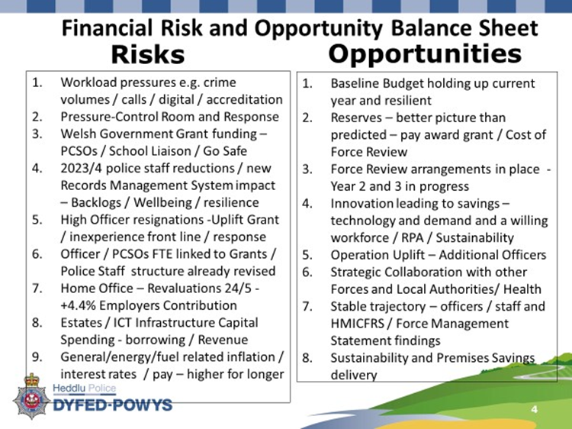

* 1. Many of these risks and opportunities have begun to materialise and will be detailed further in the following sections, some of which will be addressed in section 10 and consolidated as part of the MTFP for 2024/25.
  2. The 2023/24 in-year financial position continues to be positive and based on current monitoring, a planned underspend of £1.689m is forecasted. This position will allow for additional reserves to be established to offset one-off budget pressures and peaks in spending in 2024/25, therefore minimising the burden on police precept. An additional direct revenue contribution of £1.088m is planned in the current year to reduce the borrowing requirement and consequential financial burden for 2024/5 and beyond. The underspends are being realised through:
     + Higher than anticipated police officer resignations.
     + Police Staff vacancies partly arising from the Force Review and wider workforce market conditions.
     + Additional Home Office grant to recruit officers to a higher level to help meet national targets.
     + Operation Safeguard – grant for use of custody provision by the Prison Service.
     + Additional cost savings from sustainability, rationalisation, and inflationary increase for mast income within the Estates Department.
     + Underspend within the Training Department due to abstractions dealing with Operation Cambrian – Asylum Seekers, along with summer demand.
     + Additional Home Office grant towards ICT projects.
     + Higher levels of investment income from the early payment of £17m grant from the Home Office and higher interest rates.

1. **Workforce Plan**
   1. The following sets out the historic workforce profile:

**Picture 4– Workforce Summary**

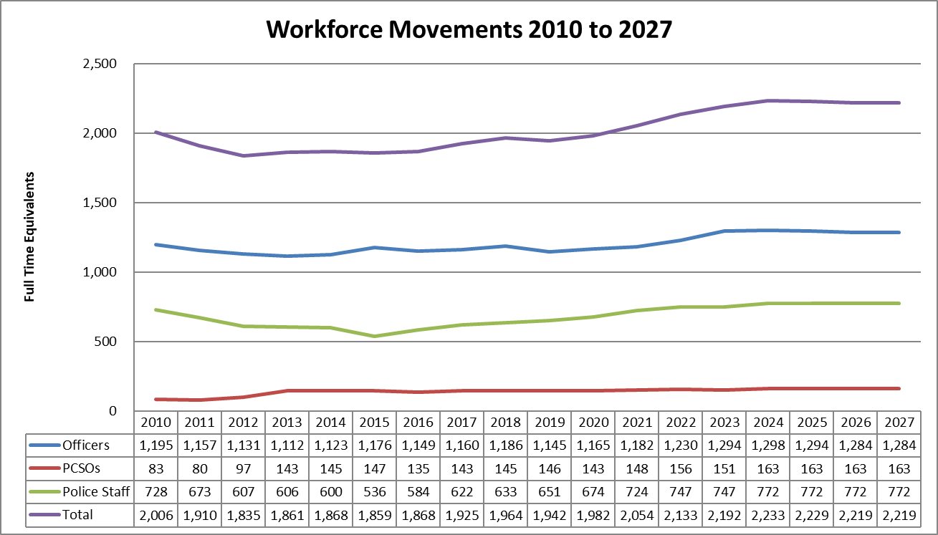

* As of 31st March each year

* 1. The continuing Force Review will consider in detail both current and anticipated demand when determining the appropriate operational structure for 2024/2025 and beyond. Current demand challenges impacting workforce capacity and capability include:
* Increasing demand on Force Control Centre resource;
* Response Officer levels across each Local Policing Area;
* Crime and Incident Hub work and impact on resources;
* Neighbourhood Policing Teams;
* Crime Investigation and Recording linked to new crime types such as stalking and harassment, and changes in recording practices;
* Shortage of PIP2 accredited Detective Constables;
* Analytical capacity - increasing demand for analysis and reporting;
* Project Management capacity - increasing requests for project assistance.
  1. The Police Uplift Programme (PUP) has seen three tranches of additional officers for Dyfed-Powys with 42 in 2020/21, 42 in 2021/22 and 57 in 2022/23. The Home Office also offered additional grant funding during 2023/24 for Forces who could overshoot their uplift targets during the year to aid achievement of the national targets. Dyfed-Powys Police was successful in bidding for an additional 10 officers, which brought additional funding of £45k per officer, plus a further 4 which brought funding of £24k per officer.
  2. The Home Office PUP maintenance target for 2024/25 is a headcount of 1,314. It is important to note that there are different counting rules for headcount which mean that full time equivalent figures differ. Officer levels are scrutinised twice yearly in September and March by the Home Office and the force faces financial penalties if Officer levels are not on target at each of these assessment points. For 2023/24, the penalties were £40k per officer (up to 20 officers), albeit that there are indications that the penalty and thresholds will be higher for 2024/25.
  3. Recruitment intakes were carefully planned and managed during 2023/24 to ensure optimal resourcing levels, availability of specialist skills and to allow the proportionate geographical distribution of staff whilst also ensuring optimal financial effectiveness at the formal reporting points. The Police Education Qualifications Framework (PEQF) continues to see intakes of student constables each year with external course providers delivering core elements of their training.
  4. It is important to note the significant proportion of officers that are training, as this clearly has associated operational and financial implications:

**Table 10 Police Officer numbers**

|  |  |  |  |  |
| --- | --- | --- | --- | --- |
|  | **Recruits** | **Change** | **Total Establishment** | **%** |
|  | **FTE** | **FTE** | **FTE** |  |
| 2022/3 | 206 |  | 1,230 | **17%** |
| 2023/4 | 245 | 39 | 1,298 | **19%** |
| 2024/5 | 248 | 3 | 1,294 | **19%** |
| 2025/6 | 229 | -19 | 1,284 | **18%** |
| 2026/7 | 225 | -4 | 1,284 | **17%** |

* 1. The Force is seeing higher levels of attrition for both Officers and Police Staff. Work is underway to better understand this but there are a range of factors including national skills shortages, cost-of-living crisis, pension changes, as well as some internal challenges including impacts on Police Staff wellbeing due to fewer internal resources as part of the Force Review, challenging operational demands with some leavers citing workload and work/life balance as reasons for their decision to resign. Long serving experienced Police Officers and Police Staff have left to join local, UK and global private and public sector organisations who can offer higher remuneration packages.
  2. The Workforce Plan will focus on the following key elements:
     + Officer and Staff attraction;
     + Recruitment processes;
     + Apprenticeship and Interns Strategy;
     + Developing and retaining diverse talent;
  3. In November 2023 and as a consequence of severe financial challenges, Welsh Government announced that their manifesto pledge to fund 600 PCSOs across Wales, was no longer possible. All Forces were requested to immediately pause recruitment. A series of meetings were held to discuss implications and planning scenarios. Dyfed-Powys’ share of 600 equated to 89 which represented an original 74 plus an additional 15, with match funding of additional 74 totalling 163.
  4. Clearly this raised a number of operational and financial concerns and risks with PCSOs being an integral and important part of neighbourhood policing and much valued resource by communities.
  5. Despite numerous discussions with Welsh Government, there is still a lack of clarity around both core grant and transitional funding (albeit some high-level figures have been articulated which can be extrapolated for the four forces). This dramatic reduction and lack of certainty is concerning and whilst details are awaited, discussions continue and the approach for 2024/25 is detailed further in section 10.

1. **Budget Process and Budget Requirement for 2024/25** 
   1. Work continued during 2023 to further embed the budget setting process and better align with wider strategic planning. This approach has seen Finance Business Partners continuing to work closely with service managers and budget holders, to fully review baseline budgets and critically assess demand and cost pressures, whilst also seeking to identify efficiencies and savings linked to the Force Review.
   2. The relationship between in-year financial monitoring and budget setting has been strengthened each year. The aim of the process is to channel resources towards the delivery of key priorities whilst ensuring a clear link between the budget, MTFP and underpinning workforce and capital investment plans and requirements.

**Picture 5 – Financial Monitoring Setting (FMS) and MTFP Linkage**



* 1. The Strategic Finance and MTFP Board, within the formal governance structure, has continued to oversee the development of this approach, with financial planning also being a key focus for the Strategic Estates Group/Operational Estates Group, ICT Strategy Group and Fleet Strategy Group.
  2. The use of both The Chartered Institute of Public Finance and Accountancy (CIPFA) and HMICFRS Value for Money profile benchmarking data continues to develop, as this is helpful to assess demand and value for money considerations. The following table provides some high-level benchmarking and comparator data for 2023/24. The data shows the significant impact that the Force’s geography has on spending, for example, custody, firearms, and traffic in comparison to others.

**Table 11- Police Objective Analysis Benchmarking Data**

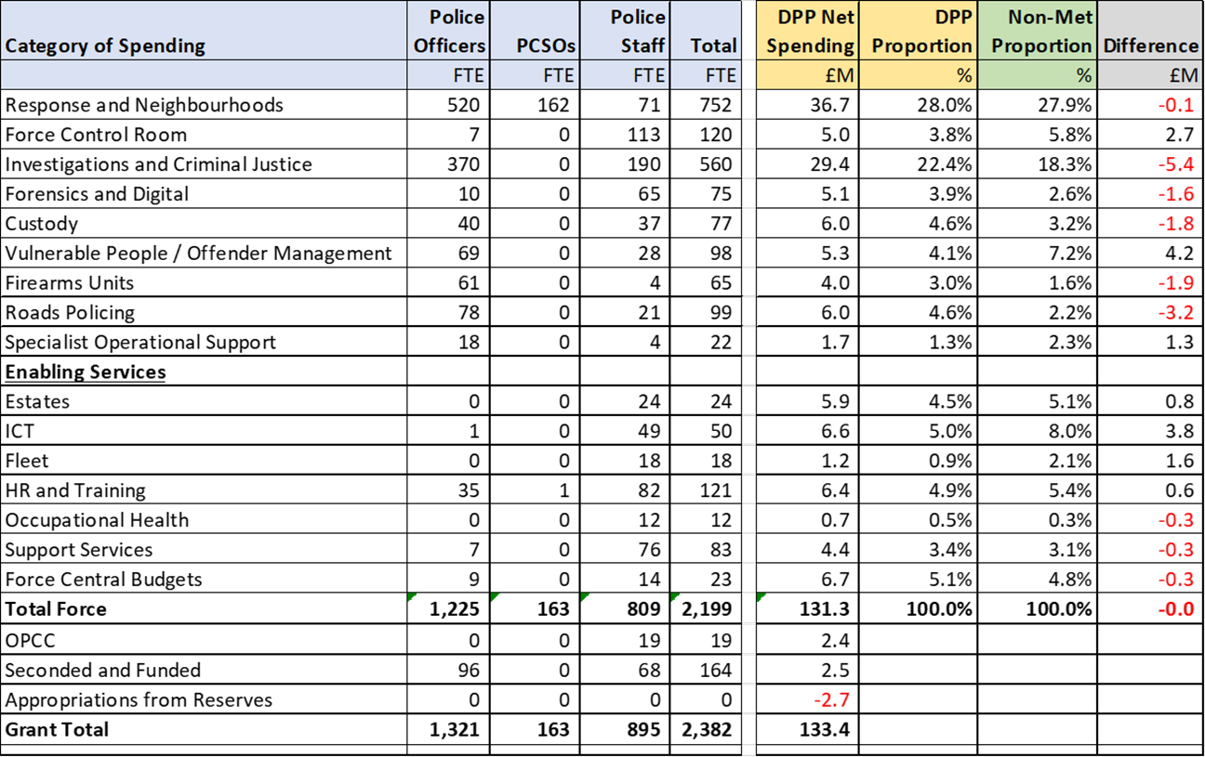

* 1. The starting point for the construction of the budget for 2024/25 was to effectively correct the pay inflation assumptions that were made during the budget process for 2022/23. As outlined above, additional grant of £2.338m was allocated to mitigate the impact of the 7% pay settlement announced in August 2023, which increased baseline pay costs by £2.741m in 2023/24 and £3.454m in 2024/25.
  2. As well as the inflation correction, the Force has numerous additional ‘standstill’ budget pressures that it must incorporate into its baseline budget. The following table sets out the detailed baseline budget pressures that the Force are facing, which effectively are the costs to maintain service delivery at the current levels without allowing for any growth or improvements. The main items are further described below the table.

**Table 12 2024/25 Standstill Requirement**

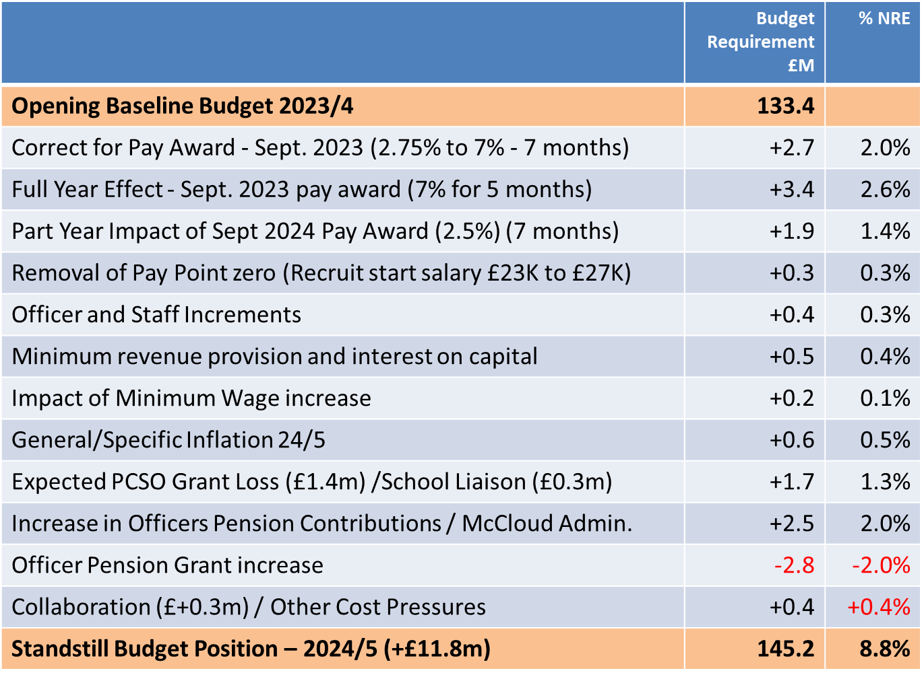

* 1. As can be seen, there are several pay related pressures arising including the 7% pay increase implemented from September 2023 and the removal of point zero for Police Officers from September 2023, which now sees recruit starting salaries increasing from £23,556 to £28,551. Police officers and staff are entitled to annual increments, which will add a further £0.4m in 2024/25 which is net of slippage that arises from people leaving the organisation.
  2. Increases in the National Living Wage are expected to increase costs of cleaning and other contracts by around £0.2m and the impact of pay and other inflation on collaboration contributions is also significant at around £0.3m on a standstill basis.
  3. As outlined in last year’s MTFP, the actuarial revaluation of Police Officer Pensions had been a recognised risk. This revaluation has now been finalised and will see employer contributions increase by 4.4% from 1st April 2024. The revaluation has been impacted by two factors. Firstly, the impact of the McCloud and Sergeant remedies, which extended protection for officers from the impact of the implementation of the career average salary pension scheme in 2015 to all officers for a period of 10 years from 2012. This remedy applies across most public sector pension schemes including fire, teachers, Local Government Pension Scheme (LGPS) and Health Service. Secondly, by the impact of general life expectancy, officer recruitment and general inflationary and pay award pressures that may be more scheme specific.
  4. After extensive representations from APCC, NPCC and the Police and Crime Commissioners Treasurers’ Society (PACCTS), it was reassuring that the UK Government recognised this burden and the need to for additional funding to meet the costs. The specific grant for pensions has been increased by £2.764m to meet this cost, albeit risks and future uncertainty must always be noted for all specific grants. The additional grant has also included a one-off contribution to help meet the significant costs of pension administrators dealing with the McCloud remedy.
  5. As referenced in section 9, 2023 saw Welsh Government making several announcements in relation to their significant financial challenges and extensive deficits. In mid-October, Welsh Government requested an immediate freeze on Police Community Support Officer (PCSO) recruitment. A number of urgent meetings ensued to discuss and assess the implications for both the immediate and future positions, recognising that each force in Wales were at different points in their PCSO levels and recruitment cycles.
  6. Whilst the final details of the specific grant agreement for 2024/25 are awaited, the latest indications are that the number of PCSOs that will be supported directly by Welsh Government will reduce from 89 to 44 for 2024/25. The above table represents an expected loss in grant funding of £1.382m from Welsh Government (from £3.655m to £2.273m). The PCSOs are a vital and intrinsic part of the Neighbourhood Policing model being a much-valued policing resource within the communities.
  7. Dyfed-Powys Police have historically funded an additional 74 FTE, with a total standstill establishment of 163. This would need to reduce by 45 to 118 funded positions given the Welsh Government announcement.
  8. It is expected that PCSOs employed by the Force will reduce to 144 FTE by March 2024 due to the recruitment freeze and then further to 132 by March 2025 without further recruitment. Following lengthy discussions between the PCC and CC, this budget requirement and MTFP assumes a long-term commitment to fund 132 FTE (44 Welsh Government and 88 Force) which will enable the continuation of Neighbourhood Policing albeit at a slightly reduced level.
  9. Without any prior discussion, Welsh Government also notified in mid-December 2023, that the totality of funding for the All-Wales Schools programme (£0.3m) would be withdrawn from 1st April 2024. The posts that are underpinned by this funding are police officers and therefore reductions cannot be made without impacting on the requirements to maintain officer numbers as part of the Police Uplift Programme. Work will be ongoing to review the future operating model and associated implications.
  10. The following table sets out the array of specific grants having been adjusted for notified increases and reductions, albeit some are still awaited:

**Table 13 Specific Grants**



* 1. Assumptions on inflation and pay awards for the next financial year continue to be challenging as forecasts from the Office of Budget Responsibility continue to be revised, however as the Consumer Price Index continues to fall, general inflation of 2.5% for non-pay related budgets has been assumed. For pay awards an assumed increase of 2.5% has been incorporated from September 2024 with reserves being earmarked potentially to fund up to 3% increase for officer and staff.
  2. An increase in capital financing and interest costs of £0.5m has been incorporated which primarily relate to the new Custody Suite in Dafen (Llanelli) which became operational in May 2023.
  3. Having updated the baseline budget requirement on a standstill basis, there are some critical growth and strategic service developments which are aligned to both the Police and Crime Plan and Chief Constable priorities/ Force Management Statement that have been incorporated into the budget requirement. These are detailed in the following table and further described below:

**Table 14 Service Developments/ Required Growth**

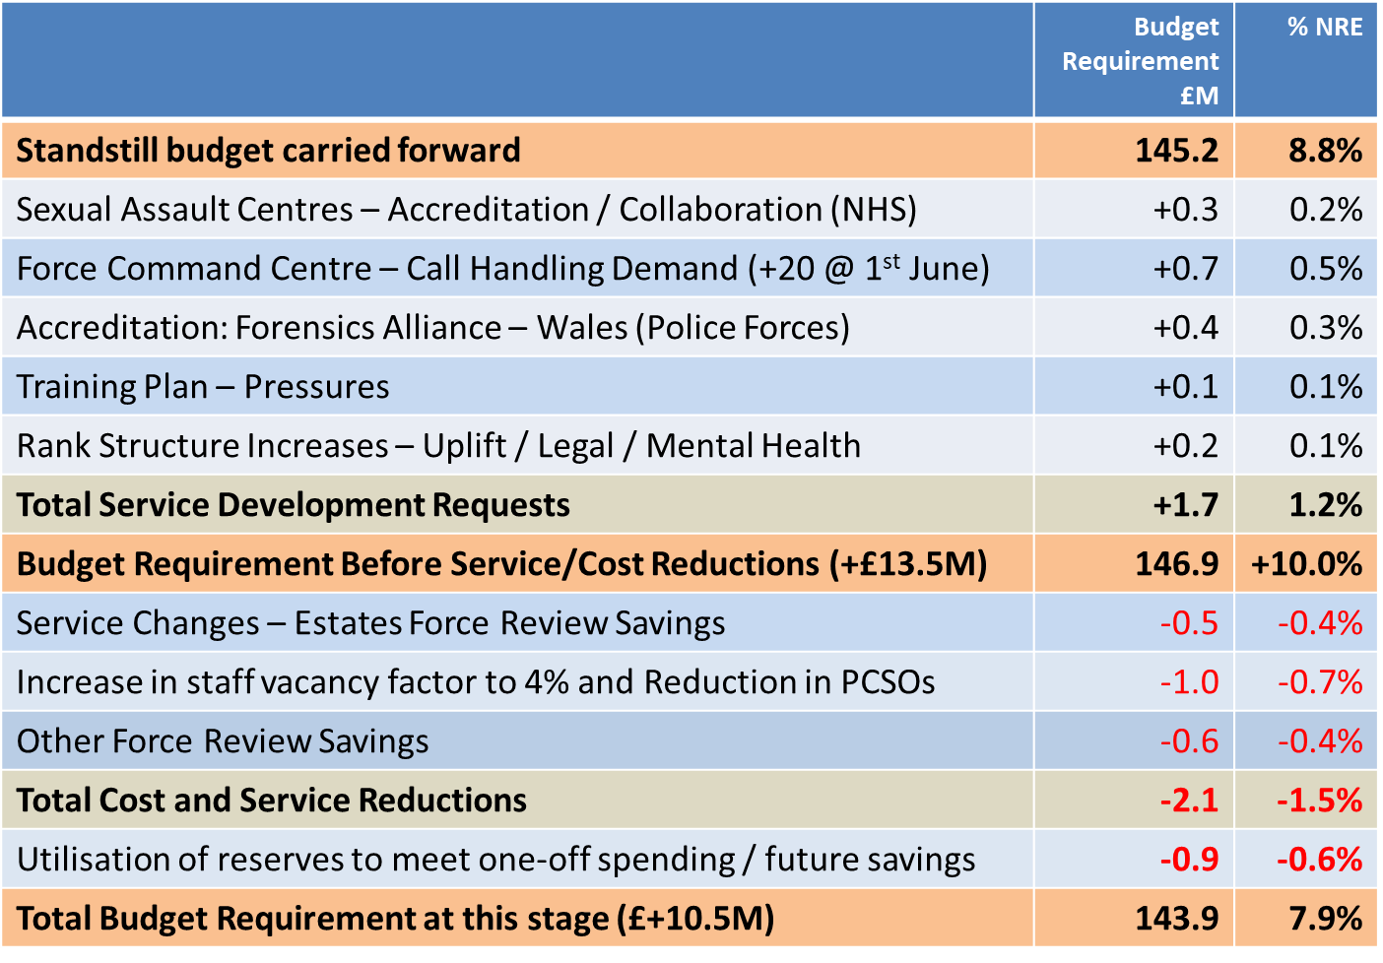

* 1. The long running Regionalisation Project for Sexual Assault Referral Centres with the NHS has made progress with Phase one starting implementation during 2023 with associated increased costs of £0.3m falling in 2024/25.
  2. As part of the last HMIC PEEL inspection, a number of observations were made in relation to the Force’s call handling arrangements which also reflected community concerns. An area for improvement was raised for the Force to reduce the number of non-emergency calls that are abandoned by the callers. It was reported that this was running at rate of 25.9% between May 2022 and April 2023.
  3. Detailed analysis has been undertaken to understand the extensive and growing demands on the Force Control Centre and modelling has been undertaken to assess the optimal level of resourcing that would be required to better meet demands and reduce the abandonment rate to below 10%. It is estimated that this would require an increase of 20 FTE in this area at a part year cost of £0.7m from 1st June 2024 being incorporated in this budget position and MTFP.
  4. This area of business is critical to both accessibility of services and is, for many, the first point of contact. It is assessed as being the top priority of the Force. Significant investment in the upgrade of telephony systems is also on schedule for delivery in 2024 which will also contribute to meeting this target.
  5. The Force has also prioritised cost growth of £0.4m associated with a collaborative project for the establishment of a Welsh Forensic Alliance. All forces forensic units in Wales have been working towards accreditation for several years and many traditional forensics disciplines such as Fingerprint Bureau, Fingerprint Development Laboratories and Footwear Identification Units (Physical Forensics) have achieved accreditation over this time and remain settled business areas.
  6. Other forensic disciplines including Crime Scene Investigation (CSI) and Forensic Collision Investigation Units (FCIU) are at the very early stages of the accreditation journey which will take several years to achieve full compliance.
  7. Digital Forensics is a business area to which accreditation requirements are being extended with a mixed landscape across all forces in Wales in terms of readiness. This forensic discipline has its own challenges relating to accreditation as processes are complex, rely on numerous third party software suppliers which are subject to regular updates in hardware resulting in constant process change. Validation requirements within these three new areas are significant and challenging.
  8. Although some national funding has been provided to establish a Forensic Capability Network (FCN) covering England and Wales, this is resulting in the production of guidance rather than the delivery of completed products to assist forensic units. The release of these is often not aligned to force timeframes or accreditation journeys.
  9. The Statutory Forensic Science Regulator (FSR) has published the new FSR CODE which came into force in October 2023. This places greater pressure on forces as accreditation is no longer optional. Dates to achieve accreditation are clearly set and declarations must be made to state compliance as part of criminal proceedings which can be taken into consideration by the court.
  10. All forces are seeing the demand for Quality Management staff increase as well as the need for Technical Managers within each forensic discipline to ensure accreditation is achieved and compliance is maintained. This is resulting in increased costs and recruiting challenges for all Welsh forces. This budget requirement will enable a collaborative approach across Wales which includes standardisation of processes under a lead Force Model with a view to minimise the collective risk and financial burden of accreditation for Police Forces in Wales.
  11. The Force has also included cost pressures from training and rank structure / police regrading within its budget requirement.
  12. The budget position is mitigated to some extent by reductions in budget that have been achieved from the Force Review both in terms of Estates changes and other departmental initiatives. In addition, the Force has increased its assumptions on staff vacancies which will reduce costs by £0.4m in addition to cost reductions of £0.6m from the reduction in PCSO numbers from 163 FTE to 144 FTE by March 2024, and to 132 FTE by March 2024 as highlighted above.
  13. The budget requirement position highlighted above includes some one-off items and potential future savings areas that can be funded from reserves. The Force is on target to deliver a planned underspend £1.7m in the current year with £1.1m of this being applied to increase direct revenue financing of capital sustainability projects in the 2023/4 capital programme and with the remaining £0.6m being used to offset one off pressures in the budget.
  14. In total, a sum of £1.129m (+£0.9m) in reserves will be utilised for revenue purposes as summarised in the Table below:
  15. Both the Commissioner and Chief Constable recognise the need to ensure that precept increases are reflective of the wider economic climate and the cost-of-living pressures that continue to be faced by the public. The Force review has delivered significant cost reductions and phase two will continue to focus on a number of specific areas which will include delivery of the total savings of £2.1 million needed to balance spending.
  16. A summary of the impact of these measures is included below:

**Table 15 – 2024/25 Budget Requirement**

|  |  |  |
| --- | --- | --- |
|  | **Budget Requirement £m** | **% NRE** |
| **Carry Forward Revenue Budget Position** | **£145.031m** | **8.7%** |
| **UTILISATION OF RESERVES (£0.3m to £1.1m)** |  |  |
| Utilisation of reserves to smooth Sexual Assault Centre Costs in 2024/5 | -0.054 | -0.0% |
| Force Review Team – backfilling costs (Year 2) | -0.242 | -0.2% |
| PEQF training Contract – future year cost reductions | -0.238 | -0.2% |
| Forensic Alliance – One-off costs in 2024/5 and 2025/6 | -0.203 | -0.2% |
| Chief Constables Reserve Utilisation – Summer Demand | -0.150 | -0.1% |
| Proceeds of Crime Act and Incentivisation Funds | -0.094 | -0.0% |
| Additional Contributions – Driver Retraining and Commissioning | -0.148 | -0.1% |
| **Final Budget Requirement** | **£143.902m** | **7.9%** |

* 1. The reduction in the budget requirement from £146.9m to the final budget requirement of £143.9m represents a net reduction of £3.0m to be delivered through the utilisation of reserves and from Force Review cost and service level reductions. There continue to be financial and operational risks inherent in terms of:
     + Embedding of Force Operating Model and dealing with residual backlogs.
     + Ongoing recruitment challenges.
     + Reduction in PCSOs (albeit at a protected level) services and police staff positions including a higher level of vacancies.
     + Inflation risks in terms of pay and non-pay assumptions.
     + Delivery risks for phase two Force Review Programme.
     + Risks to the in-year spending position due to unforeseen pressures.
     + Future risks in terms of further increases in borrowing costs or capital scheme costs.
  2. The overall result of the settlement, budget required, savings plan and proposed precept has resulted in the following balanced budget being prepared. A fuller breakdown for 2024/25 to 2028/29 is provided in Appendix A.

**Table 16: Summary Budget Requirement and Funding 2024/25**



1. **Medium Term Budget and Outlook**
   1. Despite the reduction in inflation, as detailed in section 5, the assumptions for the medium-term budget continue to be a little challenging, given the changing forecasted positions and the array of financial, economic uncertainties and world affairs which collectively impact.
   2. The discipline of maintaining a Medium-Term Financial Plan (MTFP) that is based on a set of reasonable assumptions is, however, vital to setting a balanced budget for the 2024/25 financial year and indicative budgets and precept levels for future years. Maintaining financial resilience and ensuring sustainability for not just one year but into the future is absolutely critical.
   3. It is expected that pay and price inflation will continue to exert pressure on the costs of providing policing services over the planning period of the MTFP. The assumptions are linked to the latest Office of Budget Responsibility (OBR) report, which predicts that inflation will continue to fall but at a much slower rate than they anticipated last year or indeed earlier this year. The Bank of England expect inflation to be back to around 2% by the end of 2025.

**Table 17 – MTFP Inflation Assumptions**

|  |  |  |  |  |  |
| --- | --- | --- | --- | --- | --- |
| **Budget Assumption %** | **24/25** | **25/26** | **26/27** | **27/28** | **28/29** |
| Police Officers | 2.5% | 2.5% | 2.0% | 2.0% | 2.0% |
| Police Staff | 2.5% | 2.5% | 2.0% | 2.0% | 2.0% |
| Pensions Increase | 6.7% | 2.5% | 2.0% | 2.0% | 2.0% |
| General Inflation | 3.0% | 2.5% | 2.5% | 2.0% | 2.0% |
| Utilities/Fuel | 3.0% | 2.0% | 2.0% | 2.0% | 2.0% |
| Specific Grants | 0.0% | 0.0% | 0.0% | 0.0% | 0.0% |
| PFI/ Capital Financing Grant | 0.0% | -10.0% | -10.0% | -10.0% | -10.0% |
| Core Grant | As per settlement | 2.0% | 2.0% | 2.0% | 2.0% |

* 1. In terms of exposure to risk and the sensitivity to variations and differences between the budgeted and actual inflationary increases, the following tables provide indications of the impact of a 1% variation for a financial year:

**Table 18: Impact of 1% Change on Costs**

|  |  |  |
| --- | --- | --- |
| **Heading** | **Assumption** | **Impact** |
| **Expenditure** |  | £'000 |
| Officer Pay | 1% for 7 Months | 523 |
| Staff Pay | 1% for 7 Months | 246 |
| Non-Pay | 1% Annual | 340 |
| Capital | 1% Interest | 107 |
|  |  | **1,216** |
| **Income** |  |  |
| Income | 1% Annual | -98 |
| Grants | 1% Annual | -174 |
| Settlement | 1% Annual | -610 |
|  |  | **-882** |

* 1. Specific grants remain a risk for the organisation, and it is apparent from the late notification of significant reductions of PCSO funding and withdrawal of Schools Liaison Programme funding by Welsh Government that there is no certainty of continuation. The risks surrounding specifics grants need to be recognised as these are integral to underpinning a range of policing services. Grants which underpin police officer salaries also carry the attached risk due to the stringent requirements of the Police Uplift Programme.
  2. The absence of information for future settlements remains concerning. The MTFP reflects an assumed annual increase in core grant settlements of 2% over the planning period. Clearly this remains an area of uncertainty and the lack of multi-year settlements, impending general election and changing OBR inflationary forecasts make accurate financial and strategic planning extremely difficult.
  3. The Home Office have continued their work on the review of the police funding formula but despite their ambition to implement changes to the formula in the lifetime of this parliament, this is now extremely unlikely, if not impossible, due to the impending General Election.
  4. It is believed that the next stage will form a consultation on the approach and principles but both content and timings are unclear. The Home Office previously consulted on the additional costs of rurality and seasonality. The Force made a robust submission as these factors would both impact substantially. So far there has been no indication of how transitional arrangements would be applied, including considerations to floors and ceilings. The interaction between the uplift grant and allocations of officer numbers will also be an area of specific interest in any proposals.
  5. At this time, there is no basis on which to make an informed assumption within the MTFP. Using a figure for example, from the aborted exercise in 2016, would be unreliable. With changing crime types, our share of national crime now exceeds our formula share of 0.71% which was not the case in 2016. This was evident in the case which was presented to Members of Parliament (MPs) in July 2022 and the submission to the Home Office as part of the specific consultation on rurality.

**Picture 6 Formula Funding – Key Facts 2016 v 2021**

**2021 2016**

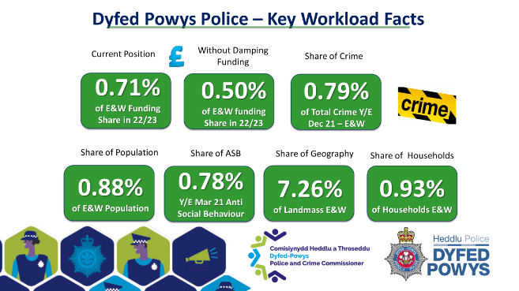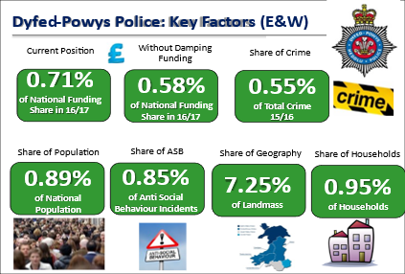

* 1. Given the scale of impact that the review of funding formula could have, both the Commissioner and Chief Constable have agreed to record this eventuality on the Strategic Risk Register. There is no doubt that any significant reductions in central grant funding would have serious implications on police services and the communities of the Dyfed-Powys area. A specific Gold Group would be established to develop sustainable plans for operational and organisational models to meet the potential scenarios.
  2. For MTFP purposes, a forward precept assumption of 5% has also been incorporated at this stage, along with an assumed taxbase increase of 0.8%.

1. **Savings/ Cost Reduction Plans and Force Review**
   1. In addition to increases in base costs, a cost and service reduction plan has been developed that aims to deliver an additional £5.0m savings over the next five years in addition to the £6.3m already delivered during 2023/24.

**Table 19 – Savings Plan/ Force Review**



* 1. The Force review will continue to further develop the forward savings/ cost reduction plan aligned with the force operating model. As previous, there is a keen desire to protect police staff jobs where possible and minimise functions where police officers will be undertaking work that would more appropriately and economically delivered by police staff, although this will be kept under active review as part of financial sustainability, recognising the constraints of the police uplift targets.
  2. The Force Review is now formally entering a second phase with the following objectives:
* Continue to meet the objectives of both the PCC’s Police Crime Plan and Chief Constable’s priorities, thereby improving the quality of service to the communities of Dyfed-Powys Police,
* Improve the response to victims of Domestic Abuse,
* Review resourcing and supervision within Uniform Response Policing to improve resilience and safety,
* Prioritise a programme of continuous improvement to enhance productivity, effectiveness, and efficiency,
* Improve crime and incident triage, assessment and recording processes to reduce demand,
* Review the current and future service delivery model within Dyfed-Powys Police,
* Support the wellbeing of officers and staff to increase engagement and retention,
* Improve the wider police officer supervision model including spans of command and command resilience,
* Articulate potential issues resulting from the decommissioning of, or decisions to deprioritise areas of work, supporting operational and strategic objectives,
* Support the delivery of further procurement and non-pay savings,
* Maximise opportunities for collaboration,
* Explore opportunities to deploy emerging technologies to maximise efficiency and effectiveness,
* Continue to review assets including premises, ICT and fleet,
* Maximise opportunities to enable sustainability and income generation.

1. **Capital Investment Plans**
   1. Assets are vital to the delivery of efficient services and should be well managed and maintained. Strategies for Estates Management, ICT and Vehicle replacements underpin the Capital Strategy, as detailed in Appendix F.
   2. The Capital Programme and financing which covers the revised position for 2023/24 through to 2028/29 is summarised below:

**Table 20- Capital Programme 2023/24 – 2028/29**



* 1. Work has continued through the Strategic Finance and MTFP Board to continue to consider and prioritise financial and investment requirements over a longer time frame. Whilst it contains several assumptions and uncertainties, the Capital Programme in Appendix G shows an extended projection covering a 10-year period. This programme will be revisited as clarity arises and annually, as part of the formal budget and precept setting.
  2. The draft capital programme requires total funding of £81.7m for 2023/24 to 2028/29 with £11.3m now being planned to be spent in 2023/24. For the current capital programme to be fully financed over the next five years, capital reserves will be depleted by the end of 2026/27.
  3. It is foreseen that external borrowing of £46.0m will be needed to fund the programme 2023/24 – 2028/29 and the full debt charges associated with this have been built into future revenue budgets in this medium-term financial plan. Most of this borrowing will be linked to new assets and fund the building of a new station and custody facility for Carmarthenshire; provide a solution to the ageing police facility in Brecon, along with the new training facility for the Joint Firearms Unit.
  4. Borrowing will also be required to support the extensive investment requirements in maintaining the estate and critical ICT infrastructure to support the effective delivery of policing services, as well as for cost saving sustainability schemes.

1. **Impact on Reserves**
   1. In accordance with the Home Office Financial Management Code of Practice (FMCoP), the Commissioner considers the role of reserves when compiling the MTFP and annual budget. The Commissioner, supported by his Chief Finance Officer (CFO), holds the responsibility for ensuring the adequacy of reserves each year so that unexpected demand-led pressures on the budget can be met, without adverse impact on the achievement of the key priorities.
   2. The FMCoP requires the Commissioner to establish a strategy on reserves in consultation with the Chief Constable. This Strategy is shown in Appendix D and details the approach for 2024/25 and beyond.
   3. In considering resilience and sustainability factors, the Commissioner keeps earmarked reserves under review, not only formally when completing the Statement of Accounts, but also during the year when considering financial management reports and preparing the MTFP. These assessments and in-year financial position have allowed for some planned mitigation of one-off pressures and cost burdens to be met by reserves.
   4. As part of the proactive steps taken during the year by both the Commissioner and Chief Constable, the General Reserve was increased at the end of 2022/23 to £4.9m which undoubtedly provides some improvement in financial resilience. A pay award reserve was also established to mitigate against higher than anticipated awards during 2023/24. Additional grant was received in year to assist in meeting the 7% pay award. The forecasted position assumes that this reserve is reduced to £0.4m which would prudently provide mitigation if pay awards were 0.5% higher than those assumed for 2024/25.
   5. With prudent financial management, financial resilience, and sustainability in mind, the 2023/24 in-year forecasted financial position and existing reserves have been critically reassessed with some reclassifications where appropriate. This will allow for the creation of a Budget Mitigation Reserve to be used to smooth peaks in expenditure and fund one-off pressures in the next few financial years, therefore easing the budget requirement burden.
   6. The following table provides a summary position with further detail provided in Appendix E.

**Table 21 – Reserves Projections 2023/24 to 2028/29**

* 1. The General Reserve is planned to be maintained at £4.862m over the course of the MTFP period, which sees overall reserves available for utilisation by the Commissioner fall in a planned manner from £19.981m in March 2023 to £6.546m by 2029. In terms of financial resilience and prudent financial management, the existence of reserves built up in recent years has been fundamental in allowing the Commissioner to fund one off costs pressures, ease burdens arising from peaks in expenditure profiles and allowed a balanced budget.

1. **Medium-Term Financial Plan Summary** 
   1. Based on the assumptions detailed above and taking cognisance of forecasted pressures and cost savings/ reductions, a summarised revenue budget position covering the period April 2023 to March 2029 is shown in Appendix A, with a variation statement shown below for the period of the MTFP:

**Table 22 – MTFP Variation Statement 2024/25 to 2028/29** 

* 1. Although a balanced budget is presented for future years, it is important to recognise that the cost reduction plan is reflected and note the risks regarding uncertainties around inflation, core and specific grant funding, service demands and the formula funding review.

1. **Section 25 and Budgetary Risk**
   1. Section 25 of the Local Government Act 2003 requires that the Chief Finance Officer (CFO) report to the Commissioner, at the time the budget is being set, on the risks and uncertainties that might require more to be spent on the service than planned, and the adequacy of financial reserves. This report is shown in Appendix B.
   2. Allowance is made for these risks by:

* making prudent allowance in the estimates; and in addition
* ensuring that there are adequate reserves to draw on if the service estimates turn out to be insufficient.
  1. It is important that budgetary risk has been minimised when the budget is set. The level of budgetary risk must be formally considered by the Commissioner, informed by the advice and judgement of their CFO.
  2. Appendix C also outlines a risk impact assessment across various budget headings and based on the percentage of the net revenue budget and the known factors, which could influence levels of actual expenditure or income.

1. **Public Consultation and Opinion**
   1. On the 2nd November 2023, the Commissioner launched a public consultation on the police precept for 2024/25. It was important to the Commissioner that he sought the views of the public and the Dyfed-Powys Police workforce. He urged all to voice their opinion on this critical issue, to ensure that as a Police Force, Dyfed-Powys Police can continue to safeguard its communities with the highest standard of service available.
   2. To assist the public in providing their views, a survey was created and promoted widely. A total of 835 people responded to the consultation, with 627 of those answering the following question on the precept level:

**Do you think funding for Dyfed-Powys Police should be:**

**Table 23 Public Consultation Responses**

|  |  |
| --- | --- |
|  | **Responses** |
| **Enhanced** – would allow for enhanced levels of service provision. | **154 (24.6%)** |
| **Increased** - would meet inflationary and cost pressures, avoid cuts to services and allow for limited investment for service improvements. | **268 (42.7%)** |
| **Minimal** – would not meet all inflationary and cost pressures and would require reductions to service. | **70 (11.2%)** |
| **Frozen** - at 2023/24 level which would not meet inflationary and cost pressures requiring extensive reductions to services. | **135 (21.5%)** |
| **Total** | **627** |

* 1. Whilst it was disappointing to see a decrease in responses to this year’s consultation, it was pleasing to see that to highlight that 67.3% of responses supported either an enhanced or increased level of funding.
  2. Respondents were also given the opportunity to provide comments, which have been analysed with some broad themes seeing significant levels of support, importance of police visibility, concerns regarding crime levels, government policy, some critical commentary on service delivery, and concerns around the impact of the cost-of-living crisis.

1. **Conclusion**
   1. As outlined in the Commissioner’s summary, given the historic funding decisions and ongoing financial challenges and operational requirements that both Dyfed-Powys Police and the wider police service face, it is vital to secure a Police Precept which will safeguard policing and support the continued delivery of the priorities set out in the Police and Crime Plan in both a sustainable, but prudent manner.
   2. The content of this report sets out the array of internal and external factors and considerations, which have informed the development of the MTFP.
   3. The Commissioner submits a precept proposal for 2024/25 and assumptions that underpin the MTFP to 2028/29, which will seek to raise the average band D property precept by £1.62 per month or **£19.38 per annum** to **£332.03, a 6.2% increase**. This increase will raise a total precept of £79.364m. This will provide a total of core central and local funding of £143.902m, representing an 6.0% increase on the revised funding level in 2023/24.
   4. The impact of this Police Precept on each property banding are shown below:

**Table 24 - Council Tax Bandings**



18.5 After taking account of the cost reduction plan, this level of funding will seek to allow the Force to continue to deliver their operational and strategic plans, provide some investment to improve accessibility and maintain an appropriate level of PCSOs provision despite funding cuts. This level of funding should positively impact the standards of service that the public can expect. The financial and operational landscape will undoubtedly remain challenging and will continue to be an area of focus for future strategic planning.



1. Section 25 of the Local Government Act 2003 requires that the Chief Finance Officer (CFO) report to the Commissioner, at the time the budget is being set on the following matters:

* the robustness of the estimates made for the purposes of calculations;
* and the adequacy of the proposed financial reserves.

1. Both the Commissioner and Police & Crime Panel (P&CP) are required to have regard to this report when considering and making decisions in connection with the budget.
2. As we know, the last few years have been unprecedented for a variety of reasons, but 2023/24 has once again continued in this vein with an unsettled economy, continued high interest rates, wars in both Ukraine and Gaza, recent shipping attached in the Red Sea along with political uncertainty and an impending general election.
3. Extensive pressures within the public sector continue to be well documented which are now seeing implications for service provision and specific grant funding.
4. Detailed discussions have been ongoing throughout 2023/24 in relation to in-year financial management and the MTFP. These have taken place within both an informal setting between the Director of Finance (DoF) and I, within a formal Force and Office of the Police and Crime Commissioner (OPCC) governance structure, as well as the series of Precept and MTFP meetings between the Commissioner, Chief Constable, DoF and myself.
5. Having recognised the extent of the future financial challenges, the Chief Constable established a Force Review team in mid-2022 as well as taking a range of early steps to proactively contain expenditure within 2022/23, which could then mitigate financial burdens as well as assisting in meeting one-off cost pressures in 2023/24.
6. In order to set a balanced budget for 2023/24, the Force identified a large and ambitious savings plan and have been successful in delivering this, albeit that there have been some organisational and operational consequential impacts. It is however recognised that efficiencies and cost reductions are proving harder to achieve and the constraints of the Uplift Programme continue to inhibit the optimal resource mix for the Force.
7. The proposed budgets that have been presented during the year are based on a comprehensive line-by-line assessment of inflation assumptions. To inform the assumptions, both the DoF and I have taken cognisance of a wide range of financial and economic data, including the very comprehensive report issued by the Office of Budget Responsibility (OBR) as well as continuing to engage closely with professional networks.
8. The Chief Constable has transparently set out his Budget Requirement at each stage and has documented the changes as they have materialised or crystalised during this period. It must be recognised that a considerable number of assumptions and estimates are used to construct the budget requirement. This is not and cannot be an exact science, and variations will be inevitable.
9. Although the MTFP has sought to make proper provision for realistic pay and price increases, and achievable levels of income, it must be recognised that there is climate of risk due to complexity of issues that are currently at play.
10. Whilst additional grant has been allocated on a recurring basis to assist in meeting the 7% pay award which was awarded during 2023/24, the settlement does not take into account of pay or wider inflationary pressures for 2024/25. Clearly with such a large proportion of the expenditure budget circa 75% being spent on pay, any variance between assumed and actual pay awards can have significant ramifications. For scale and sensitivity purposes, a 1% variation would have a part year effect of £770k (award from September).
11. Having taken cognisance of inflation forecast, the planning assumptions include a 2.5% pay award from September 2024. However, given the wider uncertainties and in order to contain the impact on local taxpayers, the Commissioner is planning to retain a reserve which would mitigate an 0.5% increase in pay awards.
12. Risks have previously been highlighted in relation to uncertainties regarding specific grants. The impacts of Welsh Government’s financial deficits have unfortunately seen these risks materialise with significant reductions to PCSO funding and the complete withdrawal of the All-Wales Schools Programme. These two instances highlight the precarious nature of policing activities which are underpinned by specific grant funding. Dealing with these cuts is not only impactful for service delivery, but in some instances is intertwined with requirements for the Police Uplift Programme.
13. There are also risks with uncertainties around the formula funding review, and the lack of multi-year funding settlements which provide no certainty for robust strategic and financial planning.
14. There was a significant increase in tax base for 2024/25 in relation to constituent authorities’ decisions in relation to premiums for second homes and empty properties. Clearly significant changes in the profile of these could impact on future tax base calculations and this should be noted as a risk.
15. Reserve levels are considered in the context of risk, which comply with The Chartered Institute of Public Finance and Accountancy (CIPFA) guidelines, which state that “*in order to assess the adequacy of unallocated general reserves…. take account of the strategic, operational and financial risks facing the authority*.”
16. The adequacy of general reserves continues to be closely monitored to ensure that it is maintained at a sustainable level. The increase at the end of 2022/23 provides additional financial resilience.
17. The assumed profile of funding and cost of services within the MTFP sees a reduction of the General Reserve falling from 3.64% of Net Revenue Expenditure at the end of 2023/24, to 2.87% by the end of 2027/28. This reduction is due to the increases in the net revenue budget rather than the utilisation, with general reserves remaining at £4.862M. It is vital and prudent that this balance is maintained to allow for unforeseen burdens and operational requirements. It is also important to note that even in a scenario where there may be eligibility for a Special Grant, costs up to the equivalent of 1% of net revenue budget (£1.439M for 2024/25) would ordinarily need to be met locally.
18. Ongoing review and consideration are given to earmarked reserves to assist in meeting particular initiatives or to mitigate against specific risks. In preparing the MTFP, consideration has been given to the anticipated in-year financial monitoring and a number of movements and reallocations have been proposed to the Commissioner to assist in mitigating one-off pressures, but this will not be finalised until the year end.
19. Despite the assumed increases in council tax precept, there will be a need for continued savings/efficiency requirements over the term of the MTFP and the uncertainties around future core and specific grant funding set against the wider economic landscape, meaning that the financial environment is likely to remain challenging for the foreseeable future.
20. I am content that the MTFP has fully considered and documented the array of known issues and assumptions which impact over the planning period to produce a balanced budget for 2024/25. I can confirm that the revenue and capital estimates contained in this MTFP are considered robust and that the level of reserves is considered adequate. Dyfed-Powys Police will however continue to operate in a challenging environment and there is a need for continued focus to ensure financial resilience and sustainability to protect the communities of the Dyfed-Powys area.

**Beverley Peatling**

**Chief Finance Officer (CFO) to the Police and Crime Commissioner for Dyfed-Powys**

| **Budget area** | **% of net costs** | **Risk level** | **Identified Risk** | **Mitigating factor** |
| --- | --- | --- | --- | --- |
| Police Officer Salary Costs and Pensions | 64.6% | High | Additional grant was provided in 2023/24 to partly mitigate the costs of the 7% pay award. This funding has been consolidated into the core grant for 2024/25 along with the additional funding to meet the full year impact. This funding was however allocated on the basis of grant formula which is not consistent with pay profiles for forces. Ministers have made a verbal suggestion that future pay awards above 2.5% may be supported by grant but this is not certain and if same formula was used as the allocation basis again, this would result in a shortfall for Dyfed-Powys Police.  There is a direct link with the specific grant for Police Uplift which has increased significantly and has stringent conditions attached in relation to officer numbers at reporting points of September and March each year. There are indications that these requirements and penalties will be increased for 2024/25.  UK Government expectations and conditions of the grant to support Operation Uplift will contradict and hinder the Force in its transformation and ability to meet future efficiency and saving requirements.  This budget is very sensitive to changes in police officer numbers and the complexities in managing retirements, ill-health retirements, retention, recruitment of new recruits, as well as meeting requirements attached to the Police Uplift programme.  Increased financial impact as a consequence of an earlier timing of the pay award.  Operational demands require overtime.  The number of officers in post increases above the approved funded establishment.  Additional specific grant funding was received for 2024/25 to mitigating the impact of the 2023 pensions valuation, but there is no certainty of the continuation of this grant.  Future changes in pension’s valuations remain a risk. | The assumptions around pay awards are based upon an array of financial and economic information which is reviewed on an ongoing basis. A reserve has been established which would mitigate a pay award 0.5% higher than assumed.  There is tight financial control and management of overtime, both by budget holders and the Force Resource Group, with continued strengthening of financial reporting and management information. Budget holders are well aware of the financial challenges and their responsibilities for prudent financial management, with a strong ethos and awareness of the need for financial control.  A Chief Constable Contingency Fund was established to ease the peaks and troughs of major and critical incidents.  Finance representation on all gold groups and other operational investigation groups occurs as a matter of course. This enables overtime and other costs to be closely monitored at each meeting, with timely reporting facilitating decision making.  The establishment is monitored through formal governance and in detail by the Force Resource Group.  People Services has a strategic workforce recruitment plan for the year ahead based on the projected number of police officer retirements, leavers, transferees, and additional officers as part of the Police Uplift Programme. The required intake of probationers is planned and allocated accordingly, with strengthening of arrangements to ensure that the Home Office targets are met, with additional reporting to the Home Office throughout the year.  Continuing representations to the Home Office through respective groups in relation to the wider implications and perhaps unintended consequences of Operation Uplift, despite the headline announcements within the three-year funding settlement.  The pay budgets are continually monitored as part of the budgetary control process, with formal reporting throughout the governance structure. Financial performance is discussed regularly by the Commissioner and Chief Constable at Policing Board, Policing Accountability Board and within dedicated Finance Seminars with both the Police & Crime Panel (P&CP), Joint Audit Committee and Audit Wales. Financial matters are also covered in the Finance and Strategy Board, Strategic Finance and Procurement Group and MTFP Group.  Overtime is routinely and closely monitored with Finance Business Partners closely engaged with Budget Holders.  Representations will be made in relation to uncertainty relating to both the specific grants for the Police Uplift Programme and Pensions. |
| Police Staff Salary Costs (including Police Community Support Officers [PCSO’s]) | 29.8% | High | Additional grant was provided in 2023/24 to partly mitigate the costs of the 7% pay award. This funding has been consolidated into the core grant for 2024/25 along with the additional funding to meet the full year impact. This funding was however allocated on the basis of grant formula which is not consistent with pay profiles for forces. Ministers have made a verbal suggestion that future pay awards above 2.5% may be supported by grant but this is not certain and if formula was used as the allocation basis again, this would result in a shortfall for Dyfed-Powys Police.  Welsh Government funding for PCSOs has been significantly reduced and there is a risk of further reductions. PCSOs are an integral part of Neighbourhood Policing, and the operational impact of reductions is significant.  Assumptions have been made in relation to future pay awards but until finalised they remain uncertain and therefore a risk.  The number of staff in post increases above the approved funded establishment.  Overspends within overtime as a consequence of organisational, operational demands and vacancy levels.  Organisational and operational risk associated with the implications of the Force Review and restructure. | The assumptions around pay awards are based upon an array of financial and economic information which is reviewed on an ongoing basis. A reserve has been established which would mitigate a pay award 0.5% higher than assumed.  The establishment is monitored through formal governance and in detail by the Resource Management Board. A Gateway process monitors and controls all changes to establishment and indeed all posts are reviewed and considered fully before being advertised.  The pay budgets are continually monitored as part of the budgetary control process, with formal reporting throughout the governance structure. Financial performance is discussed regularly by the Commissioner and Chief Constable at Policing Board, Police Accountability Board and within dedicated Finance Seminars with both the Police & Crime Panel (P&CP), Joint Audit Committee and Audit Wales. Financial matters are also covered in the Finance and Strategy Board.  Staff pay budgets and overtime are routinely and closely monitored with Finance Business Partners closely engaged with Budget Holders.  Representations to Welsh Government will continue to seek certainty over future funding to support PCSOs. |
| Indirect Staff Costs | 1.3% | Medium | Insurance costs significantly increase due to market conditions and pressures within the Bluelight arena.  Costs of training/Policing Education Qualifications Framework (PEQF) increase, and uncertainties continue in relation to longer term funding arrangements of the Apprenticeship levy. | Training budgets have been set to reflect operationally critical requirements. Budgets are monitored on a monthly basis and a Training Prioritisation Group considers training priorities before training is delivered.  Insurance pressures have been recognised within the budget and a reserve has been created to mitigate against insurance related exposure.  The Commissioner and Chief Constable continue to discuss and monitor training requirements at Policing Board.  Although funding continues to be received, discussions will continue with the Home Office in relation to a final solution for funding to support PEQF. |
| Premises Costs | 4.2% | Medium | Despite a programme of work to address the condition of the estate and maintenance backlogs, increased revenue costs may be required to ensure that the estate is maintained as a safe working environment for staff and officers.  Increasing electricity and gas costs as a result of economic and market conditions and more extreme weather conditions. | The estates requirements of the capital programme are considered as part of Medium-Term Financial Strategy and annual budget setting process and have been subject to specific review by the Finance and Strategy Board.  There has been continued strengthening of governance arrangements around Estates. The Strategic Estates Group brings together key staff from the Commissioner’s office and the Force to meet monthly to discuss estates matters including finances. Considerable work has been undertaken by this group to develop a risk-based prioritisation methodology for maintenance works. Matters are escalated to the Finance and Strategy Board, which is chaired by the Deputy Chief Constable.  National negotiation of energy contracts through Bluelight Commercial.  Review of energy utilisation to seek efficiencies and ‘invest to save’ opportunities.  Submission of grant application in relation to funding for sustainability initiatives.  The Sustainability Group will consider further opportunities and oversee the Sustainability and Transformation Reserve. |
| Transport Costs | 1.7% | Medium | Although there are planned changes to the fleet size, the costs of fuel are prone to significant market fluctuation which could increase in running costs.  Market conditions continue to be challenging as a consequence of world events and economic landscape. | The fleet requirements of capital programme are considered as part of the Medium-Term Financial Strategy and annual budget setting process and has been subject to specific review by the Finance and Strategy Board.  The Strategic Vehicle Group meets to discuss the vehicle fleet – the group is chaired by the Director of Finance (DoF) with matters being escalated to the Finance and Strategy Board.  Fuel prices are monitored, and their impact regularly assessed through the robust budget monitoring procedures that are in place.  Telematics data is allowing the Force to monitor vehicle usage and optimise the size of the fleet.  The capital programme includes provision for the continued adoption of electric vehicles, which will reap efficiencies and savings.  Market conditions continue to be monitored at a local, regional and national level. |
| Supplies and Services and Commissioning | 11.7% | Medium | Orders outside of the approved procurement framework could result in overspends against the budget.  Market conditions continue to be challenging as a consequence of world events and economic landscape.  Continued pressures and impacts of inflationary increases within Commissioned Services could impact on service delivery. | Purchase orders are processed with a built-in budget check for high value items.  The Procurement Department ensure that the procurement of goods and services are made in accordance with Financial Regulations and Procedures.  Robust budget monitoring procedures are in place and adhered to.  The establishment of Bluelight Commercial continues to facilitate and reap some national, regional and local savings. The Force is fully engaged in the work.  The Commissioner’s commissioned services are managed and authorised by the Director of Commissioning and are overseen by the Commissioning Advisory Board. Additional bids for funding are submitted wherever possible. |
| Agency and Contracted Services | 4.0% | Medium | Additional and increasing costs arising from the collaboration arrangements – specifically the Regional Organised Crime Unit (ROCU), Joint Firearms Unit (JFU) and its training facility. | Continued strengthening of governance, financial management and scrutiny surrounding collaborative arrangements. |
| Capital Financing | 2.6% | High | The scale of the capital investment requirements is significant and increases in interest rates would increase borrowing costs.  Fluctuations and increases in interest rates cause additional financial pressures.  Continued delays and increased costs for ICT programmes.  Increased costs for capital projects. | External advice from Treasury Management Consultants.  The Capital Strategy, Investment Strategy and Medium-Term Financial Plan are aligned.  Capital investment requirements will continue to be actively reviewed by relevant boards and parties.  Regular monitoring of all capital projects, both local and national.  Robust assessment and prioritisation of capital investment requirements through appropriate governance. |
| Specific Grant | -12.1% | High | Critical services that are underpinned by specific grants cannot be sustained causing significant impacts for operational and organisational delivery.  Additional financial burdens incurred as a result of lost/ reduced grant funding.  Grants should be utilised in accordance with the terms and conditions of grant.  Grant providers may cease payments of grant with minimal notice.  Home Office specific grants for pensions and police uplift programme are increasing and there is no certainty over future funding.  Changes in political landscape and policies with an impending election. | Local, regional and national representations continue to be made in relation to the range of specific grants that underpin core policing emphasising the need for longer term certainty.  The assumptions in relation to all specific grants are considered on an annual basis and routinely as part of financial monitoring.  Posts funded by grants should be recruited on a temporary basis for the duration of the grant, wherever possible, with all changes to these posts being scrutinised by the Establishment Control Group and authorised by the Director of Finance (DoF) and Head of People Services.  All terms of grant are authorised by the CFO.  Comprehensive exit plans continue to be developed for each specific activity supported by external grants.  Commissioned services supported by specific grants are authorised by the Commissioner and the Director of Commissioning after consultation with the CFO. |
| Other Income | -7.0% | Medium | Income targets are under achieved as a result of lower than forecasted activity levels. | The Strategic Finance and Procurement Group consider opportunities for the maximisation of income generation, with budget holders being actively encouraged to develop opportunities. This will be further enhanced by the Force Review in 2024/25.  Income is reviewed and monitored as part of financial management and budgetary control arrangements. |
| Use of Reserves | -0.8% | High | Unexpected demand-led pressures on budgets cannot be met without an adverse impact.  Inflationary pressures higher than those assumed.  Reduced financial resilience as reserves reduce. | Annual review and consideration of the Reserves Strategy, which outlines the approach and arrangements.  Operational reserve to mitigate peaks in critical and major incidents.  Creation of Inflation Mitigation Reserve if in-year position allows.  Insurance reserve created to mitigate against increases in self-insured levels of exposure.  Other specific reserves considered as appropriate to mitigate against one-off pressures.  Formal governance arrangements continue to review medium-term requirements, reserves and funding matters.  Regular monitoring of the financial position occurs through the formal governance structure. |
| Capital | N/A | High | The size, high cost and complexity of capital projects increases the risk of exceeding budgets, time overruns and not achieving the objectives of the original business case.  Considerable strains in market conditions as a consequence of world events and economic landscape.  Continued delays and increased costs for national ICT programmes. | The capital programme is approved and monitored through formal governance arrangements.  There has been considerable focus through the Finance and Strategy Board, MTFP Group and within the Strategic Estates, ICT and Fleet Groups to critically review infrastructure requirements over a 10-year period.  There has been ongoing strengthening in relation to project proposals and business cases and this work will continue in earnest, to ensure that all investments are fully considered, and options appraised, with business benefits being clearly identified.  Regular monitoring of all capital projects both local and national. |

**RESERVES STRATEGY**

**RESERVES, BALANCES AND PROVISIONS**

**1 Introduction**

* 1. The requirement for financial reserves is acknowledged in statute. Sections 32 and 43 of the Local Government Finance Act 1992 which require local authorities in England and Wales to have regard to the level of reserves needed for meeting estimated future expenditure when calculating their budget requirement.
  2. The Financial Management Code of Practice states that the Police and Crime Commissioner (Commissioner) should establish a strategy on reserves (including how they might be used by the Chief Constable) and provisions in consultation with the Chief Constable. This should have due regard to the need to ensure the ongoing funding of policing activities and the requirement to meet exceptional or extraordinary policing operations.
  3. Reserves are an essential part of financial management. They help the Commissioner and Chief Constable cope with unpredictable financial pressures and plan for future spending commitments.
  4. All reserves will be held by the Commissioner and managed to balance funding and spending priorities and to manage risks. This forms an integral part of the medium-term financial planning process.

1. **Definitions**
   1. Reserves and balances are different from provisions from an accounting perspective. In the case of useable reserves (as opposed to unusable reserves) and provisions, both amounts represented on the balance sheet should be matched by physical cash balances, unless internal borrowing has taken place.
   2. **Usable Reserves** – these are balances which are generally held for three specific purposes and are categorised as general reserves or earmarked reserves:

* A working balance to help smooth the impact of uneven cash flows – general reserves.
* A contingency to deal with unexpected events – general reserves.
* A means of building up funds to meet known or predicted requirements – earmarked reserves.
  1. **Earmarked Reserves** – these are balances that are being held by the Commissioner for specific initiatives and purposes.
  2. **Ring-fenced Reserves -** these are balances that are being held by the Commissioner on behalf of third parties and cannot therefore be utilised without specific direction.
  3. **Unusable Reserves** - do not have equivalent cash balances and are held for accounting purposes.
  4. **Provisions** – are required for any liabilities of uncertain timing or amount that have been incurred.

1. **Governance Arrangements**
   1. Minimum governance requirements in respect of reserves and balances are:

* The Commissioner has a soundly based strategy on the level and nature of reserves and balances it needs which will be considered by the Joint Audit Committee;
* The required levels of reserves and balances should be reflected in the annual budget and Medium-Term Financial Plan (MTFP);
* The Commissioner monitors and maintains the level of reserves and balances within the range determined by its agreed policy, advised by the CFO who will ensure that there are clear protocols for their establishment and use;
* The Commissioner retains adequate reserves so that unexpected demand-led pressures on budgets can be met without adverse impact on the achievement of the key priorities;
* The Commissioner’s strategy for reserves and balances is based on a thorough understanding of needs and risks and is properly and clearly reported at the same time the budget and precept are set. The level of balances is kept under review and managed to ensure that financial standing is sound and supports the Commissioner in the achievement of their long term objectives;
* Where target levels for reserves and balances are exceeded, the opportunity costs of maintaining these levels have been established, compared to the benefit accrued.
  1. Locally agreed Financial Regulations and the Scheme of Consent should:
* Contain full details of how the Reserves and Balances strategy will operate locally;
* Ensure that the annual budget includes a realistic amount of operational contingency that is available to the Chief Constable for operational priorities, without the need for additional approval; and
* Make provision, where appropriate, for budgets to be carried forward from one financial year to the next.

**Statutory Responsibilities**

* 1. The *“CIPFA Statement on the Role of the Chief Finance Officer of the Police and Crime Commissioner and the Chief Finance Officer of the Chief Constable”* sets out the five principles that define the core activities and behaviours that belong to the role of the CFO and the organisational arrangements needed to support them.
  2. For each principle, the Statement sets out the governance arrangements required within an organisation to ensure that CFOs are able to operate effectively and perform their core duties.
  3. Governance arrangements required in respect of reserves and balances, and which are the responsibility of the CFO are:
* Ensuring that advice is provided on the levels of reserves and balances in-line with good practice guidance;
* To report at the time, the budget is considered and the precept set on the robustness of the budget estimates and the adequacy of financial reserves, as required by Section 25 of the Local Government Act 2003, and in line with CIPFA guidance.
  1. Both should be undertaken in consultation with the Director of Finance (CFO Chief Constable).
  2. There are also a range of safeguards in place that militate against the Commissioner over-committing financially. These include:
* The balanced budget requirement;
* Chief finance officers’ Local Government Finance Act 1988 Section 114 powers, which require the Chief Finance Officer to report if there is, or is likely to be, unlawful expenditure or an unbalanced budget; and
* The external auditor’s responsibility to review and report on financial standing includes a review of the level of reserves, taking into account their knowledge of the organisation’s performance over a period of time. However, it is not the responsibility of auditors to prescribe the optimum or minimum level of reserves for individual organisations.

**5. Home Office Guidance on Police Reserves**

5.1 On 31st March 2018 the Minister for Policing and the Fire Service published new guidance on the information that each Police and Crime Commissioner (PCC) must publish in terms of police reserves.

5.2 One of the key requirements is that the information on each reserve should make clear how much of the funding falls into each of the following three categories:

• Funding for planned expenditure on projects and programmes over the period of the current medium-term financial plan.

• Funding for specific projects and programmes beyond the current planning period.

• As a general contingency to meet other expenditure needs, held in accordance with sound principles of good financial management.

5.3 The Minister also outlined that future grant funding levels would take into account the transparent publication of this information across the service.

1. **Assessing the Appropriate Level of Reserves**
   1. The Commissioner is responsible for ensuring that the level of reserves is appropriate for local circumstances and is accountable to taxpayers for the decisions made. The CFO (Commissioner) has a duty to provide the Commissioner with the advice they need to make good decisions.
   2. Reserves are maintained as a matter of prudence. They enable the organisation to provide for cash flow fluctuations and unexpected costly events and thereby help protect it from overspending the annual budget, should such events occur. Reserves for specific purposes may also be maintained where it is likely that a spending requirement will occur in the future.
   3. The public’s acceptance of the precept is partly reliant on the understanding that the precept is spent on policing and that only a reasonable and prudent amount of any over-funding is being stored away as a general reserve. Conversely, when unforeseen expenditure arises, it is likely that the public would expect that the organisation would have sufficient resources to cover the expense without recourse to overspend.
   4. In order to assess the adequacy of reserves, the CFO (Commissioner) should include an up-to-date assessment of the strategic, operational and financial risks.
   5. Setting the level of reserves is one of several related decisions that must be taken when preparing the MTFP and the budget for a particular financial year.
   6. Assessing the required level of reserves should involve carrying out an analysis of the Balance Sheet on an annual basis and projecting forward the key items of the Balance Sheet. This projection incorporates forecasting levels of reserves and balances over a three-year time horizon to cover the MTFP and capital programme.
   7. In assessing the level of reserves, due consideration is also taken of the UK Government support arrangements:

* Welsh Government Emergency Financial Assistance Scheme to help Forces faced with financial burden as a result of providing relief and carrying out immediate work in response to large scale emergencies. The scheme is subject to a threshold which is set at 0.2% of the revenue budget.
* Home Office Special Grant to meet additional costs that would be incurred from policing unexpected and exceptional events within their areas. If approved, forces are expected to meet the additional costs of the event up to 1% of the revenue budget.
  1. An effective reserves and balances strategy should consider the organisations approach to treasury management, capital expenditure plans and the need for external borrowing, against the use of balances and reserves.
  2. CIPFA guidance suggests that in addition to cash flow requirements, the following factors should be considered:

|  |  |
| --- | --- |
| **Budget Assumptions** | **Financial Standing and Management** |
| The treatment of inflation and interest rates | The overall financial standing of the organisations (level of borrowing, debt outstanding, council tax collection rates etc.) |
| Estimates of the level and timing of capital receipts | The organisations track record in budget and financial management, including the robustness of the medium-term plans |
| The treatment of demand led pressures | The organisations capacity to manage in-year budget pressures |
| The treatment of planned efficiency savings/productivity gains | The strength of the financial information and reporting arrangements |
| The financial risks inherent in any significant new funding partnerships, major outsourcing arrangements or major capital developments | The organisation’s virement and end of year procedures in relation to budget under/overspends at organisational and departmental level |
| The availability of other funds to deal with major contingencies and the adequacy of provisions | The adequacy of the organisation’s insurance arrangements to cover major unforeseen risks |

* 1. The Commissioner must have due regard to the need to ensure the ongoing funding of policing activities (including the requirement to meet exceptional or extraordinary operations). The annual budget should include a realistic amount of operational contingency to be available to the Chief Constable to meet operational priorities, without the need for additional approval.
  2. The Chief Constable will ensure that the annual revenue budget is sufficient to finance foreseeable operational needs, by presenting a business case as part of the MTFP and annual budget setting process to the CFO (Commissioner) and Commissioner, for one-off expenditure items to be funded from earmarked reserves.
  3. The business case should include consideration of the level of reserves required for major incident investigations and other operational requirements, the amount of reserves required and timescales for their use.
  4. Approval of business cases for the use of reserves will be subject to the authorisation limits set out in Financial Regulations, to assist with day-to-day operational decision making.

1. **General Reserves**
   1. The Chartered Institute of Public Finance and Accountancy (CIPFA) *“Guidance Note on Local Authority Reserves and Balances”* states that a General Reserve is required to act as *“a working balance to help cushion the impact of uneven cash flows and avoid unnecessary temporary borrowing – this forms part of general reserves.”* A General Reserve is also required to act as *“a contingency to cushion the impact of unexpected events or emergencies – this also forms part of general reserves.”*
   2. Whilst CIPFA does not stipulate a minimum or optimal level of general reserve, its general guidance is to establish a reserve representing *“resources set aside for purposes such as general contingencies and cash flow management.”*
   3. Setting the level of earmarked and general reserves is just one of several related decisions in the formulation of the MTFP and the budget for a particular year. Account should be taken of the key financial assumptions underpinning the budget, alongside a consideration of the organisation’s financial management arrangements.
   4. A positive financial position at the end of 2022/23 allowed for the Commissioner to increase his General Reserve from £4.032m to £4.862m which will provide for improved financial resilience to mitigate extraordinary and unforeseen burdens.

**8. Earmarked Reserves including Ring-fenced Reserves**

* 1. The current accounting Code requires the purpose, usage and basis of transactions of earmarked reserves to be clearly identified. A review of the purpose and level of reserves will be carried out annually during the budget setting process and details of the use of reserves included in the relevant note to the Statement of Accounts.
  2. Earmarked reserves are categorised as either “usable” reserves or “unusable” reserves. Usable reserves can be applied to fund expenditure. Unusable reserves are not resources backed and therefore do not have equivalent cash balances.
  3. It is the Commissioner’s policy to use reserves to assist in funding non-recurring purchases and mitigate peaks in spending profiles to reduce the impact on the council tax precept. This includes using capital reserves to reduce the Capital Financing Requirement (CFR), if appropriate, which in turn will reduce the Minimum Revenue Provision charged to the revenue account annually.
  4. Reserves will be assessed annually as part of the MTFP process but also both during the year and formally at year end. Considerations will be given to the continued requirement of all reserves which may be reallocated as appropriate. The level of earmarked reserves will therefore fluctuate annually but will always be justifiable and monitored to ensure levels of earmarked reserves are not too high or too low. Should the Commissioner deem that the level of usable reserves that he holds is above and beyond the levels reasonably required and specifically earmarked for future projects, the Commissioner may return reserves to the public. This is to be achieved by first utilising reserves to fund one-off investments.
  5. There are also a number of unusable reserves currently held which include:
* **Revaluation Reserve** - The Revaluation Reserve contains the gains arising from increases in the value of Property, Plant and Equipment and Intangible Assets. The balance is reduced when assets with accumulated gains are revalued downwards or impaired, consumed through depreciation, or disposed of and the gains are realised;
* **Capital Adjustment Account -** The Capital Adjustment Account absorbs the timing differences arising from the different arrangements for accounting for the consumption of non-current assets and for financing the acquisition, construction or enhancement of those assets under statutory provisions;
* **Accumulated Absences Account -** The Accumulated Absences Account absorbs the differences that would otherwise arise on the General Fund Balance from accruing for compensated absences earned but not taken in the year, e.g., annual leave entitlement carried forward at 31st March. Statutory arrangements require that the impact on the General Fund Balance is neutralised by transfers to or from the Account;
* **Pensions Reserve -** The Pensions Reserve absorbs the timing differences arising from the different arrangements for accounting for post-employment benefits and for funding benefits in accordance with statutory provisions.

1. **Reporting Framework**
   1. The Commissioner has a fiduciary duty to local taxpayers and must be satisfied that the decisions taken on balances and reserves represent proper stewardship of public funds.
   2. The level and utilisation of reserves will be informed by the advice and judgement of the CFO (Commissioner). To enable the Commissioner to reach their decision, the CFO (Commissioner) will report the factors that influenced their judgement and ensure that the advice given is recorded formally within the MTFP. As a minimum, this report will include a statement:

* detailing the level of general reserve and any movements on the fund;
* on the adequacy of the earmarked reserves, relative to spending and an estimate of provisions in respect of the forthcoming financial year and the MTFP;
* how reserves have changed over time;
* on the annual review of earmarked reserves including estimates of the year-end balances. The statement will list the various reserves, their purpose, when they will be utilised and appropriate level; and
* an assessment of the risk of major incidents (operational and non-operational) occurring, which is reflected in the budget and MTFP.
  1. This report will be provided annually, based on estimates, to the Commissioner prior to approval of the council tax precept, with the reserves position also being considered annually as part of the Commissioners approval of the Statement of Accounts.
  2. As outlined above, the Home Office issued specific guidance on Police Finance Reserves in January 2018 which seeks enhanced transparency across the service to demonstrate clear utilisation plans. The reporting framework detailed above addresses these requirements.

1. **The “Opportunity Cost” of Holding Reserves**
   1. The external auditor encourages a statement within the Reserve Policy on the opportunity cost of holding reserves. “Opportunity Cost” is an economic theory term, which means if you spend something on one thing you cannot spend it on something else.
   2. Applied to reserves, this means that if reserves are held which are too high, then an organisation is foregoing the opportunity to lower the Council Tax. This theory does not however lend itself well in practice where levels of council tax increase can be capped.
   3. During the budget setting process, the Commissioner considers using reserves for one-off investments. This is considered a more sustainable use of ‘excess’ reserves and reduces the impact on the council tax precept. As reserves reduce, the opportunity to do this reduces.
   4. It is essential that the Commissioner’s decisions on reserves are communicated clearly to local taxpayers to promote accountability.
2. **Provisions**
   1. Provisions are required for any liabilities of uncertain timing or amount that have been incurred. Provisions are required to be recognised when:

* the local authority has a present obligation (legal or constructive) as a result of a past event;
* it is probable that a transfer of economic benefits will be required to settle the obligation; and
* a reliable estimate can be made of the amount of the obligation.
  1. A transfer of economic benefits or ‘other event’ is regarded as probable if the event is more likely than not to occur. If these conditions are not met, no provision should be recognised.
  2. The requirement for provisions will be regularly assessed.







**Capital Programme and Strategy**

1. **Introduction**
   1. The Chartered Institute of Public Finance and Accountancy (CIPFA) Prudential Code 2021 requires local authorities to produce a capital strategy to demonstrate that capital expenditure and investment decisions are taken in-line with desired outcomes and take account of stewardship, value for money, prudence, sustainability and affordability.
   2. This Capital Strategy sets out the principles that underpin the production of the Police and Crime Commissioner’s (Commissioner) forward capital programme. It provides a high-level overview of how capital expenditure, capital financing and treasury management activity contribute to the delivery of desired outcomes. It also provides an overview of the governance arrangements for approval and monitoring of capital expenditure, outlines how associated risk is managed and considers the implications for future financial sustainability.
   3. The priorities for policing in the local area are detailed in the Police and Crime Plan (PCP). This document is compiled by the Commissioner in consultation with the Chief Constable. The priorities take account of the views of local people and partners, as well as the Commissioner’s priorities as the elected representative. The Commissioner published his new PCP in December 2021, and the following priorities will underpin all aspects of operational and organisational delivery:

* Victims are supported.
* Harm is prevented.
* Our justice system is more effective.
  1. The Commissioner and Chief Constable also take account of the Strategic Policing Requirements issued by the Home Secretary. The Chief Constable is responsible for supporting the Commissioner in the delivery of the priorities set out in the PCP and has developed a Police and Crime Delivery Plan to support the PCP. His operational delivery, performance monitoring frameworks and financing decisions focus on these priorities. The Chief Constable also has developed three priorities for the Force which will also support the PCP:
* The elimination of domestic abuse, stalking and harassment;
* Making the Heddlu Dyfed-Powys Police area hostile to those that deal drugs;
* A compassionate response to victims of rape and sexual assault and the relentless pursuit of offenders.
  1. The Capital Strategy is a tool to support planning and corporate working across the two Corporations Sole helping to ensure that assets are used and managed well. The Capital Strategy shows how we prioritise, monitor, deliver and evaluate our capital programme using the basic principles of the project methodology.

1. The Dyfed-Powys area is geographically the largest police area in England and Wales covering over half the landmass of Wales. It is particularly affected by the challenges associated with policing a largely rural area which includes two significant Ports, the major installations at Milford Haven and a vibrant tourist industry. Capital Assets, whether Police Stations, Police Houses, Radio Masts, Vehicles or Information and Communication Technology, and other operational equipment play a vital role in the delivery of policing services across the area and in terms of delivering PCP priorities.

**2 Key Partnerships**

2.1 In delivering each element of the strategy, the Commissioner plans to take due account of the continuing collaboration agenda and will take every opportunity to engage with neighbouring Forces and other constituent Authorities in developing strategies to counter common problems. This Capital Strategy takes account of the continuing need to invest in these key priority areas, collaborating with partners in the future.

1. **Financial Sustainability**
   1. For many years Dyfed-Powys Police has benefitted from significant levels of capital reserves which have been supplemented by the sale of operational buildings or police houses.
   2. These reserves have historically underpinned capital investment, but recent years the position moves away from the use of reserves into a position of funding through either direct revenue financing or borrowing. This therefore adds pressures to the revenue budget and consequentially to the council tax precept. It must also be noted that it is in a continued period of revenue pressures, increased demand and funding uncertainty.
   3. The strategic approach is therefore to invest in core infrastructure now, that will not only offer overall service improvements to the public, but also maximise revenue savings into the future, through more efficient and mobile use of police personnel, enabled by improved Information and Communication Technology systems and other core infrastructure, for example, connected vehicle fleet and building assets.
   4. Capital investment will also be influenced by and take account of national visions for policing, the strategic policing requirement and both regional and local priorities.
   5. All project proposals and business cases for capital investments will focus very clearly on business benefit realisation, both from a financial perspective and also from a non-financial perspective, which will provide a sound basis to inform critical decision making.
2. **Environmental Sustainability and Decarbonisation**
   1. The UK Government has set a challenging timeframe for the UK to be Net Zero / Carbon Neutral by 2050 *(Net Zero Strategy: Building Back Greener 2021*). The Police and Crime Commissioner and Force have recognised the importance of acting in the light of the climate emergency and making early progress against reducing carbon emissions. The Commissioner and Chief Constable have adopted a Sustainability Strategy that is being implemented across Policing in Wales as a collaborative programme.
   2. As part of the All-Wales approach, Dyfed-Powys Police are firmly committed to playing their part within this strategic context which sets out the ambition for decarbonisation and commitment to a long term, future sustainable police service. Achieving net zero carbon will require a thorough transformation of the systems that make up the backbone of our operations, including transport, energy use, procurement of goods and services and the built environment.
   3. A Force Policy has also been approved to underpin the wider All-Wales Strategy. This commits Dyfed-Powys Police to becoming a sustainable police force – it aims to deliver social, economic and environmental benefits each of the Local Policing Areas (LPAs) through the provision of a safe place to live and work, that aligns with our Strategic Organisational Plan:

* Establishing a carbon footprint baseline;
* Identifying mitigation potential;
* Developing plans for decarbonisation;
* Developing plans for sustainable goals;
* Monitoring progress;
* Quantifying benefits.
  1. Using the three pillars of sustainability (social, economic and environment), Dyfed-Powys Police aims to build a solid platform from which to deliver its objective outcomes.
  2. Dyfed-Powys Police is very conscious of its obligations in relation to environmental sustainability and these considerations will form an intrinsic part of all capital investment proposals.

1. **Capital Programme**
   1. Assets are vital to the delivery of efficient services and should be well managed and maintained. Strategies for Estates Management, Information and Communication Technology (ICT) and Vehicle replacements underpin the Capital Strategy, in providing the details for the longevity and the optimum replacement cycles for these items.
   2. The Capital Programme and financing which covers the revised position for 2023/24 through to 2028/29 is summarised below:

**Table 1- Capital Programme 2023/24 – 2028/29**



* 1. Work has continued through the Strategic Finance and MTFP Board to consider financial and investment requirements over a longer time frame. Whilst it contains a number of assumptions and uncertainties, this Capital Strategy includes a capital programme, shown at Appendix G, which covers a 10-year indicative period. This programme will be revisited as clarity arises and annually, as part of the formal budget and precept setting.

1. **Estates**
   1. The Commissioner has an Estates Strategy which provides clear guidance and direction around the future strategic and operational Estates requirements for the Dyfed-Powys Police Force and provides clarity for budget allocation and future investment requirements.
   2. The aim of this strategy is to:

•        Create an efficient, fit for purpose and sustainable estate that delivers value for money and facilitates flexible working in-line with the Police and Crime Plan;

•        Deliver an estate which provides an appropriate level of security for officers and staff and information;

•        Provide a visible and accessible service which enables multi-agency working and promotes visible policing.

* 1. The main focus will be:

•        Investment in the portfolio, as required, to maintain full operational effectiveness;

•        Sale of vacant and redundant properties;

•        Consolidation and collaboration with Local Service Board members and partners;

•        Delivering the new Brecon facility to provide collaborative Policing and Custody facility in South Powys;

•        Provide clarity on the future decarbonisation investment plan required to meet the 2030/2050 targets.

* 1. Governance arrangements around Estates continue to be reviewed and have continued to strengthen during 2023/24. This has ensured that all stakeholders are better represented and the inherent linkage between operational requirements and estate provision are better aligned to support policing services.
  2. All intended investment and decisions will be assessed to consider the following criteria:

•        Location: Operationally Fit for Purpose;

•        Public Facing Status - Customer Facing;

•        Overall Condition of Property and Financial Burden;

•        Where energy generation or energy reduction is a key driver, return on investment is assessed.

* 1. The Strategic Estates Group continue to use the Project Risk Based Assessment Criteria to assist with the prioritisation of capital investment aligned with financial affordability criteria:

•        Risk to operational effectiveness (to include smarter working);

•        Risk to not meeting a legislative or statutory requirement including International Standards Organisation (ISO) accreditation;

•        Risk to building fabric/system, which increases cost with long term implications;

•        Risk to Force and Commissioner Reputation (including partnership arrangements);

•        Risk to Health and Safety;

•        Risk to the Security of the Site.

* 1. Critical to the provision of policing within Dyfed-Powys has been the requirement for improved custody and station facilities in Carmarthenshire. This project completed in June 2023 and has delivered an effective 18-cell complex, with ancillary office accommodation and Police station facilities, on the outskirts of Llanelli. The facility has greatly enhanced the custody facilities for detainees across Carmarthenshire and provides a professional and effective working environment, which has been well received by all staff based at the facility. The project was delivered under the £18.6M budget and provides an effective environment with opportunities for expansion within its curtilage over the years to come.
  2. Significant refurbishment works and investment has taken place over recent years to address a considerable programme of condition survey works across the estate, however the focus now is leading towards further decarbonisation of the estate which has commenced with previous years Salix funding, this year Fabric Insulation, Building Controls and LED lighting has taken priority with further Custody improvements schemes delivered. Grant funding has been sought where possible to deliver such schemes, but availability and successful applications are very low across policing due to the limited funds and volume of work required nationally.
  3. The previous condition survey has helped inform the Estates Strategy in determining which properties to retain and where future moves and accommodation changes need to be planned to meet operational requirement. The future property strategy aligned with force crime demand analysis data has been a priority for the organisation aligned with the Force Review. This work has provided clarity on the optimum operational locations for policing hubs, and has provided direction for future collaboration opportunities, reducing revenue costs where it is deemed that other estate solutions are viable, and complement future policing in a more effective way than the current estate. The Pembrokeshire Estate Strategy has been a key area of focus which has allowed us to identify new locations with other public sector partners sites in multiple locations, all of these new opportunities serve to provided more modern operationally fit for purpose accommodation, at a lower capital and revenue cost, while also reducing our carbon footprint.
  4. Aligned with operational policing needs by site, the Force have agreed the geographic policing requirements across each territory. This process involved structured crime pattern data, response timescales, cost of running the estate, and condition of the estate. These requirements have and continue to be reviewed by the Estates function and Governance, and the future of each asset aligned with collaboration activities is being determined and validated for future investment need.
  5. Due to the deteriorating condition of the existing facility in Brecon, provision of £8.5m has been included for a potential new build. A full intrusive condition survey confirmed that it was cost effective to build new versus refurbishment of the current building. An alternative option site has been identified and we are currently progressing the scheme with partners for the possible occupation of an existing office building where a new custody and vehicle maintenance facility will be built. The operational requirements have been critically reviewed and have assessed that a considerably smaller footprint is required within Brecon. Whilst this may cause delays in its planning, given the scale of investment, ensuring full due diligence of all options, and progressing with the most cost effective and future-proofed solution remains paramount to all involved. The timing of the scheme delivery is currently anticipated to be across the 2024/25 and 2025/26 financial years pending Heads of Terms approval and planning timelines.
  6. The requirement for a firearms training facility to support the southern Welsh Forces collaborative Joint Firearms Unit was identified during 2018/19. The existing range has been deemed not fit for purpose and a new facility is required to meet the very extensive training needs and legal requirements for firearms officers. Considerable discussions have taken place between Commissioners and Forces during the last year, with a full business case being produced and approved. Extensive due diligence has been undertaken and planning has been received allowing the land purchase to be concluded imminently. Total costs of circa £59.3M with £15.8M being Dyfed-Powys Police’s proportionate share of costs profiled over the next three financial years. The effects of the Covid-19 pandemic on the scheme in terms of material pricing, inflation, along with land acquisition/ecological delays, have meant that progress has been impacted. Significant cost increases have arisen on the scheme attributed to the above caused by the rise in inflation, ground remediation works and ecological constraints relating to the site.
  7. In addition to these major developments, there will be a continued risk assessed programme for planned and reactive maintenance. Prioritisation of works is reviewed based on risk factors aligned to condition of fabric and to the occupant, legislative requirements and business continuity considerations, which inform the decision-making process and timescales. Condition surveys have previously been carried out across the whole estate determining the level of investment required at each location by each sub fabric element. Custody upgrades are carried out in a phased approach based on risk and corrective actions as identified during HMICFRS audits and national custody design guide standards.
  8. It is also worthy of note that ISO accreditation of Scientific Support facilities has attracted capital investment in Aberystwyth and Dafen, this is to ensure that fit for purpose and compliant facilities result to maintain operational policing and compliance standards.
  9. The capital budget supplements a centralised revenue budget for planned and cyclical major buildings works, which are programmed based on risk and future strategies for each building. Revenue resources are also held and managed locally for smaller scale repairs, upkeep, and maintenance initiatives/programmes. Investment has been prioritised within the capital programme to achieve efficiencies and reap reductions in revenue expenditure within the estate where possible.
  10. Significant financial pressures on utilities and rates have affected in-year and future budget management and setting, this continues to be focussed upon with income generation opportunities and further saving initiatives being investigated to mitigate as much cost to the organisation as possible, it is worthy of note that utilities rates are reducing for the next financial year but remain a significant financial pressure.
  11. The organisation continues to embed agile and efficient ways of working. This approach will have further longer-term implications for both the estate and for ICT, which may require some upfront investment to facilitate longer term efficiencies. Assessments of these, where required, have been included with the capital programme aligned with possible expansion of income generation through third part leases at Buildings and Tower sites.
  12. A Sustainability Group was established during 2019, their terms of reference seeking to explore and maximise sustainability opportunities. This work has continued in the last year, with an all-Wales strategy and resource pool being used to provide a national unified approach and direction, aligned with National Police Estates Group and Bluelight Commercial initiatives and direction. The forward capital programme includes provision for a number of initiatives, which as well as considering environmental and sustainable considerations, will also seek to achieve financial efficiencies. Effective and consistent Carbon Footprint/Global Warming Gas emissions measurement is a critical focus area for the whole operation in the coming year, aligned with effective assessment on this impact on all force and Estates investment decisions.
  13. The Facilities Management Contract as scheduled concluded in May 2023. A mid-contract review (undertaken in 2021) confirmed that the arrangements mobilised delivered statutory compliance, but fell short on key aspects of customer service. The provision of services is now being delivered directly by the Estates team function, with smaller local specialist suppliers providing the future provision. The demobilisation plan was progressed by the Estates Facilities Management team, which resulted in a seamless service to the customer with statutory compliance maintained at a high level, which was verified by internal audit. Close working with other public sector parties for the tendering of specific service contracts has brought further procurement leverage, which will be further investigated in the coming year.

1. **Fleet**
   1. The Force has a good understanding of the demand for fleet through telematics. Arrangements are in place to ensure that the Fleet make-up continues to match demand and the evolving operational requirement through the Fleet User Group and the Strategic Fleet Management Group as well as national guidelines set by the National Police Chiefs' Council (NPCC) and the National Association of Police Fleet Managers (NAPFM).
   2. A significant reduction in mileage across the marked and unmarked fleet was experienced in 2020/21 as the Force dealt with the pandemic. Whilst the 2023/24 mileage volumes have shown an increase from 2020/21, a 10% reduction in mileage is anticipated from the normal baselines due to initiatives such as agile working.
   3. The Force has already utilised telematics data to reduce the fleet from 415 vehicles in 2017/18 to 399 in 2022/23. The 10-year capital programme fully reflects the replacement requirements, based upon value for money considerations around replacements versus servicing costs. The use of telematics data has been, and will continue to be, used regarding monitoring vehicle utilisation and adjustments to vehicle demand within certain areas are being continually assessed by fleet. In turn, we are looking to reduce the quantity of hire vehicles being used by the force and utilise vehicles which have low use, and to introduce into our various pool car schemes. In 2021, the hire spend was £42k, and the 2022 spend was £52k. In relation to the changes, spend so far in 2023 is £14k. A projection of a spend for the reminder of the year would be around £28k, which would result in a saving of around £24k.
   4. Dyfed-Powys Police is aware of its obligations in terms of sustainability and has started to invest in electric vehicles and charging infrastructure. Further work is being undertaken collaboratively with Blue Light services and other public sector partners to scope and plan the requirements, particularly in relation to carbon neutrality and phasing out of diesel vehicles. The four Welsh Forces have written the “All-Wales Police Sustainability and Decarbonisation Strategy” which sets the objectives for the vehicle and fleet arenas of all Welsh Forces. There is a timeline against the Policy and in 2023, 20% of non-operational vehicles are to be electric, 2024/25 50% of new vehicles procured to be ULEV and 2026 onwards, all non-operational vehicles to be ultra-low emission (hybrid and/or electric). The increase of EV/Hybrid vehicles should also see a reduction in maintenance and fuel costs. Due to issues within marked policing and EV technology and infrastructure, Dyfed-Powys Police will also continue to explore options around alternative fuel solutions such as Hydrogen and Synthetic fuel and seek to find a resolution shared with guidance from the NPCC and NAPFM to ensure Dyfed-Powys Police reach their carbon footprint reduction goals, as well as ensuring we can reach our front-line Policing targets.
   5. Fleet will introduce a focus group with the Driver Training Unit to utilise telematic data around driver behaviour and styles. We will look to address offenders regarding aggressive driving styles in a view to reduce accident damage as well as reducing fuel spend, tyre spend, and maintenance spend. This will be implemented by use of IR3 data and close scrutinization of accidents especially blameworthy incidents and will result in action taken by the Driver Training Unit regarding vehicle permits.
   6. The Force continues to exploit collaboration through a shared fleet management system across southern Wales, as well as meeting servicing requirements of partner agencies. Dyfed-Powys Police will also continue to collaborate with NAPFM (National Association of Fleet Managers) to continually assess emerging technologies whilst linking in with other Police forces nationally.
2. **Information Technology**
   1. The current Force ICT Strategy ends in 2024. This strategy has served the force well and has provided clear direction in terms of the Force’s ambitious digital transformation aims, and the essential ICT infrastructure upgrades required to deliver a robust, resilient and performant platform, with increased capacity to support the Force’s needs over the period. The force has written its new ICT Digital Strategy for the period 2024 – 2030 - it builds on the successes and building blocks that have been set in place through the previous strategy, and clearly sets out the digital aspirations and supporting infrastructure required for the next six years. It reflects the PCC’s priorities and the linked Chief Constable’s delivery plan objectives. It also incorporates the aims of the National Police DDAT (Digital, Data and Technology) Strategy, and the goals set out in the UK Government’s Cyber Strategy. The Force’s accompanying Digital Transformation Strategy content has now been incorporated into this broader new ICT Digital Strategy, which has been extended to cover the intention of exploiting the potential benefits that are possible through the utilisation of emerging digital technology.
   2. Automation is an area of high interest across the force. Automation in its various guises is seen as a realistic and proven approach to deliver savings and increase resource capacity. So far, robotic process automation (RPA) has been successfully used to automate processes in the Vulnerability Hub, but since Niche has gone live the process has had to be switched off. Getting the process back up and working has been set as the priority process needing to be re-factored and re-process-mapped to now work for Niche. Similarly, the area of ‘Power Applications’ and ‘Power Automate’ will be further exploited during 2024, looking to develop our own apps in a managed and controlled way, but also looking at what other forces have done and re-using these for our purposes where it delivers benefits for the business. To make sure the right governance and controls are in place, the project team are building a Centre of Excellence for the development of MS PowerApps and MS PowerAutomate.
   3. The forward capital strategy takes account of a number of local strategic ICT projects, as well as a number of re-procurement projects involving technologies and ICT solutions that have reached the end of contract or end-of-life of essential equipment. The key ICT capital projects which are planned for the 2024/25 period are:
      1. The new Contact Management System project has moved to the implementation stage, there are three elements to the new system, emergency telephony, Integrated Communication Control System (ICCS) and CRM (Customer Relationship Management). There have been a number of delays for various reasons, the intention remains the same, which is to deliver the solution in stages with the emergency telephony and ICCS being made available and due to go live in May-2024. The CRM part is planned for quarter three of 2024. The new CMS will integrate with both Niche and STORM systems.
      2. The implementation of the Niche RMS was successfully delivered in May of 2023:

* Due to officer uplift exceeding a certain threshold additional licence will need to be purchased, which has both a capital and revenue element to it.
* Additional modules – such as “Missing from Home” will be implemented in the coming year – no additional cost as it is included in the licence.
* Preparation will start in readiness this year for the significant change relating to DCF (Digital Case File). The current expectation is that it will made available to our region in the second quarter 2025.
  + 1. Work has been carried out as part of the Commissioner’s reinvestment in CCTV provision across the Force. There is one remaining town, namely Aberaeron, with work planned to be completed by April 2024. The intention is to renew the support contract and replace the wireless links in the coming year to ensure the solution remains secure and operationally effective.
    2. Wide Area Network (WAN) improvements are required due to a number of key routers that provide the encryption layer needing replacement, due to reaching the suppliers end of supported life.
    3. Refresh of Disaster Recovery (DR), Server and Storage equipment that is reaching end of life is an on-going requirement with some equipment being refreshed in the year. Two DR exercises will be run in 2024 to ensure the process is being tested regularly and to capture any lessons learnt.
    4. Public Services Network for Policing – contracts for the data circuits will be extended to ensure continuity of service whilst Law Enforcement Community Network is delivered.
    5. Corporate telephony is largely covered by either MS Teams Voice or MDTs. There is a need for shared desk phones in certain areas across the force, such as within the Custody suites. For this reason, the Microsoft Teams Shared Device Licence will be purchased along with Teams-capable phones. The investment in devices will be funded from capital budget and the licenses from the revenue budget.
    6. In respect to M365 backups, even though M365 data is replicated multiple times and there are controls in place such as Data Loss Prevention (DLP), this does not guarantee against data loss/corruption. Microsoft state that it is the organisation’s duty to backup its own data. We are in the process of seeking the best M365 backup and recovery approach for Dyfed-Powys Police, which will be a balance of cost versus risk.
    7. A reserve of additional laptops/desktops have been purchased to ensure the supply chain threat can be mitigated as much as is reasonable to do so.. There is a sufficient level of stock to minimise spend in 2023/24. The aim will be to use the assets for longer and reduce the spend in this area as much as possible.
    8. A reserve of MDTs (Mobile Data Terminals) have been purchased - the intention is to minimise the spend in 2024/25.
  1. The forward capital strategy takes account of national programmes of work that are being taken forward by The National Police Chiefs Council (NPCC) and the Home Office. There are numerous schemes being taken forward nationally including the following:
     + 1. National Law Enforcement Database (NLED) programme has adopted a new approach to deliver the replacement for PNC. They are taking a product centric approach which is proving to be very successful and is well-liked by the forces, who are able to influence change in the product. The force has adopted all available products so far. The intention over the coming year will be to focus on upscaling the number of users, implement Role Based Access Control (RBAC) and deploy any new products as they are delivered.
       2. NIAM – National Identity Access Management is now live in force and being used for access to NLEDs. The force is currently working on the RBAC requirement that needs to be in place for NLEDs going forward.
       3. Digital Public Contact – Single Online Home has a detailed future capability roadmap that is planned over the next few years, which will require continued support from the organisation to ensure our public facing website develops in-line with the national programme, and has the latest advancements.
       4. National Automatic Number Plate Recognition Service: there is a lot of change happening at national level and this is being monitored closely.
       5. The National Enabling Programme has now come to a close and the work is continuing under three strands:

1. The ongoing management of the M365 Blueprint and Design Refreshes is being undertaken on behalf of policing by PDS. We are currently in the process of promoting the use of the full functionality of Microsoft Teams – aiming to get wider adoption of its rich feature set. This includes simple compliant methods for requesting a guest and a team. The project team are assisting with the migration of on-premise documents and files across onto SharePoint online – it is being done on a department by department basis – with the intention of adding in methods that will provide staff with a simple way to set appropriate nationally directed retention labels.
2. IAM – Identity and Access Management is now embedded with work ongoing with South Wales Police (SWP) and Gwent Police to assist with collaboration across the region. The Connect project has been set-up which sets out the clear scope and aspirations for this project and is being driven forward by the Assistant Chief Constable (ACC) for Collaboration.
3. NMC – National Monitoring Centre has been in place for some time and is functioning well. As an enhancement to the service we have moved to using Microsoft Sentinel, a cloud-native security information and event management (SIEM) platform - the Force is alerted to issues identified and passed to the force to address.
   * + 1. Emergency Services Network (ESN) Mobile Communications Programme is going through another programme reset with re-lotting taking place for certain key services. The current project re-start date for ESN is 2025 with delivery planned between 2028 – 2030. It is difficult to have any confidence in the programme at this stage. This has led to the need to consider (at a national level) Airwave sustainability and how best to keep the Airwave network fit for purpose until 2026 and beyond. This means we will continue to need Airwave radios and Mobile Data Terminals (MDTs) for the foreseeable future. The Force continue to buy stock of both vehicle and pocket sets to add to our pool of devices to protect us against the programme slippage for ESN.
       2. Dynamic Decision and Case Management System – a procurement exercise is under way to acquire (for policing) a national interoperable ICT solution, providing a coordinated and consistent capability to record operational action and information, informing decision making at the highest level, supporting end-to-end case management.
4. **Capital Requirements and Resources**
   1. There has been a significant reduction in core capital funding allocated by the Home Office over recent years with only £85k being received for 2021/22. The funding settlement for 2023/24 announced that all capital funding directly to Commissioners will cease and be redirected to national projects. This erosion has caused additional burden on revenue budgets with capital funding needing to be met from reducing capital reserves, increased direct revenue contributions from revenue and prudential borrowing, which brings long term additional burdens on the revenue budget to fund both interest and minimum revenue provisions.
   2. In addition to the array of investment requirements for critical local and regional infrastructure, there are also financial burdens arising from a number of mandatory national Information and Communication Technology projects, which in the main, are outside of the control of Dyfed-Powys Police. These projects continue to cause concern both in terms of delays and cost increases, with much dialogue continuing between the Association of Police and Crime Commissioners (APCC), the NPCC and the Home Office. The HMICFRS State of Policing report for 2021 also made specific critical comment.
   3. As part of his integrated service and financial planning arrangements, the Commissioner estimates the level of capital resources available for subsequent years in order to draw up a forward capital programme.
   4. The Commissioner and Chief Constable have prioritised investment in the capital programme towards strategic priorities, unavoidable spending and towards areas that reduce future revenue expenditure and a revised capital programme for 2022/23 to 2027/28 totalling £100.151M.
   5. In order to meet future capital investment requirements and mitigate the cessation of capital grant funding, the medium-term financial plan and capital programme include an increasing trajectory of revenue contributions to capital with external prudential borrowing to support investment in critical infrastructure.
   6. The profiled level of capital investment and external resources are used to assess the need for both short and long-term borrowing. The strategy also feeds into the considerations that the Commissioner makes annually in setting prudent, sustainable and affordable borrowing levels and indicators.
   7. Local Authorities, including the Police, can set their own borrowing levels based on their capital need and their ability to pay for the borrowing. The levels will be set by using the indicators and factors set out in the Prudential Code. Borrowing costs are not supported by the UK Government, so Dyfed-Powys Police needs to ensure it can fund the repayment costs. The authority’s Minimum Revenue Provision (MRP) Policy sets out a prudent approach to the amount set aside for the repayment of debt. These are set out separately under the Treasury Management Strategy, which is considered and approved by the Joint Audit Committee. The Code is explicit that the authority must not borrow to invest primarily for financial return.
   8. In addition to their own capital programme, the Commissioner and Chief Constable work with other partners to secure additional capital and revenue resources to further partnership, transformational and sustainability objectives wherever and whenever possible. These are dealt with through complementary processes.
5. **Governance Arrangements**
   1. As outlined, the capital programme has been prioritised by the Commissioner and Chief Constable, who appraise requirements against strategic priorities. The processes recognise the varying scale and complexity of capital projects and incorporate a proportionate approach to capital project appraisal, monitoring and evaluation.
   2. The Commissioner manages his capital strategy operationally through the Policing Board, which oversees the major change projects for both capital and revenue. In addition, the Finance and Strategy Board will support delivery and monitor specific programme risks. Detailed implementation work is assigned to key individuals and overseen by the Strategic Estates, Strategic ICT and Strategic Vehicle User Groups or at specific Project Boards, including the Capital Build Group, which are established to oversee and govern major capital schemes.
   3. Major projects are managed in accordance with project management best practice in terms of compliance with PRINCE2® project methodology. Links have been established between benefits management on key projects, efficiency planning and costing information.
   4. A project proposal form has been developed to capture project considerations, risks, costings, timescales and business benefits in a consistent manner across the organisation. All project proposals are considered by the Recovery, Change and Transformation Group.
   5. The Capital project proposals are considered and prioritised with reference to a business case and are considered against the following factors:

* Strategic importance - how the bid supports the Commissioner’s priorities and wider national and regional priorities;
* The outcomes that will be achieved and the specific benefits and impacts;
* Financial sustainability – whether costs are realistic and the level of future revenue implications;
* Environmental sustainability;
* What options have been considered;
* What other funding sources may be available;
* The degree to which the proposals support partnership-working.
  1. Particular consideration is given to ongoing revenue costs stemming from capital projects within the appraisal process. All potential capital bids identify ongoing revenue costs and consider how these can be met. Revenue costs stemming from capital schemes including any prudential borrowing requirements, are built into the medium-term financial plan.
  2. Prioritisation is then made, based on four categories, which are listed below in order of priority:
* Unavoidable (statutory, contractual or tortuous liability);
* Corporate Priority (relating directly to the Corporate Aims and priorities for improvement);
* Service Priority (meeting stated service priorities);
* Other (payback, invest to save, leverage of external funding, etc.).
  1. Lower priority projects which cannot be delivered within available resources can only be considered and undertaken if additional resources or an under-spend on the approved capital programme is identified during the year.
  2. Progress against capital schemes is reported as part of financial reporting to the Finance and Strategy Board, Policing Board, Force Executive Board and quarterly to the Policing Accountability Board. Specific projects and reports are also considered by the respective governance groups, which sit below these Boards i.e. Strategic Estates Group, Capital Build Group, Strategic ICT Group and Strategic Fleet User Group, with risks and highlight reporting escalated through the governance structure as appropriate.
  3. Following approval of the capital programme, a project manager and a user representative is identified for each capital project. The project manager is responsible for managing the project implementation and delivering its objectives. For all projects within the capital programme, an officer is identified as project sponsor.
  4. The user representative is responsible for representing users and customers and for defining the quality requirements. Both roles reflect the underlying principles of the PRINCE2® project management methodology. The project manager produces a project plan for approval. Progress against the project plan is reported to the Programme Management Board and Project Sponsor.
  5. Once projects have been completed, the project manager completes a post implementation review for the major capital projects. This includes identifying at what stage the post project review will be carried out. The post implementation report is reviewed by the Change and Transformation Group and escalated to the Policing Board, if required.
  6. To evaluate the actual success and outcomes of capital projects, a post project review is also carried out. The depth of this review is proportionate to the scale of the project and the benefits set out in the initial Project Initiation Documentation.
  7. This review is in effect, a check of performance against the original proposal. It focuses on the outcomes achieved, the extent to which the benefits claimed are being realised, the actual costs, both revenue and capital, and the impact of other funding and partnership working. Dyfed-Powys Police can then use this information to learn lessons and make any improvements identified during project implementation.
  8. The ongoing success of projects is monitored through a number of mechanisms such as officer feedback, public consultation and customer feedback.

1. **The Disposal of Assets**
   1. The Commissioner and Chief Constable recognise the need to dispose of surplus or unsuitable assets to help achieve its corporate aims and deliver its capital programme and the detailed process for disposal of assets is included in the Corporate Governance Framework. A number of properties have already been disposed of and plans to market further properties will be done in conjunction with delivering the Estates Strategy in-line with the Commissioners wider responsibilities.
2. **Conclusion**
   1. This Capital Strategy considers all aspects of capital management, sets out the methods for assessing capital projects and assets and outlines the revised capital programme for the period 2023/24 to 2028/29, with wider outlook to 2032/33. The strategy should be read in conjunction with the detailed Estates, ICT and Fleet Strategies, Sustainability and Decarbonisation Strategy and the Treasury Management Strategy, which covers the requirements of CIPFAs Prudential Code.

