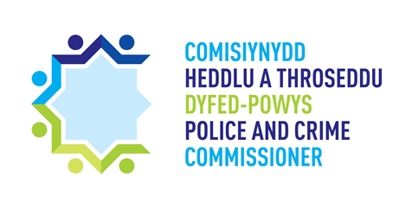

Project Ref No (for OPCC use only)

APPLICATION FORM – COMMISSIONER’S COMMUNITY FUND

Summary information

Name of lead organisation:
Other partners:
Total funding requested: | £
Revenue funding: | £
Capital funding: | £
Project timeframe (implementation to completion)

Section 1 – Organisation details and project summary

1.1 – Project title

1.2 – Agencies involved - Please identify the lead organisation for this project. Please also list other collaborating partners and/or other organisations involved.

1.3 – Project summary - Please provide a brief summary / description of the proposed activity and what outcomes you aim to deliver.
(no more than 300 words)

Section 2 – Objectives & Outcomes

2.1 How will your project meet the priorities set out in the Dyfed-Powys Police and Crime Plan 2017-2021?
(no more than 800 words)

2.2 What difference will your project make to your community? With whom have you consulted in developing this project?
(no more than 800 words)

2.3 Demonstrate why there is a need for your project, either locally or regionally and how it meets this need?
(no more than 500 words)

Section 3 - Funding Required
Please insert:
- A figure for the total amount requested and over what period of time.
- Details of how this is broken down across your planned activities and whether spend are revenue or capital.

3.1 – Funding requested for 2019/2020
Total requested: | £
Activity | Cost | Revenue/Capital
 | £
 | £
 | £
 | £
 | £
 | £
 | £
 | £
 | £
Total | £

3.2 – Details of match funding
Please provide details of opportunities for matched funding that are already secured or that you may explore to support this funding stream.

Section 4 – Delivery

4.1 – Please provide a delivery plan setting out key milestones and dates for the delivery of the project, including proposed governance arrangements, and roles / responsibilities of the key personnel involved.

.

4.2 – Please provide details of any identified risks to delivery (including likelihood and impact), with details of existing/proposed mitigations.
(no more than 500 words)

4.3 – Please include evidence of applicants’ previous experience in setting up and running similar projects.
(no more than 300 words)

Section 5 –Monitoring and Evaluation

5.1 – Please provide clear proposals for how outcomes from the project will be monitored and measured, and how you plan to evaluate your project.
(no more than 500 words)

Section 6 – Sign off

Please confirm that this project is signed off by your Chief Executive, Chief Officer or Chief Finance Officer.

Lead Organisation signature:

…..………………………………………………………………………………………………………………………

Section 7 – Contact Details

7.1 – Lead Organisation details
Name:

Phone:

Email:

7.2 – Partner Organisation contact details
Name:

Role:

Phone:

Email:

Signature:

For OPCC use only

Signature:
Name (printed):
Position:
Date received:
Project Ref No:

