

Police and Crime Commissioner for Dyfed-Powys

Scrutiny Panel
Dip Sampling Exercise

Review of possession of controlled drugs Out of Court Disposals
with a focus on women and BAME suspects
(Jan 2020 – July 2020)

Panel Members’ Findings & Feedback

October 2020

Contents

1.0 Overview 2
2.0 Background, purpose and methodology 2
3.0 Approval by Panel Chair 3
4.0 Actions taken following previous panel meeting 4
5.0 Good practice 4
6.0 Areas for improvement 4
7.0 Consideration of possession of controlled drugs cases – youth suspects 5
7.1 Observations 5
8.0 Consideration of possession of controlled drugs cases – adult suspects 8
9.0 Ethnicity and Gender - Case data breakdown 12
10.0 Panel’s assessments to date 14
10.0 Future Panel focus 17
11.0 Any other Business 17

Overview
At a meeting of the Dyfed-Powys Out of Court Disposal Scrutiny Panel held on the 26th October 2020, Members reviewed a selection of possession of controlled drugs cases which had been dealt with by way of an Out of Court Disposal. The Panel is expected to carry out an annual review of OOCD’s issued to both BAME (Black, Asian, Minority & Ethnic) communities and females and therefore the cases selected for this meeting included a selection of both BAME and female suspects.
The Panel considered a total of 21 cases, 10 involving youth suspects and 11 involving adults.
Due to the Covid-19 pandemic and Government guidelines in terms of social distancing this meeting was conducted virtually via Skype for Business.

Background, purpose and methodology
Panel Members collectively agree an area of focus for each meeting. They receive relevant case files two weeks prior to each meeting which have been randomly selected by the Panel Chair. The Panel then meets to discuss each case and where possible reach a conclusion as to the appropriateness of the disposal. In deciding which category the case falls, the Panel consider the following criteria:
• The views and feedback from the victim and the offender;
• Compliance with force policy;
• Rationale for the decision and outcome;
• Potential community impact;
• Circumstances and seriousness of the offence; and
• Potential alternative options that may have been available.
The Panel discuss each case and categorise them as one of the following:
• Appropriate use and consistent with policy;
• Appropriate use with Panel Members’ reservations;
• Inappropriate use or inconsistent with policy; and
• Panel fails to reach a conclusion.

Approval by Panel Chair

I _____JAYNE PICOUTO___ (print name) can confirm that I have read the report, and that it fully represents the views expressed by the Panel during our dip sampling exercise dated 26th October 2020.

Signed: ___Jayne Picouto____________________________
Date: ___23/02/2021______________________________

Actions taken following previous panel meeting

As a result of the Out of Court Disposal Scrutiny Panel’s work, the following action has been taken since the last meeting:
- It was identified within the last meeting that there were details missing or wrongly recorded within cases 1, 3, 5 and 8 relating to common assault and Covid-19-related cases. Following the Panel’s feedback, all cases were reviewed and updated with any absent information completed.

Good practice
The following good practice was identified as a result of the Panel’s work this quarter:
- The Panel made specific comments when reviewing two of the youth cases that the Youth Offending Team (YOT)’s reports were thorough and detailed. It was commented that individuals have been dealt with effectively and efficiently.

6.0 Areas for improvement
There was one particular area for improvement identified as a result of the Panel’s work this quarter:
- The Panel found that 6/21 cases had either been inappropriately disposed of or the Panel had reservations. In particular, it was felt that two of the adult cases should have been given a conditional caution in order to be appropriately referred to the Diversionary Scheme for support. There was also no reference given to another adult being referred when a conditional caution had been issued. Whilst the Panel considered it best practice to refer all eligible individuals, it was found that referrals to the Diversionary Scheme were not always consistently made.

7.0 Consideration of possession of controlled drugs cases – youth suspects
Nine of the cases had been dealt with by way of a Youth Community Resolution and one via a Youth Caution.
The Members’ assessments were as follows:
Members’ assessment | Number of cases
Appropriate | 8
Inappropriate | 2

Observations
Panel Members’ observations on each case are detailed below.
Case 1
The Panel felt that a Youth Community Resolution disposal was appropriate, as the suspect had no previous convictions and was engaging well with the Youth Offending Team.
Panel’s Assessment: Appropriate

Case 2
This case was in relation to a suspect who had been stop and searched and found to be in possession of a small amount of cannabis. The Panel felt that this case had been inappropriately disposed via a Youth Caution, and should have been escalated. The individual was already on a referral order at the time and the individual went on to commit further offences. It was also noted that the individual was not referred to the Youth Offending Team. This was against Policy and a missed opportunity for additional support.
Panel’s Assessment: Inappropriate

Case 3
This case was in relation to an offender who was found in possession of 5g of herbal cannabis. The suspect was dealt with via a Youth Community Resolution. The Panel agreed that this was an appropriate outcome, as this was the suspect’s first offence, was engaging well with support and had shown remorse.
Panel’s Assessment: Appropriate
Case 4
This individual was given a Youth Community Resolution for being found in possession of cannabis. This was found to be appropriate due to the cannabis amount being small and this being the suspect’s first offence. It was also noted that the individual had been referred to diversionary activity and had completed a drugs awareness course.
Panel’s Assessment: Appropriate

Case 5
The Panel felt that the outcome of this case was appropriate due to the small amount of cannabis found. However, they noted that there was a lack of information recorded in the records and that the suspect was informed of the Community Resolution outcome via a letter from YOT due to the Covid-19 pandemic. It was discussed that due to this taking place in June, a clearer procedure should have been in place and should have been followed to offer an assessment and appropriate intervention support rather than just a letter. It was noted however, that the Police did submit a Multi-Agency Referral Form which would have triggered the need for additional support.
Panel’s Assessment: Appropriate

Case 6
This case involved an individual who had been stopped and searched under the Misuse of Drugs Act and was found to be in possession of one bag of herbal Cannabis. The Panel felt that the case had not been fully investigated due to there being evidence of other possible crimes and therefore were unsatisfied with the outcome. It is also noted that the individual was given a Youth Community Resolution when the gravity matrix would suggest a youth caution as being the appropriate level of outcome.
A significant delay was noted before the paperwork was submitted by the Force to the YOT. Referrals should be submitted within 24 hours and were not submitted until 4 months later. This had been identified as being due to communication issues with the suspect, Force staffing problems, and the case being referred to court and back again. It was however noted that a thorough report was submitted by YOT following this delay.
Panel’s Assessment: Inappropriate

Action 1:
Chief Insp to review Case 6 and confirm whether any investigations were carried out in relation to the additional potential crimes. Case will be brought to next meeting for further discussions.

Case 7
Members were satisfied with the outcome of a Youth Community Resolution due to the amount of cannabis being small and the suspect having no previous convictions.
Panel’s Assessment: Appropriate

Case 8
The Panel concurred that a youth community resolution was appropriate, due to the amount of cannabis being small. Members noted that the YOT had submitted a thorough and detailed report for this individual highlighting the need for additional support. A Multi-Agency Referral Form was submitted by the force in order to try and safeguard the individual.
Panel’s Assessment: Appropriate

Case 9
The Panel found the outcome of a community resolution to be appropriate due to the individual having no previous convictions. A query was raised as to whether the individual should have been given a fixed penalty notice for breaching Covid-19 regulations in addition to the outcome for the possession of drugs. It was confirmed by the Chief Inspector that the action taken was in line with guidance issued to officers regarding Covid-19 penalties and other criminal offences.
Panel’s Assessment: Appropriate
Action 2:
OPCC to circulate information about breach of Covid-19 regulations & criminal offences to Panel Members.

Case 10
The individual in this case was given a youth community resolution, this was felt to be appropriate due to the incident being low level, the suspect admitting to the offence fully and their willingness to engage with support.
Panel’s Assessment: Appropriate

8.0 Consideration of possession of controlled drugs cases – adult suspects
Panel Members reviewed eleven adult cases; two of the cases had been dealt with by way of a Caution, four by way of a Conditional Caution and five by Community Resolution.
Members’ assessments were as follows:

Members’ assessment | Number of cases
Appropriate | 7
Inappropriate | 3
Panel Fails to Reach Conclusion | 1

Panel Members’ observations on each case are detailed below:
Case 11
The Panel felt that a Conditional Caution was an appropriate outcome for this case. The suspect, who admitted to long-term habitual use, had been found in possession of a significant amount of drugs including amphetamine and herbal cannabis. It was noted positively that the individual had been referred to the Diversionary Scheme and must engage in support as part of their conditions.
Panel’s Assessment: Appropriate

Case 12
Panel Members were happy with the disposal of Conditional Caution for this individual who had been found in possession of herbal cannabis. This was the suspect’s first offence and was engaging well with the Diversionary Scheme.
Panel’s Assessment: Appropriate

Case 13
The Panel felt that this case had been inappropriately disposed. This suspect was found to have cannabis within their home address and was given a Caution. The Panel felt that a conditional caution would have been appropriate as the individual was referred directly to the Diversionary Scheme which was inconsistent with Force policy. The suspect was unwilling to engage with scheme and the Panel expressed that this should have been part of his conditions in order to comply with policy.
Panel’s Assessment: Inappropriate

Case 14
This suspect was found to be in possession of 1g of herbal cannabis. The Panel found the outcome of a community resolution to be appropriate. This was the suspect’s first offence and the quantity of drugs found was small.
Panel’s Assessment: Appropriate

Case 15
The Panel concurred that a Community Resolution was an appropriate outcome for this case as this was the suspect’s first offence. However, it was noted that the individual was referred to the Diversionary Scheme but was failing to comply and engage.
Panel’s Assessment: Appropriate

Case 16
The offender in this case was given a Conditional Caution. The Panel had no concerns over this outcome as the offender was found in possession of 1g of herbal cannabis and although the individual had a previous conviction this was over 20 years ago. It was raised within the meeting that a referral to the Diversionary Scheme had not been submitted. However, a member of the Criminal Justice Department confirmed that this had since been followed up and a referral had now been submitted as a result of the case coming to the attention of the Panel.
Panel’s Assessment: Appropriate

Case 17
The offender in this case had been given a Community Resolution. The Panel felt that this disposal was appropriate, due to this being the suspect’s first offence and being actively engaged with support from the Diversionary Scheme.
Panel’s Assessment: Appropriate

Case 18
The Panel were unable to reach a conclusion on this case due to it being unclear whether the individual had received a community resolution or not. The individual was found in possession of 7g of Cannabis and 23 MDA tablets. The individual was engaging well with support via the Diversionary Scheme, however, it is unclear from the records whether the Community Resolution had been submitted as it appeared to be incorrectly recorded.
Panel’s Assessment: Panel Fails to Reach Conclusion
Action 3:
Case 18 to be brought to the next meeting with further information on whether a community resolution was issued.

Case 19
The Panel felt that this case had been inappropriately disposed via a Caution. This offender’s vehicle had been stopped where a search revealed four bottles of methadone. The individual admitted addiction and no referral to the Diversionary Scheme was made. The Panel felt that this was against Policy and that the individual should have received a Conditional Caution. The Panel were also concerned that there was no record of a drug test being carried out following the offender being found in possession of drugs whilst driving.
Panel’s Assessment: Inappropriate
Case 20
Panel Members felt that that this case had been inappropriately disposed via a Conditional Caution. Although over 5 years ago, the offender had a number of drug related past convictions, including the production of cannabis and had served a custodial sentences. The Panel concurred that due to the individual’s past history that this case should have been escalated.
Panel’s Assessment: Inappropriate

Case 21
Panel Members raised no concern over the disposal of this case. The offender was found in possession of 0.4g of cannabis and had no previous convictions. It was felt that a Community Resolution was therefore appropriate.
It was also noted that the offender was stop searched with the reason for the search being noted as there being a strong smell of cannabis coming from a vehicle. A discussion took place on whether this was sufficient grounds recorded in order to warrant a stop and search. Officers are advised that searches must not be based on smell alone.
Panel’s Assessment: Appropriate
Action 4:
The OPCC to review the stop and search record of case 21 for legitimacy.

9.0 Ethnicity and Gender - Case data breakdown

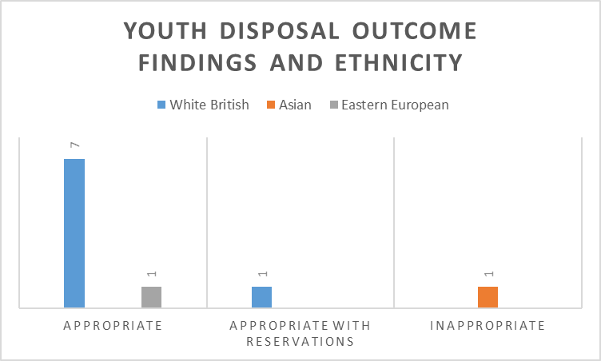

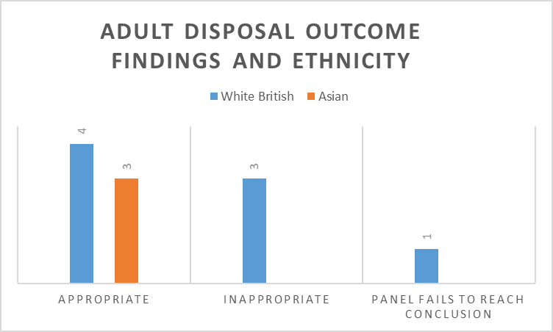

From the sample of 21 cases reviewed there were no issues or trends identified in relation to ethnicity and the Out of Court disposal outcomes given to individuals.

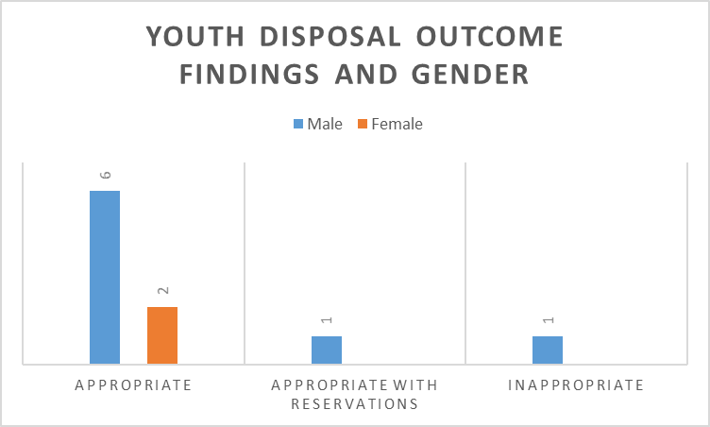
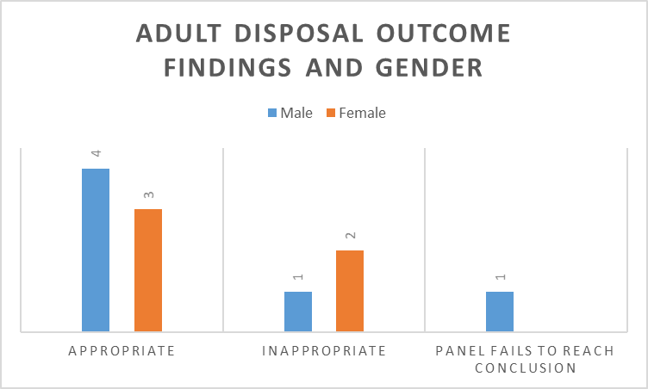
The Office of the Police and Crime Commissioner was provided with a list of all adult and youth Out of Court Disposal cases relating to drug possession from the period January – August 2020. In order to carry out the Panel’s annual review of Out of Court Disposals in relation to females and BAME individuals, all cases which had a BAME suspect were selected for review. This resulted in 5/21 cases falling into the BAME category. The cases of seven female offenders were reviewed, five adult and two youth. Due to the number of cases available, it is acknowledged that this is a small sample of individuals being reviewed, however no issues or trends were identified in relation to gender and the Out of Court disposal outcomes given to individuals.

10.0 Panel’s assessments to date
The charts below demonstrate the Panel’s assessment of the cases considered at the most recent meeting.
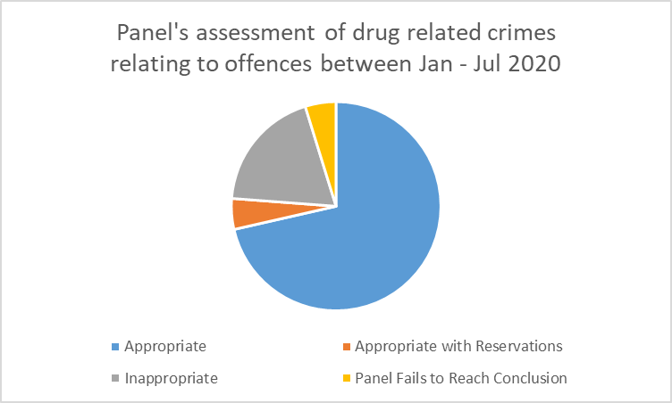

Since November 2013 the Panel has considered a range of disposals, as displayed in the graph below.
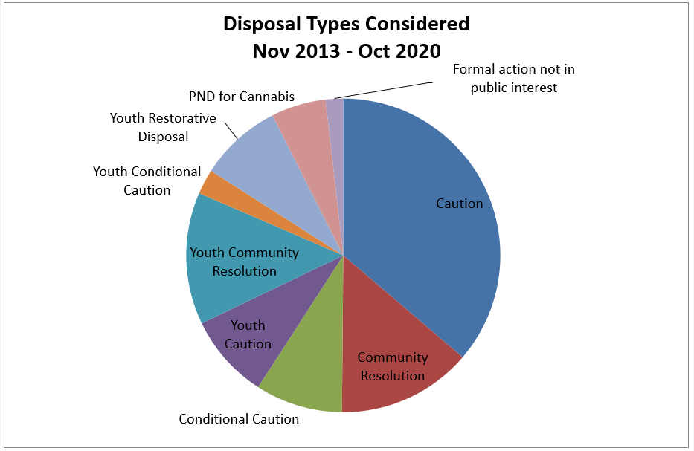
Of the 387 cases examined between April 2013 and October 2020, 57% were assessed as appropriate, 21% as inappropriate, 20% as appropriate with reservations and the panel failed to reach a conclusion in 2% of cases.
The change in conclusions reached over time can be seen in the graph below.
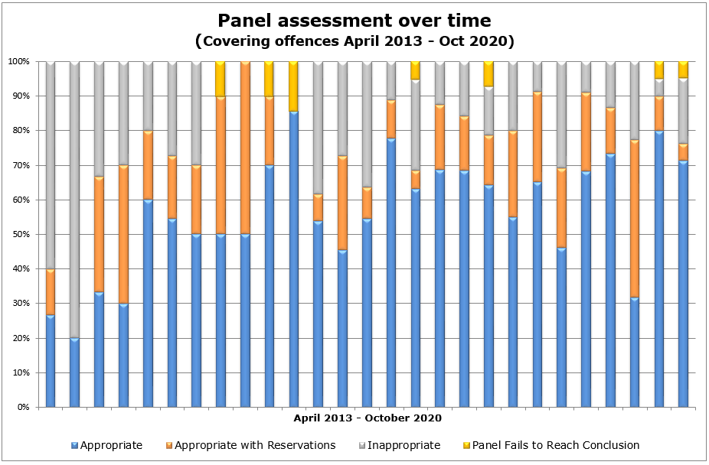
The graph below shows the breakdown by crime type as a percentage of cases considered between November 2013 and October 2020. (Please note that the numbers displayed within the graph columns indicate the number of cases reviewed with that given outcome).
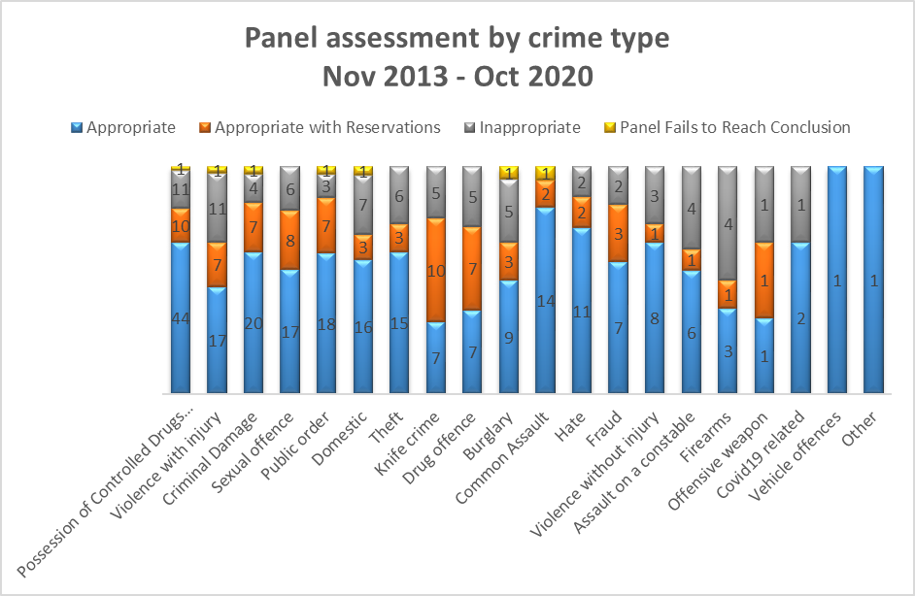
The following graph displays the actual number of cases assessed within each crime type and the resulting Panel opinions at their meetings between November 2013 and July 2020.
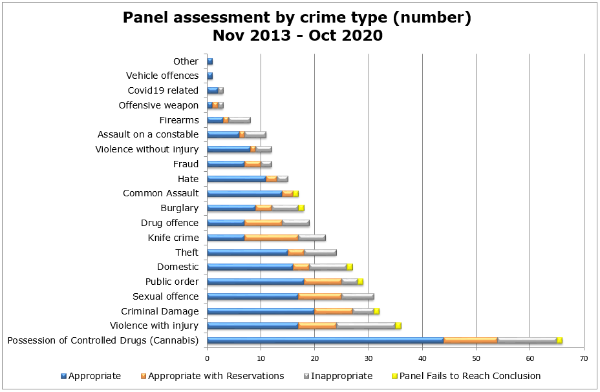

10.0 Future Panel focus
Following a discussion, the Panel wished to consider Domestic Abuse and Actual Bodily Harm related crime cases within the next meeting.

11.0 Any other Business

A discussion took place in relation to an offender in possession of drugs who had been issued with a Community Resolution. A Condition of the resolution was for the individual to make a contribution to a charity. This has been questioned with the lead Force on out of court disposals and they deemed this to be a suitable condition. The Panel concurred that contributing towards charity should be voluntary and felt that a donation to charity was not an appropriate condition in their views.
The Panel’s terms of reference was due its annual review, the only amendment to the document was to include that due to Covid-19 some meetings will be carried out virtually. The Panel accepted this addition, with no further amendments to be made.
The Panel were made aware of the Government Serious Violence Reduction Order consultation which closes on the 8th of November 2020. The consultation proposes a tool to target individuals convicted of a relevant offence (any knife / offensive weapon). This tool would be available to court alongside other targeted measures and would enable police to Stop and Search those convicted of relevant offences. This approach would create a greater likelihood of individuals being caught if they persist in carrying a knife or weapon, allowing them to be brought before the Courts & given a custodial sentence.

