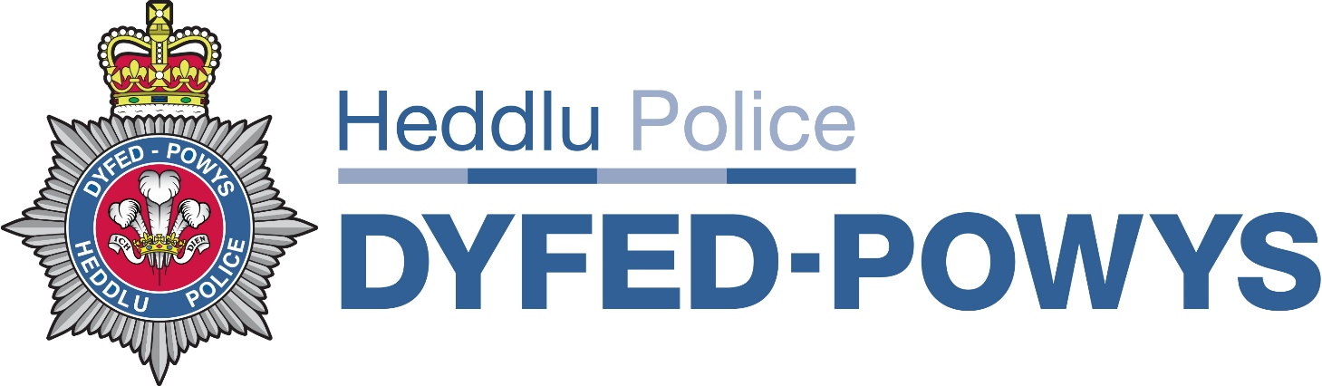

Report Title: Information Management Update

To: Policing Board

Date of report: 23 March 2021

Date of Policing Board: 30 March 2021

Author: Debby Jones, Information Manager / Data Protection Officer

Freedom of Information (FOI) – Weekly return
Reporting period week ending 01 January 2021 to 19 March 2021

Notes:

- The above charts illustrate fluctuating levels of demand during the reporting period. However they show a relatively consistent level of completion rates.

- During the current reporting period there were a total of 223 requests received compared to 192 which were closed. This equates to an average of 20.2 requests per week being received compared to an average of 17.4 requests per week being closed. These figures have increased compared to the average weekly figures from the previous reporting period ie at that time an average of 14.7 requests per week being received and an average of 16.07 requests per week being closed.

Data Protection (DP) – Weekly return
Reporting period week ending 01 January 2021 to 19 March 2021
W/E | Subject Access | Court Order | CAFCASS | LLAMAU | Safeguarding | Probation | Other | Total | Total closed
08.01.21 | 5 | 4 | 17 | 3 | 19 | 18 | 11 | 77 | 65
15.01.21 | 12 | 7 | 15 | 1 | 10 | 22 | 16 | 83 | 53
22.01.21 | 1 | 3 | 9 | 4 | 12 | 34 | 13 | 76 | 86
29.01.21 | 12 | 5 | 13 | 6 | 18 | 29 | 15 | 98 | 78
05.02.21 | 13 | 8 | 6 | 3 | 25 | 32 | 20 | 107 | 65
12.02.21 | 7 | 7 | 14 | 0 | 16 | 19 | 12 | 75 | 65
19.02.21 | 10 | 10 | 15 | 0 | 22 | 10 | 5 | 72 | 102
26.02.21 | 10 | 5 | 8 | 3 | 23 | 13 | 20 | 82 | 76
05.03.21 | 12 | 7 | 12 | 3 | 19 | 31 | 10 | 94 | 92
12.03.21 | 11 | 9 | 12 | 3 | 13 | 17 | 8 | 73 | 36
19.03.21 | 9 | 5 | 10 | 3 | 22 | 25 | 13 | 87 | 101
 | 102 | 70 | 131 | 29 | 199 | 250 | 143 | 924 | 819

Notes:
- During the current reporting period there were an average of 84 cases a week being opened (the average during the previous reporting period was 85 cases per week). On average there were 74.4 cases a week being closed.

- The previous report (19.01.21) identified a steady decrease in the number of cases being opened up to the end of the year (2020). Figures for December 2020 have been included in the above graph to highlight that case numbers steadily increased in January from the December low.

Notes
- The above chart shows three areas of high demand ie CAFCASS, Safeguarding and the Probation Service, another high area of this reporting period has been the ‘other’ category, however this case classification is made up of a variety of subject matters and therefore is not included within the above chart.

- The Probation Service, again, is the highest area of demand at 250 cases. Engagement continues with the Probation Service. Processes and templates have been reviewed. Training inputs are to be provided to Probation Service staff by members of the Disclosure Team. The Probation Service will be providing an input on their work to Disclosure staff which will provide Disclosure Officers with a greater understanding on why the Probation Service request information. Other means of reducing the volume of work directed at the Disclosure Team are being explored.

Notes:
- The above shows a small number of overdue cases during the period.

- The Disclosure Unit continues to prioritise work through risk based decision making. Taking in to account statutory requirements and service level agreements in place.

- The above chart identifies the number of requests overdue at the end of each week, ie the weekly reporting period and do not identify requests that may have become overdue during the week but completed before the end of the week (compliance rate).

- Three temporary staff continue to assist the department (one is in the process of being replaced).

FOI requests and Subject Access Requests (SARs)
Compliance rates (timeliness) – seven month period
SAR numbers and compliance rates:

 | Aug-20 | Sept-20 | Oct-20 | Nov-20 | Dec-20 | Jan-21 | Feb-21 | Total
Request numbers | 38 | 33 | 32 | 22 | 29 | 31 | 41 | 226
Compliance rate | 68% | 74% | 88% | 72% | 100% | 97% | 93%

FOI request numbers and compliance rates (timeliness):

 | Aug-20 | Sep-20 | Oct-20 | Nov-20 | Dec-20 | Jan-21 | Feb-21 | Total
Request numbers | 66 | 72 | 100 | 84 | 85 | 111 | 87 | 605
Compliance rate | 97% | 81% | 92% | 92% | 98% | 94% | 95%

Notes:

- By means of context, the Force is required to provide statistics on time for compliance concerning FOI requests, FOI Internal Reviews and Subject Access Requests to the Information Commissioner’s Office (ICO), via the NPCC Central Referral Unit (CRU). The ICO expectation is at least 90% compliance. [Legal Services undertake internal reviews].

Llamau Charity – Requests for information

Month | Missing child report | Referral to Llamau | Requests for packs and % of those referred
June 2020 | 60 | 29 | 29 (100%)
July | 73 | 33 | 33 (100%)
August * | 87 | 42 | 11 (26%) *New Process Introduced
September | 67 | 42 | 12 (28%)
October | 66 | 33 | 17 (52%)
November | 98 | 49 | 16 (32%)
December | 55 | 19 | 9 (48%)
January 2021 | 52 | 23 | 14 (61%)
February 2021 | 37 | 17 | 6 (35%)

Notes:
- Work associated with the Data Protection action plan identified that Llamau were requesting information from the Disclosure Unit regardless of whether they were going to engage with the children who had been subject to a missing person episode, or not. Following discussions with Llamau, it was agreed that they will only seek information where engagement is agreed. This has proved to be successful as can be seen from the above table. With the introduction of the new process where only those subject to de-briefs are to have intelligence packs requested.

- Whilst the figures do fluctuate, the demand on the department has decreased significantly. Even in August and September during school holidays which is a traditionally busy period, only a quarter of Llamau referrals were processed by the Disclosure Unit.

Data Protection Breaches
Reporting Period 01 January 2021 to 19 March 2021
There have been twenty nine potential Data Protection breaches recorded since the previous report. A number remain open and a number are being investigated by PSD. Zero breaches have met the threshold for self-referral to the Information Commissioner’s Office (ICO). Which demonstrates that they are low risk issues. [Referral decisions to the ICO are based upon a national referral criteria matrix]. Eight breaches are currently under investigation by PSD, not all therefore are proved data protection breaches at this time. Breaches continue to dominate a large amount of time for the Data Protection team.

Nature of breach
Inappropriate processing | 3
E-mails/letters sent to incorrect recipient | 12
Inappropriate access of personal information | 1
Inappropriate sharing/disclose of information | 13
Total | 29

Single Online Home
Four of the breaches discussed above are related to Single Online Home (SOH). An increase in breaches being reported by the Force Communications Centre (FCC) has been noted. This is as a result of members of staff responding to incidents being reported via an online form. If members of the public, intentionally or unintentionally, provide an incorrect email address – the response from FCC staff (possibly containing sensitive information) can be sent to the wrong recipient. This has been raised with the SOH Project Team and enquiries being made nationally, with a view to raising it with the national SOH Project Team.
With the current process in place, with no verification of email addresses required, FCC staff cannot control what members of the public input into the email field of the online form and are unaware if the email address provided is correct when they provide their response. This matter is included on the Information Risk Register.

Records Management
Scanning Project
The scanning project (anticipated completion was November 2020) has been particularly delayed as a result of the series of Covid lockdowns. Two members of staff will continue reviewing paper records and conducting the requisite scanning. As things stand currently it is hoped that the scanning work can be completed within the next fortnight. Pockets of data continue to be unearthed in stations and as these materialise they will be subject to the same process moving forward.

PNI Matching
Work on the PNI duplicate matching has progressed at pace, particularly as staff have been redeployed from the scanning project to this work stream while they are working from home. Additionally staff from other departments have been assisting the Records Management team as a result of COVID restrictions. There are now approximately 4,840 Group 2 nominals which remain to be examined, reducing on average at 600 a week.
Work continues in conjunction with ICT to finalise the Records Reviewing and Disposal (RRD) process it is hoped that this will be finalised and fit for purpose to coincide with the conclusion of the MOPI 2 matching process.
Following an external data assurance audit a member of staff from the Records Management Team will be assisting in the review of communications data to support CID. A temporary resource has been approved to backfill within the Records Management team. .

