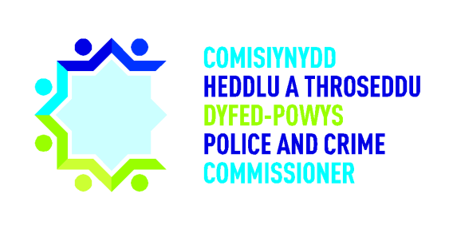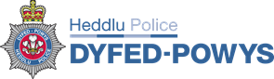

**Expression of Interest**

**Dyfed Powys Police & Crime Commissioner & Chief Constable**

**Joint Audit Committee**

|  |  |  |  |
| --- | --- | --- | --- |
| **Personal Details** | | | |
| Name: | Title: | Date of birth: | |
| Address: | | | |
| Contact number: | | | |
| Email: | | | |
| Your preferred means of communication: | | |  |

**RELEVANT SKILLS AND EXPERIENCE**

|  |
| --- |
| **Following consideration of the Information Pack, please provide information to demonstrate how you have the relevant skills and experience required to be a Member of the Dyfed Powys Police & Crime Commissioner & Chief Constable Joint Audit Committee.** |
|  |

**Equality of Opportunity Monitoring**

The Police and Crime Commissioner and Chief Constable for Dyfed-Powys are firmly committed to promoting equality of opportunity, and are determined to ensuring that everyone is treated fairly, recognising and respecting individuality. We therefore ask you to complete this questionnaire to enable us to monitor the effectiveness of our policies and procedures in recruiting, appointing and retaining individuals from a diverse range of backgrounds.

The following request for information is for monitoring and statistical purposes only. The information supplied will be handled and stored in the strictest confidence once completed and will be kept sealed until such time as the recruitment process is complete. **Disclosure of this information is strictly voluntary, but the information will help us ensure equality of opportunity. If you do not wish to disclose any of the voluntary information please tick the boxes ‘Prefer not to say’.**

|  |  |
| --- | --- |
| **1. Age Category** | |
| Under 16 |  |
| 16-24 |  |
| 25-34 |  |
| 35-44 |  |
| 45-54 |  |
| 55-64 |  |
| 65-74 |  |
| 75+ |  |

|  |  |
| --- | --- |
| **2. Gender** | |
| Male |  |
| Female |  |

|  |  |
| --- | --- |
| **3. Sexual Orientation** | |
| Bisexual |  |
| Gay |  |
| Heterosexual / Straight |  |
| Lesbian |  |
| Prefer not to say |  |

|  |  |  |  |
| --- | --- | --- | --- |
| **4. Religious Belief** | | | |
| Buddist |  | Muslim |  |
| Christian |  | Sikh |  |
| Hindu |  | Other |  |
| Jewish |  | No religion |  |
| Prefer not to say | | |  |

|  |  |
| --- | --- |
| **5. Disability** | |
| The definition of disability as defined under the Equality Act is ‘a physical or mental impairment which has a substantial and long term adverse effect on ability to carry out normal day to day activities’. | |
| **a)** **Do you consider yourself to be**  **disabled?** | |
| Yes |  |
| No |  |
| Prefer not to say |  |
| **b) If yes, how would you describe your disability?** *(tick all that apply)* | |
| Blind/visual impairment |  |
| Deaf/hearing impairment |  |
| Learning disability |  |
| Long standing illness or health condition |  |
| Mental health condition |  |
| Mobility impairment |  |
| Other physical or medical condition |  |
| Prefer not to say |  |

|  |  |
| --- | --- |
| **6. Ethnic Group** | |
| **White** | |
| British |  |
| English |  |
| Gypsy or Irish Traveller |  |
| Irish |  |
| Northern Irish |  |
| Scottish |  |
| Welsh |  |
| Any other White background (please state) |  |
| **Mixed / multiple ethnic groups** | |
| White and Asian |  |
| White and Black African |  |
| White and Black Caribbean |  |
| Any other Mixed background (please state) |  |
| **Asian / Asian British** | |
| Bangladeshi |  |
| Chinese |  |
| Indian |  |
| Pakistani |  |
| Any other Asian background (please state) |  |
| **Black – British** | |
| African |  |
| Caribbean |  |
| Any other Black background (please state) |  |
| **Other Ethnic Group** | |
| Arab |  |
| Any other ethnic group (please state) |  |
| Prefer not to say |  |

|  |  |
| --- | --- |
| **7. Welsh Language** | |
| **The Police Service in Wales has adopted a system of levels to indicate Welsh language skill. There are 6 levels:**  **Level 0: No knowledge;**  **Level 1: Meeting and greeting;**  **Level 2: Basic conversation;**  **Level 3: Conversational skills in everyday situations;**  **Level 4: Fluent;**  **Level 5: Fluent and confident in all / formal conversations.**  **Please could you indicate your Welsh language ability for the following:** | |
| **Speaking & listening** | **Level…….** |
| **Reading & writing** | **Level…….** |