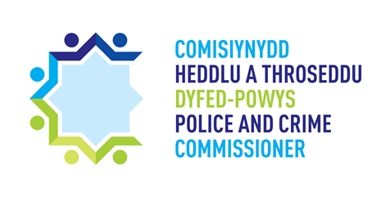

SAFER STREETS FUND APPLICATION FORM – ELLI 2 & TYISHA 2

Summary information
Name of lead organisation:
Total funding requested: | £
Project timeframe (implementation to completion)

Organisation details and project summary
Project title

Project summary - Please provide a brief summary / description of the proposed activity and what outcomes you aim to deliver.
(no more than 200 words)

How will your project meet the priorities set out for the Safer Streets Fund project and its objectives to target acquisitive crime (please see guidelines for reference)? (no more than 400 words)

Funding Required
3.1 – Funding requested for 2021/2022 only
Total requested: | £
Activity | Cost | Revenue/Capital
 | £
 | £
 | £
 | £
Total | £

Please provide a delivery plan setting out the dates for the delivery of the project (please note all expenditure muct be

Sign off
Please confirm that this project is signed off by your Chief Executive, Chief Officer or Chief Finance Officer.
Lead Organisation signature:
.………………………………………………………………………………………………………………………

Contact Details
7.1 – Lead Organisation details
Name:

Phone:

Email:

Must be completed before submitting the grant -
Bank name:
Branch name:
Sort code:
Account name:
Account number:
Address:
Post code:

