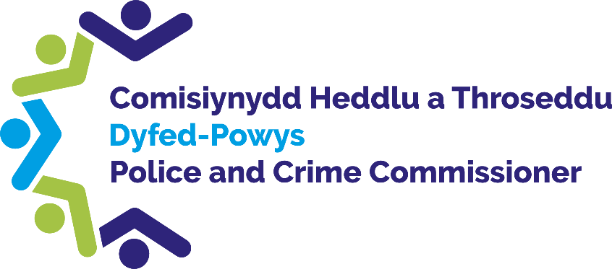

Police and Crime
Commissioner for Dyfed-Powys

Scrutiny Panel
Dip Sampling Exercise
Complaint Outcome Review Letters

Panel Members’ Findings & Feedback

January 2022

Contents
Contents 1
1.0 Overview 2
2.0 Background, Purpose and Methodology 2
3.0 Complaint Outcome Review letters 2
4.0 Best Practice 3
5.0 Observations 4
6.0 Queries raised 5
7.0 Actions 5

1.0 Overview
At the meeting of the Commissioner’s Quality Assurance Panel held on the 27th of January 2022, a random selection of 6 complaint outcome review letters were considered by the Members.
The meeting was held virtually via a Microsoft Teams meeting due to the ongoing restrictions set around the Covid-19 pandemic.

Background, Purpose and Methodology
The Quality Assurance handbook, available on the PCC’s website, states the background and purpose of the Panel along with how the dip sampling is carried out and what the Panel is asked to consider.

Complaint Outcome Review letters
The Policing and Crime Act 2017 and supporting regulations made significant changes to the police complaints and disciplinary systems. They introduced several changes designed to achieve a more customer-focused complaints system. Importantly, the reforms aim to make the discipline system more proportionate and encourage a much greater emphasis on learning from mistakes.
Since 1st February 2020, if an individual’s complaint was recorded under Schedule 3 of the Police Reform Act 2002 and the individual is unhappy with the outcome of their complaint, they can submit an application for a review to the Relevant Review Body, either the Independent Office of Police Contact (IOPC) or the Police and Crime Commissioner. Dyfed-Powys Police continue to be responsible for logging, recording and investigating complaints and for keeping complainants informed of progress.
The Office of the Police and Crime Commissioner (OPCC) has developed quality assurance mechanisms to ensure that review decisions are sound and in line with the requirements of the complaints legislation and IOPC statutory guidance.
The OPCC has a duty to consider requests for review to determine:
- Whether the request for a review was valid
- Whether the outcome of the complaint was reasonable and proportionate
- Whether any recommendations should be made to the Force because of the handling and/or outcome of the complaint

The outcome of such a review must be communicated to the complainant in writing. It must include sufficient information to enable the reader to understand what decisions and recommendations have been made, and why.
The aim of this scrutiny exercise was to consider whether complaint outcome review responses sent by the Commissioner’s Office were clear and easy to understand.

4.0 Best Practice
Panel Members highlighted the following areas they considered to be best practice:
- All letters were conveyed in a very professional manner.
- All letters were detailed and referred to the original content of the initial complaint received, this helped provide clarity and evidence for the decision made.
- Members felt that the use of the date submitted, and date received by the OPCC office was useful to the recipient as it acknowledged the time frame in which the letter was dealt with.

5.0 Observations
Panel Members made the following observations:
- Members found the letters lengthy and felt they could be shortened. Repetition was identified within the letters which could be removed to make the letters succinct and easier to read.
- The use of bullet points was suggested to help aid understanding and to break down the content.
- It was recognised that legal matters must be referenced, however it was felt that these references could be simplified or explained to ensure clarity and aid understanding. It was noted that it would be better to use simple English to ensure that letters were accessible to all reading abilities.
- It was noted within the letters that Dyfed-Powys Police was referred to as the “Appropriate Authority”, it was felt that replacing this with Dyfed-Powys Police would help aid understanding.
- It was felt that the outcome review decision should be made clearer at the start of the letters and that it would be beneficial to summarise the outcome of the review at the start of the letter.
- Members suggested that the letters should make it clear that they are being written on behalf of the Police and Crime Commissioner.
- A discussion took place on the use of hyperlinks within the letters, and the need for an option to be made for those who do not have access to a computer to obtain further information.
- It was noted that all acronyms (such as MAVIS) need to be explained.
- The use of an appendix at the end of the letter to include the in-depth complaint detail and exact copies of the original complaint and initial Professional Standards Department response was recommended. Members felt that removing these from the main letter would help keep the letter concise but would allow the individual to have easy access to this further detail if desired.

6.0 Queries raised
- Members queried whether the office had reviewed the outcome review letters of other OPCCs to see if any good practice can be found.
- It was asked if consideration was given to individuals who are partially sighted or have any special requests, for example, larger font, support to complete forms and to use the language of their choice.

7.0 Actions
Observations | OPCC Response
As a result of the above observations, the Panel have drafted and wish to propose a new letter template for complaint outcome review letters. This new template takes into account the feedback from the Panel as noted above, for example, the letter length, the language used, necessary content, the use of an appendix and making the outcome of the letter clear from the outset. The Panel ask for this template to be considered. | The OPCC is very receptive to any suggestions that aid understanding and provide clarity to members of the public.  The OPCC has considered the proposed amendments to the review letter and consider that the use of an Appendix would assist in shortening the length of the letter, whilst retaining the in-depth complaint detail, that can still be easily accessed by the member of the public for reference purposes.  The OPCC can also see the benefit of amending the format of the legal matters into a bullet point format, in order to allow for a better flow and breakdown of the information provided to members of the public.
Members queried whether the OPCC office had reviewed the outcome review letters of other OPCCs to see if any good practice can be found. | The OPCC has considered the format of complaint review related templates from a neighbouring OPCC and the OPCC is in regular communication with the Independent Office for Police Conduct (IOPC), who oversee the police complaints system in England and Wales.  The OPCC has agreed to be involved in a ‘Review Project’ undertaken by the IOPC, with a view to identifying best practice relating to Complaint Review work across OPCCs in England and Wales. The OPCC is keen to be involved in this project, in order to ensure that we are providing the best service possible to individuals within the Dyfed-Powys Police Force area. The OPCC also recognises the importance of consistency in the review process provided to members of the public across all regions in England and Wales and therefore consider the IOPC Review Project to be a valuable tool to achieve a consistent best practice outcome.  Additionally, further to the feedback received in this report, the OPCC has contacted the IOPC with a view to sharing the two template review outcome letter responses (the OPCC’s original template format and the suggested amended template format provided from QAP) for further feedback/considerations from the IOPC.
It was asked if consideration was given to individuals who are partially sighted or have any special requests, for example, larger font, support to complete forms and to use their language of choice. | Within the OPCC Review Form there is a section at the beginning of the form titled ‘Accessibility’ which provides a contact number and email address in order for members of the public to contact the OPCC to discuss any difficulties in using the form.  Additionally, there is a section within the review form titled ‘Reasonable Adjustments,’ providing members of the public the opportunity to advise the OPCC of any adjustments that the OPCC need to be aware of e.g. visually impaired and requires larger text in documentation.  The OPCC is continually mindful of any requests/reasonable adjustment information provided by members of the public and seek to accommodate those requests e.g. the OPCC have organised telephone meetings, in order for a member of OPCC staff to complete the review form over the phone, sending a copy to the individual to check for accuracy, sign and return to our office. The OPCC has also written (either by email or post depending on the individual’s preference) and offered a follow-up telephone call to discuss the content of each piece of communication (e.g. acknowledgement, review outcome, recommendations outcome etc.) sent from our office.
The use of hyperlinks within the letters, and the need for an option to be made for those who do not have access to a computer to obtain further information to be considered. | The OPCC has separate review acknowledgement templates, ensuring that any email correspondence includes the hyperlinks and any postal communication includes the full information e.g. information concerning how the OPCC handles personal information in relation to a review and a copy of the privacy notice.  Consideration is also given to the provision of information/hyperlinks when writing the review outcome letters, ensuring that any to be sent by post include the full details/information, alongside reference to the hyperlink the information has been obtained from.

