This document is also available in Welsh.

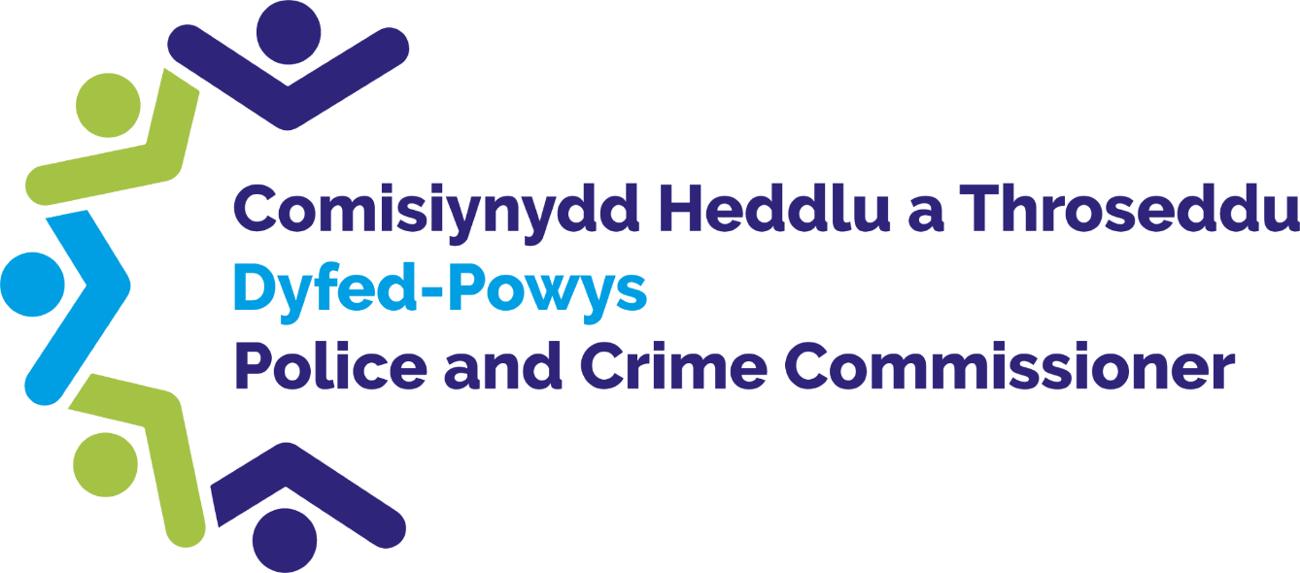

INDEPENDENT CUSTODY
VISITING SCHEME

ANNUAL REPORT
2021/22

DYFED-POWYS
POLICE AND
Contents
1. Foreword from the Dyfed-Powys Police and Crime Commissioner 3
2. Introduction 4
3. Independent Custody Visitors 4
4. ICV Rotas 5
5. Visiting Data 6
I. Number of Visits and ICV Calls 6
II. Number of Detainees 6
III. Timings of visits 7
6. Issues Raised 8
7. Training and Events 10
8. Independent Custody Observers Pilot and Custody Record Reviewing 10
9. Anti-rip suit pilot 11
10. Quality Assurance Framework 13
11. Future Developments 13
12. Interested in becoming an ICV? 13
Appendix A: 14
Appendix B 15

Foreword from the Dyfed-Powys Police and Crime Commissioner

Independent Custody Visiting was borne out of Lord Scarman’s report on the Brixton riots in 1981 which recommended that a system of independent, unannounced inspection of procedures and detention in police stations by local community members be introduced. This was formalised in 2002 by the Police Reform Act which places a statutory duty on all Police and Crime Commissioners to implement an Independent Custody Visiting Scheme.

Custody Visiting has introduced transparency in police custody processes. Independent Custody Visitors (ICVs) have a crucial role in ensuring the Human Rights of detainees are upheld and that the Police and Criminal Evidence Act 1984 is complied with.

An Independent Custody Visiting Scheme was established in Dyfed-Powys in 2001. Since its roll out, thousands of visits have been made to custody suites across the Dyfed-Powys area, ensuring detainees are treated with respect and dignity irrespective of the reason for their detention.

2021-22 continued to be a challenging year for my ICVs, with physical visits having to be put on pause for a period of time due to the Covid-19 pandemic and the implementation of ICV telephone calls into our custody suites. I would like to take this opportunity to thank them all for their support, enthusiasm and flexibility. The continued commitment shown by all ICVs is instrumental in the success of the Scheme, and I would like to offer my personal thanks to them all.
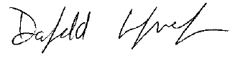

Dyfed-Powys Police and Crime Commissioner

Introduction

Independent Custody Visitors (ICVs) are volunteers from our local community who visit police custody suites in pairs, unannounced, to check on the welfare of detainees, ensuring that their rights are upheld. ICVs also undertake checks on the custody environment to ensure it is safe and of a good standard. If any concerns are identified, they are raised by ICVs initially with the Custody Police Sergeant and also via the Police and Crime Commissioner’s office for discussion with senior officers in charge of custody matters. Updates on progress made in relation to matters of concern are provided to the Office of the Police and Crime Commissioner (OPCC)in a timely manner. Any overarching themes are fed into the appropriate governance boards for consideration of further action to be taken if appropriate. The ICVs’ role offers protection to detainees and transparency of detention processes.

Independent Custody Visitors

At the end of March 2022 there were 24 Independent Custody Visitors (ICVs) on the Scheme, spread across the 4 ICV Panel areas; Carmarthenshire, Ceredigion, Pembrokeshire, and Powys.

Figure 1: Number of ICVs in each Panel Area

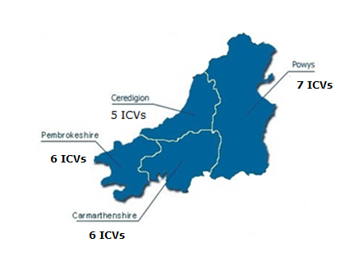
We had four ICVs resign from the Scheme between 1 April 2021 and 31 March 2022 and eight new ICVs joining within this period. There are two ICVs currently waiting on vetting clearance for the Ceredigion area.

Every effort is made for the Scheme to represent the demography of Dyfed-Powys, but critically, volunteers who show a genuine commitment and interest in the Scheme are appointed to the Team. Within our last recruitment drive, every effort was made to recruit individuals from a diverse range of ages, making a slight improvement on last year’s overview.

Age: | Percentage 2021/22 | Percentage 2020/21
18-24 | 4% | 17%
25-34 | 8% | 0%
35-44 | 4% | 0%
45-54 | 4% | 5%
55-64 | 32% | 26%
65-74 | 32% | 35%
75+ | 16% | 17%
Figure 2: Gender and Age of ICVs

ICV Rotas
Ammanford, Aberystwyth, Haverfordwest, Brecon and Newtown are the main Custody Suites in the Dyfed-Powys area. Ammanford, Aberystwyth and Haverfordwest are visited once a week with Brecon and Newtown being visited on a fortnightly basis. This is due to their varying size and use. There are two other Custody Suites in Dyfed-Powys; Cardigan and Llanelli. They are used as overspill suites and ICVs do not routinely visit these Custody Suites. However, should these overspill suites be used, the OPCC will be notified and can arrange an ICV visit if necessary.

Custody Suite | Cell Capacity and detention rooms (used for the detention of children)
Ammanford | 6 cells  2 detention rooms
Haverfordwest | 17 cells  2 Detention rooms
Aberystwyth | 7 cells  1 Detention room and 1 dry room
Brecon | 8 cells  1 Detention rooms
Newtown | 9 cells  1 Detention room
Llanelli  (Only used as an overspill) | 8 cells  2 detention rooms
Cardigan  (Only used as an overspill) | 6 cells

ICVs are provided with a rota assigning a pair of ICVs to a week / fortnight. They then arrange the day and time of the visit within the specified week / fortnight.

Within their six-monthly ICV Panel meetings, ICVs are provided with data on their recent visits as well as the profile of custody throughput. They are asked to consider this data when arranging visits to ensure visits are conducted at varied days and times throughout the week.

ICVs also have the option of visiting a custody suite in a different Panel area. This ensures good practice is shared across the areas. Cross visits started back in March 2022, following the Covid-19 levels decreasing.

Visiting Data

Number of Visits and ICV Calls

During 2021/2022, a total of 31 ICV calls, and 116 physical visits were conducted by ICVs to custody suites across the Force area; during which time there were 251 detainees in custody. Of these, 100 detainees consented to be visited or spoken to and 42 detainees were observed. The number of detainees who were willing to accept a visit from an ICV was far greater than the number of detainees who were willing to accept a telephone call. As such ICVs were keen to revert to physical visits as soon as possible.

Number of Detainees

During 1st April 2021 to 31st March 2022, a total of 6,179 detainees were held in the custody suites across Dyfed-Powys. Of these, 251 were in custody at the time of the ICVs’ visits. 40% of those detainee’s present were visited by ICVs (100).

Custody Suite | April 2021 –March 2022 throughput | Number of ICV Visits/ calls undertaken
Ammanford | 1,973 | 30
Llanelli (Only used as an overspill) | 30 | 0
Haverfordwest | 1,790 | 46
Aberystwyth | 853 | 33
Cardigan (Only used as an overspill) | 56 | 0
Brecon | 668 | 18
Newtown | 820 | 22

Timings of visits

Figure 5: The number of calls and visits during 1st April 2021 to 31st March 2022

Figure 6: The number of visits during 1st April 2021 to 31st March 2022
During the pandemic and through the introduction of ICV calls we have seen an increase in the amount of ICV contact on the weekends. Visit days continue to be well spread out and unpredictable.

ICVs carry out visits most commonly in the morning, which is the busiest time in custody, therefore maximising the chance of seeing as many detainees as possible. No visits were carried out after 21:00 as detainees tend to be sleeping and therefore ICVs are likely to have a lower number of detainees to speak to during later hours. ICVs do however try to carry out visits during a variety of times including weekends as well as weekdays so as to ensure a level of unpredictability in terms of the days and times they visit.

Issues Raised

During their visits ICVs check on the welfare of the detainees as well as the conditions in which they are held. ICVs are mindful of the rights afforded to detainees whilst held in Custody as per Code C of the Police and Criminal Evidence (PACE) Act 1984. A summary of these can be found in Appendix B.
ICVs are expected to discuss any minor welfare or environmental issues with the Custody Sergeant or accompanying officer at the time of the visit.
Any issues which cannot be resolved during a visit, or which ICVs feel need to be dealt with at a higher level are reported to the Scheme Administrator within the OPCC.
These are then recorded and followed up with Dyfed-Powys Police’s (DPP) Custody Chief Inspector or the relevant Inspectors. They then consider the issues, provide the scheme administrator with an update / report, and take any necessary actions.
Positive comments and observations are also noted on the forms and reported back to senior custody staff.
The Scheme Administrator notifies ICVs of the outcome of their report, and further discussions around the issue are held at the next ICV Panel Meeting.
Should any issues need to be considered at a higher level, they are discussed at the appropriate governance board, including Policing Board where the Police and Crime Commissioner holds the Chief Constable to account.

Below is a list of concerns raised by ICVs Between 1st April 2021 and 31st March 2022 with a response as to the progress made against each concern.

Concern identified | Progress made
Laundry company is returning the wrong items of clothing and bedding back to custody, missing items etc.  Some delays with Laundry being returned resulting of only a handful of anti-rip suits being available. | Ongoing: Communication has been sent to the laundry company, situation has much improved, but still the occasional issue. ICVs will continue to monitor.
CCTV storage and retention issues | Ongoing: Issue is on the Force Risk Register and a new CCTV system is being planned.
Entrance intercom not working in one of the suites. | Resolved: This issue has been fixed.
Audio in cell 5 not working in one of the suites. | Resolved: Audio is no longer a requirement following guidance from College of Policing.
Fire safety remote door unlocking not working. | Ongoing: Discussions are taking place between health and safety and estates to resolve this issue in-line with guidance.
There are no toilets within the cells for children in one of the suites. | Resolved: Following a feasibility assessment by Estates it was deemed not feasible to install toilets into these cells. Positively the number of children detained in custody is very low. It was decided that this will be managed by custody, Children brought into custody should always have an AA, be released from custody as soon as possible and staff will ensure that all individuals are comfortable and know about the facilities.
Medical cover. Delays in Healthcare arriving in custody. | Ongoing: Custody is in the process of liaising with the Healthcare contractor and Force Management to try and find a solution to ease these issues.
Detainees have not been issued custody plimsolls when their shoes have been routinely removed. | Resolved: A reminder has been circulated to staff in terms of offering footwear to all detainees. ICVs will continue to monitor.
The temperature probe test book in the kitchen is not being completed every day. If no food is issued this should be entered in the register. | Resolved: Suites should test the first meal of every day to ensure things are working appropriately. A reminder has been circulated to staff. This will continue to be monitored by ICVs.
Damage to roof of food cupboard in one of the suites. | Resolved: This issue was reported, and necessary work has been completed.
Staff Shortages in Custody. ICVs found a significant delay in the processing of detainees on a recent visit. | Ongoing: Discussions are ongoing.
No Easy Read leaflets available at one of the custody desks. | Resolved: Easy Read leaflets are now available.
There have been delays with providing Appropriate Adults from the Hafal service due to no staff being available. | Resolved: Hafal have noted that they have recruited additional staff which should now ease the issue.
There have also been some problems with the food provider not delivering the ordered food but giving replacements which do not correspond to the order. | Ongoing: There is a national shortage of certain food options. Replacement options have been found in the interim.
One of the suites front desk is not fit for purpose and needs a microphone. | Ongoing: Refurbishment work is planned for September 2022.

Over the last year many positive comments have been noted. ICVs regularly note within their findings that custody is clean and tidy with everything in good order.

Training and Events

- On the 1st of March 2022 a training session was held for any ICVs wanting to take part in Custody Record reviews.
- ICV Panel meetings were conducted virtually via Microsoft Teams. Panel meetings took place in April and November 2021.
- During National Volunteers week the 1st-7th of June, the Police and Crime Commissioner held virtual calls with all the ICVs in order to thank everyone individually for their contributions.

Independent Custody Observers Pilot and Custody Record Reviewing

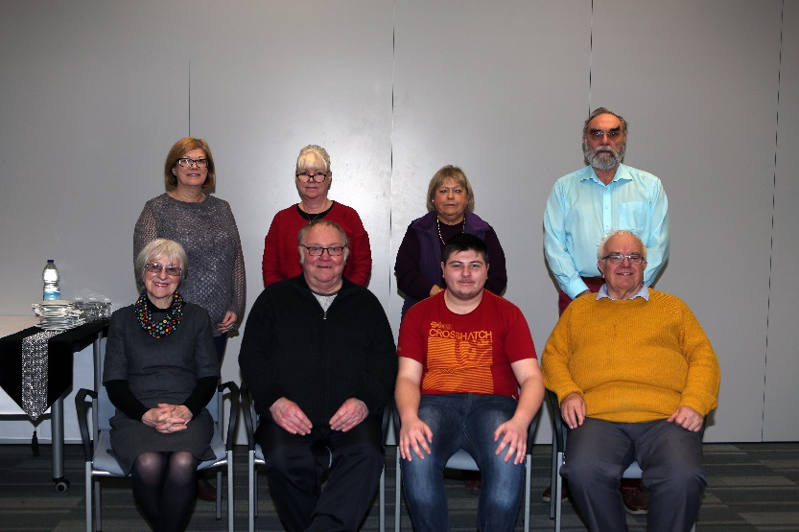
Back in September 2019 our Independent Custody Visiting Scheme became one of five Force areas, the only in Wales, to take part in a national ‘Independent Custody Observers Pilot’. The 6-month Pilot, run by the Independent Custody Visiting Association (ICVA), aimed to further protect the welfare of those identified as vulnerable within police custody, including young people. The Pilot gave ICVs the opportunity to routinely review a selection of custody records of vulnerable detainees, giving them an opportunity to consider a detainee’s entire journey through custody.
The independent evaluation of the Pilot was finalised in July 2020 which recommended that these additional checks during ICV visits and regular Custody Record Reviews become a regular part of the ICV role. These changes are currently with the Home Office for consideration.
Unfortunately, due to Covid-19 our ICVs were unable to meet and review custody records until March 2022. However, throughout the Pandemic the office has been undertaking independent dip-sampling of custody records on a monthly basis to ensure that checks on the welfare of detainees continue, and that all rights and entitlements continue to be granted during this unprecedented time.

146 Records were reviewed in total from April 2021 to March 2022. Findings are shared with the Chief Inspector of Custody and any issues are highlighted.
Positively, in March 2022 ICVs were able to re-commence reviewing custody records on a monthly basis at Police Headquarters, Carmarthen.
Main findings:
- Improvements in females being appointed a female member of staff.
- No major delays in AAs or solicitors identified.
- Accommodation for children continues to be an issue; a meeting took place in November 2021 with the Commissioner and the Heads of Children Services. Heads of Children Services are considering their current facilities and resources to see if they can look to use as an emergency bed for children brought into custody.
- The use of the Children in custody checklist has significantly improved.
- It was found that hygiene provisions and covid-19 safety measures are not regularly recorded in logs.

Anti-rip suit pilot

In March 2022 our ICV Scheme commenced an Anti-Harm Suit pilot scheme between Dyfed-Powys Police and the Independent Custody Visiting Association (ICVA). Dyfed-Powys is currently leading on this as the only pilot area.
Anti-rip clothing or anti harm suits are clothing that are used in many custody suites across the UK. The material of the clothing is made to prevent detainees being able to rip the material and make ligatures.
This Pilot has come about following a thematic review of the use of anti-harm clothing in police custody by ICVA.
ICVA found that Inspectorate reports reveal consistent concerns with the use of anti-harm clothing in custody, some of the concerns found nationally include;
- Poor recording and practice in terms of both proportionality and justification of the use of the suits,
- The suits are recorded as being used in the absence of risk information, often with difficult detainees, by force, and have been noted as being potentially punitive,
- Concerns regarding detainee dignity being effectively maintained during clothing removal by force
- Detainees have been left naked in an endeavour to manage harming behaviours, in suites both where the clothing is used, and those where it is not.
The Pilot will see our ICVs independently review the custody records of individuals within Dyfed-Powys custody suites who have been issued with an anti-harm suit, looking particularly at:
- Are the suits are being issued appropriately,
- Are they being removed as soon as possible,
- Is there sufficient rationale for their use recorded within Custody logs.
In March my ICVs reviewed 12 records of those issued with an anti-rip suit.
Records have been reviewed using the following rag rating:
Reason for Rating | Follow Up Action
Drop down in use, full rationale for use of suit, which is both justifiable and proportionate to risk posed. | No further action required at this point.
Suit removed as soon as practicable.
Clear de-escalation, distraction items etc. used to mitigate risk of detainee DSH.
Little or unlclear justification for the use of the suit. | Advice/further training given to custody staff.
Insuffcient information to determine the proportionality of the use of the suit.
Detainee left in suit for elongated periods of time.
Suit drop down used but no further information. | Further exploration required as to use/rationale. Cases to be raised with custody inspector.
Suit used in absence of risk information but no other rationale.
Suit used by force with no further information.
Drop down not used, information on suit discovered as part of routine CRR by ICVs

The following rating was given to the 12 records reviewed in March 2022:
Green | 4
Amber | 5
Red | 3

The aim is that the pilot will dramatically reduce the number of anti-rip suits being issued and ensure that sufficient rationale is recorded should a suit be used. Findings are discussed monthly with ICVA and the Chief Inspector of Custody. Any custody records that receive a red grading are highlighted to the Chief Inspector of Custody and the record numbers are provided. This allows for constructive feedback to be given to the owners of those records, to help raise awareness and spread good practice.
As part of the pilot ICVs will continue to meet on a monthly basis to review approx. 15 records per month with a focus on those who have been issued with an anti-rip suit. It is proposed that this pilot will run up until August 2022.

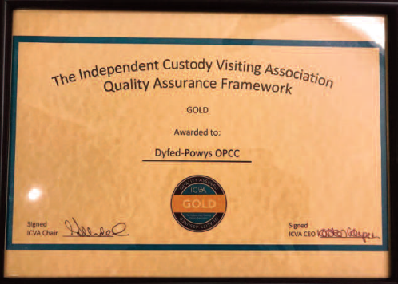
Quality Assurance Framework
The Independent Custody Visiting Association (ICVA) Quality Assurance Awards were presented at a ceremony at the House of Lords on the 15th of May 2019. There were four graded levels of award, and the Dyfed-Powys Scheme was delighted to have received the Gold standard; meaning the Scheme provides an excellent standard of custody visiting and volunteer management. Due to Covid-19 this level will be re-assessed in September 2023.

Future Developments
.
- A training day is planned for August 2022 at Police Headquarters, inputs within this training day will include and overview of a detainee’s journey from being booked into custody through to release, an input on equality and diversity and an input on detainee dignity.
- There are is an aim that in 2022 that the ICV scheme will move to electronic reporting instead of paper ICV visit report forms.
- Plans continue for the new Carmarthenshire Policing Hub and Custody Suite in Llanelli. Planning permission was granted to the Office of Police and Crime Commissioner by Carmarthenshire County Council back in April 2021 for the proposed development, which is to be an ambitious sustainable construction, with a BREEAM excellence rating. ICVs are to be invited to an open event to visit the construction site of the new build on the 24th June 2022.

Interested in becoming an ICV?
If you are interested in volunteering for the Police and Crime Commissioner and becoming an ICV within the Dyfed-Powys area, or would like some further information, please visit:
http://www.dyfedpowys-pcc.org.uk/en/the-office/volunteer-schemes/independent-custody-visitors/
Or contact Caryl Bond on 01267 226440
Or Email: caryl.bond@dyfed-powys.police.uk

Appendix A:
A detainee’s rights under Code C of PACE are summarised below. This is the information provided to detainees at the police station. Full details are available in the Police Code of Practice C.
1. Tell the police if you want a solicitor to help you while you are at the police station. This is free.
2. Tell the police if you want someone to be told where you are. This is free.
3. Tell the police if you want to look at their rules – they are called the Codes of Practice.
4. Tell the police if you need medical help. Tell the police if you feel ill or have been injured. Medical help is free.
5. If you are asked questions about a suspected offence, you do not have to say anything. However, it may harm your defence if you do not mention when questioned something which you later rely on in court. Anything you do say may be given in evidence.
6. The police must tell you about the offence they think you have committed and why you have been arrested and are being detained.
7. The police must let you or your solicitor see records and documentation about why you have been arrested and are being detained and about your time at the police station.
8. If you need an interpreter, the police must get you one. You can also have certain documents translated. This is free.
9. Tell the police if you are not British and you want to contact your embassy or consulate or want them to be told you are detained. This is free.
10. The police must tell you how long they can detain you for.
11. If you are charged and your case goes to court, you or your solicitor will have a right to see the prosecution evidence before the court hearing.

Appendix B

The environmental checks that ICVs undertake whilst visiting Custody:
- Check that the cells are clean (both occupied and empty cells where possible).
- Check that the kitchen and food preparation area is clean and tidy.
- Check that all other areas within Custody are clean and tidy.
- Check that the heating, lighting and ventilation is adequate.
- Check that the medical room is locked if no healthcare professional is present.
- Check that a first aid kit is readily available.
- Check that there are sufficient stocks of bedding, anti-rip suits & spare clothing.
- Check that there are sufficient stocks of food.
- Check that the Custody Suite is clear of any apparent health and safety hazards.
- Check that the cell buzzer and CCTV systems are in working order.
- Check that religious materials are readily available to detainees.
- Check that there are no ligature points posing a risk to detainees.

The welfare checks that ICVs undertake whilst visiting Custody:
- Are they being treated reasonably?
- Have they been made aware of their legal and visitor rights?
- Do they understand their rights as they have been explained to them?
- Has someone been informed of their detention (if they have requested this)?
- Have they seen a solicitor (if they have requested this)?
- Have they been offered/ provided with food/drink?
- Have they requested / received medical attention if needed?
- Have they been given access to toilet/ hygiene/ washing facilities?
- Has additional bedding/ replacement clothing/ blanket been provided, if required?
- Have suitable rest periods and/or exercise been made available, if appropriate?

