Police and Crime Commissioner
for Dyfed Powys

Dip Sampling – Timeliness
& Communication of Complaints Handles outside of schedule 3

OPCC Findings & Feedback

Date January 2023

1.0 Overview
On the 23rd of January 2023 the Office for the Police and Crime Commissioner (OPCC) reviewed a random selection of closed complaint cases which were handled outside of schedule 3 by the Professional Standards Department (PSD) for quarter 1 and quarter 2 i.e. April – September 2022. The main purpose of this scrutiny work was to independently review complaints recorded outside of schedule 3 which are not eligible for a complaint review to consider whether there is any learning identified in terms of timeliness and communication.

2.0 Background, Purpose and Methodology
The background and purpose of the scrutiny dip sampling work, alongside how the dip sampling is carried out is detailed within the Complaints Scrutiny Framework and Dip Sampling Protocol, which are available on the PCC website via the following hyperlink: http://www.dyfedpowys-pcc.org.uk/en/the-office/strategies-and-policies/.

The Policing and Crime Act 2017 and supporting regulations made significant changes to the police complaints and disciplinary systems. They introduced a number of changes designed to achieve a more customer-focused complaints system in February 2020.
The complaints system has expanded to cover a broader range of matters. Formerly, the way that the term ‘complaint’ was defined meant that it needed to relate to the conduct of an individual officer. Now a complaint can be made about a much wider range of issues including the service provided by the police as an organisation. This was designed to increase access to the police complaints system. The IOPC expects forces to consider the information they keep about complaints with the intent of the reforms in mind – a positive obligation to increase access and to collect information that enables forces and local policing bodies to learn from complaints and other matters.
The changes allow for certain types of complaints to be resolved outside the requirements of Schedule 3 to the Police Reform Act 2002. Complaints dealt with outside the requirements of Schedule 3 must be handled with a view to resolving them to the complainant’s satisfaction.
Handling such complaints outside of Schedule 3, promptly, may be the most efficient, effective, and beneficial way to resolve the complaint. It can assure the complainant that their concerns have been listened to and addressed, while potentially providing a learning opportunity for the force (and, if appropriate, any individuals involved).

3.2 IOPC Statistics
The following statistics have been extracted from the IOPC Police Complaints Statistics for England and Wales Reporting period: 1st of April 2022 – 30th of September 2022.
The table below shows how long, on average, it takes from the customer’s perspective from when they made the complaint and the force’s performance of the initial handling from when it received the complaint.
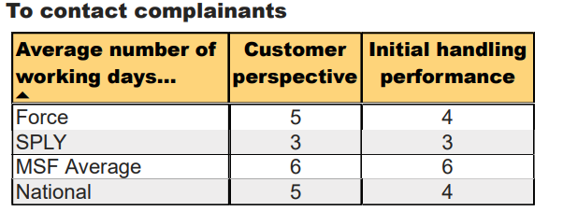
The table blow shows the time it takes the force to finalise allegations by how they were handled. It gives a breakdown of allegations handled informally outside of Schedule 3 and those that were handled formally by either by investigation or handled other than by investigation. Timeliness is calculated from the date the allegation was received by the force.
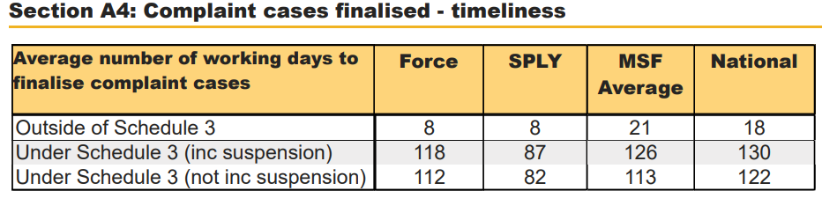

The above table presents information about what happened as a result of the allegation (action). Actions are captured at allegation level and multiple actions can be selected, where appropriate, on a single allegation. The figures shown in this table are based on allegations on finalised complaint cases that resulted in the corresponding action. As more than one action can be selected for a single allegation, the sum of all percentages will not equal 100%.
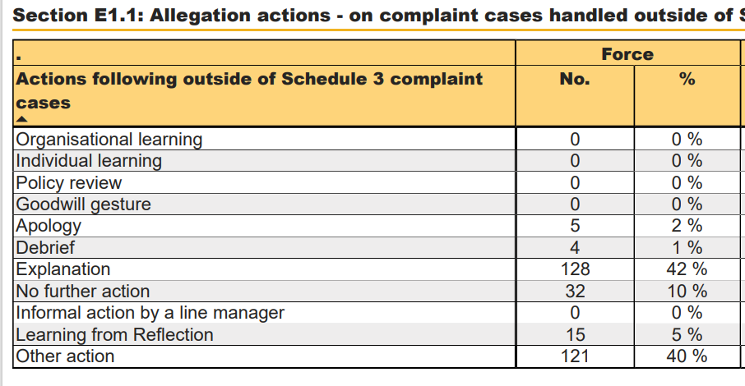
Having considered the table above it shows that 42% of actions taken to resolve the complaint was through providing an explanation. In addition 40% of the actions were recorded as “Other action”.
Having considered the IOPC Guidance on capturing data about police complaints it states that, “Multiple actions should be selected where appropriate:… if ‘other action’ is selected, a short description of the action should be logged. The description should not contain any personal identifying or other sensitive information and should be limited to describing the action taken / to be taken.https://www.policeconduct.gov.uk/sites/default/files/Documents/statutoryguidance/Guidance_on_capturing_data_about_police
It was not identified during this dip sampling activity that the action of cases reviewed were recorded as “other action”. However, it should be noted that the OPCC considers 40% of actions recorded as “other” to be excessive and that PSD should be mindful of the IOPC guidance on capturing data about police complaints to ensure that information is accurately recorded for the purpose of analysing data and monitoring performance.

3.0 Professional Standards Closed Complaint Cases
There was a total of 318 complaints handled outside of schedule 3 during the period 1st of April 2022 – 30th September 2022.

In January 2023, the OPCC undertook a dip sampling exercise and reviewed a total of 16 complaint cases closed between 1st of April 2022 and 30th April 2022 (5% of the total cases closed during the time period). PSD provided the complaint case reference numbers alongside relevant documentation in order to consider any best practices or whether there could be improvements to processes/procedures.

Consideration was given towards the time taken to acknowledge the complaint and the number of days taken before the complaint was closed. The IOPC Statutory guidance states, “The conclusion of handling a complaint outside of Schedule 3 must be communicated to the complainant within five working days of the outcome being determined, and subject to the exemptions in paragraphs 11.16 – 11.20”

There is no set procedure to follow when handling a complaint outside the requirements of Schedule 3. The key consideration is whether a course of action is appropriate and whether it will be an effective response to a complaint, which will satisfy the complainant.

3.1 OPCC Considerations

Timeliness

Having considered 16 complaint cases it was noted that when a complaint is made to PSD the average day for the complaint to be acknowledged was 4 days which is in line with the IOPC guidance.

Additionally, at the time of acknowledging the complaint, prompt action was taken to remedy the concerns. The cases reviewed were either provided with an explanation by PSD at the time the complaint was acknowledged, or it was sent out to the Local Policing Area for service recovery by a supervisor.

The OPCC were unable to determine the outcome of the complaint for case 1 . A complaint was forwarded to PSD from the Force Communication Centre (FCC). PSD contacted the complainant but there was no further update on the record. There may be a number of explanations for this. It is best practice that any action taken/not taken is recorded on the case file.

Case 16 exceeded the 5 days expected to acknowledge the complaint and was concluded in 23 days. The complainant remained dissatisfied following the initial explanation and the complaint was subsequently formally recorded. A clear explanation was provided advising why it could not proceed through the complaints system.

Communication

Complaints which were remedied by means of an explanation by PSD demonstrated quality customer service by the complaint handlers. For example, in Case 11 the complaint was resolved within a day of being received. The complaint handler was able to view Body Worn Video footage available and provide the complainant with an explanation to address concerns.

Of the 16 cases reviewed, 12 cases had been sent out to the Local Policing Are to be service recovered. It was identified that the supervisors made contact directly with the complainants to remedy the dissatisfaction. Clear communication was identified between the supervisors and the complainants, and the supervisors provided PSD with updates of when they made contact with the complainant or when the complaint had concluded. In Case 9 the complainant responded to the supervisor, thanking them for the support they provided.

The IOPC expects police forces to routinely consider whether any learning can be taken from each complaint. Case 14 is a good example of this where there was a misunderstanding between a member of public and a call handler within the Force Communication Centre. The call handler reviewed the call with their supervisor to reflect on the situation and what could have been done differently. An apology was offered to the complainant and an explanation provided on the action taken. Additionally case 13 the supervisor attended the property to remedy the complaint. It was identified that debris had been left by officers who attended an incident with their neighbours. Officers immediately attended the area to clean up the debris and an apology was provided to the complainant.

There was one case where the outcome of the complaint was uncertain . Case 5 was referred to the department concerned for contact to be made with the complainant. Although it is noted that a confirmation email was sent to PSD to advise that the department would contact the complainant there was no further record to suggest that this had been done. Although it can be argued that no further complaint was received by the complainant, it would improve the service if this process was in place as any delays in responses can be monitored.

4.0 Conclusions and Recommendations

To conclude, the dip sampling has demonstrated that overall PSD are efficient at handling complaints outside of schedule 3 in a timely manner. Although there are no set rules for handling a complaint outside of schedule 3, the OPCC considers that the complaints reviewed were handled reasonably and proportionately.

Where the complaint was sent out to division or handled by PSD directly the OPCC were satisfied that the complaint was handled appropriately. There was only one case in the dip sample where a complaint was sent to the department complained of to be resolved which the OPCC were unable to identify the outcome of the complaint.

The Police and Crime Commissioner has a statutory duty to ensure there is an effective complaints process and through scrutiny activity consider whether there are any opportunities to improve processes/procedures.

OPCC Recommendations | Force Response
PSD should ensure that when a complaint is sent outside of the complaints department to be service recovered that there is a clear process in place to ensure that they are provided with confirmation/update of when contact has been made with the complainant, and that they are advised of the outcome of that contact. | Over the last few months we have reviewed the initial complaint handling process with a view to improving efficiency. As a result of the review we have refined the process, employing greater use of the Centurion workflow function to more efficiently manage and monitor complaints handled outside schedule 3. The Admin and Initial Complaint handling team started following the new process on 30/05/2023. This will be kept under review.
PSD should ensure that actions are accurately captured/recorded on Force systems for data collection and analysis. | This relates to the high rate of use of the outcome category “Other action”. This issue was identified and brought to the attention of the PSD Complaints and Misconduct Supervisor at the time of the Dip Sampling review. As a result the Complaints and Misconduct Supervisor briefed the Initial Complaint Handling team and advised them in future to consider what other outcomes were more appropriate before applying “other action”.

