Police Crime Sentencing and Courts Act 2022

Serious Violence Duty

Strategy

Dyfed-Powys Region

Introduction

This Strategy document has been produced as part of the requirements of the Serious Violence Duty, introduced by the Police Crime Sentencing and Courts Act 2022.

The duty places several requirements upon local areas, including agreeing a local partnership arrangement to lead on the duty, agreeing a definition of serious violence, having consistent data sharing, analytical processes to produce a Strategic Needs Assessment, and production of a Strategy to set out how the duty will be implemented locally.

The Duty requires specified authorities to work together to prevent and reduce serious violence, including identifying the kinds of serious violence that occur in the area, the causes of that violence, and to prepare and implement a strategy for preventing and reducing serious violence.

The responsible authorities (also known as ‘duty holders’) in the Serious Violence Duty will be:
- the police
- fire and rescue authorities
- justice organisations (youth offending teams and probation services)
- health bodies (Integrated Care Boards)
- local authorities

Educational institutions, prisons and youth custodial institutions will be under a separate duty to co-operate with duty holders, but they are not duty holders.

This strategy takes account of guidance issued by the government, as well as Welsh guidance, developed by the Wales Violence Reduction Unit.

The strategy sets out the agreed definition of Serious Violence for the region, summarises the key aspects of the Serious Violence Strategic Needs Assessment, the partnership arrangements that have been agreed locally to lead on delivery of the duty, the areas of activity to prevent and reduce serious violence, and activity to engage with voluntary sector organisations, communities - including young people.

Definition of Serious Violence

The Police Crime Sentencing and Courts Act 2022 provides that, for the purposes of the Duty, serious violence includes domestic abuse, sexual offences, violence against property and threats of violence, but does not include terrorism.

In considering serious violence within their area, specified authorities should encompass serious violence as defined for the purposes of the Government’s Serious Violence Strategy and include a focus on issues such as public space youth violence. The Governments Serious Violence Strategy sets out specific types of crime of concern, including homicide, violence against the person which may include both knife crime and gun crime, and areas of criminality where serious violence or its threat is inherent, such as in county lines drug dealing. These crimes should be at the core of the serious violence duty for the purpose of its reduction and prevention.

Whilst the government guidance sets out types of violence that should be incorporated within the definition of serious violence, there is no definition provided and it allows each local area to define serious violence.

Dyfed Powys Serious Violence Definition

At a Dyfed Powys partnership planning meeting on 15th May 2023, Duty Holders agreed to adopt the WHO’s definition of violence and agreed that the needs assessment would focus on the following crime types and descriptors (figure 1). The definition also recognises that the Serious Violence Duty encourages to include both domestic abuse and sexual assault.

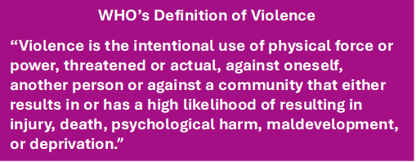

Figure 1: Dyfed Powys Strategic Violence Definition Crime Types and Descriptors

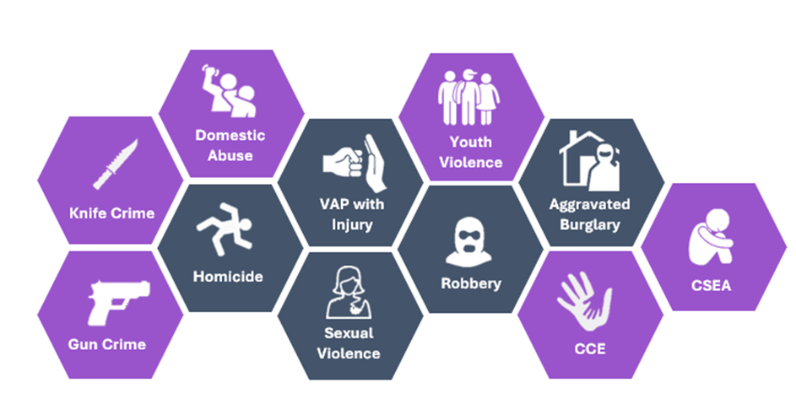
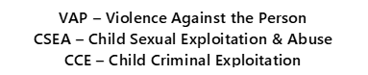

Crime Types - Violence with injury (non-domestic related), homicides, sexual violence (rape & other serious sexual offences), robbery and aggravated burglary.

Descriptors – Have a high likelihood of resulting in injury, death and psychological harm so will include occurrences where injury and no injury has been sustained.

N.B. Terrorism is not included.

Local Partnership Arrangements

The partnership structure that will be used in Dyfed-Powys to undertake the requirements of the Serious Violence Duty is the Serious Violence and Organised Crime Board (SVOC).

This structure contains representation from:

- Local Health Boards – Powys Heath Board and Hywel Dda Health Board
- Fire and Rescue – Mid & West Wales Fire and Rescue
- Police – Dyfed-Powys Police
- Local Authorities – County Councils for Carmarthenshire, Ceredigion, Pembrokeshire and Powys
- HMPPS Probation
- Youth Offending teams.

These specified authorities are jointly responsible for decision-making regarding the Duty, and decisions around how the Duty is implemented in Dyfed-Powys are multi-agency in nature.

The SVOC Board is chaired by the Director of Intelligence of Dyfed Powys Police and is at the rank of Detective Superintendent.

The Board meets four times a year on a quarterly basis.

Embedded below is the Terms of Reference for the DPP Serious Violence and Organised Crime Board

Figure 2: Dyfed Powys Strategic Violence Partnership Structure
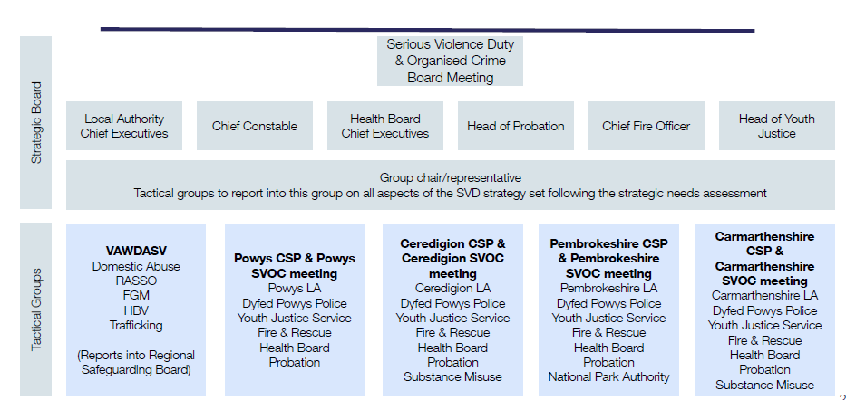

Figure 3 demonstrates the intervention and prevention work delivered through services commissioned by the OPCC and through organisations receiving funding from the OPCC. These interventions and preventative activities take place across a range of geographies, including pan-Dyfed Powys, and focus on a range of vulnerabilities and themes across primary, secondary and tertiary levels of intervention,

Figure 3 OPCC funded initiatives by themes.
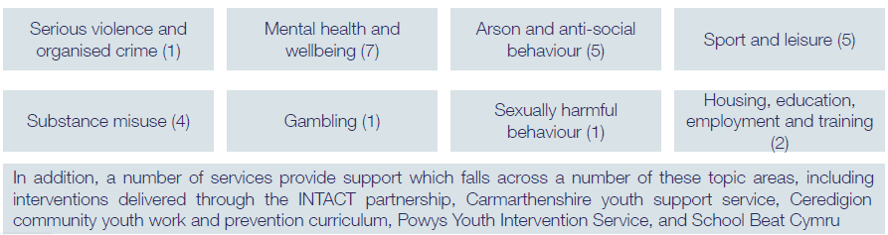

Summary of the Strategic Needs Assessment of Violence

The strategic needs assessment is intended to enable partners to identify current and long-term issues relating to serious violence and those most vulnerable to involvement in the local area. This provides a greater understanding of established and emerging serious violence trends, priority locations or other high-risk issues.

The Dyfed Powys Serious Violence Strategic Needs Assessment has been developed following an evidence-based analysis of data relating to violence, as well as broader datasets including those in relation to deprivation and health. It measures the levels and nature of violence across Dyfed Powys, explains drivers and risk factors of violence, identifies population and geographical areas most affected and aims to inform the development, targeting and evaluation of prevention activity.

The strategic needs assessment has looked at the critical areas of violence and vulnerability within the definition of serious violence, including domestic abuse and sexual violence.

The following is high level executive summary of the strategic needs assessment.

Serious violence offences are on the rise in Dyfed Powys.

Whilst applying the Dyfed-Powys definition of serious violence it is evident to see that serious violence is on the rise in our communities. Police recorded crime od serious violence in 202/23 has now increase to above pre-pandemic levels. However, some caution should be taken as recently lots of work has been undertaken to improve the police’s crime recording practices and to encourage victims to report to the police. These recording practice improvements have potentially attributed to the rise, but to what degree is unknown.

Violence with injury makes up the majority of serious violence crimes.

17,919 violence with injury offences were reported to the police in the last 5 years – 69.3% of all serious violence.

Domestic abuse incidents are increasing year on year, a trend seen across each local authority.

Domestic abuse incidents and crimes have risen from 6,791 in 2018/19 to 11,601 in 2022/23.

30% of violence with injury has been domestic related over the past 5 years.

31% of victims did not want to support or withdrew support for any legal action.

26% of rape offences were domestic related.

Victims of domestic abuse are more likely to experience repeat victimisation than victims of other crimes.

Pre-pandemic annual rape and serious offences were dropping, but since the pandemic they have been on the rise.

39.8% of other sexual offences was sexual assault of a female age 13 & over.

64% of rape victims were (17 years and over), 36% were children.

30.9% of victims did not want to support or withdrew support for any legal action.

Children and young people are frequently involved in serious violence as victims or suspects.

Victims

67% of victims of all violent crime were male.

Of the 21 homicide victims from 2019-2022 11 were male and 10 were female

40% of rape victims and 58% of other sexual offences were under the age of 18.

Perpetrators

71% of homicide and near miss homicides suspects were male.

1 in 2 sexual offences against women are carries out by their partner or ex-partner.

Under 18s make up a quarter of other sexual offence suspects

Homicide and near miss homicides are most common on weekends and at night-time.

71.3% of homicides and near miss homicides in the last five years happen between 6pm and 5.59am

19% of violence against the person offences occurred in July and August.

Drugs and alcohol are major drivers for serious violence, and Adverse Childhood Experiences are key risk factors in drug use.

Drugs

Drug misuse was a factor in 4 out of 21 homicides and 21% of near miss homicides.

Nine of the top twelve areas for community violence in Dyfed-Powys are also in the top twelve for drug trafficking and possession offences.

Adverse Childhood Experiences were likely to be responsible for 59% of drug use.

Alcohol
Over 1/3 of community violence suspects were under the influence of alcohol

23% of knife crime was alcohol related.

27% of violence with injury was alcohol related.

17% of children brought into police custody were under the influence of alcohol.

Gender inequality has been identified as a predictor for Violence Against Women and Girls

Action to Prevent and Reduce Serious Violence

Taking account of the Strategic Needs Assessment, the local partnership has agreed
the following strategic objectives for the next 12 months to prevent and reduce serious violence:

- Priority focusing on the online threat, supporting children and young people, parents, and teachers to increase knowledge and resilience. In particular, there will be support to focus on supporting parents with education and awareness raising.

- Priority focusing on a more preventative response, speciﬁcally reducing risk of Adverse Childhood Experiences, substance abuse and mental health. We will build on existing work related to the drivers and risk factors of violence already in existence to its sustainable, and gaps in the current provision are identiﬁed.

- Priority focusing on violence against women, domestic abuse and sexual violence, particularly working to improve community education, reporting of VAWDASV, and partnership data sharing. We will focus on delivering key initiatives such as the Multi Agency Tasking And Coordination (MATAC) approach to identifying and tackling perpetrators of serious violence and the IRIS training support and referral programme for General Practice within Health, as well as supporting communications around VAWDASV.

- Priority focusing on the night-time economy, particularly gaining further insight into alcohol-related serious violence locally, embedding existing projects and education initiatives. We will commission further analysis of this area to ensure any further work is evidence-led.

The partnership has agreed a range of activity to reduce the risks of violence and vulnerability, in support of the strategic objectives. These are set out within the below Implementation Action Plan, however, figure 4 also highlights and summarises the Mid and West Wales Regional VAWDASV Partnership – Violence against Women, Domestic Abuse and Sexual Violence Strategy 2023-2027, which will contribute to the objectives set out by this strategy.

Figure 4. An overview of the regions VAWDASV strategy for 2023-2027
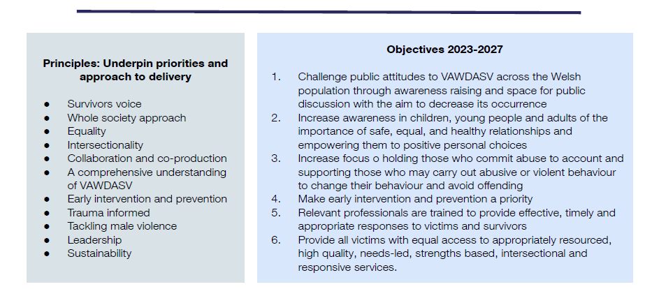

Serious Violence Reduction Implementation Plan

Priority | Key next steps | Priority and timeline | Lead individual/ organisation
Building on and adding value to existing and ongoing work | 1. Embedding the strategy within existing governance arrangements will be important, particularly with the amount of work being done across all the regional boards. Within the three months, individuals in the partnership should present the strategy to colleagues on other Boards, highlighting the priorities agreed, key outcomes and actions, as well as to wider stakeholders - this could be supported by a communications plan. | High priority within 3 months of the publication of this strategy | tbc
 | 2. Reviewing grant funding arrangements over the next two years in addition to other funding streams and potential resources provided by speciﬁed authorities to understand how to sustain work, particularly interventions, beyond the next two years of central funding and aligning funding to match the long term outcomes under each of the priorities - Violence Reduction Units are now required to review the sustainability of their work, and may provide useful advice on how to approach this in Dyfed-Powys. Within the next year, the partnership should convene a sustainability subgroup/ workstream to consider the long-term future of the Partnership - this workstream should produce a strategic commissioning plan that supports the response strategy and delivery plan, particularly relating to VAWDASV and prevention (as outlined below). | Low priority within 12 months of the publication of this strategy | tbc

Priority | Key next steps |  | Priority and timeline |  | Lead individual/ organisation
Targeting the most deprived wards in all activities |  | 1. The partnership indicated it wants to be targeted in its approach, based on its understanding of deprivation and areas which see high rates of serious violence. The partnership should ensure it monitors rates of serious violence, developing a list of hotspots that can be used in discussions on targeting delivery and partnership working. | High priority within 3 months of the publication of this strategy  Set up an ongoing monitoring process and discussion point | tbc

Priority | Key next steps |  |  | Priority and timeline |  | Lead individual/ organisation
Focusing on the online threat, supporting children and young people, parents, and teachers to increase knowledge and resilience.  Partners expressed an interest in a focus on supporting parents with education and awareness raising. |  | 1. Ahead of any initiative focusing on supporting parents, partners should consider consulting users of online technologies about what they need, focusing on 16–25-year-olds and parents. The partnership should discuss whether to conduct this exercise and what its parameters would be.  This exercise will incur labour costs. | High priority, within the next three months pf the publication of this strategy (deciding whether to consult) |  | tbc
 |  | 2. In developing an initiative on supporting parents should consider the following process:  ● Conduct a rapid review of ongoing action in this area and available local information. The partnership should task an individual/ agency with reviewing the provision across Dyfed-Powys, highlighting consistency and opportunities to improve the provision, including linking this to evidence of ‘What Works’.  ● Develop an educational package for parents. The partnership should discuss how this will be resourced and developed, even within the partnership and/or by an external provider.  This will be an opportunity to use the grant funding.  ● Produce a communications and marketing strategy for the educational package, including supporting services to disseminate key messages to parents and signposting sources of support to parents.  ○ The partnership should consider how to support access to and engagement in this educational package.  ○ The partnership should identify who will lead the roll-out of this package. | Medium priority, within the next three months of the publication of this strategy |  | tbc
 |  | 3. The partnership should consider how to involve key stakeholders in the development and roll-out of this package, including education, youth services and health. The partnership should discuss this with relevant leads. | High priority, within the next three to six months of the publication of this strategy |  | tbc
 |  | 4. In order to measure the impact of the educational package, the partnership should develop an evaluation plan, including how to use data collected by the School Health Research Network. The partnership should identify how this initiative will be evaluated.  This may incur labour costs. | Low priority, within the next 12 months (but ahead of the roll-out of the package) of the publication of this strategy |  | tbc

Priority | Key next steps |  | Priority and timeline |  |  | Lead individual/ organisation
Focusing on a more preventative response, speciﬁcally reducing risk of Adverse Childhood Experiences, substance abuse and mental health  Partners thought that existing work related to the drivers and risk factors of violence is aligned and made sustainable, and gaps in the current provision are identiﬁed. |  | 1. The partnership is keen to undertake gap analysis of current governance structures and boards dealing with children and young people to better inform how they can add value, especially reviewing the consistency of provision across Dyfed-Powys. The partnership should identify how to complete this mapping exercise  This may incur labour costs. |  | High priority, within the next three to six months of the publication of this strategy | tbc
 |  | 2. Sharing good practice on ‘what works’ to tackle the long-term causes and risk factors of involvement in serious violence. The partnership should use the mapping exercise to highlight good practice and refer to ‘What Works’ evidence. |  | Medium priority, within the next six months of the publication of this strategy | tbc
 |  | 3. Using the mapping exercise, the partnership should develop a plan for retaining provision of existing eﬀective preventative activity, ensuring that funding for this activity is sustainable. The partnership should develop a strategic commissioning plan to support its strategy, particularly around the preventative response - based on the mapping exercise. There will be an opportunity to use the grant funding in the short-term. |  | Low priority, within the next twelve months of the publication of this strategy | tbc
 |  | 4. The partnership has identiﬁed it needs to further the sharing of existing datasets between organisations on the local causes and risk factors of serious violence. The partnership should task an individual/ agency to collate and monitor this information, including to work through data sharing issues.  This may incur labour costs. |  | Low priority, within the next twelve months of the publication of this strategy (building on the ﬁndings in the Strategic Needs Assessment) | tbc

Priority | Key next steps |  | Priority and timeline |  |  | Lead individual/ organisation
Focusing on violence against women, domestic abuse, and sexual violence, particularly working to improve community education, reporting of VAWDASV, and partnership data sharing  Partners wished to focus on delivering key initiatives such as MATAC and IRIS, as well as supporting communications around VAWDASV. |  | 1. The partnership decided in order to avoid duplication, that it should collaborate with the regional VAWDASV advisor and Board to identify gaps in existing communications strategy. The partnership should organise a joint workshop to review the delivery plan, ﬂesh out opportunities and how the Duty can be used to deliver these opportunities. |  | Medium, within the next three to six months of the publication of this strategy | tbc
 |  | 2. The partnership saw a clear opportunity to use the Duty to collaborate with the regional VAWDASV Board to set up a Multi-Agency Tasking and Coordination (MATAC) process, with the purpose of reducing risk for domestic abuse perpetrators and the community. Key steps, outlined include:  ● Developing Terms of Reference for monthly MATAC meetings and planning an introductory workshop for key partners  ● Developing processes to identify high risk perpetrators in each county - collaborating with the police  ● Understanding how to take a perpetrator-focussed approach, using best practice from other areas with a MATAC process  ● Developing an Information Sharing Protocol to support this process  ● Establishing processes to feed ﬁndings of domestic abuse perpetrator proﬁling into other preventative work e.g. wider perpetrator programmes or drug and alcohol services  ● Scoping IT requirements - existing  MARAC systems may be able to be utilised  An individual will need to be tasked by the partnership to progress these steps and set up the process.  This will incur labour costs. |  | High priority, within the next three months of the publication of this strategy (has been identiﬁed by a quick win for the partnership) | tbc
 |  | 3. The IRIS pilot was identiﬁed as a positive intervention that was due to have its funding withdrawn/ lost. There was a desire from the partnership to understand how IRIS could be kept. The partnership could consider using the grant funding to continue the intervention, while using a strategic commissioning plan to understand how to support this intervention in the long-term. This is an opportunity to use the grant funding. |  | High priority, within the next three months of the publication of this strategy (due to the imminent funding implications) | tbc

Priority | Key next steps | Priority and timeline | Lead individual/ organisation
Focusing on the night-time economy, particularly gaining further insight into alcohol-related serious violence locally, embedding existing projects and education initiatives | 1. Partners wanted to conduct a problem proﬁle on oﬀences occurring at night-time and with alcohol/drugs ﬂags including violence with injury, sexual oﬀences, robbery. Partners should commission an in-depth analysis of the night-time economy in Dyfed-Powys This will incur labour costs. | Medium term, within the next three to six months of the publication of this strategy | tbc
 | 2. Partners reference it would be useful to deliver training on data recording to police oﬃcers, in order to improve data quality and our understanding of serious violence associated with the night-time economy. Following the in-depth analysis, partners should hear and action recommendations on how to improve recording. | Low priority, within the next twelve months of the publication of this strategy | tbc

Engagement with the young people

In developing the local strategy to reduce serious violence, we have consulted with the communities via the Dyfed Powys Police and OPCC 2022 Youth Survey, which focused on those areas of policing that are important for our young victims and young member of our communities.

Mental health support and improving support for children and young people impacted by Domestic Abuse where the themes that came through the greatest.

Identified funding streams or resources that can be used by the partnership for prevention and reduction activities.

In addition to the partnership prioritisation of the Serious Violence Duty funding provided by the Home Office, partners have access to resources and funds that complement this activity.

The Police and Crime Commissioner’s team have worked to convene and support partners in establishing the Duty and developing the strategy and associated documents. The team will continue to work with partners in overseeing delivery of the interventions.

Dyfed Powys Police’s Serious Violence and Organized Crime Coordinator currently leads the programme of work for the INTACT partnership, delivering activity aimed at reducing the harm caused to individuals and communities by serious violence and organised crime. This includes resourcing of 11 PCSOs across the Force area, working with partners including youth services to deliver targeted interventions. These roles are part of the core funding of the Force and are dedicated to this area of work. The interventions delivered as part of the programme are also funded via both Dyfed Powys Police and the Police and Crime Commissioner.

The Police and Crime Commissioner provides funding to local Youth Offending and Prevention Teams to assist in their delivery of prevention and early intervention work with young people.

The recently awarded Safer Streets 5 funding includes projects that contribute to the reduction and prevention of Serious Violence in Dyfed Powys.
Most of the Safer Streets 5 projects within Dyfed Powys are directly tackling VAWG crime types, with a focus on prevention and education activity to influence positive behavioural change in our communities.

A number of partners contribute funding to the Regional Violence Against Women, Domestic Abuse and Sexual Violence strategic partnership. This currently provides a number of pilot programmes delivering intervention around domestic abuse and stalking perpetration, including support for victims and families.

Partners also deliver interventions that contribute to prevention of serious violence; examples include the Phoenix programme run by the Fire and Rescue Service which is delivered to young people at risk of offending, including arson and road safety education.

In addition to the above, the Police and Crime Commissioner has community funding that is made available to projects that contribute directly towards the Police and Crime Plan. This has been utilised for projects including the Kicks programme, providing grass roots football programmes for children in areas of deprivation and at risk of exploitation and offending. To date the Commissioner has provided over £300,000 of funding to this programme.

This is for the local partnership to provide high level information on the resource’s partners are investing in work to reduce serious violence.

This could be a summary of co-located resources each partner has provided to support violence and vulnerability reduction and/or core financial investment.

Please note that this is specific section set out in the Home Office guidance and so should be completed to demonstrate compliance with the duty.

Publishing of the Strategy

This Strategy document will be published on partners’ websites by 31st January 2024.

Date for review/annual review mechanism

This Strategy document will be reviewed annually, with the next review due by January 2025.

Progress of this strategy, the objectives set out within it and the local action plan, will be reviewed at least quarterly through the Serious Violence and Organised Crime Board.

Summary of Annual Assessment of Progress

This section will be applicable 12 months after the local Strategy is produced and will provide a summary of the annual assessment of the partnership’s performance against the previous years’ strategy and will be incorporate the work of the Serious Violence Duty Coordinator role, once appointed.

