18th of October 2017

TO: The Police and Crime Commissioner, Chief Constable, Deputy Chief Constable, Assistant Chief Constable, Director of Finance, Chief Finance Officer and Director of Resources

Copy to: ACPO and Senior Officers/Staff
OPCC Staff
Press

Dear Sir/Madam,
A meeting of the Dyfed-Powys Policing Accountability Board will be held on Friday the 3rd of November 2017 at 10:00 hrs in Room L1.17, Pembrokeshire College for the transaction of the business on the attached agenda. Members of the Press and Public may attend this meeting. Those wishing to do so are asked to contact the OPCC in advance to inform us of any requirements, or if they wish to contribute to the meeting through the medium of Welsh.

Yours sincerely
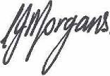

Carys Morgans
Chief of Staff

Encl.

AGENDA

- Welcome and Apologies
- Minutes of the Accountability Meeting held on 27th of July 2017 and Matters Arising

- Force Performance Report Quarter 2

- Financial performance during quarter 2

- Update on the Police and Crime Delivery Plan, focusing on:
- Victim Satisfaction
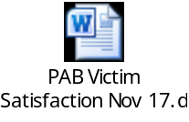
- Public Confidence

- Organisational Health and Wellbeing

- HMIC

- IPCC


- Update on Policing Board focus areas during quarter 2.

- Estates

- Scrutiny activity feedback
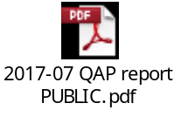
- Action and Risk Summary from Meeting
- AoB
- Presentation from Chief Insp. Nicola Carter

