8th October 2015

TO: The Police and Crime Commissioner, Deputy Police and Crime Commissioner, Chief Constable, Deputy Chief Constable, Assistant Chief Constable, Director of Finance, Chief Finance Officer, Director of Resources and Director of Legal

Copy to: ACPO and Senior Officers/Staff
OPCC Staff
Press

Dear Sir/Madam,
A meeting of the Dyfed-Powys Policing Accountability Board will be held on Thursday, 15th October 2015 at 10:30 p.m. in Ceredigion Room 4, Police Headquarters, Llangunnor, Carmarthen for the transaction of the business on the attached agenda. Members of the Press and Public may attend this meeting.

Yours sincerely
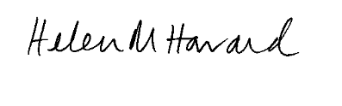

Dr H Morgan-Howard
Chief of Staff

Encl.

AGENDA - Priority 3: Bringing People to Justice

- Welcome and Apologies
- Minutes of the Accountability Meeting held on 17th September 2015 and Matters Arising
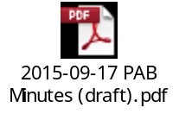

- Performance:
  - Force Accountability Report on Priority 3
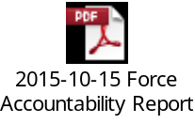
  - OPCC Accountability Report on Priority 3
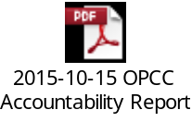
  - OPCC Monitoring Performance Report
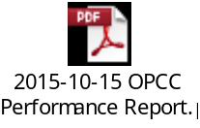
- Update Reports:
  - Questions from the Chief Officer Group minutes
- Action and Risk Summary from Meeting
- AOB

