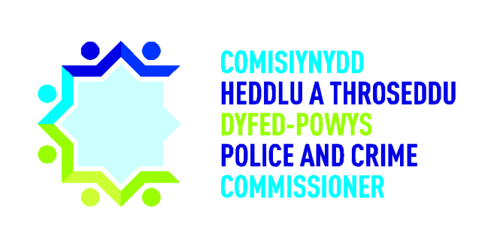

Police and Crime
Commissioner for Dyfed-Powys

Snapshot Review of
Hate Crime and Incident Cases

September 2019

Overview
As part of the Commissioner’s scrutiny framework, four OPCC staff members conducted a snapshot review of 11 hate crimes and incidents which occurred between February and June 2019.

Background, Purpose and Methodology
The Police and Crime Commissioner’s scrutiny has mainly been undertaken in one of three ways: through direct requests for information and questioning at governance meetings; via scrutiny panels’ formal reviews of cases; and more recently, thematic deep dives. The Commissioner’s new scrutiny framework has been designed to offer an enhanced suite of methodologies, to provide more flexible and proportionate options.

These 11 cases had been previously selected for consideration by the Commissioner’s Quality Assurance Panel during their meeting in August 2019, but had not been reviewed due to time constraints. The Panel reviewed a total of 10 cases within their meeting, the results of which can be seen within their report.

Summary of cases reviewed
Type of hate crime / incident | Cases reviewed
Racially Aggravated | 2
Homophobic / Transphobic | 5
Religiously Aggravated | 2
Disability related / mate crime | 2
Total | 11

Summary of findings

Best practice
These areas were identified as best practice by the staff members:
- Good evidence of extra provisions and adjustments being made for vulnerable victims. For example, the victim within one case was identified as partially sighted and therefore required additional support with written materials, which was provided by the officer. This raised the question as to the range of alternative formats (such as audio versions) of hate crime information that is available and easily accessible by Hate Crime Support Officers (HCSOs).
- Whilst the delayed deployment of a HCSO within one case was contradictory to policy, reviewers consider it to be appropriate that the organisation did not necessarily require a HCSO to make contact within 48 hours as there were no direct victims.

Areas of learning
The following were identified as potential areas for improvement in future cases:
- Goleudy had been suggested for further support for the victim within two cases, however Goleudy does not provide support for victims of hate crime. The victims should have been referred to Victim Support.
- There may be some discrepancies in victim contracts when a generic template is used rather than it being tailored to the specific victim. For example, we found pronouns being used interchangeably within one contract. No assumption should be made as to the preferred use of pronoun. Officers should ask the individual if they are uncertain.
- Some cases may have benefitted from additional evidence of the HCSOs’ contact with victims. Not all cases appeared to acknowledge that victims of hate crimes are entitled to an enhanced service under the Victims’ Code of Practice.

Detailed findings
Criteria | Number of cases | Comments
HCSO contacted within 48 hours | 3
HCSO declined by victim | 4
HCSO contacted outside of 48 hour target | 2 | 1 allocated after 6 days.  Case where there was no direct victim attended 20 days later
HCSO not appropriate | 2 | 1 case closed day after reported, 1 not considered a hate crime by victim
Supervisor regularly endorsed crime log | 11
Victim contract agreed | 8
Victim contract not applicable | 2 | Both agreed with victims that no further action (NFA) would be taken
No evidence of victim contract | 1 | Case closed 5 days after incident
Victim updates in line with contract | 7
Victim updates not applicable | 3 | 1 case closed after 5 days and two agreed NFA
Victim not updated in line with contract | 1 | Vulnerable victim preferred text contact rather than email

